3GPP TR 38.855 V16.0.0 (2019-03)

Technical Report

3rd Generation Partnership Project;

Technical Specification Group Radio Access Network;

Study on NR positioning support

(Release 16)

** 

The present document has been developed within the 3rd Generation Partnership Project (3GPP TM) and may be further elaborated for the purposes of 3GPP.  
The present document has not been subject to any approval process by the 3GPPOrganizational Partners and shall not be implemented.  
This Report is provided for future development work within 3GPPonly. The Organizational Partners accept no liability for any use of this Specification.  
Specifications and Reports for implementation of the 3GPP TM system should be obtained via the 3GPP Organizational Partners' Publications Offices.

Keywords

<NR, Positioning>

***3GPP***

Postal address

3GPP support office address

650 Route des Lucioles - Sophia Antipolis

Valbonne - FRANCE

Tel.: +33 4 92 94 42 00 Fax: +33 4 93 65 47 16

Internet

http://www.3gpp.org

***Copyright Notification***

No part may be reproduced except as authorized by written permission.  
The copyright and the foregoing restriction extend to reproduction in all media.

© 2019, 3GPP Organizational Partners (ARIB, ATIS, CCSA, ETSI, TSDSI, TTA, TTC).

All rights reserved.

UMTS™ is a Trade Mark of ETSI registered for the benefit of its members

3GPP™ is a Trade Mark of ETSI registered for the benefit of its Members and of the 3GPP Organizational Partners  
LTE™ is a Trade Mark of ETSI registered for the benefit of its Members and of the 3GPP Organizational Partners

GSM® and the GSM logo are registered and owned by the GSM Association

Contents

Foreword 6

1 Scope 7

2 References 7

3 Definitions and abbreviations 9

3.1 Definitions 9

3.2 Abbreviations 10

4 General description of NR positioning 10

5 Rel-16 NR positioning requirements 11

6 Deployment scenarios and evaluation methodologies for NR positioning 12

6.1 Scenarios and system parameters for positioning evaluations 12

6.2 Performance metrics 15

6.2.1 Horizontal accuracy 15

6.2.2 Vertical accuracy 15

6.2.3 Other metrics 16

7 Studied NR positioning technologies 16

7.1 RAT-dependent NR positioning technologies 16

7.1.1 Downlink based solutions 16

7.1.2 Uplink based solutions 17

7.1.3 Downlink and uplink based solutions 17

7.2 RAT-independent and hybrid NR positioning technologies 17

7.2.1 Remaining attributes of GNSS SSR assistance data 18

7.2.2 Hybrid RAT dependent and RAT independent 18

7.2.3 Summary of RAT independent and hybrid positioning discussions 18

8 Evaluation results of NR positioning 19

8.1 Downlink evaluations 19

8.1.1 System simulations for Scenario 1 – Indoor Office 19

8.1.1.1 Results from [10] 19

8.1.1.2 Results from [11] 25

8.1.1.3 Results from [12] 26

8.1.1.4 Results from [13] 28

8.1.1.5 Results from [14] 30

8.1.1.6 Results from [15] 31

8.1.1.7 Results from [16] 32

8.1.1.8 Results from [17] 33

8.1.1.9 Results from [18] 35

8.1.1.10 Results from [19] 36

8.1.1.11 Results from [21] 38

8.1.1.12 Results from [22] 40

8.1.1.13 Results from [23] 41

8.1.1.14 Results from [25] 43

8.1.2 System simulations for Scenario 2 - UMi 50

8.1.2.1 Results from [10] 50

8.1.2.2 Results from [11] 56

8.1.2.3 Results from [12] 57

8.1.2.4 Results from [13] 59

8.1.2.5 Results from [14] 63

8.1.2.6 Results from [15] 64

8.1.2.7 Results from [16] 65

8.1.2.8 Results from [17] 66

8.1.2.9 Results from [18] 68

8.1.2.10 Results from [19] 70

8.1.2.11 Results from [20] 71

8.1.2.12 Results from [21] 74

8.1.2.13 Results from [23] 75

8.1.2.14 Results from [25] 77

8.1.3 System simulations for Scenario 3 - UMa 81

8.1.3.1 Results from [10] 81

8.1.3.2 Results from [11] 84

8.1.3.3 Results from [13] 85

8.1.3.4 Results from [14] 90

8.1.3.5 Results from [15] 92

8.1.3.6 Results from [16] 92

8.1.3.7 Results from [17] 93

8.1.3.8 Results from [19] 95

8.1.3.9 Results from [20] 97

8.1.3.10 Results from [21] 100

8.1.3.11 Results from [23] 101

8.1.3.12 Results from [25] 103

8.2 Uplink evaluations 106

8.2.1 System simulations for Scenario 1 – Indoor Office 106

8.2.1.1 Results from [10] 106

8.2.1.2 Results from [11] 113

8.2.1.3 Results from [14] 114

8.2.1.4 Results from [19] 115

8.2.1.5 Results from [23] 117

8.2.1.6 Results from [24] 120

8.2.1.7 Results from [25] 122

8.2.2 System simulations for Scenario 2 - UMi 124

8.2.2.1 Results from [10] 124

8.2.2.2 Results from [11] 131

8.2.2.3 Results from [14] 132

8.2.2.4 Results from [15] 133

8.2.2.5 Results from [19] 134

8.2.2.6 Results from [23] 136

8.2.3 System simulations for Scenario 3 - UMa 139

8.2.3.1 Results from [10] 139

8.2.3.2 Results from [11] 143

8.2.3.3 Results from [14] 144

8.2.3.4 Results from [19] 146

8.2.3.5 Results from [23] 148

8.3 Downlink and uplink evaluations 150

8.3.1 System simulations for Scenario 1 – Indoor Office 150

8.3.1.1 Results from [10] 150

8.3.1.2 Results from [19] 156

8.3.1.3 Results from [23] 158

8.3.1.4 Results from [24] 160

8.3.1.5 Results from [25] 162

8.3.2 System simulations for Scenario 2 - UMi 164

8.3.2.1 Results from [10] 164

8.3.2.2 Results from [19] 170

8.3.2.3 Results from [23] 172

8.3.3 System simulations for Scenario 3 - UMa 175

8.3.3.1 Results from [10] 175

8.3.3.2 Results from [19] 177

8.3.3.3 Results from [23] 179

8.4 GNSS and Hybrid NR-GNSS Evaluations 181

8.4.1 Hybrid GNSS-DL-TDOA evaluation [37] 181

8.4.1.1 Scenarios and Methodology 181

8.4.1.2 Simulation results 183

8.4.1.3 Summary for horizontal and vertical positioning error 185

8.5 Summary for evaluations 186

8.5.1 Summary for Downlink evaluations 186

8.5.1.1 Summary for Scenario 1 – Indoor Office 186

8.5.1.2 Summary for Scenario 2 – UMi 187

8.5.1.3 Summary for Scenario 3 – UMa 187

8.5.2 Summary for Uplink evaluations 187

8.5.2.1 Summary for Scenario 1 – Indoor Office 187

8.5.2.2 Summary for Scenario 2 – UMi 188

8.5.2.3 Summary for Scenario 3 – UMa 188

8.5.3 Summary for Downlink and Uplink evaluations 188

8.5.3.1 Summary for Scenario 1 – Indoor Office 188

8.5.3.2 Summary for Scenario 2 – UMi 189

8.5.3.3 Summary for Scenario 3 – UMa 189

9 Identified NR impacts 189

9.1 Signal definitions and configuration parameters 189

9.1.1 Downlink signal definitions and configuration parameters 189

9.1.2 Uplink signal definitions and configuration parameters 191

9.2 Procedure and protocol aspects 192

9.3 Architecture aspects 192

9.3.1 NG-RAN support for location management functionality 192

9.3.2 Architecture procedure and protocol High Layer aspects 193

9.4 Additional Enhancement Identified for NR Positioning 193

9.4.1 Received Signal Waveform Reporting 193

9.4.2 UE-Based Positioning 193

9.4.3 Multipath Measurements 193

9.4.4 LOS Detection 193

9.4.5 Positioning for UEs in RRC_IDLE/INACTIVE States 194

9.4.6 UL SRS Enhancements for NR Positioning 194

9.4.7 Carrier Phase Based Positioning 194

9.4.8 Phase Difference of Arrival Based Positioning 194

10. Conclusions 194

Annex A: Change history 197

# Foreword

This Technical Report has been produced by the 3rd Generation Partnership Project (3GPP).

The contents of the present document are subject to continuing work within the TSG and may change following formal TSG approval. Should the TSG modify the contents of the present document, it will be re-released by the TSG with an identifying change of release date and an increase in version number as follows:

Version x.y.z

where:

x the first digit:

1 presented to TSG for information;

2 presented to TSG for approval;

3 or greater indicates TSG approved document under change control.

y the second digit is incremented for all changes of substance, i.e. technical enhancements, corrections, updates, etc.

z the third digit is incremented when editorial only changes have been incorporated in the document.

# 1 Scope

The present document captures the findings of the study item "Study on NR positioning support" [1]. The purpose of the present document is to support NR positioning in TSG RAN WG1, WG2 and WG3 to properly model and evaluate the performance of NR positioning solutions in deployment scenarios representing relevant use cases, both regulatory and commercial.

# 2 References

The following documents contain provisions which, through reference in this text, constitute provisions of the present document.

- References are either specific (identified by date of publication, edition number, version number, etc.) or non‑specific.

- For a specific reference, subsequent revisions do not apply.

- For a non-specific reference, the latest version applies. In the case of a reference to a 3GPP document (including a GSM document), a non-specific reference implicitly refers to the latest version of that document *in the same Release as the present document*.

The following documents contain provisions which, through reference in this text, constitute provisions of the present document.

[1] RP-182155, "SID, "Study on NR positioning support"

[2] 3GPP TR 21.905, "Vocabulary for 3GPP Specifications".

[3] 3GPP TS 22.071, "Location Services (LCS); Service description; Stage 1".

[4] 3GPP TS 22.261, "Service requirements for next generation new services and markets"

[5] 3GPP TR 22.804, "Study on Communication for Automation in Vertical domains (CAV)"

[6] SP-170589, "New SID on Study on positioning use cases"

[7] 3GPP TR 22.872, "Study on positioning use cases"

[8] 3GPP TR 38.913, "Study on scenarios and requirements for next generation access technologies"

[9] 3GPP TR 22.862, "Feasibility study on new services and markets technology enablers for critical communications; Stage 1"

[10] R1-1901577, "Performance evaluations for NR positioning", Huawei, HiSilicon

[11] R1-1901717, "Evaluation for RAT-Dependent Positioning Techniques", vivo

[12] R1-1901781, "System-level evaluations on Rat-dependent positioning", ZTE Corporation, Sanechips

[13] R1-1903331, "System level performance with explicit link level simulation for downlink OTDOA and angle based techniques", MediaTek Inc.

[14] R1-1901850, "Updated system level simulation results for NR Positioning", Nokia, Nokia Shanghai Bell

[15] R1- 1903222, "Updated System-level Performance Evaluation for NR Positioning", CATT

[16] R1- 1903347, "Discussion on Performance Evaluation for RAT-Dependent Positioning Techniques", LG Electronics

[17] R1-1902246, "System-level Performance Evaluation for RAT-Dependent Positioning Techniques", Samsung

[18] R1-1902397, "System-level Performance Evaluation for SSB Angle Based Positioning", Polaris Wireless

[19] R1-1902514, "NR Positioning Evaluation Results", Intel Corporation

[20] R1-1902550, "System level simulations for OTDOA", ESA

[21] R1-1902698, "System-level Performance Evaluation of Co-band TBS for TR 38.855", BUPT, ZTE, CAICT

[22] R1-1903386, "Evaluation results for NR positioning", Mitsubishi Electric Co.

[23] R1-1903021, "Evaluation results for RAT-dependent positioning Techniques", Qualcomm Incorporated

[24] R1-1903054, "SLS results for NR positioning potential solutions", Fraunhofer IIS, Fraunhofer HHI

[25] R1-1903142, "System-level Performance Evaluation for RAT-Dependent Positioning Techniques", Ericsson

[26] R1-1900236, "Performance evaluation for hybrid positioning based on GNSS and NR", ESA.

[27] ETSI TS 103 246-3, "Satellite Earth Stations and Systems (SES); GNSS based location systems; Part 3: Performance requirements," V1.1.1, July 2015.

[28] 3GPP TS 36.355, "Evolved Universal Terrestrial Radio Access (E-UTRA); LTE Positioning Protocol (LPP)".

[29] RTCM Standard 10403.3, "Differential GNSS, (Global Navigation Satellite Systems), Services – Version 3", October 7 2016.

[30] R2-1806601, "RAN2#101bis Report of 3GPP TSG RAN WG2 meeting #101bis Sanya", China, 16-20 April 2018

[31] "Quasi-Zenith Satellite System Interface Specification, Centimeter Level Augmentation Service", IS-QZSS-L6-001, 5 November 2018, Cabinet Office.

[32] RP-170813, "New WID: UE Positioning Accuracy Enhancements for LTE", Nokia, Alcatel-Lucent Shanghai Bell, RAN#75, Dubrovnik, Croatia, March 2017.

[33] 3GPP TS 23.271, "Functional stage 2 description of Location Services (LCS)"

[34] 3GPP TS 38.805, "Stage 2 functional specification of User Equipment (UE) positioning in NR"

[35] 3GPP, TS 36.211, "E-UTRA Physical channels and modulation", V15.3.0, September 2018.

[36] "Fourth Report and Order, In the Matter of Wireless E911 Location Accuracy Requirements," PS Docket No. 07-114, Federal Communications Commission, Washington, D.C., February 3, 2015.

[37] R1-1902549, "TP on hybrid positioning and GNSS enhancements for TR 38.855", ESA, Mitsubishi Electric Corporation, u-blox AG

[38] R1-1901578, "Positioning with GNSS", Huawei, HiSilicon

[39] R1-1903022, "GNSS-RTK and Hybrid Positioning for NG-RAN", Qualcomm

[40] R1-1810801, "Techniques for NR Positioning", Intel Corporation

[41] R1-1902516, "Reporting of Received Signal Waveform to Boost NR Positioning Performance", Intel Corporation

[42] R1-1903020, "RAT-dependent DL & UL NR positioning techniques", Qualcomm Incorporated

[43] R1-1900918, "RAT Independent and Hybrid Positioning Solutions", Qualcomm Incorporated

[44] R1-1901576, "Remaining issues on DL & UL positioning", Huawei, HiSilicon

[45] R1-1901263, "On single-BS positioning technique", Huawei, HiSilicon

[46] R1-1903239, "On downlink OTDOA and angle based techniques", MediaTek

[47] R1-1812236, "Potential techniques for NR positioning", Huawei

[48] R1-1901716, "Views on NR DL & UL positioning techniques", vivo

[49] R1-1901847, "DL based NR Positioning", Nokia, Nokia Shanghai Bell

[50] R1-1902836, "Views on DL and UL positioning techniques", Mitsubishi Electric Co

[51] R1-1901980, "Further discussion of NR RAT-dependent DL positioning", CATT

[52] R1-1901981, "Further discussion of NR RAT-dependent UL positioning", CATT

[53] R1-1903055, "Carrier Phase enhanced potential solution for NR positioning schemes", Fraunhofer IIS, Fraunhofer HHI

[54] R1-1903346, "Discussions on DL only based Positioning", LG Electronics

[55] R1-1902101, "Discussions on Combination of DL & UL based Positioning", LG Electronics

[56] 3GPP TS 38.305, "NG Radio Access Network (NG-RAN); Stage 2 functional specification of User Equipment (UE) positioning in NG-RAN"

[57] 3GPP TR 23.731, "Study on Enhancement to the 5GC LoCation Services"

[58] 3GPP TS 38.455: "NG-RAN; NR Positioning Protocol A (NRPPa)".

[59] ETSI TS 103 246-3 V1.1.1 (2015-07) "Satellite Earth Stations and Systems (SES); GNSS based location systems; Part 3: Performance requirements"

[60] R1-1901718, "Views on potential techniques for NR RAT-Independent positioning", vivo

[61] R1-1901984, "Further discussion of NR Hybrid Positioning Techniques", CATT

[62] R1-1902103, "Discussion on Potential Hybrid Techniques of RAT-Independent and RAT-Dependent Positioning", LG Electronics

[63] R1-1902190, "Considerations on RAT Independent and Hybrid Positioning for NR", Sony

[64] R1-1902247, "Potential Techniques for NR RAT Independent Positioning", Samsung

[65] R1-1903143, "NR RAT Independent and Hybrid Positioning Solutions", Ericsson

[66] 3GPP, TS 38.211, "NR, Physical channels and modulation", V15.3.0, September 2018.

# 3 Definitions and abbreviations

## 3.1 Definitions

For the purposes of the present document, the terms and definitions given in TR 21.905 [2] and the following apply.   
A term defined in the present document takes precedence over the definition of the same term, if any, in TR 21.905 [2].

**example:** text used to clarify abstract rules by applying them literally.

## 3.2 Abbreviations

For the purposes of the present document, the abbreviations given in TR 21.905 [2] and the following apply.   
An abbreviation defined in the present document takes precedence over the definition of the same abbreviation, if any, in TR 21.905 [2].

CID Cell ID

CDF Cumulative Distribution Function

ECID Enhanced Cell ID

GNSS Global Navigation Satellite System

LCS LoCation Services

LPP LTE Positioning Protocol

DL-TDOA Downlink Time Difference Of Arrival

TBS Terrestrial Beacon System

TTFF Time To First Fix

UL-TDOA Uplink Time Difference Of Arrival

WLAN Wireless Local Area Network

# 4 General description of NR positioning

The 3GPP NR radio-technology is uniquely positioned to provide added value in terms of enhanced location capabilities. The operation in low and high frequency bands (i.e. below and above 6GHz) and utilization of massive antenna arrays provides additional degrees of freedom to substantially improve the positioning accuracy. The possibility to use wide signal bandwidth in low and especially in high bands brings new performance bounds for user location for well-known positioning techniques based DL-TDOA and UL-TDOA, Cell-ID or E-Cell-ID etc., utilizing timing measurements to locate UE. The recent advances in massive antenna systems (massive MIMO) can provide additional degrees of freedom to enable more accurate user location by exploiting spatial and angular domains of propagation channel in combination with time measurements.

A general description of location services and service requirements are given in TS 22.071 [3].

Rel-15 NR WI specified Cell-ID, inter-RAT and RAT-independent positioning methods by reusing LPP, but NR standalone based RAT-dependent positioning was excluded.

According to [4], the 5G system shall support the use of 3GPP and non-3GPP technologies to achieve higher accuracy positioning. The corresponding positioning information shall be acquired in a timely fashion, be reliable, and be available (e.g., it is possible to determine the position). The 3GPP system also presents 5G communication for automation in vertical domains [5]. This is communication that is involved in the production of and working on work pieces and goods, and/or the delivery of services in the physical world. Such communication often necessitates low latency, high reliability, and high communication service availability.

The SA1 HYPOS study [6] focused on positioning use cases in indoor and outdoor environments. The technical report [7] complements existing work on 5G use cases involving positioning needs in order to identify potential requirements for 5G positioning services. The document further develops the identified use cases by providing some considerations on the suitability of positioning technologies to these use cases.

The following requirements were captured in [8]. NR should enable, and improve if suitable, state-of-art positioning techniques, such as RAN-embedded (Cell-ID, E-Cell ID, DL-TDOA, UL-TDOA, etc.) and RAN-external (GNSS, Bluetooth, WLAN, Terrestrial Beacon Systems (TBS), sensors, etc.). NR positioning shall exploit high bandwidth, massive antenna systems, network architecture/ functionalities (e.g. heterogeneous networks, broadcast, MBMS) and deployment of massive number of devices. NR positioning shall support indoors and outdoors use cases.

NR shall support regulatory positioning requirements.

NR design targets for commercial positioning use cases include:

1) Support for range of accuracy levels, latency levels and device categories

2) Support accuracy and latency as defined in TR 22.862 for some use cases

3) Reduced network complexity

4) Reduced device cost

5) Reduced device power consumption

6) Efficient signalling over the air interface and in the network

7) Support for hybrid positioning methods

8) Scalability (support for large number of devices)

9) High security

10) High availability

11) Support UE speed as defined in [9]

# 5 Rel-16 NR positioning requirements

Regulatory requirements are considered as a minimum performance targets for NR Positioning studies. Additional requirements based on commercial use cases can be used as input performance targets that are subject to further analysis in terms of performance/ complexity tradeoffs in different evaluation scenarios. For regulatory use cases, the following requirements are considered as a minimum performance targets for NR positioning:

- Horizontal positioning error <= 50m for 80% of UEs

- Vertical positioning error <5 m for 80% of UEs

- Note: The regulatory requirements of [36] refer to floor level vertical accuracy

- End to end latency and TTFF < 30 seconds

As a starting point for commercial use cases, the following requirements are considered as performance targets for RAT dependent solutions, which are subject to further analysis in terms of performance/ complexity tradeoffs of NR positioning radio-layer solutions:

- Horizontal positioning error < 3m for 80% of UEs in indoor deployment scenarios

- Vertical positioning error < 3m for 80% of UEs in indoor deployment scenarios

- Horizontal positioning error < 10m for 80% of UEs in outdoor deployments scenarios

- Vertical positioning error < 3m for 80% of UEs in outdoor deployment scenarios

- End to end latency < 1s

- Notes:

- This does not eliminate more or less demanding commercial use cases.

- For commercial use cases, indoor deployment means indoor deployed UEs and gNBs.

- For commercial use cases, outdoor deployment means outdoor deployed UEs and gNBs.

Note: It is understood that no single positioning technology has to meet all the requirements for every scenario.

# 6 Deployment scenarios and evaluation methodologies for NR positioning

## 6.1 Scenarios and system parameters for positioning evaluations

For evaluating baseline performance, scenarios (with various options/configurations) are defined below for RAT-dependent positioning techniques for NR positioning study

- Scenario 1. Indoor Office for FR1 and FR2 (Open office)

- Scenario 2. UMi street canyon for FR1 and FR2 (ISD 200m)

- Scenario 3. UMa (ISD 500m) for FR1 only (Macro cell only deployment scenario)

The evaluation methodology does not define any baseline reference signals. The existing channel models as provided in the TR 38.901 are used for NR positioning evaluation as a baseline. The results from the evaluations can potentially be used to select a subset of the reference signals studied as part of the evaluations when considering design options. Companies can provide additional results and describe modifications made for NLOS channel model.

The scenario parameters common to all scenarios are detailed in table 6.1.1-1. Parameters specific to scenario 1,2 and 3 are detailed in table 6.1.1-3, 6.1.1-4 and 6.1.1-6, respectively.

Table 6.1.1-1: Common scenario parameters applicable for all scenarios

|  |  |  |
| --- | --- | --- |
|  | FR1 Specific Values | FR2 Specific Values |
| Carrier frequency, GHz | 2GHz, 4GHz – Note 1 | 30 GHz – Note 1 |
| Bandwidth, MHz | 5MHz,  50MHz for 2GHz  100MHz for 4GHz | 100MHz, 400MHz |
| Subcarrier spacing, kHz | 15kHz for 5MHz and 50MHz  30kHz for 100MHz | 120kHz |
| gNB model parameters |  |  |
| gNB noise figure, dB | 5dB | 7dB |
| UE max. TX power, dBm | 23dBm – Note 1 | 23dBm – Note 1  EIRP should not exceed 43 dBm. |
| UE model parameters |  |  |
| UE noise figure, dB | 9dB – Note 1 | 13dB – Note 1 |
| UE antenna configuration | Panel model 1 – Note 1  Mg = 1, Ng = 1, P = 2, dH = 0.5λ, (M, N, P, Mg, Ng) = (1, 2, 2, 1, 1) | Multi-panel Configuration 1 and Panel Configuration a – Note 1  - Multi-panel Configuration 1: (Mg, Ng) = (1, 2); Θmg,ng=90°; Ω0,1=Ω0,0+180°; (dg,H, dg,V)=(0,0)  - Panel Configuration a:  - Each antenna array has shape dH=dV=0.5λ  - Config a: (M, N, P) = (2, 4, 2),  - the polarization angles are 0° and 90°  - The antenna elements of the same polarization of the same panel is virtualized into one TXRU  - Optional: Provided by company |
| UE antenna radiation pattern | Omni, 0dBi | Antenna model according to Table 6.1.1-2 |
| PHY/link level abstraction | Explicit simulation of all links, individual parameters estimation is applied. Companies to provide description of applied algorithms for estimation of signal location parameters. | |
| Network synchronization | The network synchronization error, per UE dropping, is defined as a truncated Gaussian distribution of (T1 ns) rms values between an eNB and a timing reference source which is assumed to have perfect timing, subject to a largest timing difference of T2 ns, where T2 = 2*T1  – That is, the range of timing errors is [-T2, T2]  – T1: 0ns (perfectly synchronized), 50ns | |
| Note 1: According to 3GPP TR 38.802  Note 2: According to 3GPP TR 38.901 | | |

Table 6.1.1-2: UE antenna radiation pattern model 1 (FR2)

|  |  |
| --- | --- |
| Parameter | Values |
| Antenna element radiation pattern in  dim (dB) | $$A_{E,V}(θ^{''})=−\text{min}\left[\text{12}{\left(\frac{θ^{''}−{\text{90}}^{0}}{θ_{3\text{dB}}}\right)}^{2},{\text{SLA}}_{V}\right],θ_{3\text{dB}}={\text{90}}^{0},{\text{SLA}}_{V}=\text{25}$$ |
| Antenna element radiation pattern in  dim (dB) | $$A_{E,H}(ϕ^{''})=−\text{min}\left[\text{12}{\left(\frac{ϕ^{''}}{ϕ_{3\text{dB}}}\right)}^{2},A_{m}\right],ϕ_{3\text{dB}}={\text{90}}^{0},A_{m}=\text{25}$$ |
| Combining method for 3D antenna element pattern (dB) | $$A^{''}(θ^{''},ϕ^{''})=−\text{min}\left\{−\left[A_{E,V}(θ^{''})+A_{E,H}(ϕ^{''})\right],A_{m}\right\}$$ |
| Maximum directional gain of an antenna element GE,max | 5dBi |
|  | Note: $(θ^{''},ϕ^{''})$ are in local coordinate system. |

Table 6.1.1-3: Scenario 1. Indoor office scenario parameters

|  |  |  |
| --- | --- | --- |
|  | FR1 Specific Values | FR2 Specific Values |
| Layout | Indoor floor: (12BSs per 120m x 50m), TRP number per floor:12, Inter-gNB distance = 20m - Note 1 | |
| Total gNB TX power, dBm | 24dBm | 24dBm  EIRP should not exceed 58 dBm |
| gNB antenna configuration | (M, N, P, Mg, Ng) = (4, 4, 2, 1, 1), dH=dV=0.5λ – Note 1 | (M, N, P, Mg, Ng) = (4, 8, 2, 1, 1), dH=dV=0.5λ – Note 1  One TXRU per polarization per panel is assumed |
| gNB antenna radiation pattern | Single sector – Note 1 | 3-sector antenna configuration – Note 1 |
| Channel model | Indoor open office – Note 2 | |
| Peneteration loss | 0dB | |
| Number of floors | 1 | |
| UE drop procedure | 100% indoor, uniformly distributed over the horizontal area | |
| UE mobility | 3km/h | |
| UE antenna height | 1.5m | |
| Min gNB-UE distance (2D), m | 0m | |
| gNB antenna height | 3m | |
| Note 1: According to 3GPP TR 38.802  Note 2: According to 3GPP TR 38.901 | | |

Table 6.1.1-4: Scenario 2: Urban micro (UMi) scenario parameters

|  |  |  |
| --- | --- | --- |
|  | FR1 Specific Values | FR2 Specific Values |
| Layout | Hexagonal grid, 19 or 7 macro sites, 3 sectors per site, ISD = 200m, Note 1  Wrap-around is applied, Note 2 | |
| Total gNB TX power, dBm | 44dBm | 37dBm per panel  EIRP should not exceed 73dBm |
| gNB antenna configuration | (M, N, P, Mg, Ng) = (8, 8, 2, 1, 1), (dH, dV) = (0.5, 0.8)λ, - Note 1 | (M, N, P, Mg, Ng) = (4, 8, 2, 2, 2), (dH, dV) = (0.5, 0.5)λ, (dg,H,dg,V) = (4.0, 2.0)λ, - Note 1 |
| gNB antenna radiation pattern | Directional, 8dBi – Note 1  Table 6.1.1-5 | Directional, 8dBi – Note 1  Table 6.1.1-5 |
| Channel model | UMi Street Canyon – Note 3 | |
| Penetration loss | For outdoor UEs: 0dB | |
| Number of floors | All UEs are on the ground. | |
| UE drop procedure | 100% outdoor uniformly distributed over the horizontal area | |
| UE mobility (for modeling Doppler effects) | Outdoor: 3km/h | |
| UE height, m | 1.5m | |
| Min. gNB-UE distance (2D), m | 10m | |
| gNB antenna height | 10 m by default. Companies can bring results with uniform distribution [5-20]m​ | |
| Note 1: According to 3GPP TR 38.802  Note 2: In case if interference considerations are not properly taken into account for 7 sites companies are encouraged to provide results for 19 sites.  Note 3: According to 3GPP TR 38.901 | | |

Table 6.1.1-5: gNB antenna patterns for UMi and UMa

|  |  |
| --- | --- |
| Parameter | Values |
| Antenna element vertical radiation pattern (dB) | $$A_{E,V}(θ^{''})=−\text{min}\left[\text{12}{\left(\frac{θ^{''}−{\text{90}}^{0}}{θ_{3\text{dB}}}\right)}^{2},{\text{SLA}}_{V}\right],θ_{3\text{dB}}={\text{65}}^{0},{\text{SLA}}_{V}=\text{30}$$ |
| Antenna element horizontal radiation pattern (dB) | $$A_{E,H}(ϕ^{''})=−\text{min}\left[\text{12}{\left(\frac{ϕ^{''}}{ϕ_{3\text{dB}}}\right)}^{2},A_{m}\right],ϕ_{3\text{dB}}={\text{65}}^{0},A_{m}=\text{30}$$ |
| Combining method for 3D antenna element pattern (dB) | $$A^{''}(θ^{''},ϕ^{''})=−\text{min}\left\{−\left[A_{E,V}(θ^{''})+A_{E,H}(ϕ^{''})\right],A_{m}\right\}$$ |
| Maximum directional gain of an antenna element GE,max | 8dBi |

Table 6.1.1-6: Scenario 3: Outdoor macro (UMa) scenario parameters

|  |  |
| --- | --- |
|  | FR1 Specific Values |
| Layout | Hexagonal grid, 3 sectors per site, 7 or 19 macro sites, ISD = 500m – Note 1  Wrap-around is applied. Note 2 |
| Total gNB TX power, dBm | 49dBm |
| gNB antenna configuration | (M, N, P, Mg, Ng) = (8, 8, 2, 1, 1), (dH, dV) = (0.5, 0.8)λ – Note 1  Applicable for 2GHz and 4 GHz carrier frequency. |
| gNB antenna radiation pattern | Directional, 8dBi – Note 1, Table 6.1.1-5 |
| Channel model | UMa scenario – Note 3 |
| Penetration loss | For outdoor UEs: 0dB For indoor UEs: 20dB+0.5d2D-in – Note 3 |
| Number of floors, (floor height) | 8, (3m) |
| Antenna Height: | Uniformly distributed [20-50] m – Note 4  25m + α, where α~uniform[-5, 25] |
| UE Height | 3(nfl – 1) + 1.5 m – Note 4  where, nfl ~ uniform(1,Nfl) and Nfl = 8 |
| UE dropping procedure | 50% indoor and 50% outdoor uniformly distributed over the horizontal area (separate statistic) |
| Min. gNB-UE distance (2D), m | 35m |
| UE mobility (for modeling Doppler effects) | For indoor UEs: 3km/h  For outdoor UEs: 60km/h |
| Note 1: According to 3GPP TR 38.802  Note 2: In case if interference considerations are not properly taken into account for 7 sites companies are encouraged to provide results for 19 sites.  Note 3: According to 3GPP TR 38.901  Note 4: According to 3GPP TR 37.857 | |

## 6.2 Performance metrics

For evaluating performance of NR positioning technologies, the following metrics apply.

### 6.2.1 Horizontal accuracy

Horizontal accuracy is the difference between the calculated horizontal position and the actual horizontal position of a UE. At least CDFs of horizontal positioning errors are used as a performance metrics in NR positioning evaluations. At least the following percentiles of positioning error are analyzed 50%, 67%, 80%, 90%.

### 6.2.2 Vertical accuracy

Vertical accuracy is the difference between the calculated vertical position and the actual vertical position of a UE. Vertical error is not necessarily applicable to all solutions and/or scenarios. In terms of applicability, the CDFs of vertical positioning errors are used as a performance metrics in NR positioning evaluations. At least the following percentiles of positioning error are analyzed 50%, 67%, 80%, 90%.

### 6.2.3 Other metrics

Physical layer latency, UE power consumption, scalability/capacity, network deployment complexity, availability, UE and gNB complexity can be considered as important design factors for NR positioning solutions and can be evaluated analytically for the proposed solutions.

# 7 Studied NR positioning technologies

In this TR, RAT-dependent, RAT independent, and combination of RAT-dependent and RAT-independent techniques are considered for NR positioning.

## 7.1 RAT-dependent NR positioning technologies

The RAT dependent solutions considered for study include:

- Downlink based solutions

- Downlink and uplink based solutions

- Uplink based solutions

- Any combination thereof.

Whether it is beneficial to support and if so, how to support, NR based positioning for UEs in RRC-IDLE and/or RRC-INACTIVE states is left to future specification work.

Broadcast of positioning assistance data has been proposed and is left for further specification work.

Note: UEs in RRC-IDLE and/or RRC-INACTIVE states and broadcast of positioning assistance data involve RAN2 aspects. Both methods can be applied to RAT independent as well as RAT dependent positioning techniques.

### 7.1.1 Downlink based solutions

The following candidate techniques are considered for study of DL positioning:

- Timing based techniques

- Timing of arrival path(s)

- Phase difference based techniques

- Angle-based techniques

- Downlink angle(s) of departure

- Downlink angle(s) of arrival

- Carrier-phase based techniques

- Received reference signal power based techniques

- Cell ID and TRP related information (e.g. RS resource and/or resource set ID)

The following candidate techniques were identified for NR DL-based positioning support:

- NR should support timing (DL-TDOA) based DL-only positioning techniques in FR1 and FR2.

- NR should support angle (DL-AoD) based DL-only positioning techniques with at least beam sweeping at least at the gNB in FR1 and FR2.

- Note: This does not necessarily need different reference signals from the timing based DL positioning techniques.

### 7.1.2 Uplink based solutions

The following candidate techniques are considered for study of UL positioning:

- Timing based techniques

- Timing of arrival path(s)

- Angle-based techniques

- Uplink angle(s) of departure

- Uplink angle(s) of arrival

- Carrier-phase based techniques

- Received reference signal power based techniques

The following candidate techniques were identified for NR UL-based positioning support:

- NR should support timing (UL-TDOA) based UL-only positioning techniques in FR1 and FR2.

- UL-TDOA with two or more neighboring gNBs/TRPs for NR UL positioning should be supported

- NR should support UL-AoA based positioning techniques in FR1 and FR2

- UL-AoA with one or more neighboring gNBs/TRPs for NR UL positioning should be supported

### 7.1.3 Downlink and uplink based solutions

The following candidate techniques are considered for study of DL and UL positioning:

- Timing based techniques

- Round trip time measurement including support for multiple TRPs

- Combination of DL and UL techniques for NR positioning

- e.g. E-CID like techniques (including one or multiple cells)

The following candidate techniques were identified for NR DL and UL-based positioning support:

- Round-trip time (RTT) with one or more neighbouring gNBs/TRPs for NR DL and UL positioning should be supported for FR1 and FR2.

- E-CID based positioning

- E-CID downlink measurements should be supported based on at least RRM measurements defined in NR Rel. 15

- Support of NR Rel-16 signals, measurements and procedures for E-CID are left to future specification work

- NR Rel-15 signals may be used to define additional UE/gNB measurements to facilitate E-CID support

The reference signals agreed for DL-only and UL-only positioning techniques can be reused for DL+UL RTT positioning with multiple TPs/gNBs.

## 7.2 RAT-independent and hybrid NR positioning technologies

Studied RAT-independent and hybrid NR positioning technologies and aspects includes:

- Remaining attributes of GNSS SSR assistance data

- Hybrid RAT independent and RAT dependent NR positioning

### 7.2.1 Remaining attributes of GNSS SSR assistance data

Support for GNSS OSR and parts of GNSS SSR assistance data was included in Rel. 15 in TS 36.355, and a set of attributes "GNSS SSR phase 2" were identified [30] for future addition due to lack of an open reference. Since then, an open reference has been published, which means that the support for GNSS SSR assistance data can be completed.

The remaining attributes are:

- Satellite carrier phase bias

- Ionospheric delay parameters

- Tropospheric delay parameters

For details, see [37][39], and in particular the QZSS CLAS interface specification [31].

### 7.2.2 Hybrid RAT dependent and RAT independent

Support for RAT independent positioning in NR was introduced in Rel. 15. Hybridization between RAT independent and NR RAT dependent positioning methods should be supported for NR.

### 7.2.3 Summary of RAT independent and hybrid positioning discussions

The source contributions are cited in references [37], [38], [39], [60]-[65].

In [37] and [38], GNSS performance results from field trials are presented.

In [61], several RAT independent methods are analyzed (GNSS, WLAN, Bluetooth, TBS, IMU positioning). It is observed that RAT-independent positioning methods have no impact on the NR physical layer design, although measurement impact may happen in future specification work.

In [37] and [39], the topic of GNSS with PPP-RTK is discussed, and it is noted that the remaining attributes from GNSS SSR of Rel 15 can now be completed due to an open reference being available.

In [60][62][63][37][39][65], the topic of hybrid positioning (as in a combination of RAT dependent and RAT independent methods) is discussed. It is noted that issues such as network authorization for use of location information from the network nodes should be studied. In [62] it is proposed to study the usefulness of the joint utilization of the measurement information from the UE sensors and RAT-dependent positioning technique(s). In [39] UE-based positioning is discussed for all positioning methods included in Rel-16.

In [61], hybrid positioning are categorized into 3 subcategories, standalone, UE based and network based, depending on which of network terminal or UE integrates the multiple measurements into a positioning result. In [61] the procedures, protocols and messages developed for network-based and UE-based LTE hybrid positioning are discussed. From NR legacy, [63] proposes that all RAT-independent positioning techniques in NR rel.15 (including motion sensors) should be considered for the NR hybrid positioning solutions.

In [64], the use of RAT independent assisting RAT dependent angle based methods (with gyroscope measurements) are discussed together with the use of UE orientation measurement via RAT-independent positioning.

# 8 Evaluation results of NR positioning

## 8.1 Downlink evaluations

### 8.1.1 System simulations for Scenario 1 – Indoor Office

#### 8.1.1.1 Results from [10]

Table 8.1.1.1-1: Parameters details for FR1 from [10]

|  |  |  |  |  |  |  |  |  |
| --- | --- | --- | --- | --- | --- | --- | --- | --- |
| Parameter | Case 1 InH, FR1 | Case 2 InH, FR1 | Case 3 InH, FR1 | Case 4 InH, FR1 | Case 5 InH, FR1 | Case 6 InH, FR1 | Case 7 InH, FR1 | Case 8 InH, FR1 |
| Channel model (baseline, otherwise state any modifications) | 38.901 | 38.901 | 38.901 | 38.901 | 38.901 | 38.901 | 38.901 | 38.901 |
| Carrier frequency | 4GHz | 4GHz | 2GHz | 2GHz | 4GHz | 4GHz | 2GHz | 2GHz |
| Subcarrier spacing | 30kHz | 15kHz | 15kHz | 15kHz | 30kHz | 15kHz | 15kHz | 15kHz |
| Reference Signal Transmission Bandwidth | 100MHz | 50MHz | 50MHz | 5MHz | 100MHz | 50MHz | 50MHz | 5MHz |
| Reference Signal Physical Structure and Resource Allocation (RE pattern) (reference to figure in contribution) | Comb-6 | Comb-6 | Comb-6 | Comb-6 | Comb-6 | Comb-6 | Comb-6 | Comb-6 |
| Reference signal (type of sequence, number of ports, …) | PRS: Gold, 1-port | PRS: Gold, 1-port | PRS: Gold, 1-port | PRS: Gold, 1-port | PRS: Gold, 1-port | PRS: Gold, 1-port | PRS: Gold, 1-port | PRS: Gold, 1-port |
| Number of sites | 12 | 12 | 12 | 12 | 12 | 12 | 12 | 12 |
| Number of symbols used per occasion | 8 | 8 | 8 | 8 | 8 | 8 | 8 | 8 |
| number of occasions used per positioning estimate | 4 | 4 | 4 | 4 | 4 | 4 | 4 | 4 |
| Power-boosting level | 7.8dB | 7.8dB | 7.8dB | 7.8dB | 7.8dB | 7.8dB | 7.8dB | 7.8dB |
| Uplink power control (applied/not applied) | Not applied | Not applied | Not applied | Not applied | Not applied | Not applied | Not applied | Not applied |
| interference modelling (ideal muting, or other) | Ideal muting | Ideal muting | Ideal muting | Ideal muting | Ideal muting | Ideal muting | Ideal muting | Ideal muting |
| Description of Measurement Algorithm (e.g. super resolution, interference cancellation, ….) | Regular | Regular | Regular | Regular | Super resolution (MUSIC) | Super resolution (MUSIC) | Super resolution (MUSIC) | Super resolution (MUSIC) |
| Description of positioning technique / applied positioning algorithm (e.g. Least square, Taylor series, etc) | DL-TDOA, Guass-Newton algorithm | DL-TDOA, Guass-Newton algorithm | DL-TDOA, Guass-Newton algorithm | DL-TDOA, Guass-Newton algorithm | DL-TDOA, Guass-Newton algorithm | DL-TDOA, Guass-Newton algorithm | DL-TDOA, Guass-Newton algorithm | DL-TDOA, Guass-Newton algorithm |
| Network synchronization assumptions | No sync error | No sync error | No sync error | No sync error | No sync error | No sync error | No sync error | No sync error |
| Beam-related assumption (beam sweeping / alignment assumptions at the tx and rx sides) | N/A | N/A | N/A | N/A | N/A | N/A | N/A | N/A |
| Precoding assumptions (codebook, nrof antenna elements used, etc) | SVD | SVD | SVD | SVD | SVD | SVD | SVD | SVD |
| Additional notes, if any |  |  |  |  |  |  |  |  |

Table 8.1.1.1-2: Parameters details for FR1 from [10], cont'd

|  |  |  |  |  |
| --- | --- | --- | --- | --- |
| Parameter | Case 9 InH, FR1 | Case 10 InH, FR1 | Case 11 InH, FR1 | Case 12 InH, FR1 |
| Channel model (baseline, otherwise state any modifications) | 38.901 | 38.901 | 38.901 | 38.901 |
| Carrier frequency | 4GHz | 4GHz | 2GHz | 2GHz |
| Subcarrier spacing | 30kHz | 15kHz | 15kHz | 15kHz |
| Reference Signal Transmission Bandwidth | 100MHz | 50MHz | 50MHz | 5MHz |
| Reference Signal Physical Structure and Resource Allocation (RE pattern) (reference to figure in contribution) | Comb-6 | Comb-6 | Comb-6 | Comb-6 |
| Reference signal (type of sequence, number of ports, …) | PRS: Gold, 1-port | PRS: Gold, 1-port | PRS: Gold, 1-port | PRS: Gold, 1-port |
| Number of sites | 12 | 12 | 12 | 12 |
| Number of symbols used per occasion | 8 | 8 | 8 | 8 |
| number of occasions used per positioning estimate | 4 | 4 | 4 | 4 |
| Power-boosting level | 7.8dB | 7.8dB | 7.8dB | 7.8dB |
| Uplink power control (applied/not applied) | Not applied | Not applied | Not applied | Not applied |
| interference modelling (ideal muting, or other) | Ideal muting | Ideal muting | Ideal muting | Ideal muting |
| Description of Measurement Algorithm (e.g. super resolution, interference cancellation, ….) | Regular | Regular | Regular | Regular |
| Description of positioning technique / applied positioning algorithm (e.g. Least square, Taylor series, etc) | DL-TDOA, Guass-Newton algorithm | DL-TDOA, Guass-Newton algorithm | DL-TDOA, Guass-Newton algorithm | DL-TDOA, Guass-Newton algorithm |
| Network synchronization assumptions | Sync error 50ns | Sync error 50ns | Sync error 50ns | Sync error 50ns |
| Beam-related assumption (beam sweeping / alignment assumptions at the tx and rx sides) | N/A | N/A | N/A | N/A |
| Precoding assumptions (codebook, nrof antenna elements used, etc) | SVD | SVD | SVD | SVD |
| Additional notes, if any |  |  |  |  |

Table 8.1.1.1-3: Parameters details for FR2 from [10]

|  |  |  |  |  |  |  |
| --- | --- | --- | --- | --- | --- | --- |
| Parameter | Case 13 InH, FR2 | Case 14 InH FR2 | Case 15 InH, FR2 | Case 16 InH FR2 | Case 17 InH FR2 | Case 18 InH FR2 |
| Channel model (baseline, otherwise state any modifications) | 38.901 | 38.901 | 38.901 | 38.901 | 38.901 | 38.901 |
| Carrier frequency | 30GHz | 30GHz | 30GHz | 30GHz | 30GHz | 30GHz |
| Subcarrier spacing | 120kHz | 120kHz | 120kHz | 120kHz | 120kHz | 120kHz |
| Reference Signal Transmission Bandwidth | 100MHz | 400MHz | 100MHz | 400MHz | 100MHz | 400MHz |
| Reference Signal Physical Structure and Resource Allocation (RE pattern) (reference to figure in contribution) | Comb-6 | Comb-6 | Comb-6 | Comb-6 | Comb-6 | Comb-6 |
| Reference signal (type of sequence, number of ports, …) | PRS: Gold, 1-port | PRS: Gold, 1-port | PRS: Gold, 1-port | PRS: Gold, 1-port | PRS: Gold, 1-port | PRS: Gold, 1-port |
| Number of sites | 12 | 12 | 12 | 12 | 12 | 12 |
| Number of symbols used per occasion | 8 | 8 | 8 | 8 | 8 | 8 |
| number of occasions used per positioning estimate | 4 | 4 | 4 | 4 | 4 | 4 |
| Power-boosting level | 7.8dB | 7.8dB | 7.8dB | 7.8dB | 7.8dB | 7.8dB |
| Uplink power control (applied/not applied) | Not applied | Not applied | Not applied | Not applied | Not applied | Not applied |
| interference modelling (ideal muting, or other) | Ideal muting | Ideal muting | Ideal muting | Ideal muting | Ideal muting | Ideal muting |
| Description of Measurement Algorithm (e.g. super resolution, interference cancellation, ….) | Regular | Regular | Regular | Regular | Regular | Regular |
| Description of positioning technique / applied positioning algorithm (e.g. Least square, Taylor series, etc) | DL-TDOA, Tylor expansion | DL-TDOA, Tylor expansion | DL-TDOA, Tylor expansion | DL-TDOA, Tylor expansion | ML estimation based on PDP | ML estimation based on PDP |
| Network synchronization assumptions | Sync error 0ns | Sync error 0ns | Sync error 50ns | Sync error 50ns | Sync error 0ns | Sync error 0ns |
| Beam-related assumption (beam sweeping / alignment assumptions at the tx and rx sides) | BPL with Largest RSRP | BPL with Largest RSRP | BPL with Largest RSRP | BPL with Largest RSRP | 8 TX-beam sweeping, RX beam in the largest RSRP BPL | 8 TX-beam sweeping, RX beam in the largest RSRP BPL |
| Precoding assumptions (codebook, nrof antenna elements used, etc) | DFT codebook | DFT codebook | DFT codebook | DFT codebook | DFT codebook | DFT codebook |
| Additional notes, if any |  |  |  |  |  |  |

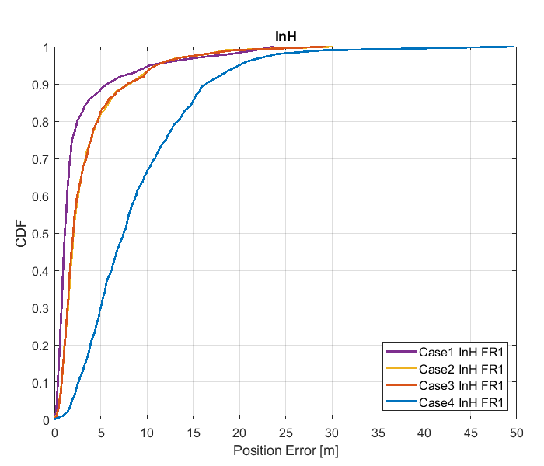

Figure 8.1.1.1-1: Results for FR1 from [10]

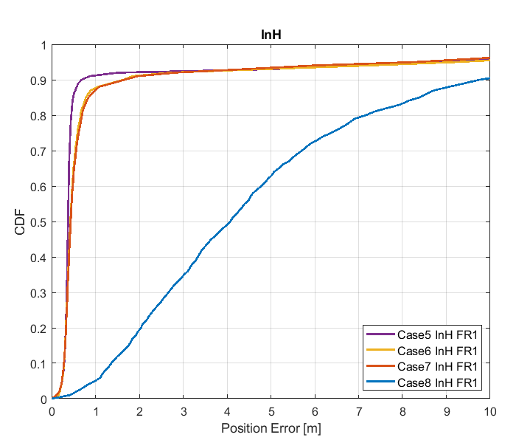

Figure 8.1.1.1-2: Results for FR1 from [10]

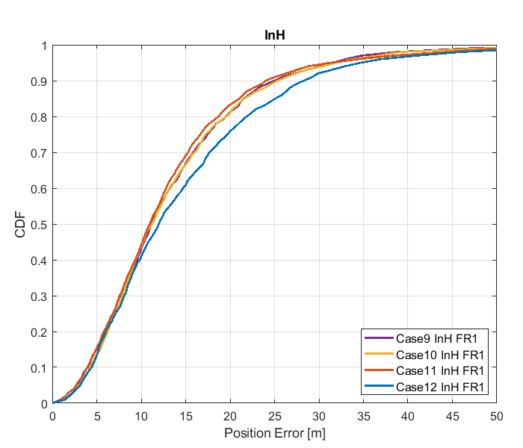

Figure 8.1.1.1-3: Results for FR1 from [10]

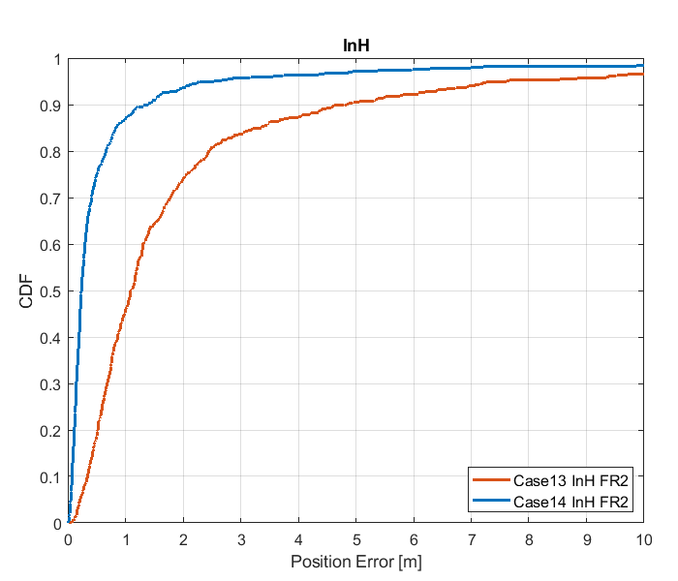

Figure 8.1.1.1-4: Results for FR2 from [10]

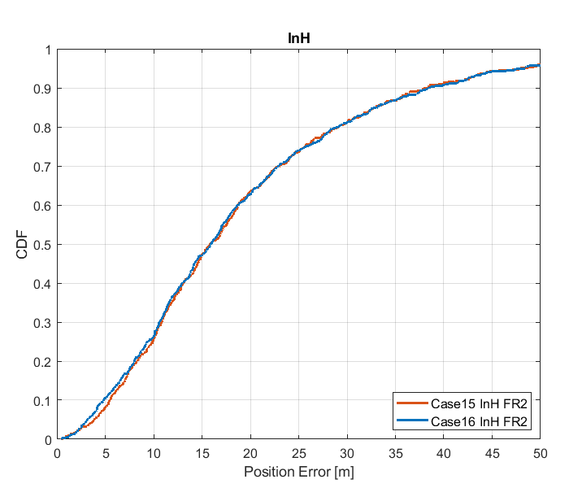

Figure 8.1.1.1-5: Results for FR2 from [10]

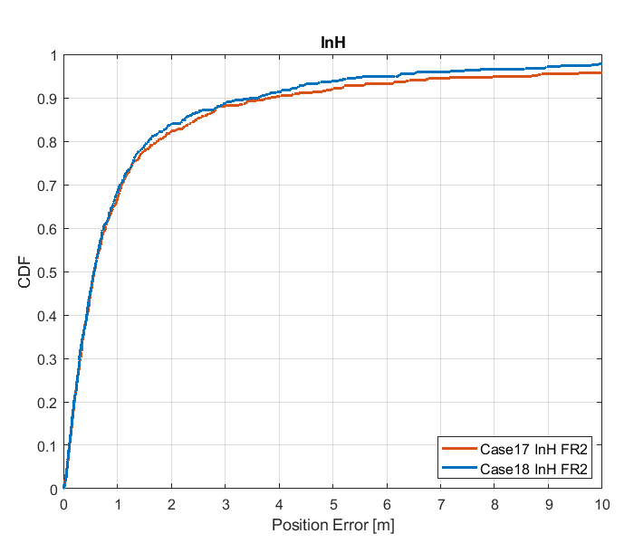

Figure 8.1.1.1-6: Results for FR2 from [10]

Table 8.1.1.1-4: Results for FR1 from [10]

|  |  |  |  |  |  |  |
| --- | --- | --- | --- | --- | --- | --- |
|  |  | Source | 50% | 67% | 80% | 90% |
| FR1 | InH | Case 1 InH FR1 | 1.1 | 1.5 | 2.4 | 5.7 |
| Case 2 InH FR1 | 2.0 | 2.9 | 4.6 | 8.1 |
| Case 3 InH FR1 | 2.0 | 2.9 | 4.6 | 7.9 |
| Case 4 InH FR1 | 7.5 | 10.1 | 13.0 | 16.0 |
| Case 5 InH FR1 | 0.37 | 0.40 | 0.45 | 0.70 |
| Case 6 InH FR1 | 0.42 | 0.51 | 0.66 | 1.72 |
| Case 7 InH FR1 | 0.43 | 0.52 | 0.70 | 1.72 |
| Case 8 InH FR1 | 4.0 | 5.4 | 7.2 | 9.7 |
| Case 9 InH FR1 | 11.2 | 15.1 | 19.8 | 24.9 |
| Case 10 InH FR1 | 11.2 | 15.1 | 19.7 | 25.3 |
| Case 11 InH FR1 | 11.1 | 14.4 | 18.9 | 23.9 |
| Case 12 InH FR1 | 12.0 | 17.0 | 22.0 | 28.8 |

Table 8.1.1.1-5: Results for FR2 from [10]

|  |  |  |  |  |  |  |
| --- | --- | --- | --- | --- | --- | --- |
|  |  | Source | 50% | 67% | 80% | 90% |
| FR2 | InH | Case 13 InH FR2 | 1.1 | 1.6 | 2.4 | 4.8 |
| Case 14 InH FR2 | 0.2 | 0.4 | 0.7 | 1.4 |
| Case 15 InH FR2 | 15.9 | 21.7 | 29.1 | 38.5 |
| Case 16 InH FR2 | 15.8 | 21.7 | 29.1 | 38.1 |
| Case 17 InH FR2 | 0.6 | 1.0 | 1.8 | 3.8 |
| Case 18 InH FR2 | 0.6 | 1.0 | 1.6 | 3.6 |

#### 8.1.1.2 Results from [11]

The parameters corresponding to the results are listed in table 8.1.1.2-1 below.

Table 8.1.1.2-1: Parameters for DL-TDOA evaluations

|  |  |
| --- | --- |
| Parameter | R1-1901717 |
| Channel model (baseline, otherwise state any modifications) | baseline |
| Carrier frequency | 4 GHz for FR1  30 GHz for FR2 |
| Subcarrier spacing | 30 kHz for FR1  120 kHz for FR2 |
| Reference Signal Transmission Bandwidth | 100 MHz for FR1  400 MHz for FR2 |
| Reference Signal Physical Structure and Resource Allocation (RE pattern) (reference to figure in contribution) | LTE PRS within a slot  (comb-6 frequency structure, 8 symbols within a slot) |
| Reference signal (type of sequence, number of ports, …) | 1 port, QPSK-PN sequence |
| Number of sites | 5 |
| Number of symbols used per occasion | 8 |
| number of occasions used per positioning estimate | 1 |
| Power-boosting level | 7.78 dB |
| Uplink power control (applied/not applied) | not applied |
| interference modelling (ideal muting, or other) | ideal muting |
| Description of Measurement Algorithm (e.g. super resolution, interference cancellation, ….) | Threshold-based ToA estimation method |
| Description of positioning technique / applied positioning algorithm (e.g. Least square, Taylor series, etc) | CHAN algorithm |
| Network synchronization assumptions | Perfect/50ns |
| Beam-related assumption (beam sweeping / alignment assumptions at the tx and rx sides) | alignment assumptions at the tx and rx sides |
| Precoding assumptions (codebook, nrof antenna elements used, etc) | N/A |
| UE type | Indoor UEs for Indoor open office |
| Additional notes, if any | only LOS path to calculate ToA |

The results corresponding to the Indoor open office scenario are provided below



Figure 8.1.1.2-1: CDF curve of positioning for DL-TDOA evaluations of Indoor open office: FR1 (left) and FR2 (right)

Table 8.1.1.2-2: Accuracy results (m) for DL-TDOAevaluations for Indoor open office

|  |  |  |  |  |  |
| --- | --- | --- | --- | --- | --- |
| Percentile | | 50% | 67% | 80% | 90% |
| FR1 100M | Perfect sync | 1.3 | 1.9 | 3.1 | 6.3 |
| Sync. error 50ns | 18.9 | 22.7 | 31 | 41.7 |
| FR2 400M | Perfect sync | 0.31 | 0.54 | 0.80 | 1.2 |
| Sync. error 50ns | 15.4 | 18.7 | 21.1 | 24.5 |

#### 8.1.1.3 Results from [12]

The parameters corresponding to the results are listed in table 8.1.1.3‑1 below.

Table 8.1.1.3‑1 Parameters for Downlink evaluations in Scenario 1

|  |  |  |
| --- | --- | --- |
| Parameter | [[12], FR1] | [[12], FR2] |
| Channel model (baseline, otherwise state any modifications) | Baseline Indoor open office | Baseline indoor open office |
| Carrier frequency | 4GHz | 30GHz |
| Subcarrier spacing | 30 KHz | 120KHz |
| Reference Signal Transmission Bandwidth | 100MHz | 400MHz |
| Reference Signal Physical Structure and Resource Allocation (RE pattern) (reference to figure in contribution) | Reuse LTE PRS pattern | Reuse LTE PRS pattern |
| Reference signal (type of sequence, number of ports, …) | Reuse LTE PRS sequence, one port | Reuse LTE PRS sequence, one port |
| Number of sites | 12 | 12 |
| Number of symbols used per occasion | 8 | 8 |
| number of occasions used per positioning estimate | 1 | 1 |
| Power-boosting level | No | No |
| Uplink power control (applied/not applied) | Not applied | Not applied |
| interference modelling (ideal muting, or other) | Ideal muting | Ideal muting |
| Description of Measurement Algorithm (e.g. super resolution, interference cancellation, ….) | Correlation peak detection | Correlation peak detection |
| Description of positioning technique / applied positioning algorithm (e.g. Least square, Taylor series, etc) | Combination of leat square and Taylor series | Combination of leat square and Taylor series |
| Network synchronization assumptions | Perfect sync and T1=50 | Perfect sync and T1=50 |
| Beam-related assumption (beam sweeping / alignment assumptions at the tx and rx sides) | Enhancement of first cluster by precoding | Enhancement of first cluster by precoding |
| Precoding assumptions (codebook, nrof antenna elements used, etc) |  |  |
| Additional notes, if any |  |  |

The results corresponding to the Indoor open office scenario are provided below in figure 8.1.1.3‑1-2 and table 8.1.1.3‑2:



Figure 8.1.1.3-1: Horizontal distance error of InH in meters (FR1)



Figure 8.1.1.3-2: Horizontal distance error of InH in meters (FR2)

Table 8.1.1.3‑2 results for downlink methods evaluations of Scenario 1 – Indoor Open Office

|  |  |  |  |  |
| --- | --- | --- | --- | --- |
| Percentile | 50 | 67 | 80 | 90 |
| FR1, Perfect sync | 1.276 m | 2.125 m | 3.122 m | 4.659 m |
| FR1, T1=50 ns | 14.29 m | 19.15 m | 23.35 m | 28.8 m |
| FR2, Perfect sync | 0.2737 m | 0.4774 m | 0.7 m | 1.029 m |
| FR2, T1=50 ns | 12.48 m | 15.51 m | 18.12 m | 21.08 m |

#### 8.1.1.4 Results from [13]

The parameters corresponding to the results are listed in table 8.2.1.1.4-1 below.

Table 8.2.1.1.4-1 Parameters for Downlink evaluations in Scenario 1

|  |  |  |
| --- | --- | --- |
| Parameter | [[13], FR1] |  |
| Channel model (baseline, otherwise state any modifications) | baseline |  |
| Carrier frequency | 4GHz |  |
| Subcarrier spacing | 30KHz |  |
| Reference Signal Transmission Bandwidth | 100MHz |  |
| Reference Signal Physical Structure and Resource Allocation (RE pattern) (reference to figure in contribution) | R1-1903331 |  |
| Reference signal (type of sequence, number of ports, …) | PN sequence,  1 port |  |
| Number of sites | 12 |  |
| Number of symbols used per occasion | 12 |  |
| number of occasions used per positioning estimate | 1 |  |
| Power-boosting level | 7.8dB (due to comb-6) |  |
| Uplink power control (applied/not applied) | Not applied |  |
| interference modelling (ideal muting, or other) | 12 sectors (one sector in each site) in transmission in the same slot |  |
| Description of Measurement Algorithm (e.g. super resolution, interference cancellation, ….) | CIR estimation for time delay |  |
| Description of positioning technique / applied positioning algorithm (e.g. Least square, Taylor series, etc) | Least square |  |
| Network synchronization assumptions | ideal |  |
| Beam-related assumption (beam sweeping / alignment assumptions at the tx and rx sides) | A single fixed beam |  |
| Precoding assumptions (codebook, nrof antenna elements used, etc) | No precoding |  |
| Additional notes, if any | DL-TDOA |  |

The results corresponding to the Indoor open office scenario are provided below

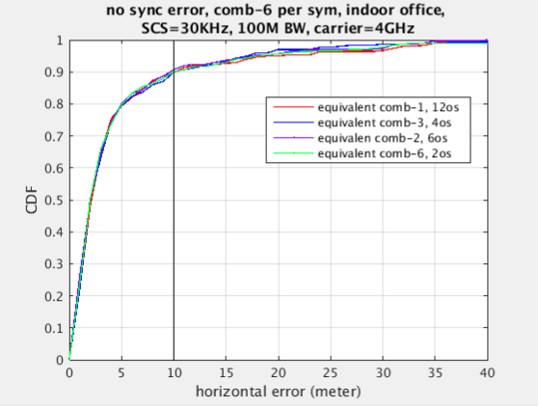

Figure 8.1.1.4-1: DL-TDOA technique curve

Table 8.1.4-2: Results for downlink methods evaluations of Scenario 1 – Indoor Open Office

|  |  |  |  |  |
| --- | --- | --- | --- | --- |
| Percentile | 50 | 67 | 80 | 90 |
| DL-TDOA with 12-symbol comb-6 RS  Ideal sync | 2.1m | 3.25m | 5.25m | 10m |

#### 8.1.1.5 Results from [14]

The parameters corresponding to the results are listed in Table 8.1.1.5‑1 below.

Table 8.1.1.5‑1: Parameters for Downlink evaluations in Scenario 1

|  |  |  |
| --- | --- | --- |
| Parameter | [[14], FR1] | [[14], FR2] |
| Channel model (baseline, otherwise state any modifications) | Baseline | Baseline |
| Carrier frequency | 4 GHz | 30 GHz |
| Subcarrier spacing | 15 kHz, 30 kHz | 120 kHz |
| Reference Signal Transmission Bandwidth | 5 MHz, 100 MHz | 100 MHz, 400 MHz |
| Reference Signal Physical Structure and Resource Allocation (RE pattern) (reference to figure in contribution) | LTE PRS Structure from [35] (with additional symbols where CRS was in LTE) | LTE PRS Structure from [35] (with additional symbols where CRS was in LTE) |
| Reference signal (type of sequence, number of ports, …) | LTE PRS Structure from [35] | LTE PRS Structure from [35] |
| Number of sites | 12 | 12 |
| Number of symbols used per occasion | 11 | 11 |
| number of occasions used per positioning estimate | 1 | 1 |
| Power-boosting level | 10*log10(6) | 10*log10(6) |
| Uplink power control (applied/not applied) | N/A | N/A |
| interference modelling (ideal muting, or other) | Perfect muting | Perfect muting |
| Description of Measurement Algorithm (e.g. super resolution, interference cancellation, ….) | Both no threshold and threshold of 0.5 at the UE | Threshold of 0.5 at the UE |
| Description of positioning technique / applied positioning algorithm (e.g. Least square, Taylor series, etc) | Both Least squares and BLADE results | Both Least squares and BLADE |
| Network synchronization assumptions | Perfect synchronization | Perfect synchronization |
| Beam-related assumption (beam sweeping / alignment assumptions at the tx and rx sides) | Sectorized beams | Ideal beam selected for PRS transmission |
| Precoding assumptions (codebook, nrof antenna elements used, etc) | N/A | Codebook based beam |
| Additional notes, if any | N/A | N/A |

The results corresponding to the Indoor open office scenario are provided below

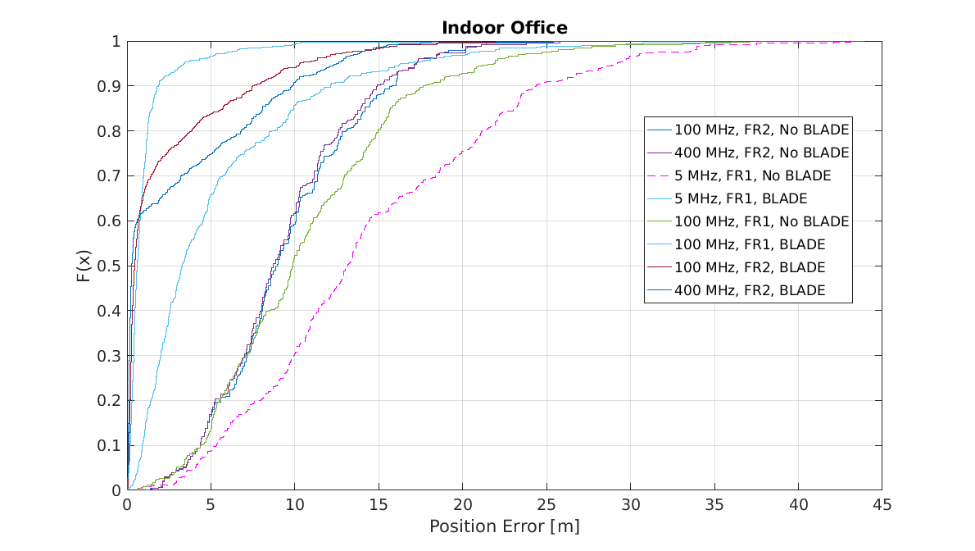

Figure 8.1.1.5‑1

Table 8.1.1.5‑2: Results for downlink methods evaluations of Scenario 1 – Indoor Open Office

|  |  |  |  |  |
| --- | --- | --- | --- | --- |
| Percentile | 50 | 67 | 80 | 90 |
| DL-TDOA, FR1, 5 MHz, without BLADE | 13.1 | 17.2 | 21.2 | 24.4 |
| DL-TDOA, FR1, 100 MHz, without BLADE | 9.9 | 12.6 | 15.0 | 17.6 |
| DL-TDOA, FR2, 100 MHz, without BLADE | 8.9 | 11.1 | 13.1 | 15.8 |
| DL-TDOA, FR2, 400 MHz, without BLADE | 8.7 | 10.3 | 12.6 | 14.9 |
| DL-TDOA, FR1, 5 MHz, with BLADE | 3.3 | 5.2 | 8.6 | 12.1 |
| DL-TDOA, FR1, 100 MHz, with BLADE | 0.6 | 0.9 | 1.2 | 1.9 |
| DL-TDOA, FR2, 100 MHz, with BLADE | 0.5 | 1.1 | 3.9 | 7.5 |
| DL-TDOA, FR2, 400 MHz, with BLADE | 0.3 | 2.5 | 6.8 | 9.8 |

#### 8.1.1.6 Results from [15]

The parameters corresponding to the results are listed in Table 8.1.1.6-1 below.

Table 8.1.1.6-1: Parameters for Downlink evaluations in Scenario 1

|  |  |
| --- | --- |
| Parameter | [15] (R1-1903222) |
| Channel model (baseline, otherwise state any modifications) | According to 3GPP TR 38.901 (Indoor Open Office) |
| Carrier frequency | 4GHz |
| Subcarrier spacing | 15KHz |
| Reference Signal Transmission Bandwidth | 5MHz, 50MHz |
| Reference Signal Physical Structure and Resource Allocation (RE pattern) (reference to figure in contribution) | New NR PRS based on the modification of LTE PRS. NR PRS REs are mapped in frequency domain evenly to all subcarriers in the PRS OFDM symbols. The detail of the mapping is presented in R1-1901980. |
| Reference signal (type of sequence, number of ports, …) | Length-31 Gold sequence, 1 port |
| Number of sites | 12 sectors / 12 sites. Up to 6 sites used for DL-TDOA |
| Number of symbols used per occasion | 13 |
| number of occasions used per positioning estimate | 1 |
| Power-boosting level | 7.78dB (10*log10(6) = 7.78) |
| Uplink power control (applied/not applied) | N/A |
| interference modelling (ideal muting, or other) | Ideal muting |
| Description of Measurement Algorithm (e.g. super resolution, interference cancellation, ….) | No super resolution, and no interference cancellation |
| Description of positioning technique / applied positioning algorithm (e.g. Least square, Taylor series, etc) | Chan's algorithm "A simple and efficient estimator for Hyperbolic location", Y.T. Chan and K.C. Ho, IEEE transactions on signal processing, vol.42, no. 8, August 1994. |
| Network synchronization assumptions | Perfect synchronization. |
| Beam-related assumption (beam sweeping / alignment assumptions at the tx and rx sides) | Wide Tx beam without beam sweeping is assumed. No Rx beam sweeping. |
| Precoding assumptions (codebook, nrof antenna elements used, etc) | Tx: 64 antenna elements Rx: 4 antenna elements codebook: 64*1 precoder used to generate widebeam |
| Additional notes, if any |  |

The results corresponding to the Indoor open office scenario are provided below

Table 8.1.1.6-2: Results for downlink methods evaluations of Scenario 1 – Indoor Open Office

|  |  |  |  |  |
| --- | --- | --- | --- | --- |
| Percentile | 50 | 67 | 80 | 90 |
| [5Mhz: DL-TDOA ] | 13.1 | 17.1 | 22.0 | 28.9 |
| [50Mhz: DL-TDOA ] | 7.8 | 10.5 | 13.2 | 17.5 |

#### 8.1.1.7 Results from [16]

The parameters corresponding to the results are listed in table 8.1.1.7-1 below.

Table 8.1.1.7-1: Parameters for Downlink evaluations in Scenario 1

|  |  |
| --- | --- |
| Parameter | [16], FR1 |
| Channel model (baseline, otherwise state any modifications) | Baseline |
| Carrier frequency | 2 GHz |
| Subcarrier spacing | 15 kHz |
| Reference Signal Transmission Bandwidth | 5, 50 MHz |
| Reference Signal Physical Structure and Resource Allocation (RE pattern) (reference to figure in contribution) | Based on LTE PRS |
| Reference signal (type of sequence, number of ports, …) | Based on LTE PRS |
| Number of sites | 12 |
| Number of symbols used per occasion | 8 |
| number of occasions used per positioning estimate | 6 |
| Power-boosting level | 7.78 dB |
| Uplink power control (applied/not applied) | Not applied |
| interference modelling (ideal muting, or other) | Ideal muting |
| Description of Measurement Algorithm (e.g. super resolution, interference cancellation, ….) | Cross correlation |
| Description of positioning technique / applied positioning algorithm (e.g. Least square, Taylor series, etc) | DL-TDOA/ Least square |
| Network synchronization assumptions | Perfect Synchronization |
| Beam-related assumption (beam sweeping / alignment assumptions at the tx and rx sides) | No |
| Precoding assumptions (codebook, nrof antenna elements used, etc) | No |
| Additional notes, if any | - |

The results corresponding to the Indoor open office scenario are provided below

Table 8.1.1.7‑2: Results for downlink methods evaluations of Scenario 1 – Indoor Open Office

|  |  |  |  |  |
| --- | --- | --- | --- | --- |
| Percentile | 50 | 67 | 80 | 90 |
| DL-TDOA, 5MHz | 9.59m | 12.41m | 15.29m | 18.89 m |
| DL-TDOA, 50MHz | 1.7m | 2.55m | 3.76m | 6.22 m |

#### 8.1.1.8 Results from [17]

The parameters corresponding to the results are listed in table 8.1.1.8-1 below.

Table 8.1.1.8-1: Parameters for Downlink evaluations in Scenario 1

|  |  |  |
| --- | --- | --- |
| Parameter | [17], FR1 | [17], FR2 |
| Channel model (baseline, otherwise state any modifications) | baseline | baseline |
| Carrier frequency | 4 GHz | 30 GHz |
| Subcarrier spacing | 30 kHz | 120 kHz |
| Reference Signal Transmission Bandwidth | 100 MHz | 400 MHz |
| Reference Signal Physical Structure and Resource Allocation (RE pattern) (reference to figure in contribution) | Fig.2(a) of [17] | Fig.2 of [17] |
| Reference signal (type of sequence, number of ports, …) | Gold sequence according to NR specification for CSI-RS, 1 port | Gold sequence according to NR specification for CSI-RS, 1 port |
| Number of sites | 12 | 12 |
| Number of symbols used per occasion | 6 | 6, 2 |
| number of occasions used per positioning estimate | 6 | 6 |
| Power-boosting level | 7.8 dB | 7.8, 6 dB |
| Uplink power control (applied/not applied) | Not applied | Not applied |
| interference modelling (ideal muting, or other) | Ideal muting | Ideal muting |
| Description of Measurement Algorithm (e.g. super resolution, interference cancellation, ….) | Correlation | Correlation |
| Description of positioning technique / applied positioning algorithm (e.g. Least square, Taylor series, etc) | Taylor series | Taylor series |
| Network synchronization assumptions | Perfect synchronization | Perfect synchronization |
| Beam-related assumption (beam sweeping / alignment assumptions at the tx and rx sides) | No beam sweeping | Beam sweeping |
| Precoding assumptions (codebook, nr. of antenna elements used, etc) | Based on TR 38.802 | Based on TR 38.802 |
| Additional notes, if any |  |  |

The results corresponding to the Indoor open office scenario are provided below. For InH Scenario, only indoor UEs should be considered. The simulation results of FR1 are shown in Figure 8.1.1.8‑1 and Table 8.1.1.8‑2.



Figure 8.1.1.8‑1: Horizontal Positioning Error for InH scenario (100MHz, PRS)

Table 8.1.1.8-2: Results for downlink methods evaluations of Scenario 1 – Indoor Open Office

|  |  |  |  |  |
| --- | --- | --- | --- | --- |
| Positioning percentage | 90% | 80% | 67% | 50% |
| Positioning error | 4.8 m | 1.5 m | 1 m | 0.6 m |

The simulation results of FR2 are shown in Figure 8.1.1.8‑2 and Table-8.1.1.8‑3.



Figure 8.1.1.8‑2: Horizontal Positioning Error for InH scenario (400MHz)

Table 8.1.1.8-3: Results for downlink methods evaluations of Scenario 1 – Indoor Open Office

|  |  |  |  |  |
| --- | --- | --- | --- | --- |
| Positioning percentage | 90% | 80% | 67% | 50% |
| Positioning error (TRS) | 3.1 m | 2 m | 1.1 m | 0.4 m |
| Positioning error (PRS) | 2.1 m | 1.6m | 1.1 m | 0.5 m |

#### 8.1.1.9 Results from [18]

The parameters corresponding to the results are listed in table 8.1.1.9-1 below.

Table 8.1.1.9‑1: Parameters for Downlink evaluations in Scenario 1

|  |  |
| --- | --- |
| Parameter | [18], FR2 30 GHz |
| Channel model (baseline, otherwise state any modifications) | Baseline |
| Carrier frequency | 30 GHz |
| Subcarrier spacing | 120 kHz |
| Reference Signal Transmission Bandwidth | 400 MHz |
| Reference Signal Physical Structure and Resource Allocation (RE pattern) (reference to figure in contribution) | SSB reference signal structure |
| Reference signal (type of sequence, number of ports, …) | SSB reference signal |
| Number of sites | 12 |
| Number of symbols used per occasion | 4 |
| Number of occasions used per positioning estimate | 1 |
| Power-boosting level | No power boosting |
| Uplink power control (applied/not applied) | Not applied |
| Interference modelling (ideal muting, or other) | No muting |
| Description of Measurement Algorithm (e.g. super resolution, interference cancellation, ….) | AOD and ZOD were derived from max received SSB  TA was approximated from first arrival with a random perturbation based on TA resolution |
| Description of positioning technique / applied positioning algorithm (e.g. Least square, Taylor series, etc) | Maximum a posteriori |
| Network synchronization assumptions | Perfect |
| Beam-related assumption (beam sweeping / alignment assumptions at the tx and rx sides) | 64 SSB/beams, no UE beam sweeping |
| Precoding assumptions (codebook, nrof antenna elements used, etc) | No precoding assumptions |
| Additional notes, if any |  |

The results corresponding to the Indoor open office scenario are provided below

Table 8.1.1.9-2: Results for downlink methods evaluations of Scenario 1 – Indoor Open Office

|  |  |  |  |  |  |  |  |  |  |  |  |
| --- | --- | --- | --- | --- | --- | --- | --- | --- | --- | --- | --- |
| Percentile | 10 | 20 | 30 | 40 | 50 | 60 | 67 | 70 | 80 | 90 | 95 |
| AOD + ZOD  FR2 30 GHz | 0.4 | 0.6 | 0.7 | 0.9 | 1.2 | 1.4 | 1.6 | 1.7 | 2.1 | 2.8 | 3.6 |
| AOD + ZOD + TA  FR2 30 GHz | 0.4 | 0.8 | 1.1 | 1.4 | 1.8 | 2.2 | 2.4 | 2.4 | 2.7 | 3.4 | 3.7 |

#### 8.1.1.10 Results from [19]

The parameters used for evaluation of the DL based positioning in Scenario 1 (Indoor Open Office) are listed in Table 8.1.1.10-1 below.

Table 8.1.1.10-1: Parameters for Downlink evaluations in Scenario 1

|  |  |  |  |
| --- | --- | --- | --- |
| Parameter | Setup 1 | Setup 2 | Setup 3 |
| Channel model (baseline, otherwise state any modifications) | Baseline | Baseline | Baseline |
| Carrier frequency | 4 GHz | 4 GHz | 30 GHz |
| Subcarrier spacing | 15 kHz | 30 kHz | 120 kHz |
| Reference Signal Transmission Bandwidth | 5 MHz | 100 MHz | 100 MHz |
| Reference Signal Physical Structure and Resource Allocation (RE pattern) (reference to figure in contribution) | 12 REs per PRB, single symbol | 12 REs per PRB, single symbol | 12 REs per PRB, single symbol |
| Reference signal (type of sequence, number of ports, …) | QPSK, Pseudo random, single Tx port | QPSK, Pseudo random, single Tx port | QPSK, Pseudo random, single Tx port |
| Number of sites | 12 sectors / 12 sites | 12 sectors / 12 sites | 36 sectors / 12 sites |
| Number of symbols used per occasion | 1x12(sites) | 1x12(sites) | 8(beams)x36(sectors) |
| Number of occasions used per positioning estimate | 1 | 1 | 1 |
| Power-boosting level | 0 dB | 0 dB | 0 dB |
| Uplink power control (applied/not applied) | NA | NA | NA |
| Interference modelling (ideal muting, or other) | Ideal muting | Ideal muting | Ideal muting |
| Description of Measurement Algorithm (e.g. super resolution, interference cancellation, ….) | Option 1: Threshold based algorithm for the first arrival path (FAP) estimation  Option 2: MUSIC | Threshold based algorithm for the first arrival path (FAP) estimation | Threshold based algorithm for the first arrival path (FAP) estimation |
| Description of positioning technique / applied positioning algorithm (e.g. Least square, Taylor series, etc) | Taylor based, measurements above -15 dB are used for positioning | Taylor based, measurements above -15 dB are used for positioning | Taylor based, measurements above -15 dB are used for positioning |
| Network synchronization assumptions | Option 1: T1 = 0ns(Perfect)  Option 2: T1 = 50ns | Option 1: T1 = 0ns(Perfect)  Option 2: T1 = 50ns | Option 1: T1 = 0ns(Perfect)  Option 2: T1 = 50ns |
| Beam-related assumption (beam sweeping / alignment assumptions at the tx and rx sides) | No sweeping | No sweeping | Tx sweeping |
| Precoding assumptions (codebook, nrof antenna elements used, etc) | Single Tx port | Single Tx port | Single Tx port |
| Additional notes, if any | RX Waveform reporting is assumed to perform super resolution timing estimation algorithm at gNB side |  |  |

The system level evaluation results for DL positioning in Scenario 1 (Indoor open office) are provided below

|  |
| --- |
| Figure 8.1.1.10-1 (a) FR1 evaluations    Figure 8.1.1.10-2 (b) FR2 evaluations |

#### 8.1.1.11 Results from [21]

The parameters corresponding to the results are listed in table 8.1.1.11-1 below.

Table 8.1.1.11-1: Parameters for Downlink evaluations in Scenario 1

|  |  |
| --- | --- |
| Parameter | [[21], FR1] |
| Channel model (baseline, otherwise state any modifications) | baseline |
| Carrier frequency | 2GHz |
| Subcarrier spacing | 30kHz |
| Reference Signal Transmission Bandwidth | 100MHz |
| Reference Signal Physical Structure and Resource Allocation (RE pattern) (reference to figure in contribution) | Figure 2 in R1-1902699 |
| Reference signal (type of sequence, number of ports, …) | Weil10230 |
| Number of sites | 12 |
| Number of symbols used per occasion | 6000 |
| number of occasions used per positioning estimate | 20 |
| Power-boosting level | No |
| Uplink power control (applied/not applied) | not applied |
| interference modelling (ideal muting, or other) | ideal muting |
| Description of Measurement Algorithm (e.g. super resolution, interference cancellation, ….) | Serial interference cancellation and loop tracking |
| Description of positioning technique / applied positioning algorithm (e.g. Least square, Taylor series, etc) | Combination of Chan and Newton |
| Network synchronization assumptions | Perfect sync. |
| Beam-related assumption (beam sweeping / alignment assumptions at the tx and rx sides) | No beamforming |
| Precoding assumptions (codebook, nrof antenna elements used, etc) | No |
| Additional notes, if any |  |

The results corresponding to the Indoor open office scenario are provided below

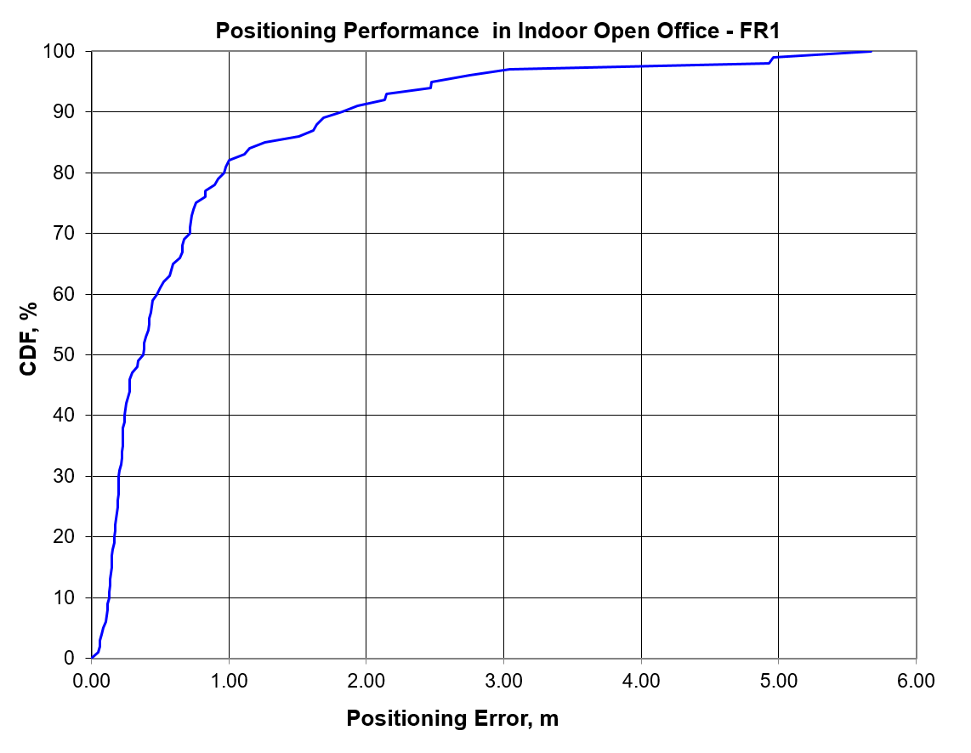

Figure 8.1.1.11-1: The CDF of Positioning error for scenario 1

Table 8.1.1.11-2: Results for downlink methods evaluations of Scenario 1 – Indoor Open Office

|  |  |  |  |  |  |  |  |  |  |  |  |
| --- | --- | --- | --- | --- | --- | --- | --- | --- | --- | --- | --- |
| Percentile | 10 | 20 | 30 | 40 | 50 | 60 | 67 | 70 | 80 | 90 | 95 |
| Co-band TBS | 0.13 | 0.17 | 0.20 | 0.24 | 0.37 | 0.47 | 0.66 | 0.72 | 0.96 | 1.82 | 2.47 |

#### 8.1.1.12 Results from [22]

Table 8.1.1.12-1: Simulation parameters (scenario 1)

|  |  |
| --- | --- |
| Parameter | [[22], Indoor open office, FR2] |
| Channel model (baseline, otherwise state any modifications) | Indoor office from TR 38.901 |
| Carrier frequency | 30GHz |
| Subcarrier spacing | 120kHz |
| Reference Signal Transmission Bandwidth | 100MHz |
| Reference Signal Physical Structure and Resource Allocation (RE pattern) (reference to figure in contribution) | SSB as defined in TS 38.211  PRS occupying 12 REs |
| Reference signal (type of sequence, number of ports, …) | PN sequence for PRS |
| Number of sites | 12 sites, 36 sectors |
| Number of symbols used per occasion | 1 (PRS) |
| number of occasions used per positioning estimate | 64 |
| Power-boosting level | 0dB |
| Uplink power control (applied/not applied) | Not applied |
| interference modelling (ideal muting, or other) | Ideal muting |
| Description of Measurement Algorithm (e.g. super resolution, interference cancellation, ….) |  |
| Description of positioning technique / applied positioning algorithm (e.g. Least square, Taylor series, etc) | Distance estimated by power attenuation (Method 1) or beam spot based distance estimation (Method 2), angle of UE estimated by AoD from gNB, as shown below. |
| Network synchronization assumptions | Ideal |
| Beam-related assumption (beam sweeping / alignment assumptions at the tx and rx sides) | Beam sweeping at TX and RX are implemented and alignment is established between gNB TX and UE RX beam |
| Precoding assumptions (codebook, nrof antenna elements used, etc) | None |
| Additional notes, if any | -No PDSCH are transmitted during positioning process in the evaluation  -Antenna parameters follow the assumptions in TR 38.855 |

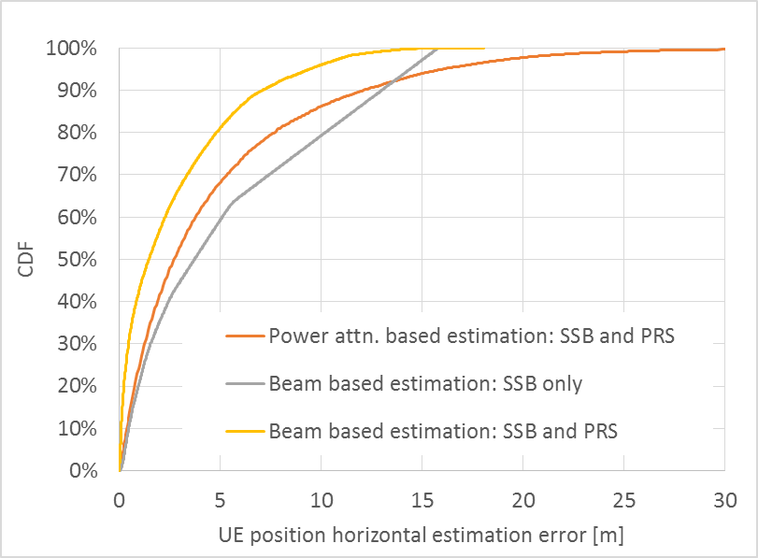

Figure 8.1.1.12-1: UE position horizontal estimation error

#### 8.1.1.13 Results from [23]

The parameters corresponding to the results are listed in table 8.1.1.13-1 below.

Table 8.1.1.13-1: Parameters for Downlink evaluations in Scenario 1

|  |  |  |  |  |  |
| --- | --- | --- | --- | --- | --- |
| Parameter | [23], FR1, 100 MHz | [23], FR1, 50 MHz | [23], FR1, 5 MHz | [23], FR2, 400 MHz | [23], FR2, 100 MHz |
| Channel model (baseline, otherwise state any modifications) | Baseline Channel Model based on common assumptions defined related to the channel models of 3GPP TRs 38.901 / 38.802 / 37.857. | | | | |
| Carrier frequency | 4 GHz | | | 30 GHz | |
| Subcarrier spacing | 30 KHz | 15 KHz | 15 KHz | 120 KHz | |
| Reference Signal Transmission Bandwidth | 100 MHz | 50 MHz | 5 MHz | 400 MHz | 100 MHz |
| Reference Signal Physical Structure and Resource Allocation (RE pattern) (reference to figure in contribution) | Comb-1 | | | | |
| Reference signal (type of sequence, number of ports, …) | 1-port, QPSK sequence | | | | |
| Number of sites | 12 | | | | |
| Number of symbols used per occasion | 1 | | | | |
| number of occasions used per positioning estimate | 1 | | | | |
| Power-boosting level | 0 dB | | | | |
| interference modelling (ideal muting, or other) | Ideal muting | | | | |
| Description of Measurement Algorithm (e.g. super resolution, interference cancellation, ….) | TOA estimation without oversampling with TOA pruning before the positioning engine using the ratio of the estimated TOA peak over the median of the Channel Energy Response (CER). | | | | |
| Description of positioning technique / applied positioning algorithm (e.g. Least square, Taylor series, etc) | For DL-TDOA Pick the best between Taylor series, and Chan's Algorithm:  Chan's Algorithm according to:  Y. T. Chan, K. C. Ho, " A Simple and Efficient Estimator for Hyperbolic Location", IEEE Transactions on Signal Processing, vol. 42, pp. 1905-1915, Aug. 1994.  Taylor Series Algorithm:  W. H. Foy, " Position-Location Solutions by Taylor-Series Estimation", IEEE Transactions on Aerospace and Electronic Systems, vol. AES-12, pp. 187-194, March 1976.  For DL-TDOA+AoD, the algorithm presented in the following paper is used:  Chunhua Yang, Yi Huang and Xu Zhu, 'HYBRID TDOA/AOA METHOD FOR INDOOR POSITIONING SYSTEMS', IEEE Sig. Proc. Letters, Vol23, issue 1, 2016  Equal weight is used in the TOA covariance matrix. | | | | |
| Network synchronization assumptions | Perfect Sync and Realistic Sync with T1 = 50 nsec | | | | |
| Beam-related assumption (beam sweeping / alignment assumptions at the tx and rx sides) | The best beam pair is identified based on the criteria of receiving the earliest path given that the received power is larger than a threshold (20 dB lower than the maximum received power) using the genie CDL channel profiles. For a single sector scenario (only Indoor hotspop 4GHz), the directions of beams are within [, 180] degrees in azimuth and [,180] degrees in zenith. For a 3-sector scenario, the directions of beams are within [, ] degrees in azimuth and [,180] degrees in zenith. | | | | |
| Precoding assumptions (codebook, nrof antenna elements used, etc) | Kronecker product between vertical and horizontal weight vectors taken from DFT, with oversampling factor r. The DFT beam candidate in beam selection method is generated according to the uniform vertical and horizontal angular distribution shown as follows:  , for i=1,…,rN  where r denotes the oversampling factor, N denotes the number of vertical/horizontal antennas. For FR2, Tx oversampling factor r equals to 2 and Rx oversampling factor equals to 1. For FR1, Tx oversampling factor for 100 MHz is 4, for 50 MHz is 1, for 5 MHz is 1. | | | | |

The results corresponding to the Indoor open office scenario are provided below

Table 8.1.1.13‑2: Results for downlink methods evaluations of Scenario 1 – Indoor Open Office

|  |  |  |  |  |  |
| --- | --- | --- | --- | --- | --- |
| Percentile | 50 | 67 | 80 | 90 | 95 |
| DL-TDOA, FR1, 100 MHz, Perfect Sync | 1.2 | 1.6 | 2.4 | 3.6 | 5.5 |
| DL-TDOA, FR1, 100 MHz, Realistic Sync | 12 | 17.8 | 27.6 | 45.8 | 61.9 |
| DL-TDOA, FR1, 50 MHz, Perfect Sync | 4.8 | 7.7 | 12.6 | 27.3 | 50.7 |
| DL-TDOA, FR1, 50 MHz, Realistic Sync | 12.1 | 17.5 | 28.6 | 48.3 | 65.4 |
| DL-TDOA, FR1, 5 MHz, Perfect Sync | 13.2 | 18.4 | 29.1 | 51.2 | 66.3 |
| DL-TDOA, FR1, 5 MHz, Realistic Sync | 16.3 | 24.3 | 37.4 | 56.6 | 70 |
| DL-TDOA, FR2, 400 MHz, Perfect Sync | 0.4 | 0.8 | 1.6 | 4.2 | 9.5 |
| DL-TDOA, FR2, 400 MHz, Realistic Sync | 11.8 | 17.2 | 25 | 40.1 | 54.2 |
| DL-TDOA, FR2, 100 MHz, Perfect Sync | 1.2 | 1.8 | 2.9 | 5.3 | 8.6 |
| DL-TDOA, FR2, 100 MHz, Realistic Sync | 12.8 | 18.6 | 26.7 | 41.8 | 57.6 |
| DL-TDOA+AoD, FR2, 400 MHz, Perfect Sync | 0.3 | 0.4 | 1.1 | 2.5 | 6.1 |
| DL-TDOA+AoD, FR2, 400 MHz, Realistic Sync | 10.6 | 16 | 24.1 | 36.4 | 48.5 |
| DL-TDOA+AoD, FR2, 100 MHz, Perfect Sync | 0.7 | 1 | 1.6 | 2.8 | 5.2 |
| DL-TDOA+AoD, FR2, 100 MHz, Realistic Sync | 11.8 | 17.7 | 26.4 | 40 | 53.7 |

#### 8.1.1.14 Results from [25]

The parameters corresponding to the results in FR 1are listed in table 8.1.1.14-1 below.

Table 8.1.1.14‑1: Parameters for Downlink evaluations in Scenario 1, FR1

|  |  |  |  |  |  |  |  |  |  |  |
| --- | --- | --- | --- | --- | --- | --- | --- | --- | --- | --- |
| Parameter | Source 1 | Source 2 | Source 3 | Source 4 | Source 5 | Source 6 | Source 7 | Source 8 | Source 9 | Source 10 |
| Channel model (baseline, otherwise state any modifications) | IOO FR1 | IOO FR1 | IOO FR1 | IOO FR1 | IOO FR1 | IOO FR1 | IOO FR1 | IOO FR1 | IOO FR1 | IOO FR1 |
| Carrier frequency | 2GHz | 2GHz | 2GHz | 4GHz | 4GHz | 4GHz | 4GHz | 4GHz | 4GHz | 4GHz |
| Subcarrier spacing | 15khz | 15khz | 15khz | 15khz | 15khz | 15khz | 15khz | 15khz | 15khz | 15khz |
| Reference Signal Transmission Bandwidth | 50MHz | 50MHz | 50MHz | 100MHz | 100MHz | 100MHz | 100MHz | 100MHz | 100MHz | 100MHz |
| Reference Signal Physical Structure and Resource Allocation (RE pattern) (reference to figure in contribution) | TRS,comb 4, 9 occasions, 2 slot, 2 symbols per slot configuration | Extended TRS: 9 occasions, 1 slot, 4 symbols per slot configuration | NR PRS: 3 occasions, 1 slot configuration, 12 symbols per slot | TRS,comb 4, 9 occasions, 2 slot, 2 symbols per slot configuration | Extended TRS: 9 occasions, 1 slot, 4 symbols per slot configuration | NR PRS: 3 occasions, 1 slot configuration, 12 symbols per slot | TRS,comb 4, 9 occasions, 2 slot, 2 symbols per slot configuration | Extended TRS: 9 occasions, 1 slot, 4 symbols per slot configuration | NR PRS: 3 occasions, 1 slot configuration, 12 symbols per slot | NR PRS: 3 occasions, 1 slot configuration, 12 symbols per slot |
| Reference signal (type of sequence, number of ports, …) | 1 port, TRS | 1 port extended TRS | 1port PRS | 1 port, TRS | 1 port extended TRS | 1port PRS | 1 port, TRS | 1 port extended TRS | 1port PRS | 1port PRS |
| Number of sites | 7 | 7 | 7 | 7 | 7 | 7 | 7 | 7 | 7 | 7 |
| Number of symbols used per occasion | 4 | 4 | 12 | 4 | 4 | 12 | 4 | 4 | 12 | 12 |
| number of occasions used per positioning estimate | 9 | 9 | 3 | 9 | 9 | 3 | 9 | 9 | 3 | 3 |
| Power-boosting level | 0 | 0 | 0 | 0 | 0 | 0 | 0 | 0 | 0 | 0 |
| Uplink power control (applied/not applied) |  |  |  |  |  |  |  |  |  |  |
| interference modelling (ideal muting, or other) | none | none | none | none | none | none | none | none | none | Inter-ference added |
| Description of Measurement Algorithm (e.g. super resolution, interference cancellation, ….) |  |  |  |  |  |  | Interpo-lation added | Interpo-lation added | Interpo-lation added | Interpo-lation added |
| Description of positioning technique / applied positioning algorithm (e.g. Least square, Taylor series, etc) | DL-TDOA | DL-TDOA | DL-TDOA | DL-TDOA | DL-TDOA | DL-TDOA | DL-TDOA | DL-TDOA | DL-TDOA | DL-TDOA |
| Network synchronization assumptions | no error | no error | no error | no error | no error | no error | no error | no error | no error | no error |
| Beam-related assumption (beam sweeping / alignment assumptions at the tx and rx sides) | N/A | N/A | N/A | N/A | N/A | N/A | N/A | N/A | N/A | N/A |
| Precoding assumptions (codebook, nrof antenna elements used, etc) | horizontal wide beam with same pattern in Table 6.1.1-3. vertical pattern as shown in R1-1901198 | horizontal wide beam with same pattern in Table 6.1.1-3. vertical pattern as shown in R1-1901198 | horizontal wide beam with same pattern in Table 6.1.1-3. vertical pattern as shown in R1-1901198 | horizontal wide beam with same pattern in Table 6.1.1-3. vertical pattern as shown in R1-1901198 | horizontal wide beam with same pattern in Table 6.1.1-3. vertical pattern as shown in R1-1901198 | horizontal wide beam with same pattern in Table 6.1.1-3. vertical pattern as shown in R1-1901198 | horizontal wide beam with same pattern in Table 6.1.1-3. vertical pattern as shown in R1-1901198 | horizontal wide beam with same pattern in Table 6.1.1-3. vertical pattern as shown in R1-1901198 | horizontal wide beam with same pattern in Table 6.1.1-3. vertical pattern as shown in R1-1901198 | horizontal wide beam with same pattern in Table 6.1.1-3. vertical pattern as shown in R1-1901198 |
| Additional notes, if any |  |  |  |  |  |  |  |  |  |  |

The results corresponding to the Indoor open office scenario are provided below

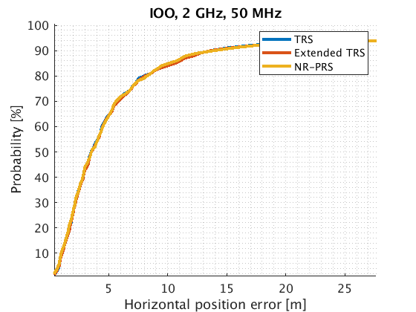

Figure 8.1.1.14-1: Positioning estimation error in indoor open office (2 GHz).

Table 8.1.1.14-2: FR1 (2 GHz) positioning accuracy summary in indoor open office scenario with ideal muting.

|  |  |  |  |  |
| --- | --- | --- | --- | --- |
| Bandwidth configuration | 50% TRS/Extended TRS/ NR PRS  (m) | 67% TRS/Extended TRS/ NR PRS  (m) | 80% TRS/Extended TRS/ NR PRS  (m) | 90% TRS/Extended TRS/ NR PRS  (m) |
| 2 GHz, 50 MHz (source 1,2,3) | 3.507/3.528/3.518 | 5.315/5.342/5.315 | 7.99/8.08/8.242 | 13.166/9.684/10.82 |

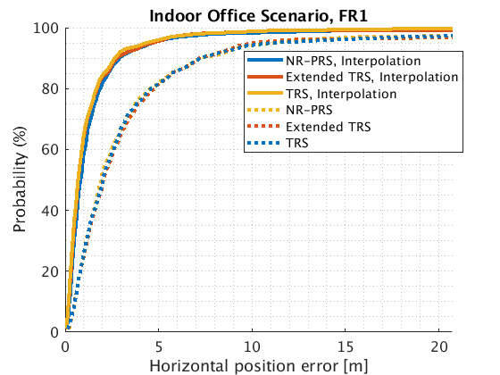

Figure 8.1.1.14-2: FR1(4 GHz) positioning accuracy in indoor open office scenario, bandwidth = 100MHz.

Table 8.1.1.14-3: Positioning accuracy summary in indoor open office scenario with and without interpolation (BW=100MHz, carrier=4GHz).

|  |  |  |  |  |
| --- | --- | --- | --- | --- |
| Interpolation | 50% TRS/Extended TRS/ NR PRS  (m) | 67% TRS/Extended TRS/ NR PRS  (m) | 80% TRS/Extended TRS/ NR PRS  (m) | 90% TRS/Extended TRS/ NR PRS  (m) |
| Yes (source 7,8,9) | 0.7/0.7/0.8 | 1/1/1 | 1.6/1.7/1.8 | 2.6/2.7/2.7 |
| No (source 4,5,6) | 2/2/1.9 | 2.9/3/3.1 | 4.5/4.6/4.8 | 7.1/7.1/7.1 |

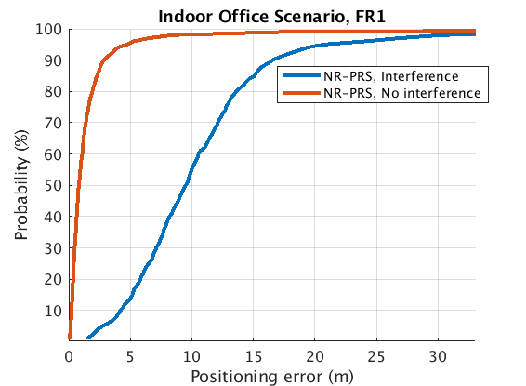

Figure 8.1.1.14-3: Positioning error FR1, 4 GHz, in indoor open office scenario (BW=100MHz, carrier=4GHz).

Table 8.1.1.14-4: Positioning accuracy summary in indoor open office scenario with and without interference (BW=100MHz, carrier=4GHz).

|  |  |  |  |  |
| --- | --- | --- | --- | --- |
| Interference | 50% NR PRS  (m) | 67% NR PRS  (m) | 80% NR PRS  (m) | 90% NR PRS  (m) |
| No (source 9) | 0.8 | 1 | 1.8 | 2.7 |
| Yes (source 10) | 9.5 | 11.7 | 13.6 | 16.5 |

The parameters corresponding to the results in FR 2 are listed in table 8.1.1.14-5 below.

Table 8.1.1.14-5: Parameters for Downlink evaluations in Scenario 1, FR2

|  |  |  |  |  |  |  |
| --- | --- | --- | --- | --- | --- | --- |
| Parameter | Source 1 | Source 2 | Source 3 | Source 4 | Source 5 | Source 6 |
| Channel model (baseline, otherwise state any modifications) | IOO FR2 | IOO FR2 | IOO FR2 | IOO FR2 | IOO FR2 | IOO FR2 |
| Carrier frequency | 30GHz | 30GHz | 30GHz | 30GHz | 30GHz | 30GHz |
| Subcarrier spacing | 120kHz | 120kHz | 120kHz | 120kHz | 120kHz | 120kHz |
| Reference Signal Transmission Bandwidth | 400MHz | 400MHz | 400MHz | 400MHz | 400MHz | 400MHz |
| Reference Signal Physical Structure and Resource Allocation (RE pattern) (reference to figure in contribution) | TRS,comb 4, 9 occasions, 2 slot, 2 symbols per slot configuration | Extended TRS: 9 occasions, 1 slot, 4 symbols per slot configuration | NR PRS: 3 occasions, 1 slot configuration, 12 symbols per slot | TRS,comb 4, 9 occasions, 2 slot, 2 symbols per slot configuration | Extended TRS: 9 occasions, 1 slot, 4 symbols per slot configuration | NR PRS: 3 occasions, 1 slot configuration, 12 symbols per slot |
| Reference signal (type of sequence, number of ports, …) | 1 port, TRS | 1 port extended TRS | 1port PRS | 1 port, TRS | 1 port extended TRS | 1port PRS |
| Number of sites | 7 | 7 | 7 | 7 | 7 | 7 |
| Number of symbols used per occasion | 4 | 4 | 12 | 4 | 4 | 12 |
| number of occasions used per positioning estimate | 9 | 9 | 3 | 9 | 9 | 3 |
| Power-boosting level | 0 | 0 | 0 | 0 | 0 | 0 |
| Uplink power control (applied/not applied) |  |  |  |  |  |  |
| interference modelling (ideal muting, or other) | interference modeled | interference modeled | interference modeled | no interference | no interference | no interference |
| Description of Measurement Algorithm (e.g. super resolution, interference cancellation, ….) |  |  |  |  |  |  |
| Description of positioning technique / applied positioning algorithm (e.g. Least square, Taylor series, etc) | DL-TDOA | DL-TDOA | DL-TDOA | DL-TDOA | DL-TDOA | DL-TDOA |
| Network synchronization assumptions | no error | no error | no error | no error | no error | no error |
| Beam-related assumption (beam sweeping / alignment assumptions at the tx and rx sides) | N/A | N/A | N/A | N/A | N/A | N/A |
| Precoding assumptions (codebook, nrof antenna elements used, etc) | horizontal wide beam with same pattern in Table 6.1.1-3. vertical pattern as shown in R1-1901198 | horizontal wide beam with same pattern in Table 6.1.1-3. vertical pattern as shown in R1-1901198 | horizontal wide beam with same pattern in Table 6.1.1-3. vertical pattern as shown in R1-1901198 | horizontal wide beam with same pattern in Table 6.1.1-3. vertical pattern as shown in R1-1901198 | horizontal wide beam with same pattern in Table 6.1.1-3. vertical pattern as shown in R1-1901198 | horizontal wide beam with same pattern in Table 6.1.1-3. vertical pattern as shown in R1-1901198 |
| Additional notes, if any |  |  |  |  |  |  |

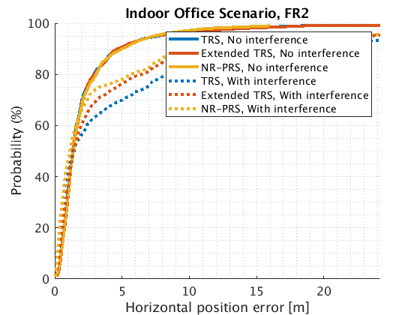

Figure 8.1.1.14-4: Positioning error FR2, 30 GHz, in indoor open office scenario (BW=400MHz, carrier=30GHz).

Table 8.1.1.14-6: Positioning accuracy summary in indoor open office scenario with and without interference.

|  |  |  |  |  |
| --- | --- | --- | --- | --- |
| Interference | 50% TRS/Extended TRS/ NR PRS  (m) | 67% TRS/Extended TRS/ NR PRS  (m) | 80% TRS/Extended TRS/ NR PRS  (m) | 90% TRS/Extended TRS/ NR PRS  (m) |
| Yes (source 1,2,3) | 1.3/1.4/1.1 | 3.9/2.6/2.1 | 8.3/6.4/5.3 | 14.8/10/9.7 |
| No (source 4,5,6) | 1.3/1.3/1.3 | 1.9/1.9/1.9 | 2.9/2.9/3 | 4.8/4.6/5 |

### 8.1.2 System simulations for Scenario 2 - UMi

#### 8.1.2.1 Results from [10]

Table 8.1.2.1-1: Parameters details for FR1 from [10]

|  |  |  |  |  |  |  |  |  |
| --- | --- | --- | --- | --- | --- | --- | --- | --- |
| Parameter | Case 1 UMi, FR1 | Case 2 UMi, FR1 | Case 3 UMi, FR1 | Case 4 UMi, FR1 | Case 5 UMi, FR1 | Case 6 UMi, FR1 | Case 7 UMi, FR1 | Case 8 UMi, FR1 |
| Channel model (baseline, otherwise state any modifications) | 38.901 | 38.901 | 38.901 | 38.901 | 38.901 | 38.901 | 38.901 | 38.901 |
| Carrier frequency | 4GHz | 4GHz | 2GHz | 2GHz | 4GHz | 4GHz | 2GHz | 2GHz |
| Subcarrier spacing | 30kHz | 15kHz | 15kHz | 15kHz | 30kHz | 15kHz | 15kHz | 15kHz |
| Reference Signal Transmission Bandwidth | 100MHz | 50MHz | 50MHz | 5MHz | 100MHz | 50MHz | 50MHz | 5MHz |
| Reference Signal Physical Structure and Resource Allocation (RE pattern) (reference to figure in contribution) | Comb-6 | Comb-6 | Comb-6 | Comb-6 | Comb-6 | Comb-6 | Comb-6 | Comb-6 |
| Reference signal (type of sequence, number of ports, …) | PRS: Gold, 1-port | PRS: Gold, 1-port | PRS: Gold, 1-port | PRS: Gold, 1-port | PRS: Gold, 1-port | PRS: Gold, 1-port | PRS: Gold, 1-port | PRS: Gold, 1-port |
| Number of sites | 19 | 19 | 19 | 19 | 19 | 19 | 19 | 19 |
| Number of symbols used per occasion | 8 | 8 | 8 | 8 | 8 | 8 | 8 | 8 |
| number of occasions used per positioning estimate | 4 | 4 | 4 | 4 | 4 | 4 | 4 | 4 |
| Power-boosting level | 7.8dB | 7.8dB | 7.8dB | 7.8dB | 7.8dB | 7.8dB | 7.8dB | 7.8dB |
| Uplink power control (applied/not applied) | Not applied | Not applied | Not applied | Not applied | Not applied | Not applied | Not applied | Not applied |
| interference modelling (ideal muting, or other) | Ideal muting | Ideal muting | Ideal muting | Ideal muting | Ideal muting | Ideal muting | Ideal muting | Ideal muting |
| Description of Measurement Algorithm (e.g. super resolution, interference cancellation, ….) | Regular | Regular | Regular | Regular | Super resolution (MUSIC) | Super resolution (MUSIC) | Super resolution (MUSIC) | Super resolution (MUSIC) |
| Description of positioning technique / applied positioning algorithm (e.g. Least square, Taylor series, etc) | DL-TDOA, Guass-Newton algorithm | DL-TDOA, Guass-Newton algorithm | DL-TDOA, Guass-Newton algorithm | DL-TDOA, Guass-Newton algorithm | DL-TDOA, Guass-Newton algorithm | DL-TDOA, Guass-Newton algorithm | DL-TDOA, Guass-Newton algorithm | DL-TDOA, Guass-Newton algorithm |
| Network synchronization assumptions | No sync error | No sync error | No sync error | No sync error | No sync error | No sync error | No sync error | No sync error |
| Beam-related assumption (beam sweeping / alignment assumptions at the tx and rx sides) | N/A | N/A | N/A | N/A | N/A | N/A | N/A | N/A |
| Precoding assumptions (codebook, nrof antenna elements used, etc) | SVD | SVD | SVD | SVD | SVD | SVD | SVD | SVD |
| Additional notes, if any |  |  |  |  |  |  |  |  |

Table 8.1.2.1-2: Parameters details for FR1 from [10], cont'd

|  |  |  |  |  |
| --- | --- | --- | --- | --- |
| Parameter | Case 9 UMi, FR1 | Case 10 UMi FR1 | Case 11 UMi, FR1 | Case 12 UMi, FR1 |
| Channel model (baseline, otherwise state any modifications) | 38.901 | 38.901 | 38.901 | 38.901 |
| Carrier frequency | 4GHz | 4GHz | 2GHz | 2GHz |
| Subcarrier spacing | 30kHz | 15kHz | 15kHz | 15kHz |
| Reference Signal Transmission Bandwidth | 100MHz | 50MHz | 50MHz | 5MHz |
| Reference Signal Physical Structure and Resource Allocation (RE pattern) (reference to figure in contribution) | Comb-6 | Comb-6 | Comb-6 | Comb-6 |
| Reference signal (type of sequence, number of ports, …) | PRS: Gold, 1-port | PRS: Gold, 1-port | PRS: Gold, 1-port | PRS: Gold, 1-port |
| Number of sites | 19 | 19 | 19 | 19 |
| Number of symbols used per occasion | 8 | 8 | 8 | 8 |
| number of occasions used per positioning estimate | 4 | 4 | 4 | 4 |
| Power-boosting level | 7.8dB | 7.8dB | 7.8dB | 7.8dB |
| Uplink power control (applied/not applied) | Not applied | Not applied | Not applied | Not applied |
| interference modelling (ideal muting, or other) | Ideal muting | Ideal muting | Ideal muting | Ideal muting |
| Description of Measurement Algorithm (e.g. super resolution, interference cancellation, ….) | Regular | Regular | Regular | Regular |
| Description of positioning technique / applied positioning algorithm (e.g. Least square, Taylor series, etc) | DL-TDOA, Guass-Newton algorithm | DL-TDOA, Guass-Newton algorithm | DL-TDOA, Guass-Newton algorithm | DL-TDOA, Guass-Newton algorithm |
| Network synchronization assumptions | Sync error 50ns | Sync error 50ns | Sync error 50ns | Sync error 50ns |
| Beam-related assumption (beam sweeping / alignment assumptions at the tx and rx sides) | N/A | N/A | N/A | N/A |
| Precoding assumptions (codebook, nrof antenna elements used, etc) | SVD | SVD | SVD | SVD |
| Additional notes, if any |  |  |  |  |

Table 8.1.2.1-3: Parameters details for FR2 from [10]

|  |  |  |  |  |  |  |
| --- | --- | --- | --- | --- | --- | --- |
| Parameter | Case 13 UMi, FR2 | Case 14 UMi FR2 | Case 15 UMi, FR2 | Case 16 UMi, FR2 | Case 17 UMi FR2 | Case 18 UMi FR2 |
| Channel model (baseline, otherwise state any modifications) | 38.901 | 38.901 | 38.901 | 38.901 | 38.901 | 38.901 |
| Carrier frequency | 30GHz | 30GHz | 30GHz | 30GHz | 30GHz | 30GHz |
| Subcarrier spacing | 120kHz | 120kHz | 120kHz | 120kHz | 120kHz | 120kHz |
| Reference Signal Transmission Bandwidth | 100MHz | 400MHz | 100MHz | 400MHz | 100MHz | 400MHz |
| Reference Signal Physical Structure and Resource Allocation (RE pattern) (reference to figure in contribution) | Comb-6 | Comb-6 | Comb-6 | Comb-6 | Comb-6 | Comb-6 |
| Reference signal (type of sequence, number of ports, …) | PRS: Gold, 1-port | PRS: Gold, 1-port | PRS: Gold, 1-port | PRS: Gold, 1-port | PRS: Gold, 1-port | PRS: Gold, 1-port |
| Number of sites | 7 | 7 | 7 | 7 | 7 | 7 |
| Number of symbols used per occasion | 8 | 8 | 8 | 8 | 8 | 8 |
| number of occasions used per positioning estimate | 4 | 4 | 4 | 4 | 4 | 4 |
| Power-boosting level | 7.8dB | 7.8dB | 7.8dB | 7.8dB | 7.8dB | 7.8dB |
| Uplink power control (applied/not applied) | Not applied | Not applied | Not applied | Not applied | Not applied | Not applied |
| interference modelling (ideal muting, or other) | Ideal muting | Ideal muting | Ideal muting | Ideal muting | Ideal muting | Ideal muting |
| Description of Measurement Algorithm (e.g. super resolution, interference cancellation, ….) | Regular | Regular | Regular | Regular | Regular | Regular |
| Description of positioning technique / applied positioning algorithm (e.g. Least square, Taylor series, etc) | DL-TDOA, Tylor expansion | DL-TDOA, Tylor expansion | DL-TDOA, Tylor expansion | DL-TDOA, Tylor expansion | ML estimation based on PDP | ML estimation based on PDP |
| Network synchronization assumptions | Sync error 0ns | Sync error 0ns | Sync error 50ns | Sync error 50ns | Sync error 0ns | Sync error 0ns |
| Beam-related assumption (beam sweeping / alignment assumptions at the tx and rx sides) | BPL with Largest RSRP | BPL with Largest RSRP | BPL with Largest RSRP | BPL with Largest RSRP | 8 TX-beam sweeping, RX beam in the largest RSRP BPL | 8 TX-beam sweeping, RX beam in the largest RSRP BPL |
| Precoding assumptions (codebook, nrof antenna elements used, etc) | DFT codebook | DFT codebook | DFT codebook | DFT codebook | DFT codebook | DFT codebook |
| Additional notes, if any |  |  |  |  |  |  |

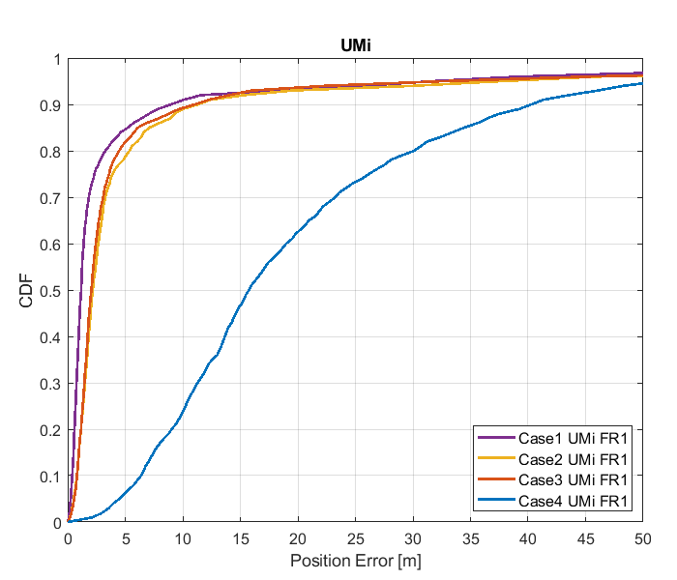

Figure 8.1.2.1-1: Results for FR1 from [10]

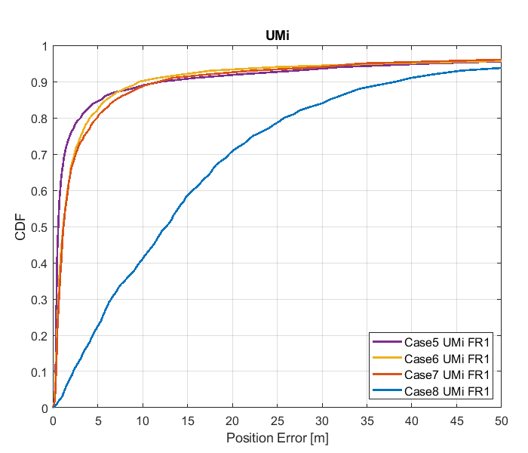

Figure 8.1.2.1-2: Results for FR1 from [10]

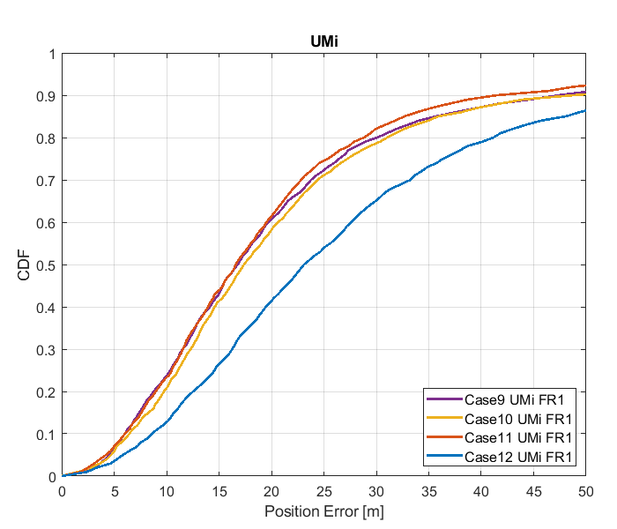

Figure 8.1.2.1-3: Results for FR1 from [10]

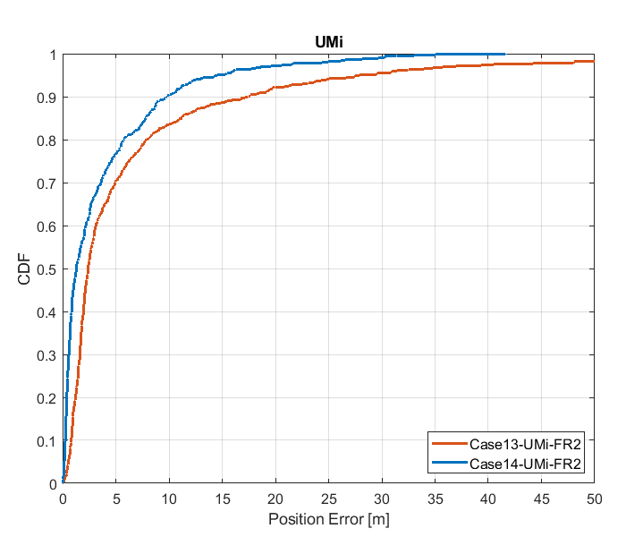

Figure 8.1.2.1-4: Results for FR2 from [10]

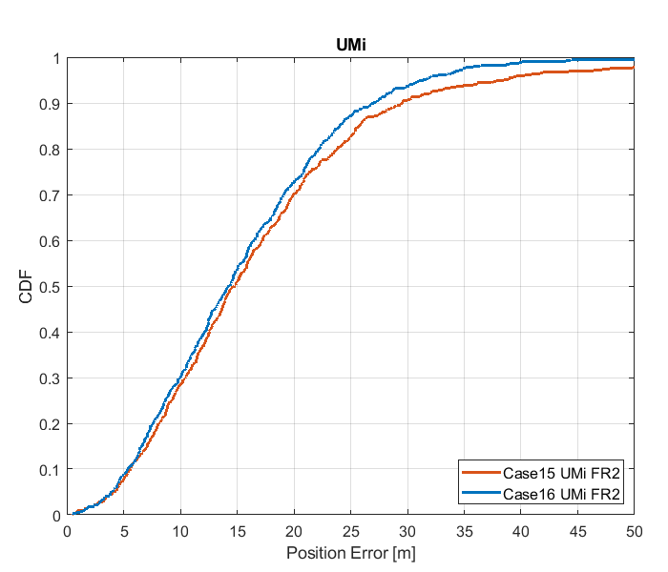

Figure 8.1.2.1-5: Results for FR2 from [10]

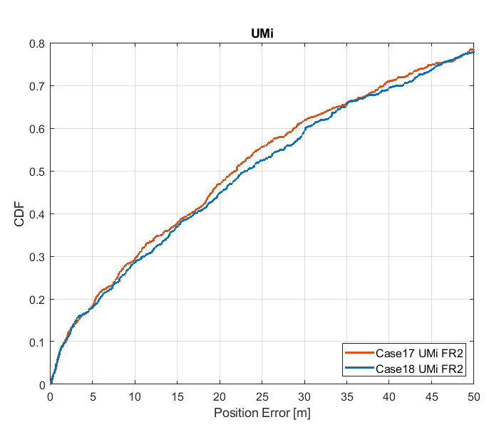

Figure 8.1.2.1-6: Results for FR2 from [10]

Table 8.1.2.1-4: results for FR1 from [10]

|  |  |  |  |  |  |  |
| --- | --- | --- | --- | --- | --- | --- |
|  |  | Source | 50% | 67% | 80% | 90% |
| FR1 | UMi | Case 1 UMi FR1 | 1.2 | 1.6 | 3.5 | 9.1 |
| Case 2 UMi FR1 | 2.0 | 2.8 | 5.5 | 11.0 |
| Case 3 UMi FR1 | 2.0 | 2.8 | 4.5 | 11.0 |
| Case 4 UMi FR1 | 15.8 | 21.7 | 29.8 | 40.3 |
| Case 5 UMi FR1 | 0.6 | 1.1 | 3.0 | 9.9 |
| Case 6 UMi FR1 | 1.1 | 2.1 | 4.1 | 9.9 |
| Case 7 UMi FR1 | 1.1 | 2.1 | 5.0 | 9.8 |
| Case 8 UMi FR1 | 12.9 | 18.5 | 25.8 | 38.5 |
| Case 9 UMi FR1 | 16.6 | 22.4 | 30.4 | 47.6 |
| Case 10 UMi FR1 | 17.2 | 23.5 | 31.1 | 47.6 |
| Case 11 UMi FR1 | 16.6 | 21.8 | 28.8 | 42.6 |
| Case 12 UMi FR1 | 23.1 | 30.5 | 41.2 | 57.8 |

Table 8.1.2.1-5: Results for FR2 from [10]

|  |  |  |  |  |  |  |
| --- | --- | --- | --- | --- | --- | --- |
|  |  | Source | 50% | 67% | 80% | 90% |
| FR2 | UMi | Case 13 UMi FR2 | 2.4 | 4.4 | 7.9 | 17.5 |
| Case 14 UMi FR2 | 1.3 | 3.0 | 5.7 | 9.7 |
| Case 15 UMi FR2 | 14.8 | 19.3 | 23.8 | 29.5 |
| Case 16 UMi FR2 | 14.2 | 18.5 | 22.2 | 26.9 |
| Case 17 UMi FR2 | 21.9 | 36.3 | 52.3 | 77.6 |
| Case 18 UMi FR2 | 23.2 | 36.7 | 53.6 | 77.5 |

#### 8.1.2.2 Results from [11]

The parameters corresponding to the results are listed in table 8.1.2.2-1 below.

Table 8.1.2.2-1: Parameters for DL-TDOA evaluations

|  |  |
| --- | --- |
| Parameter | R1-1901717 |
| Channel model (baseline, otherwise state any modifications) | baseline |
| Carrier frequency | 4 GHz for FR1  30 GHz for FR2 |
| Subcarrier spacing | 30 kHz for FR1  120 kHz for FR2 |
| Reference Signal Transmission Bandwidth | 100 MHz for FR1  400 MHz for FR2 |
| Reference Signal Physical Structure and Resource Allocation (RE pattern) (reference to figure in contribution) | LTE PRS with a slot  (comb-6 frequency structure, 8 symbols within a slot) |
| Reference signal (type of sequence, number of ports, …) | 1 port, QPSK-PN sequence |
| Number of sites | 5 |
| Number of symbols used per occasion | 8 |
| number of occasions used per positioning estimate | 1 |
| Power-boosting level | 7.78dB |
| Uplink power control (applied/not applied) | not applied |
| interference modelling (ideal muting, or other) | ideal muting |
| Description of Measurement Algorithm (e.g. super resolution, interference cancellation, ….) | Threshold-based ToA estimation method |
| Description of positioning technique / applied positioning algorithm (e.g. Least square, Taylor series, etc) | CHAN algorithm |
| Network synchronization assumptions | Perfect/50ns |
| Beam-related assumption (beam sweeping / alignment assumptions at the tx and rx sides) | alignment assumptions at the tx and rx sides |
| Precoding assumptions (codebook, nrof antenna elements used, etc) | N/A |
| UE type | Outdoor UEs for UMi |
| Additional notes, if any | only LOS path to calculate ToA |

The results corresponding to the UMi scenario are provided below



Figure 8.1.2.2-1: CDF curve of positioning for DL-TDOA evaluations of UMi: FR1 (left) and FR2 (right)

Table 8.1.2.2-2: Accuracy results (m) for DL-TDOA evaluations of UMi

|  |  |  |  |  |  |
| --- | --- | --- | --- | --- | --- |
| Percentile | | 50% | 67% | 80% | 90% |
| FR1 100M | Perfect sync | 0.82 | 1.1 | 1.4 | 5.6 |
| Sync. error 50ns | 12.9 | 15.6 | 19.5 | 25.2 |
| FR2 400M | Perfect sync | 0.17 | 0.25 | 0.33 | 1.2 |
| Sync. error 50ns | 12.7 | 16.2 | 19.6 | 25.9 |

#### 8.1.2.3 Results from [12]

The parameters corresponding to the results are listed in table 8.1.2.3-1 below.

Table 8.1.2.3-1: Parameters for Downlink evaluations in Scenario 2

|  |  |  |
| --- | --- | --- |
| Parameter | [[12], FR1] | [[12], FR2] |
| Channel model (baseline, otherwise state any modifications) | Baseline UMi | Baseline UMi |
| Carrier frequency | 4GHz | 30GHz |
| Subcarrier spacing | 30 KHz | 120KHz |
| Reference Signal Transmission Bandwidth | 100MHz | 400MHz |
| Reference Signal Physical Structure and Resource Allocation (RE pattern) (reference to figure in contribution) | Reuse LTE PRS pattern | Reuse LTE PRS pattern |
| Reference signal (type of sequence, number of ports, …) | Reuse LTE PRS sequence, one port | Reuse LTE PRS sequence, one port |
| Number of sites | 7 | 7 |
| Number of symbols used per occasion | 8 | 8 |
| number of occasions used per positioning estimate | 1 | 1 |
| Power-boosting level | No | No |
| Uplink power control (applied/not applied) | Not applied | Not applied |
| interference modelling (ideal muting, or other) | Ideal muting | Ideal muting |
| Description of Measurement Algorithm (e.g. super resolution, interference cancellation, ….) | Correlation peak detection | Correlation peak detection |
| Description of positioning technique / applied positioning algorithm (e.g. Least square, Taylor series, etc) | Combination of least square and Taylor series | Combination of least square and Taylor series |
| Network synchronization assumptions | Perfect sync and T1=50 | Perfect sync and T1=50 |
| Beam-related assumption (beam sweeping / alignment assumptions at the tx and rx sides) | Enhancement of first cluster by precoding | Enhancement of first cluster by precoding |
| Precoding assumptions (codebook, nrof antenna elements used, etc) |  |  |
| Additional notes, if any |  |  |

The results corresponding to the UMi scenario are provided below in figure 8.1.2.3-1-2 and table 8.1.2.3-2.



Figure 8.1.2.3-1: Horizontal distance error of UMi in meters(FR1)



Figure 8.1.2.3-2: Horizontal distance error of UMi in meters (FR2)

Table 8.1.2.3-2: Results for downlink methods evaluations of Scenario 2 – UMi

|  |  |  |  |  |
| --- | --- | --- | --- | --- |
| Percentile | 50 | 67 | 80 | 90 |
| FR1, Perfect sync, | 0.3614 m | 0.5881 m | 1.023 m | 2.602 m |
| FR1, T1 = 50 ns | 18.72 m | 22.06 m | 26.22 m | 35.56 m |
| FR2, Perfect sync | 0.4223 m | 0.6937 m | 1.08 m | 2.275 m |
| FR2, T1 = 50 ns | 12.48 m | 15.51 m | 26.93 m | 38.75 m |

#### 8.1.2.4 Results from [13]

The parameters corresponding to the results are listed in table 8.1.2.4-1 below.

Table 8.1.2.4-1: Parameters for Downlink evaluations in Scenario 2

|  |  |  |  |  |
| --- | --- | --- | --- | --- |
| Parameter | [[13], FR1, ideal sync, DL-TDOA] | [[13], FR1, with sync error, DL-TDOA] | [[13], FR1, with sync error, DL-TDOA] | [[13], FR1,  Angle based] |
| Channel model (baseline, otherwise state any modifications) | baseline | baseline | baseline | AWGN, assume all LOS |
| Carrier frequency | 4GHz | 4GHz | 4GHz | 4Gz |
| Subcarrier spacing | 30KHz | 30KHz | 30KHz | 15kHz |
| Reference Signal Transmission Bandwidth | 100MHz | 100MHz | 100MHz | 20MHz |
| Reference Signal Physical Structure and Resource Allocation (RE pattern) (reference to figure in contribution) | R1-1903331 | R1-1903331 | R1-1903331 | In a two-symbol PRS occasion:  1st symbol is comb-4 starting at RE 0  2nd symbol is comb-4 starting at RE 2 |
| Reference signal (type of sequence, number of ports, …) | PN sequence,  1 port | PN sequence,  1 port | PN sequence,  1 port | PN sequence,  1 port |
| Number of sites | 19 | 19 | 19 | 7 |
| Number of symbols used per occasion | 12/6/4 | 12/6 | 12/6 | 2 |
| number of occasions used per positioning estimate | 1 | 1 | 1 | 10 |
| Power-boosting level | 7.8dB (due to comb-6) | 7.8dB (due to comb-6) | 7.8dB (due to comb-6) | 6.02 dB |
| Uplink power control (applied/not applied) | Not applied | Not applied | Not applied | Not applied |
| interference modelling (ideal muting, or other) | 57 sectors in transmission in the same slot | 57 sectors in transmission in the same slot | 57 sectors in transmission in the same slot | Ideal muting |
| Description of Measurement Algorithm (e.g. super resolution, interference cancellation, ….) | CIR estimation for time delay | CIR estimation for time delay | CIR estimation for time delay | RSRP = average power per RE |
| Description of positioning technique / applied positioning algorithm (e.g. Least square, Taylor series, etc) | Least square | Least square | Least square | AoD estimation:  gNB beam pattern is known in advance, so a LUT table saving the AoD and power of each beam can be constructed. UE reports the measured RSRP ratio of beams to gNBs (see method 1 in our companion contribution R1-1901817)  Transforming AoD estimation results to UE location:  Least-square estimator |
| Network synchronization assumptions | ideal | Error range  [-100ns, 100ns] | Error range  [-50ns, 50ns] | Ideal |
| Beam-related assumption (beam sweeping / alignment assumptions at the tx and rx sides) | A single fixed beam | A single fixed beam | A single fixed beam | Each gNB perform beamsweeping with LCS α angle = [-52.5 -37.5 -22.5 -7.5 7.5 22.5 37.5 52.5] degrees.  Note these angles are equally 15-degree spaced and centered at zero |
| Precoding assumptions (codebook, nrof antenna elements used, etc) | No precoding | No precoding | No precoding | N/A |
| Additional notes, if any | DL-TDOA | DL-TDOA | DL-TDOA | Angle based |

The results corresponding to the UMi scenario are provided below

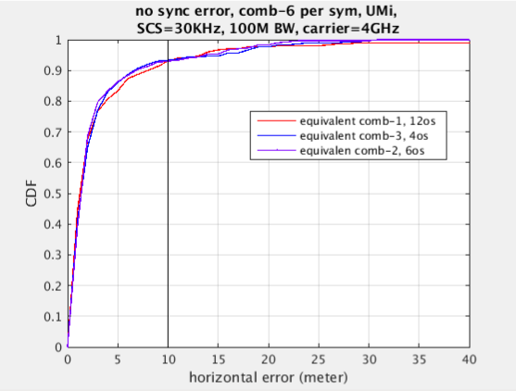

Figure 8.1.2.4-1: DL-TDOA technique curve

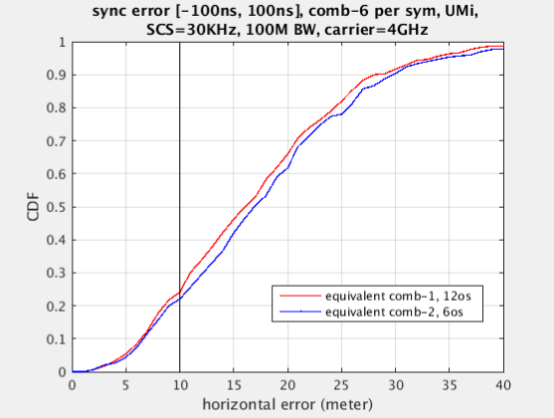

Figure 8.1.2.4-2: DL-TDOA technique curve

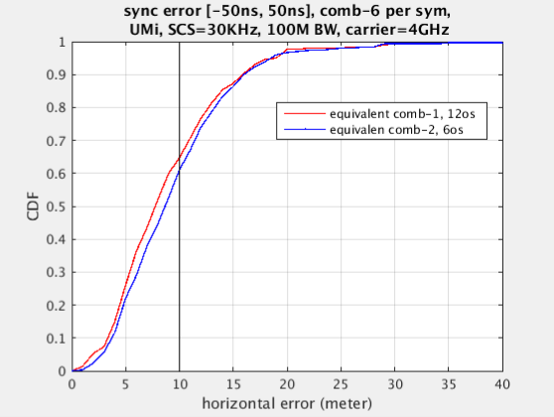

Figure 8.1.2.4-3: DL-TDOA technique curve

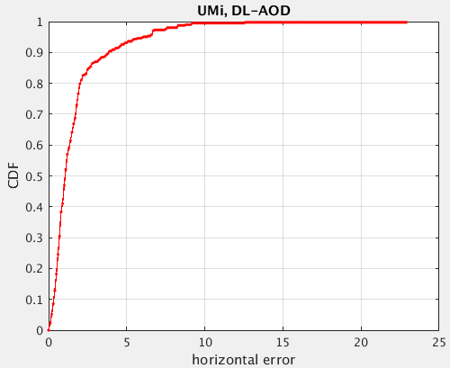

Figure 8.1.2.4-4: Angle based technique curve

Table 8.1.2.4-2: Results for downlink methods evaluations of Scenario 2 – UMi

|  |  |  |  |  |
| --- | --- | --- | --- | --- |
| Percentile | 50 | 67 | 80 | 90 |
| DL-TDOA with 12-symbol comb-6 RS  Ideal sync | 1.2m | 1.95m | 3.8m | 8m |
| DL-TDOA with 12-symbol comb-6 RS  sync error [-100ns, 100ns] | 16m | 20.2m | 24.3m | 28m |
| DL-TDOA with 12-symbol comb-6 RS  sync error [-50ns, 50ns] | 7.8m | 10.4m | 12.7m | 15.9m |
| Angle based | 1.1m | 1.6m | 2m | 3.8m |

#### 8.1.2.5 Results from [14]

The parameters corresponding to the results are listed in Table 8.1.2.5-1 below.

Table 8.1.2.5-1: Parameters for Downlink evaluations in Scenario 2

|  |  |  |
| --- | --- | --- |
| Parameter | [[14], FR1] | [[14], FR2] |
| Channel model (baseline, otherwise state any modifications) | Baseline | Baseline |
| Carrier frequency | 4 GHz | 30 GHz |
| Subcarrier spacing | 15 kHz, 30 kHz | 120 kHz |
| Reference Signal Transmission Bandwidth | 5 MHz, 100 MHz | 100 MHz, 400 MHz |
| Reference Signal Physical Structure and Resource Allocation (RE pattern) (reference to figure in contribution) | LTE PRS Structure from [35] (with additional symbols where CRS was in LTE) | LTE PRS Structure from [35] (with additional symbols where CRS was in LTE) |
| Reference signal (type of sequence, number of ports, …) | LTE PRS Structure from [35] | LTE PRS Structure from [35] |
| Number of sites | 7 | 7 |
| Number of symbols used per occasion | 11 | 11 |
| number of occasions used per positioning estimate | 1 | 1 |
| Power-boosting level | 10*log10(6) | 10*log10(6) |
| Uplink power control (applied/not applied) | N/A | N/A |
| interference modelling (ideal muting, or other) | Perfect muting | Perfect muting |
| Description of Measurement Algorithm (e.g. super resolution, interference cancellation, ….) | Both no threshold and threshold of 0.5 at the UE | Threshold of 0.5 at the UE |
| Description of positioning technique / applied positioning algorithm (e.g. Least square, Taylor series, etc) | Both Least squares and BLADE results | Both Least squares and BLADE |
| Network synchronization assumptions | Perfect synchronization | Perfect synchronization |
| Beam-related assumption (beam sweeping / alignment assumptions at the tx and rx sides) | Sectorized beams | Ideal beam selected for PRS transmission |
| Precoding assumptions (codebook, nrof antenna elements used, etc) | N/A | Codebook based beam |
| Additional notes, if any | N/A | N/A |

The results corresponding to the Urban Micro scenario are provided below

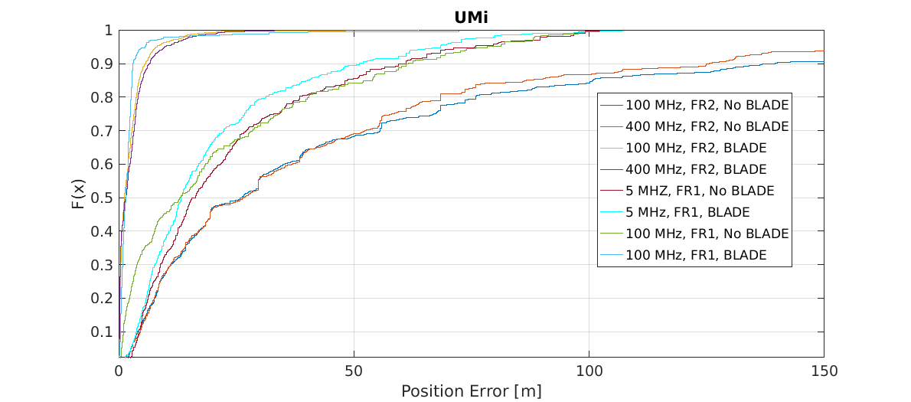

Figure 8.1.2.5-1

Table 8.1.2.5-2: Results for downlink methods evaluations of Scenario 2 – Urban Micro

|  |  |  |  |  |
| --- | --- | --- | --- | --- |
| Percentile | 50 | 67 | 80 | 90 |
| DL-TDOA, FR1, 5 MHz, without BLADE | 16.3 | 25.3 | 38.5 | 60 |
| DL-TDOA, FR1, 100 MHz, without BLADE | 13.1 | 24.6 | 40.4 | 61.0 |
| DL-TDOA, FR2, 100 MHz, without BLADE | 26.4 | 45.4 | 75.9 | 139.5 |
| DL-TDOA, FR2, 400 MHz, without BLADE | 26.6 | 46.0 | 68.4 | 125.4 |
| DL-TDOA, FR1, 5 MHz, with BLADE | 13.3 | 20.3 | 31.2 | 51.2 |
| DL-TDOA, FR1, 100 MHz, with BLADE | 1.6 | 2.2 | 2.6 | 3.1 |
| DL-TDOA, FR2, 100 MHz, with BLADE | 1.5 | 3.0 | 4.1 | 6.6 |
| DL-TDOA, FR2, 400 MHz, with BLADE | 1.3 | 2.5 | 3.8 | 5.7 |

#### 8.1.2.6 Results from [15]

The parameters corresponding to the results are listed in table 8.1.2.6-1 below.

Table 8.1.2.6-1: Parameters for Downlink evaluations in Scenario 2

|  |  |
| --- | --- |
| Parameter | [15] (R1-1903222) |
| Channel model (baseline, otherwise state any modifications) | According to 3GPP TR 38.901 (UMi Street Canyon) |
| Carrier frequency | 4GHz |
| Subcarrier spacing | 15KHz |
| Reference Signal Transmission Bandwidth | 5MHz, 50MHz |
| Reference Signal Physical Structure and Resource Allocation (RE pattern) (reference to figure in contribution) | New NR PRS based on the modification of LTE PRS. NR PRS REs are mapped in frequency domain evenly to all subcarriers in the PRS OFDM symbols. The detail of the mapping is presented in R1-1901980. |
| Reference signal (type of sequence, number of ports, …) | Length-31 Gold sequence 1 port |
| Number of sites | 57 sectors / 19 sites,  Up to 6 sites used for DL-TDOA |
| Number of symbols used per occasion | 13 |
| number of occasions used per positioning estimate | 1 |
| Power-boosting level | 7.78dB (10*log10(6) = 7.78) |
| Uplink power control (applied/not applied) | N/A |
| interference modelling (ideal muting, or other) | Ideal muting |
| Description of Measurement Algorithm (e.g. super resolution, interference cancellation, ….) | No super resolution, and no interference cancellation |
| Description of positioning technique / applied positioning algorithm (e.g. Least square, Taylor series, etc) | Chan's algorithm "A simple and efficient estimator for Hyperbolic location", Y.T. Chan and K.C. Ho, IEEE transactions on signal processing, vol.42, no. 8, August 1994. |
| Network synchronization assumptions | Perfect synchronization. |
| Beam-related assumption (beam sweeping / alignment assumptions at the tx and rx sides) | Wide Tx beam without beam sweeping is assumed. No Rx beam sweeping. |
| Precoding assumptions (codebook, nrof antenna elements used, etc) | Tx: 64 antenna elements Rx: 4 antenna elements codebook: 64*1 precoder used to generate widebeam |
| Additional notes, if any |  |

The results corresponding to the UMi Street Canyon scenario are provided below

Table 8.1.2.6-2: Results for downlink methods evaluations of Scenario 2 –UMi

|  |  |  |  |  |
| --- | --- | --- | --- | --- |
| Percentile | 50 | 67 | 80 | 90 |
| [5Mhz: DL-TDOA ] | 25.9 | 31.9 | 38.5 | 49.9 |
| [50Mhz: DL-TDOA ] | 14.4 | 18.2 | 22.2 | 25.1 |

#### 8.1.2.7 Results from [16]

The parameters corresponding to the results are listed in table 8.1.2.7-1 below.

Table 8.1.2.7-1: Parameters for Downlink evaluations in Scenario 2

|  |  |
| --- | --- |
| Parameter | [16], FR1 |
| Channel model (baseline, otherwise state any modifications) | Baseline |
| Carrier frequency | 2 GHz |
| Subcarrier spacing | 15 kHz |
| Reference Signal Transmission Bandwidth | 5, 50 MHz |
| Reference Signal Physical Structure and Resource Allocation (RE pattern) (reference to figure in contribution) | Based on LTE PRS |
| Reference signal (type of sequence, number of ports, …) | Based on LTE PRS |
| Number of sites | 57 |
| Number of symbols used per occasion | 8 |
| number of occasions used per positioning estimate | 6 |
| Power-boosting level | 7.78 dB |
| Uplink power control (applied/not applied) | Not applied |
| interference modelling (ideal muting, or other) | Ideal muting |
| Description of Measurement Algorithm (e.g. super resolution, interference cancellation, ….) | Cross correlation |
| Description of positioning technique / applied positioning algorithm (e.g. Least square, Taylor series, etc) | DL-TDOA/ Least square |
| Network synchronization assumptions | Perfect Synchronization |
| Beam-related assumption (beam sweeping / alignment assumptions at the tx and rx sides) | No |
| Precoding assumptions (codebook, nrof antenna elements used, etc) | No |
| Additional notes, if any | - |

The results corresponding to the UMi scenario are provided below

Table 8.1.2.7-2: Results for downlink methods evaluations of Scenario 2 – UMi

|  |  |  |  |  |
| --- | --- | --- | --- | --- |
| Percentile | 50 | 67 | 80 | 90 |
| DL-TDOA, 5MHz | 9.79m | 12.56m | 15.27m | 19.47m |
| DL-TDOA, 50MHz | 1.76m | 2.69m | 4.58m | 8.07m |

#### 8.1.2.8 Results from [17]

The parameters corresponding to the results are listed in table 8.1.2.8 -1 below.

Table 8.1.2.8-1: Parameters for Downlink evaluations in Scenario 2

|  |  |  |
| --- | --- | --- |
| Parameter | [17], FR1 | [17], FR2 |
| Channel model (baseline, otherwise state any modifications) | baseline | baseline |
| Carrier frequency | 4 GHz | 30 GHz |
| Subcarrier spacing | 30 kHz | 120 kHz |
| Reference Signal Transmission Bandwidth | 100 MHz | 400 MHz |
| Reference Signal Physical Structure and Resource Allocation (RE pattern) (reference to figure in contribution) | Fig.2(a) of [17] | Fig.2 of [17] |
| Reference signal (type of sequence, number of ports, …) | Gold sequence according to NR specification for CSI-RS, 1 port | Gold sequence according to NR specification for CSI-RS, 1 port |
| Number of sites | 19 | 19 |
| Number of symbols used per occasion | 6 | 6, 2 |
| number of occasions used per positioning estimate | 6 | 6 |
| Power-boosting level | 7.8 dB | 7.8, 6 dB |
| Uplink power control (applied/not applied) | Not applied | Not applied |
| interference modelling (ideal muting, or other) | Ideal muting | Ideal muting |
| Description of Measurement Algorithm (e.g. super resolution, interference cancellation, ….) | Correlation | Correlation |
| Description of positioning technique / applied positioning algorithm (e.g. Least square, Taylor series, etc) | Taylor series | Taylor series |
| Network synchronization assumptions | Perfect synchronization | Perfect synchronization |
| Beam-related assumption (beam sweeping / alignment assumptions at the tx and rx sides) | Sectorized | Beam sweeping |
| Precoding assumptions (codebook, nr. of antenna elements used, etc) | Based on TR 38.802 | Based on TR 38.802 |
| Additional notes, if any |  |  |

For UMi Scenario, only outdoor UEs should be considered. The simulation results of FR1 are shown in Figure 8.1.2.8-1 and Table 8.1.2.8-2.



Figure 8.1.2.8-1: Horizontal Positioning Error for UMi scenario (100MHz)

Table 8.1.2.8-2: Results for downlink methods evaluations of Scenario 2 – UMi

|  |  |  |  |  |
| --- | --- | --- | --- | --- |
| Positioning percentage | 90% | 80% | 67% | 50% |
| Positioning error | 9.1 m | 6.3 m | 4.2 m | 2.9 m |

The simulation results of FR2 are shown in Figure 8.1.2.8-2 and Table-8.1.2.8-3.



Figure 8.1.2.8-2: Horizontal Positioning Error for UMi scenario (400MHz)

Table 8.1.2.8-3: Results for downlink methods evaluations of Scenario 2 – UMi

|  |  |  |  |  |
| --- | --- | --- | --- | --- |
| Positioning percentage | 90% | 80% | 67% | 50% |
| Positioning error (TRS) | 28 m | 6.5 m | 1.9 m | 0.8 m |
| Positioning error (PRS) | 8 m | 2.5 m | 1.8 m | 0.6 m |

#### 8.1.2.9 Results from [18]

The parameters corresponding to the results are listed in table 8.1.2.9 -1 below.

Table 8.1.2.9-1: Parameters for Downlink evaluations in Scenario 2

|  |  |  |  |
| --- | --- | --- | --- |
| Parameter | [18], FR1 2 GHz | [18], FR1 4 GHz | [18], FR2 30 GHz |
| Channel model (baseline, otherwise state any modifications) | Baseline | Baseline | Baseline |
| Carrier frequency | 2 GHz | 4 GHz | 30 GHz |
| Subcarrier spacing | 15 KHz | 30 KHz | 120 KHz |
| Reference Signal Transmission Bandwidth | 5 MHz | 100 MHz | 400 MHz |
| Reference Signal Physical Structure and Resource Allocation (RE pattern) (reference to figure in contribution) | SSB reference signal structure | SSB reference signal structure | SSB reference signal structure |
| Reference signal (type of sequence, number of ports, …) | SSB reference signal | SSB reference signal | SSB reference signal |
| Number of sites | 7 | 7 | 7 |
| Number of symbols used per occasion | 4 | 4 | 4 |
| Number of occasions used per positioning estimate | 1 | 1 | 1 |
| Power-boosting level | No power boosting | No power boosting | No power boosting |
| Uplink power control (applied/not applied) | Not applied | Not applied | Not applied |
| Interference modelling (ideal muting, or other) | No muting | No muting | No muting |
| Description of Measurement Algorithm (e.g. super resolution, interference cancellation, ….) | AOD and ZOD were derived from max received SSB  TA was approximated from first arrival with a random perturbation based on TA resolution | AOD and ZOD were derived from max received SSB  TA was approximated from first arrival with a random perturbation based on TA resolution | AOD and ZOD were derived from max received SSB  TA was approximated from first arrival with a random perturbation based on TA resolution |
| Description of positioning technique / applied positioning algorithm (e.g. Least square, Taylor series, etc) | Maximum a posteriori | Maximum a posteriori | Maximum a posteriori |
| Network synchronization assumptions | Perfect | Perfect | Perfect |
| Beam-related assumption (beam sweeping / alignment assumptions at the tx and rx sides) | 4 SSB/beams, no UE beam sweeping | 8 SSB/beams, no UE beam sweeping | 64 SSB/beams, no UE beam sweeping |
| Precoding assumptions (codebook, nrof antenna elements used, etc) | No precoding assumptions | No precoding assumptions | No precoding assumptions |
| Additional notes, if any |  |  |  |

The results corresponding to the Urban Micro scenario are provided below

Table 8.1.2.9-2: Results for downlink methods evaluations of Scenario 2 – Urban Micro (UMi)

|  |  |  |  |  |  |  |  |  |  |  |  |
| --- | --- | --- | --- | --- | --- | --- | --- | --- | --- | --- | --- |
| Percentile | 10 | 20 | 30 | 40 | 50 | 60 | 67 | 70 | 80 | 90 | 95 |
| AOD + ZOD  FR1 2 GHz | 17.5 | 26.7 | 44 | 53.6 | 61.7 | 74.7 | 85.6 | 90.6 | 124.5 | 160.8 | 201.5 |
| AOD + ZOD + TA FR1 2 GHz | 10.4 | 17.2 | 22 | 27.2 | 32.5 | 37 | 44.4 | 46.2 | 58 | 79.2 | 88.9 |
| AOD + ZOD  FR1 4 GHz | 15.2 | 19.5 | 25.1 | 46.2 | 59.2 | 72.6 | 84.3 | 89.7 | 102.1 | 140.2 | 188.7 |
| AOD + ZOD + TA  FR1 4 GHz | 6.8 | 10.9 | 16.3 | 19.3 | 21.6 | 27.3 | 30.8 | 35.7 | 43.9 | 64.4 | 78.3 |
| AOD + ZOD  FR2 30 GHz | 10.2 | 15.7 | 19.6 | 30.1 | 44.1 | 61.1 | 75.2 | 82.2 | 100.8 | 134.6 | 173.8 |
| AOD + ZOD + TA  FR2 30 GHz | 4.6 | 7.8 | 13.2 | 17.2 | 22.2 | 24.3 | 27.8 | 30.8 | 45.1 | 65.1 | 85.5 |

#### 8.1.2.10 Results from [19]

The parameters used for evaluation of the DL based positioning in Scenario 2 (UMi) are listed in Table 8.1.2.1-1 below.

Table 8.1.2.10-1: Parameters for Downlink evaluations in Scenario 2

|  |  |  |  |
| --- | --- | --- | --- |
| Parameter | Setup 1 | Setup 2 | Setup 3 |
| Channel model (baseline, otherwise state any modifications) | Baseline | Baseline | Baseline |
| Carrier frequency | 4 GHz | 4 GHz | 30 GHz |
| Subcarrier spacing | 15 kHz | 30 kHz | 120 kHz |
| Reference Signal Transmission Bandwidth | 5 MHz | 100 MHz | 100 MHz |
| Reference Signal Physical Structure and Resource Allocation (RE pattern) (reference to figure in contribution) | 12 REs per PRB, single symbol | 12 REs per PRB, single symbol | 12 REs per PRB, single symbol |
| Reference signal (type of sequence, number of ports, …) | QPSK, Pseudo random, single Tx port | QPSK, Pseudo random, single Tx port | QPSK, Pseudo random, single Tx port |
| Number of sites | 57 sectors / 19 sites | 57 sectors / 19 sites | 57 sectors / 19 sites |
| Number of symbols used per occasion | 1x57(sectors) | 1x57(sectors) | 16(beams)x57(sectors) |
| Number of occasions used per positioning estimate | 1 | 1 | 1 |
| Power-boosting level | 0 dB | 0 dB | 0 dB |
| Uplink power control (applied/not applied) | NA | NA | NA |
| Interference modelling (ideal muting, or other) | Ideal muting | Ideal muting | Ideal muting |
| Description of Measurement Algorithm (e.g. super resolution, interference cancellation, ….) | Option 1: Threshold based algorithm for the first arrival path (FAP) estimation  Option 2: MUSIC | Threshold based algorithm for the first arrival path (FAP) estimation | Threshold based algorithm for the first arrival path (FAP) estimation |
| Description of positioning technique / applied positioning algorithm (e.g. Least square, Taylor series, etc) | Taylor based, measurements above -15 dB are used for positioning | Taylor based, measurements above -15 dB are used for positioning | Taylor based, measurements above -15 dB are used for positioning |
| Network synchronization assumptions | Option 1: T1 = 0ns(Perfect)  Option 2: T1 = 50ns | Option 1: T1 = 0ns(Perfect)  Option 2: T1 = 50ns | Option 1: T1 = 0ns(Perfect)  Option 2: T1 = 50ns |
| Beam-related assumption (beam sweeping / alignment assumptions at the tx and rx sides) | No Tx sweeping | No Tx sweeping | Tx sweeping |
| Precoding assumptions (codebook, nrof antenna elements used, etc) | Single Tx port | Single Tx port | Single Tx port |
| Additional notes, if any | RX Waveform reporting is assumed to perform super resolution timing estimation algorithm at gNB side |  |  |

The system level evaluation results for DL positioning in Scenario 2 (UMi) are provided below.

|  |
| --- |
| Figure 8.1.2.10-1 (a) FR1 evaluations    Figure 8.1.2.10-2 (b) FR2 evaluations |

#### 8.1.2.11 Results from [20]

The parameters corresponding to the results are listed in table 8.1.2.11-1 below.

Table 8.1.2.11-1: Parameters for Downlink evaluations in Scenario 2 - UMi

|  |  |  |  |  |
| --- | --- | --- | --- | --- |
| Parameter | [20], FR1, 0ns, baseline channel model | [20], FR1, 0ns, modified channel model | [20], FR1, 50ns, baseline channel model | [20], FR1, 50ns, modified channel model |
| Channel model (baseline, otherwise state any modifications) | Baseline | Baseline + removal of path delays norm. for NLoS | Baseline | Baseline + removal of path delays norm. for NLoS |
| Carrier frequency | 4 GHz | 4 GHz | 4 GHz | 4 GHz |
| Subcarrier spacing | 30 kHz | 30 kHz | 30 kHz | 30 kHz |
| Reference Signal Transmission Bandwidth | 100 MHz | 100 MHz | 100 MHz | 100 MHz |
| Reference Signal Physical Structure and Resource Allocation (RE pattern) (reference to figure in contribution) | PRS pattern | PRS pattern | PRS pattern | PRS pattern |
| Reference signal (type of sequence, number of ports, …) | PRS | PRS | PRS | PRS |
| Number of sites | 19 micro sites | 19 micro sites | 19 micro sites | 19 micro sites |
| Number of symbols used per occasion | 1 | 1 | 1 | 1 |
| number of occasions used per positioning estimate | 1 | 1 | 1 | 1 |
| Power-boosting level | 0 dB | 0 dB | 0 dB | 0 dB |
| Uplink power control (applied/not applied) | Not applied | Not applied | Not applied | Not applied |
| interference modelling (ideal muting, or other) | Ideal muting | Ideal muting | Ideal muting | Ideal muting |
| Description of Measurement Algorithm (e.g. super resolution, interference cancellation, ….) | Adaptive threshold-based with a fine estimation range | Adaptive threshold-based with a fine estimation range | Adaptive threshold-based with a fine estimation range | Adaptive threshold-based with a fine estimation range |
| Description of positioning technique / applied positioning algorithm (e.g. Least square, Taylor series, etc) | Weighted least squares (WLS) | Weighted least squares (WLS) | Weighted least squares (WLS) | Weighted least squares (WLS) |
| Network synchronization assumptions | Perfect sync. | Perfect sync. | 50 ns rms sync. error | 50 ns rms sync. error |
| Beam-related assumption (beam sweeping / alignment assumptions at the tx and rx sides) | No beam sweeping | No beam sweeping | No beam sweeping | No beam sweeping |
| Precoding assumptions (codebook, nrof antenna elements used, etc) | 8 TX antenna elements, 2 RX antenna elements | 8 TX antenna elements, 2 RX antenna elements | 8 TX antenna elements, 2 RX antenna elements | 8 TX antenna elements, 2 RX antenna elements |
| Additional notes, if any | 100% outdoor | 100% outdoor | 100% outdoor | 100% outdoor |

The results corresponding to the UMi scenario are provided below:



Figure 8.1.2.11-1: Scenario 2 - UMi: CDF of the horizontal positioning accuracy.

Table 8.1.2.11-2: Results of horizontal accuracy for downlink methods evaluations of Scenario 2 – UMi.

|  |  |  |  |  |  |  |  |  |  |
| --- | --- | --- | --- | --- | --- | --- | --- | --- | --- |
| Percentile | 10 | 20 | 30 | 40 | 50 | 60 | 70 | 90 | 95 |
| DL-TDOA, FR1, 0ns, baseline channel model | 0.24 | 0.42 | 0.59 | 0.76 | 0.93 | 1.11 | 1.33 | 2.11 | 2.60 |
| DL-TDOA, FR1, 0ns, modified channel model | 0.68 | 1.10 | 1.46 | 1.82 | 2.22 | 2.67 | 3.28 | 6.10 | 9.51 |
| DL-TDOA, FR1, 50ns, baseline channel model | 4.28 | 6.28 | 7.98 | 9.68 | 11.32 | 13.20 | 15.36 | 26.15 | >30 |
| DL-TDOA, FR1, 50ns, modified channel model | 4.50 | 6.50 | 8.34 | 10.04 | 11.79 | 13.75 | 16.08 | >30 | >30 |



Figure 8.1.2.11-2: Scenario 2 - UMi: CDF of the vertical positioning accuracy.

Table 8.1.2.11-3: Results of vertical accuracy for downlink methods evaluations of Scenario 2 – UMi.

|  |  |  |  |  |  |  |  |  |  |
| --- | --- | --- | --- | --- | --- | --- | --- | --- | --- |
| Percentile | 10 | 20 | 30 | 40 | 50 | 60 | 70 | 90 | 95 |
| DL-TDOA, FR1, 0ns, baseline channel model | 0.71 | 1.67 | 2.84 | 4.27 | 6.03 | 8.06 | 10.85 | 24.72 | >30 |
| DL-TDOA, FR1, 0ns, modified channel model | 1.90 | 4.08 | 6.69 | 9.52 | 13.24 | 18.23 | 24.68 | >30 | >30 |
| DL-TDOA, FR1, 50ns, baseline channel model | 10.19 | 20.00 | 28.30 | >30 | >30 | >30 | >30 | >30 | >30 |
| DL-TDOA, FR1, 50ns, modified channel model | 10.49 | 20.72 | >30 | >30 | >30 | >30 | >30 | >30 | >30 |

#### 8.1.2.12 Results from [21]

The parameters corresponding to the results are listed in table Table 8.1.2.12-1 below.

Table 8.1.2.12-1: Parameters for Downlink evaluations in Scenario 1

|  |  |
| --- | --- |
| Parameter | [[21], FR1] |
| Channel model (baseline, otherwise state any modifications) | baseline |
| Carrier frequency | 2GHz |
| Subcarrier spacing | 30kHz |
| Reference Signal Transmission Bandwidth | 100MHz |
| Reference Signal Physical Structure and Resource Allocation (RE pattern) (reference to figure in contribution) | Figure 2 in R1-1902699 |
| Reference signal (type of sequence, number of ports, …) | Weil10230 |
| Number of sites | 7 |
| Number of symbols used per occasion | 6000 |
| number of occasions used per positioning estimate | 20 |
| Power-boosting level | No |
| Uplink power control (applied/not applied) | not applied |
| interference modelling (ideal muting, or other) | ideal muting |
| Description of Measurement Algorithm (e.g. super resolution, interference cancellation, ….) | Serial interference cancellation and loop tracking |
| Description of positioning technique / applied positioning algorithm (e.g. Least square, Taylor series, etc) | Combination of Chan and Newton |
| Network synchronization assumptions | Perfect sync. |
| Beam-related assumption (beam sweeping / alignment assumptions at the tx and rx sides) | No beamforming |
| Precoding assumptions (codebook, nrof antenna elements used, etc) | No |
| Additional notes, if any |  |

The results corresponding to the Indoor open office scenario are provided below

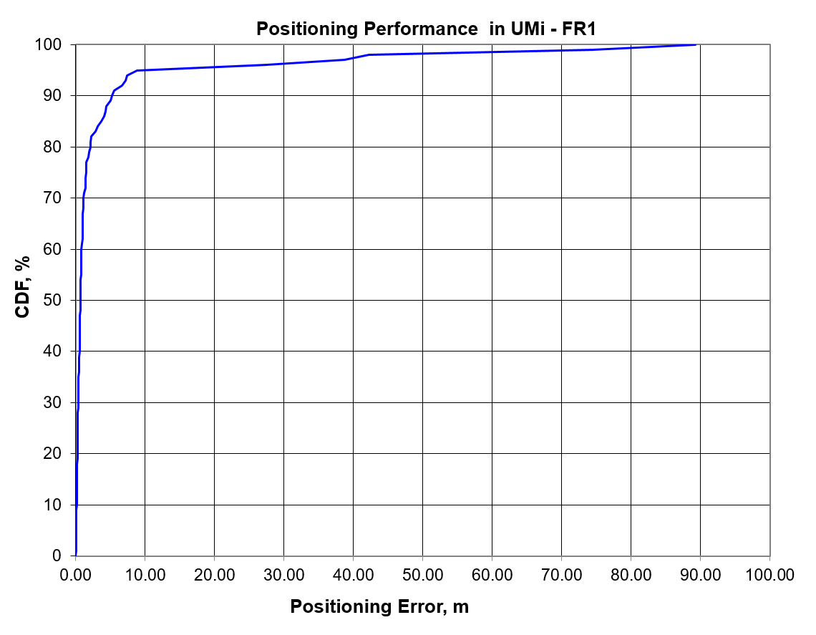

Figure 8.1.2.12-1: The CDF of Positioning error for scenario 2

Table 8.1.2.12-2: Results for downlink methods evaluations of Scenario 2

|  |  |  |  |  |  |  |  |  |  |  |  |
| --- | --- | --- | --- | --- | --- | --- | --- | --- | --- | --- | --- |
| Percentile | 10 | 20 | 30 | 40 | 50 | 60 | 67 | 70 | 80 | 90 | 95 |
| Co-band TBS | 0.15 | 0.26 | 0.37 | 0.56 | 0.71 | 0.86 | 1.06 | 1.17 | 2.12 | 5.22 | 8.83 |

#### 8.1.2.13 Results from [23]

The parameters corresponding to the results are listed in table Table 8.1.2.13-1 below.

Table 8.1.2.13-1: Parameters for Downlink evaluations in Scenario 2

|  |  |  |  |  |  |
| --- | --- | --- | --- | --- | --- |
| Parameter | [23], FR1, 100 MHz | [23], FR1, 50 MHz | [23], FR1, 5 MHz | [23], FR2, 400 MHz | [23], FR2, 100 MHz |
| Channel model (baseline, otherwise state any modifications) | Baseline Channel Model based on common assumptions defined related to the channel models of 3GPP TRs 38.901 / 38.802 / 37.857. | | | | |
| Carrier frequency | 4 GHz | | | 30 GHz | |
| Subcarrier spacing | 30 KHz | 15 KHz | 15 KHz | 120 KHz | |
| Reference Signal Transmission Bandwidth | 100 MHz | 50 MHz | 5 MHz | 400 MHz | 100 MHz |
| Reference Signal Physical Structure and Resource Allocation (RE pattern) (reference to figure in contribution) | Comb-1 with 1-symbol PRS resource | | | | |
| Reference signal (type of sequence, number of ports, …) | 1-port, QPSK sequence | | | | |
| Number of sites | 19 (3-sector) | | | | |
| Number of symbols used per occasion | 1 | | | | |
| number of occasions used per positioning estimate | 1 | | | | |
| Power-boosting level | 0 dB | | | | |
| interference modelling (ideal muting, or other) | Ideal muting | | | | |
| Description of Measurement Algorithm (e.g. super resolution, interference cancellation, ….) | TOA estimation without oversampling with TOA pruning before the positioning engine using the ratio of the estimated TOA peak over the median of the Channel Energy Response (CER). | | | | |
| Description of positioning technique / applied positioning algorithm (e.g. Least square, Taylor series, etc) | For DL-TDOA Pick the best between Taylor series, and Chan's Algorithm.  Chan's Algorithm according to:  Y. T. Chan, K. C. Ho, " A Simple and Efficient Estimator for Hyperbolic Location", IEEE Transactions on Signal Processing, vol. 42, pp. 1905-1915, Aug. 1994.  Taylor Series Algorithm:  W. H. Foy, " Position-Location Solutions by Taylor-Series Estimation", IEEE Transactions on Aerospace and Electronic Systems, vol. AES-12, pp. 187-194, March 1976.  Equal weight is used in the TOA covariance matrix. | | | | |
| Network synchronization assumptions | Perfect Sync and Realistic Sync with T1 = 50 nsec | | | | |
| Beam-related assumption (beam sweeping / alignment assumptions at the tx and rx sides) | The best beam pair is identified based on the criteria of receiving the earliest path given that the received power is larger than a threshold (20 dB lower than the maximum received power) using the genie CDL channel profiles. For a single sector scenario (only Indoor hotspop 4GHz), the directions of beams are within [, 180] degress in azimuth and [,180] degrees in zenith. For a 3-sector scenario, the directions of beams are within [, ] degress in azimuth and [,180] degrees in zenith. | | | | |
| Precoding assumptions (codebook, nrof antenna elements used, etc) | Kronecker product between vertical and horizontal weight vectors taken from DFT, with oversampling factor = 1. The DFT beam candidate in beam selection method is generated according to the uniform vertical and horizontal angular distribution shown as follows:  , for i=1,…,rN  where r denotes the oversampling factor, N denotes the number of vertical/horizontal antennas. For FR2, Tx oversampling factor r equals to 2 and Rx oversampling factor equals to 1. For FR1, Tx oversampling factor equals to1. | | | | |

The results corresponding to the UMi scenario are provided below

Table 8.1.2.13-2: Results for downlink methods evaluations of Scenario 2 – UMi

|  |  |  |  |  |  |
| --- | --- | --- | --- | --- | --- |
| Percentile | 50 | 67 | 80 | 90 | 95 |
| DL-TDOA, FR1, 100 MHz, Perfect Sync | 3.1 | 4.5 | 6.4 | 9.2 | 12.8 |
| DL-TDOA, FR1, 100 MHz, Realistic Sync | 6.7 | 8.7 | 10.8 | 13.7 | 16.6 |
| DL-TDOA, FR1, 50 MHz, Perfect Sync | 3.7 | 5.4 | 7.8 | 11.3 | 14.7 |
| DL-TDOA, FR1, 50 MHz, Realistic Sync | 7.1 | 9.4 | 12 | 15.1 | 18 |
| DL-TDOA, FR1, 5 MHz, Perfect Sync | 12.2 | 16.2 | 20.4 | 25.3 | 29.7 |
| DL-TDOA, FR1, 5 MHz, Realistic Sync | 13.2 | 17.2 | 21.7 | 26.5 | 31 |
| DL-TDOA, FR2, 400 MHz, Perfect Sync | 0.9 | 2.2 | 4.2 | 9.4 | 16 |
| DL-TDOA, FR2, 400 MHz, Realistic Sync | 9.2 | 11.9 | 15.5 | 20.3 | 26.3 |
| DL-TDOA, FR2, 100 MHz, Perfect Sync | 1.5 | 2.5 | 4.3 | 9.5 | 17.5 |
| DL-TDOA, FR2, 100 MHz, Realistic Sync | 8 | 10.6 | 13.2 | 17.3 | 22.9 |

#### 8.1.2.14 Results from [25]

The parameters corresponding to the results are listed in table 8.1.2.14-1 below.

Table 8.1.2.14-1: Parameters for Uplink evaluations in Scenario 2, FR1

|  |  |  |  |  |  |  |  |  |  |
| --- | --- | --- | --- | --- | --- | --- | --- | --- | --- |
| Parameter | Source 1 | Source 2 | Source 3 | Source 4 | Source 5 | Source 6 | Source 7 | Source 8 | Source 9 |
| Channel model (baseline, otherwise state any modifications) | UMi, FR1 | UMi, FR1 | UMi, FR1 | UMi, FR1 | UMi, FR1 | UMi, FR1 | UMi, FR1 | UMi, FR1 | UMi, FR1 |
| Carrier frequency | 2GHz | 2GHz | 2GHz | 4GHz | 4GHz | 4GHz | 4GHz | 4GHz | 4GHz |
| Subcarrier spacing | 15khz | 15khz | 15khz | 15khz | 15khz | 15khz | 15khz | 15khz | 15khz |
| Reference Signal Transmission Bandwidth | 50MHz | 50MHz | 50MHz | 100MHz | 100MHz | 100MHz | 100MHz | 100MHz | 100MHz |
| Reference Signal Physical Structure and Resource Allocation (RE pattern) (reference to figure in contribution) | TRS,comb 4, 9 occasions, 2 slot, 2 symbols per slot configuration | Extended TRS: 9 occasions, 1 slot, 4 symbols per slot configuration | NR PRS: 3 occasions, 1 slot configuration, 12 symbols per slot | TRS,comb 4, 9 occasions, 2 slot, 2 symbols per slot configuration | Extended TRS: 9 occasions, 1 slot, 4 symbols per slot configuration | NR PRS: 3 occasions, 1 slot configuration, 12 symbols per slot | TRS,comb 4, 9 occasions, 2 slot, 2 symbols per slot configuration | Extended TRS: 9 occasions, 1 slot, 4 symbols per slot configuration | NR PRS: 3 occasions, 1 slot configuration, 12 symbols per slot |
| Reference signal (type of sequence, number of ports, …) | 1 port, TRS | 1 port extended TRS | 1port PRS | 1 port, TRS | 1 port extended TRS | 1port PRS | 1 port, TRS | 1 port extended TRS | 1port PRS |
| Number of sites | 7 | 7 | 7 | 7 | 7 | 7 | 7 | 7 | 7 |
| Number of symbols used per occasion | 4 | 4 | 12 | 4 | 4 | 12 | 4 | 4 | 12 |
| number of occasions used per positioning estimate | 9 | 9 | 3 | 9 | 9 | 3 | 9 | 9 | 3 |
| Power-boosting level | 0 | 0 | 0 | 0 | 0 | 0 | 0 | 0 | 0 |
| Uplink power control (applied/not applied) |  |  |  |  |  |  |  |  |  |
| interference modelling (ideal muting, or other) | no interference | no interference | no interference | no interference | no interference | no interference | interference | interference | interference |
| Description of Measurement Algorithm (e.g. super resolution, interference cancellation, ….) |  |  |  | interpolation added | interpolation added | interpolation added | interpolation added | interpolation added | interpolation added |
| Description of positioning technique / applied positioning algorithm (e.g. Least square, Taylor series, etc) | DL-TDOA | DL-TDOA | DL-TDOA | DL-TDOA | DL-TDOA | DL-TDOA | DL-TDOA | DL-TDOA | DL-TDOA |
| Network synchronization assumptions | no error | no error | no error | no error | no error | no error | no error | no error | no error |
| Beam-related assumption (beam sweeping / alignment assumptions at the tx and rx sides) | N/A | N/A | N/A | N/A | N/A | N/A | N/A | N/A | N/A |
| Precoding assumptions (codebook, nrof antenna elements used, etc) | horizontal wide beam with same pattern in Table 6.1.1-3. vertical pattern as shown in R1-1901198 | horizontal wide beam with same pattern in Table 6.1.1-3. vertical pattern as shown in R1-1901198 | horizontal wide beam with same pattern in Table 6.1.1-3. vertical pattern as shown in R1-1901198 | horizontal wide beam with same pattern in Table 6.1.1-3. vertical pattern as shown in R1-1901198 | horizontal wide beam with same pattern in Table 6.1.1-3. vertical pattern as shown in R1-1901198 | horizontal wide beam with same pattern in Table 6.1.1-3. vertical pattern as shown in R1-1901198 | horizontal wide beam with same pattern in Table 6.1.1-3. vertical pattern as shown in R1-1901198 | horizontal wide beam with same pattern in Table 6.1.1-3. vertical pattern as shown in R1-1901198 | horizontal wide beam with same pattern in Table 6.1.1-3. vertical pattern as shown in R1-1901198 |
| Additional notes, if any |  |  |  |  |  |  |  |  |  |

The results corresponding to the Indoor open office scenario are provided below

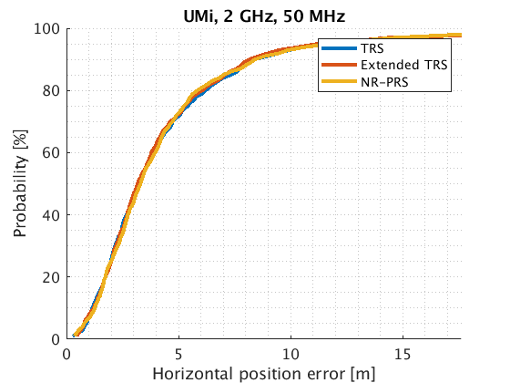

Figure 8.1.2.14-1: FR1 (2 GHz) positioning error in urban micro scenario.

Table 8.1.2.14-2: FR1 (2 GHz) positioning accuracy summary in urban micro scenario.

|  |  |  |  |  |
| --- | --- | --- | --- | --- |
| Bandwidth | 50% TRS/Extended TRS/ NR PRS  (m) | 67% TRS/Extended TRS/ NR PRS  (m) | 80% TRS/Extended TRS/ NR PRS  (m) | 90% TRS/Extended TRS/ NR PRS  (m) |
| 2 GHz, 50 Mhz (source 1,2,3) | 3.2/3.1/3.3 | 4.4/4.2/4.3 | 6.2/6/5.8 | 8.4/8.4/8.1 |

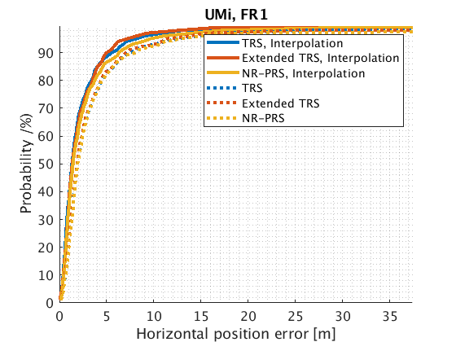

Figure 8.1.2.14-2: FR1 (4 GHz) positioning accuracy in urban micro scenario.

Table 8.1.2.14-3: FR1 positioning accuracy summary in indoor open office scenario with and without interpolation.

|  |  |  |  |  |
| --- | --- | --- | --- | --- |
| Interpolation | 50% TRS/Extended TRS/ NR PRS  (m) | 67% TRS/Extended TRS/ NR PRS  (m) | 80% TRS/Extended TRS/ NR PRS  (m) | 90% TRS/Extended TRS/ NR PRS  (m) |
| Yes (source 7,8,9) | 1.3/1.3/1.4 | 2/2.1/2.3 | 3.4/3.4/3.7 | 5.5/5/6.2 |
| No (source 4,5,6) | 1.9/1.9/1.9 | 2.8/2.8/2.9 | 4.5/4.4/4.8 | 7.3/7/8 |

### 8.1.3 System simulations for Scenario 3 - UMa

#### 8.1.3.1 Results from [10]

Table 8.1.3.1-1: Parameters details for FR1 from [10]

|  |  |  |  |  |  |  |  |  |
| --- | --- | --- | --- | --- | --- | --- | --- | --- |
| Parameter | Case 1 UMa, FR1 | Case 2 UMa, FR1 | Case 3 UMa, FR1 | Case 4 UMa, FR1 | Case 5 UMa, FR1 | Case 6 UMa, FR1 | Case 7 UMa, FR1 | Case 8 UMa, FR1 |
| Channel model (baseline, otherwise state any modifications) | 38.901 | 38.901 | 38.901 | 38.901 | 38.901 | 38.901 | 38.901 | 38.901 |
| Carrier frequency | 4GHz | 4GHz | 2GHz | 2GHz | 4GHz | 4GHz | 2GHz | 2GHz |
| Subcarrier spacing | 30kHz | 15kHz | 15kHz | 15kHz | 30kHz | 15kHz | 15kHz | 15kHz |
| Reference Signal Transmission Bandwidth | 100MHz | 50MHz | 50MHz | 5MHz | 100MHz | 50MHz | 50MHz | 5MHz |
| Reference Signal Physical Structure and Resource Allocation (RE pattern) (reference to figure in contribution) | Comb-6 | Comb-6 | Comb-6 | Comb-6 | Comb-6 | Comb-6 | Comb-6 | Comb-6 |
| Reference signal (type of sequence, number of ports, …) | PRS: Gold, 1-port | PRS: Gold, 1-port | PRS: Gold, 1-port | PRS: Gold, 1-port | PRS: Gold, 1-port | PRS: Gold, 1-port | PRS: Gold, 1-port | PRS: Gold, 1-port |
| Number of sites | 19 | 19 | 19 | 19 | 19 | 19 | 19 | 19 |
| Number of symbols used per occasion | 8 | 8 | 8 | 8 | 8 | 8 | 8 | 8 |
| number of occasions used per positioning estimate | 4 | 4 | 4 | 4 | 4 | 4 | 4 | 4 |
| Power-boosting level | 7.8dB | 7.8dB | 7.8dB | 7.8dB | 7.8dB | 7.8dB | 7.8dB | 7.8dB |
| Uplink power control (applied/not applied) | Not applied | Not applied | Not applied | Not applied | Not applied | Not applied | Not applied | Not applied |
| interference modelling (ideal muting, or other) | Ideal muting | Ideal muting | Ideal muting | Ideal muting | Ideal muting | Ideal muting | Ideal muting | Ideal muting |
| Description of Measurement Algorithm (e.g. super resolution, interference cancellation, ….) | Regular | Regular | Regular | Regular | Super resolution (MUSIC) | Super resolution (MUSIC) | Super resolution (MUSIC) | Super resolution (MUSIC) |
| Description of positioning technique / applied positioning algorithm (e.g. Least square, Taylor series, etc) | DL-TDOA, Guass-Newton algorithm | DL-TDOA, Guass-Newton algorithm | DL-TDOA, Guass-Newton algorithm | DL-TDOA, Guass-Newton algorithm | DL-TDOA, Guass-Newton algorithm | DL-TDOA, Guass-Newton algorithm | DL-TDOA, Guass-Newton algorithm | DL-TDOA, Guass-Newton algorithm |
| Network synchronization assumptions | No sync error | No sync error | No sync error | No sync error | No sync error | No sync error | No sync error | No sync error |
| Beam-related assumption (beam sweeping / alignment assumptions at the tx and rx sides) | N/A | N/A | N/A | N/A | N/A | N/A | N/A | N/A |
| Precoding assumptions (codebook, nrof antenna elements used, etc) | SVD | SVD | SVD | SVD | SVD | SVD | SVD | SVD |
| Additional notes, if any |  |  |  |  |  |  |  |  |

Table 8.1.3.1-2: Parameters details for FR1 from [10]

|  |  |  |  |  |
| --- | --- | --- | --- | --- |
| Parameter | Case 9 UMa, FR1 | Case 10 UMa, FR1 | Case 11 UMa, FR1 | Case 12 UMa, FR1 |
| Channel model (baseline, otherwise state any modifications) | 38.901 | 38.901 | 38.901 | 38.901 |
| Carrier frequency | 4GHz | 4GHz | 2GHz | 2GHz |
| Subcarrier spacing | 30kHz | 15kHz | 15kHz | 15kHz |
| Reference Signal Transmission Bandwidth | 100MHz | 50MHz | 50MHz | 5MHz |
| Reference Signal Physical Structure and Resource Allocation (RE pattern) (reference to figure in contribution) | Comb-6 | Comb-6 | Comb-6 | Comb-6 |
| Reference signal (type of sequence, number of ports, …) | PRS: Gold, 1-port | PRS: Gold, 1-port | PRS: Gold, 1-port | PRS: Gold, 1-port |
| Number of sites | 19 | 19 | 19 | 19 |
| Number of symbols used per occasion | 8 | 8 | 8 | 8 |
| number of occasions used per positioning estimate | 4 | 4 | 4 | 4 |
| Power-boosting level | 7.8dB | 7.8dB | 7.8dB | 7.8dB |
| Uplink power control (applied/not applied) | Not applied | Not applied | Not applied | Not applied |
| interference modelling (ideal muting, or other) | Ideal muting | Ideal muting | Ideal muting | Ideal muting |
| Description of Measurement Algorithm (e.g. super resolution, interference cancellation, ….) | Regular | Regular | Regular | Regular |
| Description of positioning technique / applied positioning algorithm (e.g. Least square, Taylor series, etc) | DL-TDOA, Guass-Newton algorithm | DL-TDOA, Guass-Newton algorithm | DL-TDOA, Guass-Newton algorithm | DL-TDOA, Guass-Newton algorithm |
| Network synchronization assumptions | Sync error 50ns | Sync error 50ns | Sync error 50ns | Sync error 50ns |
| Beam-related assumption (beam sweeping / alignment assumptions at the tx and rx sides) | N/A | N/A | N/A | N/A |
| Precoding assumptions (codebook, nrof antenna elements used, etc) | SVD | SVD | SVD | SVD |
| Additional notes, if any |  |  |  |  |

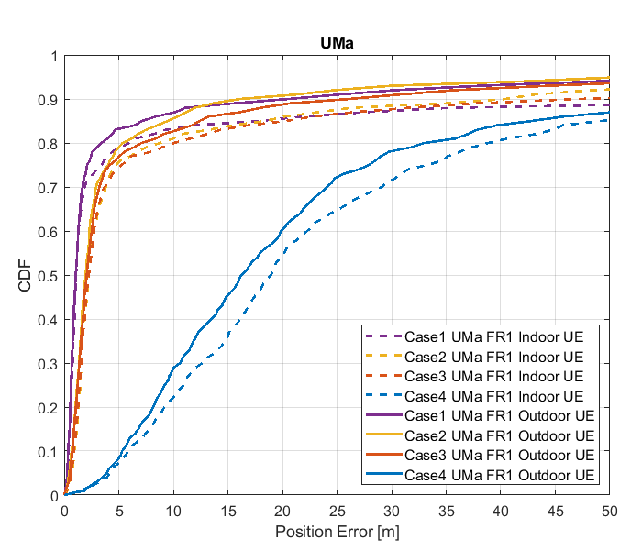

Figure 8.1.3.1-1: Results for FR1 from [10]

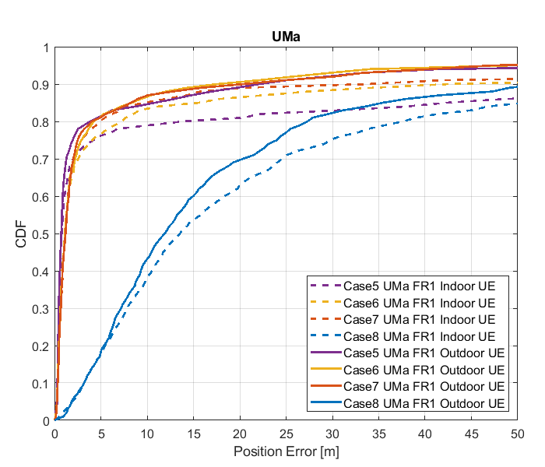

Figure 8.1.3.1-2: Results for FR1 from [10]

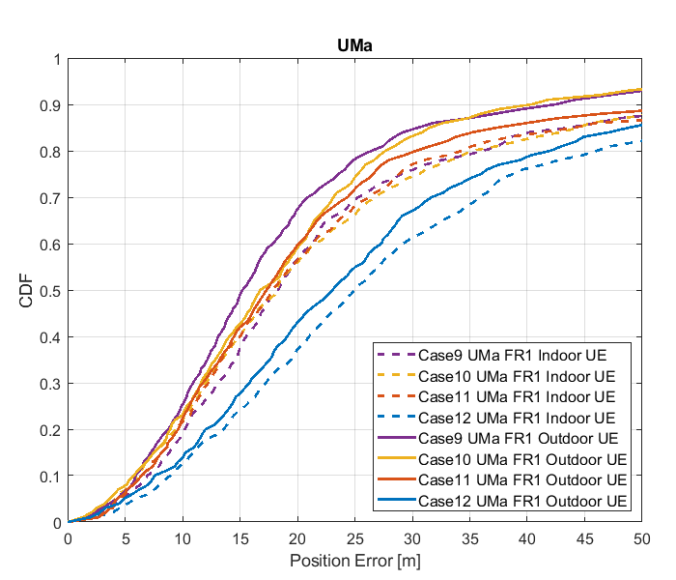

Figure 8.1.3.1-3: Results for FR1 from [10]

Table 8.1.3.1-3: results for FR1 from [10]

|  |  |  |  |  |  |  |
| --- | --- | --- | --- | --- | --- | --- |
|  |  | Source | 50% | 67% | 80% | 90% |
| FR1 | UMa indoor | Case 1 UMa FR1 | 1.1 | 1.6 | 6.0 | 27.9 |
| Case 2 UMa FR1 | 1.9 | 2.8 | 8.6 | 40.6 |
| Case 3 UMa FR1 | 2.2 | 3.1 | 10.0 | 46.8 |
| Case 4 UMa FR1 | 18.7 | 26.0 | 38.9 | 81.1 |
| Case 5 UMa FR1 | 0.7 | 1.6 | 13.9 | 23 |
| Case 6 UMa FR1 | 1.2 | 1.8 | 7.4 | 42 |
| Case 7 UMa FR1 | 1.2 | 1.8 | 4.7 | 31 |
| Case 8 UMa FR1 | 13 | 23 | 37 | 87 |
| Case 9 UMa FR1 | 18 | 24 | 36 | 65 |
| Case 10 UMa FR1 | 17 | 26 | 35 | 61 |
| Case 11 UMa FR1 | 17 | 25 | 34 | 73 |
| Case 12 UMa FR1 | 25 | 34 | 46 | 78 |
| UMa outdoor | Case 1 UMa FR1 | 1.1 | 1.5 | 3.5 | 62.4 |
| Case 2 UMa FR1 | 1.9 | 2.5 | 5.7 | 16.5 |
| Case 3 UMa FR1 | 2.2 | 2.8 | 7.9 | 32.1 |
| Case 4 UMa FR1 | 16.3 | 22.9 | 34.0 | 68.4 |
| Case 5 UMa FR1 | 0.7 | 1.1 | 4.7 | 23 |
| Case 6 UMa FR1 | 1.2 | 1.8 | 4.7 | 17 |
| Case 7 UMa FR1 | 1.2 | 1.8 | 4.7 | 17 |
| Case 8 UMa FR1 | 11 | 18 | 27 | 53 |
| Case 9 UMa FR1 | 15 | 20 | 27 | 42 |
| Case 10 UMa FR1 | 16 | 23 | 28 | 40 |
| Case 11 UMa FR1 | 17 | 23 | 31 | 55 |
| Case 12 UMa FR1 | 23 | 30 | 42 | 62 |

#### 8.1.3.2 Results from [11]

The parameters corresponding to the results are listed in table 8.1.3.2-1 below.

Table 8.1.3.2-1: Parameters for DL-TDOA evaluations

|  |  |
| --- | --- |
| Parameter | R1-1901717 |
| Channel model (baseline, otherwise state any modifications) | baseline |
| Carrier frequency | 4 GHz for FR1 |
| Subcarrier spacing | 30 kHz for FR1 |
| Reference Signal Transmission Bandwidth | 100 MHz for FR1 |
| Reference Signal Physical Structure and Resource Allocation (RE pattern) (reference to figure in contribution) | LTE PRS within a slot  (comb-6 frequency structure, 8 symbols within a slot) |
| Reference signal (type of sequence, number of ports, …) | 1 port, QPSK-PN sequence |
| Number of sites | 5 |
| Number of symbols used per occasion | 8 |
| number of occasions used per positioning estimate | 1 |
| Power-boosting level | 7.78 dB |
| Uplink power control (applied/not applied) | not applied |
| interference modelling (ideal muting, or other) | ideal muting |
| Description of Measurement Algorithm (e.g. super resolution, interference cancellation, ….) | Threshold-based ToA estimation method |
| Description of positioning technique / applied positioning algorithm (e.g. Least square, Taylor series, etc) | CHAN algorithm |
| Network synchronization assumptions | Perfect/50ns |
| Beam-related assumption (beam sweeping / alignment assumptions at the tx and rx sides) | alignment assumptions at the tx and rx sides |
| Precoding assumptions (codebook, nrof antenna elements used, etc) | N/A |
| UE type | Outdoor UEs for UMa |
| Additional notes, if any | only LOS path to calculate ToA |

The results corresponding to the UMa scenario are provided below



Figure 8.1.3.2-1: CDF curve of positioning error for DL-TDOA evaluations of UMa in FR1

Table 8.1.3.2-2: Accuracy results (m) for DL-TDOA evaluations of UMa

|  |  |  |  |  |
| --- | --- | --- | --- | --- |
| Percentile | 50% | 67% | 80% | 90% |
| perfect synchronization | 1.1 | 2.6 | 7.3 | 21.7 |
| synchronization error (50ns) | 12.5 | 17.4 | 23.1 | 42 |

#### 8.1.3.3 Results from [13]

The parameters corresponding to the results are listed in table 8.1.3.3-1 below.

Table 8.1.3.3-1: Parameters for Downlink evaluations in Scenario 3

|  |  |  |  |  |  |
| --- | --- | --- | --- | --- | --- |
| Parameter | [[13], FR1, ideal sync, DL-TDOA] | [[13], FR1, with sync error, DL-TDOA] | [[13], FR1, ideal sync, DL-TDOA] | [[13], FR1, ideal sync, DL-TDOA] | [[13], FR1, angle based] |
| Channel model (baseline, otherwise state any modifications) | baseline | baseline | baseline | baseline | AWGN, assume all LOS |
| Carrier frequency | 4GHz | 4GHz | 4GHz | 2GHz | 4Gz |
| Subcarrier spacing | 30KHz | 30KHz | 30KHz | 15KHz | 15kHz |
| Reference Signal Transmission Bandwidth | 100MHz | 100MHz | 100MHz | 50MHz | 20MHz |
| Reference Signal Physical Structure and Resource Allocation (RE pattern) (reference to figure in contribution) | R1-1903331 | R1-1903331 | R1-1903331 | R1-1903331 | In a two-symbol PRS occasion:  1st symbol is comb-4 starting at RE 0  2nd symbol is comb-4 starting at RE 2 |
| Reference signal (type of sequence, number of ports, …) | PN sequence,  1 port | PN sequence,  1 port | PN sequence,  1 port | PN sequence,  1 port | PN sequence, 1 port |
| Number of sites | 19 | 19 | 19 | 19 | 7 |
| Number of symbols used per occasion | 12/6/4 | 12/6/4 | 8/4 | 12/6/4 | 2 |
| number of occasions used per positioning estimate | 1 | 1 | 1 | 1 | 10 |
| Power-boosting level | 7.8dB (due to comb-6) | 7.8dB (due to comb-6) | 6dB (due to comb-4) | 7.8dB (due to comb-6) | 6.02 dB |
| Uplink power control (applied/not applied) | Not applied | Not applied | Not applied | Not applied | Not applied |
| interference modelling (ideal muting, or other) | 57 sectors in transmission in the same slot | 57 sectors in transmission in the same slot | 57 sectors in transmission in the same slot | 57 sectors in transmission in the same slot | Ideal muting |
| Description of Measurement Algorithm (e.g. super resolution, interference cancellation, ….) | CIR estimation for time delay | CIR estimation for time delay | CIR estimation for time delay | CIR estimation for time delay | RSRP = average power per RE |
| Description of positioning technique / applied positioning algorithm (e.g. Least square, Taylor series, etc) | Least square | Least square | Least square | Least square | AoD estimation:  gNB beam pattern is known in advance, so a LUT table saving the AoD and power of each beam can be constructed. UE reports the measured RSRP ratio of beams to gNBs (see method 1 in our companion contribution R1-1901817)  Transforming AoD estimation results to UE location:  Least-square estimator |
| Network synchronization assumptions | ideal | Error range  [-100ns, 100ns] | ideal | ideal | Ideal |
| Beam-related assumption (beam sweeping / alignment assumptions at the tx and rx sides) | A single fixed beam | A single fixed beam | A single fixed beam | A single fixed beam | Each gNB perform beamsweeping with LCS α angle = [-52.5 -37.5 -22.5 -7.5 7.5 22.5 37.5 52.5] degrees.  Note these angles are equally 15-degree spaced and centered at zero |
| Precoding assumptions (codebook, nrof antenna elements used, etc) | No precoding | No precoding | No precoding | No precoding | N/A |
| Additional notes, if any | DL-TDOA  (UMa indoor has similar performance as the UMa outdoor) | DL-TDOA  (UMa indoor has similar performance as the UMa outdoor) | DL-TDOA  (UMa indoor has similar performance as the UMa outdoor) | DL-TDOA  (UMa indoor has similar performance as the UMa outdoor) | Angle based |

The results corresponding to the UMa scenario are provided below

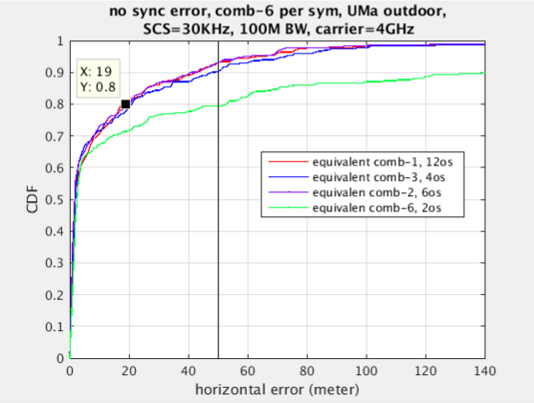

Figure 8.1.3.3-1: DL-TDOA technique curve

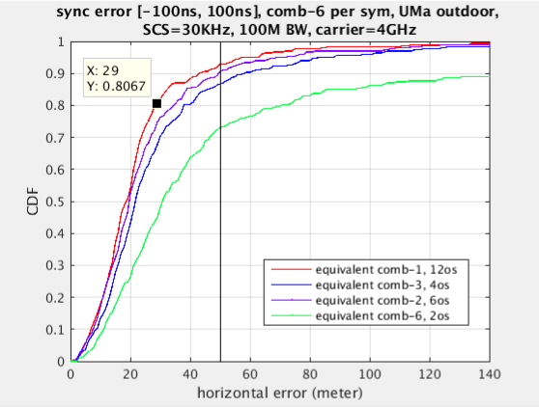

Figure 8.1.3.3-2: DL-TDOA technique curve

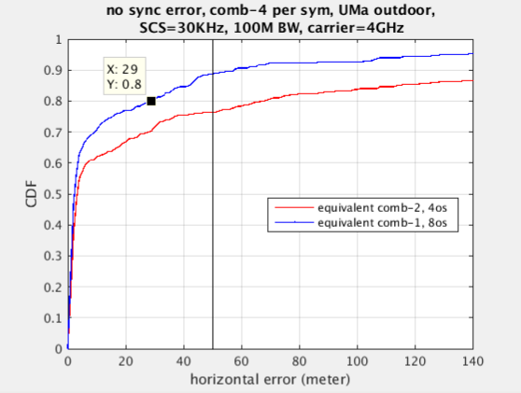

Figure 8.1.3.3-3: DL-TDOA technique curve

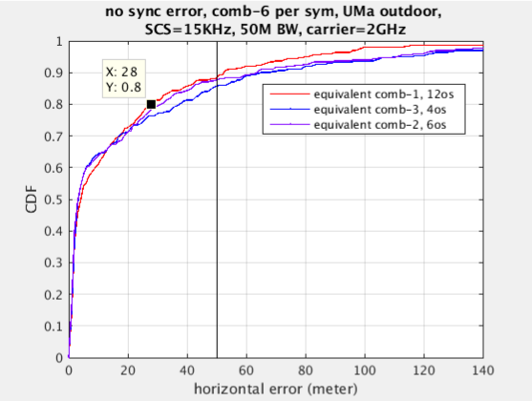

Figure 8.1.3.3-4: DL-TDOA technique curve

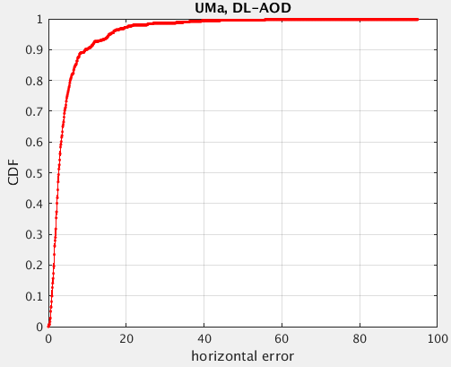

Figure 8.1.3.3-5: Angle based technique curve

Table 8.1.3.3-2: Results for downlink methods evaluations of Scenario 3 – UMa

|  |  |  |  |  |
| --- | --- | --- | --- | --- |
| Percentile | 50 | 67 | 80 | 90 |
| DL-TDOA with 12-symbol comb-6 RS  Ideal sync  100MHz BW | 2m | 7m | 19m | 43m |
| DL-TDOA with 12-symbol comb-6 RS  sync error [-100ns, 100ns]  100MHz BW | 18.5m | 22.7m | 28.5m | 43m |
| DL-TDOA with 8-symbol comb-4 RS  Ideal sync  100MHz BW | 2.3m | 7m | 29m | 57.5m |
| DL-TDOA with 12-symbol comb-6 RS  Ideal sync  50MHz BW | 4m | 14m | 28m | 52.5m |
| Angle based | 2.7m | 3.9m | 5.7m | 9.5m |

#### 8.1.3.4 Results from [14]

The parameters corresponding to the results are listed in Table 8.1.3.4-1 below.

Table 8.1.3.4-1: Parameters for Downlink evaluations in Scenario 3

|  |  |
| --- | --- |
| Parameter | [[14], FR1] |
| Channel model (baseline, otherwise state any modifications) | Baseline |
| Carrier frequency | 4 GHz |
| Subcarrier spacing | 15 kHz, 30 kHz |
| Reference Signal Transmission Bandwidth | 5 MHz, 100 MHz |
| Reference Signal Physical Structure and Resource Allocation (RE pattern) (reference to figure in contribution) | LTE PRS Structure from [35] (with additional symbols where CRS was in LTE) |
| Reference signal (type of sequence, number of ports, …) | LTE PRS Structure from [35] |
| Number of sites | 7 |
| Number of symbols used per occasion | 11 |
| number of occasions used per positioning estimate | 1 |
| Power-boosting level | 10*log10(6) |
| Uplink power control (applied/not applied) | N/A |
| interference modelling (ideal muting, or other) | Perfect muting |
| Description of Measurement Algorithm (e.g. super resolution, interference cancellation, ….) | Both no threshold and threshold of 0.5 at the UE |
| Description of positioning technique / applied positioning algorithm (e.g. Least square, Taylor series, etc) | Both Least squares and BLADE results |
| Network synchronization assumptions | Perfect synchronization |
| Beam-related assumption (beam sweeping / alignment assumptions at the tx and rx sides) | Sectorized beams |
| Precoding assumptions (codebook, nrof antenna elements used, etc) | N/A |
| Additional notes, if any | N/A |

The results corresponding to the Urban Macro scenario are provided below

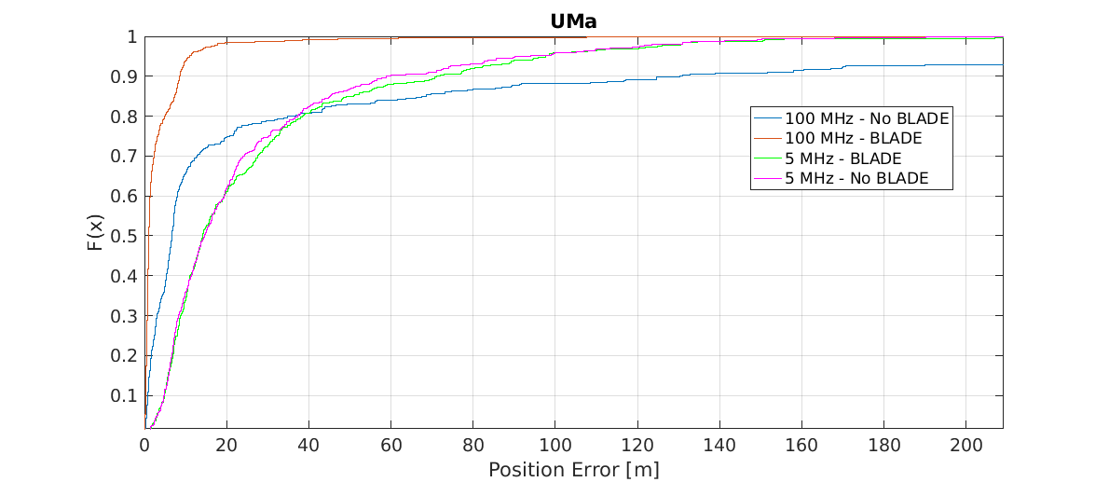

Figure 8.1.3.4-1

Table 8.1.3.4-2: Results for downlink methods evaluations of Scenario 3 – Urban Macro

|  |  |  |  |  |
| --- | --- | --- | --- | --- |
| Percentile | 50 | 67 | 80 | 90 |
| DL-TDOA, FR1, 5 MHz, without BLADE | 14.6 | 22.3 | 37.3 | 58.8 |
| DL-TDOA, FR1, 100 MHz, without BLADE | 6.7 | 10.5 | 34.9 | 130.4 |
| DL-TDOA, FR1, 5 MHz, with BLADE | 14.2 | 25.4 | 38.6 | 71 |
| DL-TDOA, FR1, 100 MHz, with BLADE | 1.1 | 1.9 | 5.0 | 8.6 |

#### 8.1.3.5 Results from [15]

The parameters corresponding to the results are listed in table 8.1.3.5-1 below.

Table 8.1.3.5-1: Parameters for Downlink evaluations in Scenario 3

|  |  |
| --- | --- |
| Parameter | [15] (R1-1903222) |
| Channel model (baseline, otherwise state any modifications) | According to 3GPP TR 38.901 (UMa) |
| Carrier frequency | 4GHz |
| Subcarrier spacing | 15KHz |
| Reference Signal Transmission Bandwidth | 5MHz, 50MHz |
| Reference Signal Physical Structure and Resource Allocation (RE pattern) (reference to figure in contribution) | New NR PRS based on the modification of LTE PRS. NR PRS REs are mapped in frequency domain evenly to all subcarriers in the PRS OFDM symbols. The detail of the mapping is presented in R1-1901980. |
| Reference signal (type of sequence, number of ports, …) | Length-31 Gold sequence 1 port |
| Number of sites | 57 sectors / 19 sites,  Up to 6 sites used for DL-TDOA |
| Number of symbols used per occasion | 13 |
| number of occasions used per positioning estimate | 1 |
| Power-boosting level | 7.78dB (10*log10(6) = 7.78) |
| Uplink power control (applied/not applied) | Not applied |
| interference modelling (ideal muting, or other) | Ideal muting |
| Description of Measurement Algorithm (e.g. super resolution, interference cancellation, ….) | No super resolution, and no interference cancellation |
| Description of positioning technique / applied positioning algorithm (e.g. Least square, Taylor series, etc) | Chan's algorithm "A simple and efficient estimator for Hyperbolic location", Y.T. Chan and K.C. Ho, IEEE transactions on signal processing, vol.42, no. 8, August 1994. |
| Network synchronization assumptions | Perfect synchronization. |
| Beam-related assumption (beam sweeping / alignment assumptions at the tx and rx sides) | Wide Tx beam without beam sweeping is assumed. No Rx beam sweeping. |
| Precoding assumptions (codebook, nrof antenna elements used, etc) | Tx: 64 antenna elements Rx: 4 antenna elements codebook: 64*1 precoder used to generate widebeam |
| Additional notes, if any |  |

The results corresponding to the UMa scenario are provided below

Table 8.1.3.5-2: Results for downlink methods evaluations of Scenario 3 –UMa

|  |  |  |  |  |
| --- | --- | --- | --- | --- |
| Percentile | 50 | 67 | 80 | 90 |
| [5Mhz: DL-TDOA ] | 34.9 | 48.4 | 65.5 | 90.9 |
| [50Mhz: DL-TDOA ] | 8.8 | 13.3 | 19.1 | 33.7 |

#### 8.1.3.6 Results from [16]

The parameters corresponding to the results are listed in table 8.1.3.6 -1 below.

Table 8.1.3.6-1: Parameters for Downlink evaluations in Scenario 3

|  |  |
| --- | --- |
| Parameter | [16], FR1 |
| Channel model (baseline, otherwise state any modifications) | Baseline |
| Carrier frequency | 2 GHz |
| Subcarrier spacing | 15 kHz |
| Reference Signal Transmission Bandwidth | 5, 50 MHz |
| Reference Signal Physical Structure and Resource Allocation (RE pattern) (reference to figure in contribution) | Based on LTE PRS |
| Reference signal (type of sequence, number of ports, …) | Based on LTE PRS |
| Number of sites | 57 |
| Number of symbols used per occasion | 8 |
| number of occasions used per positioning estimate | 6 |
| Power-boosting level | 7.78 dB |
| Uplink power control (applied/not applied) | Not applied |
| interference modelling (ideal muting, or other) | Ideal muting |
| Description of Measurement Algorithm (e.g. super resolution, interference cancellation, ….) | Cross correlation |
| Description of positioning technique / applied positioning algorithm (e.g. Least square, Taylor series, etc) | DL-TDOA/ Least square |
| Network synchronization assumptions | Perfect Synchronization |
| Beam-related assumption (beam sweeping / alignment assumptions at the tx and rx sides) | No |
| Precoding assumptions (codebook, nrof antenna elements used, etc) | No |
| Additional notes, if any | - |

The results corresponding to the UMa office scenario are provided below

Table 8.1.3.6-2: Results for downlink methods evaluations of Scenario 3 – UMa

|  |  |  |  |  |
| --- | --- | --- | --- | --- |
| Percentile | 50 | 67 | 80 | 90 |
| DL-TDOA, 5MHz | 9.2m | 12.16m | 15.12m | 19.06m |
| DL-TDOA, 50MHz | 2.93m | 3.96m | 5.09m | 7.21m |

#### 8.1.3.7 Results from [17]

The parameters corresponding to the results are listed in table 8.1.3.7-1 below.

Table 8.1.3.7-1: Parameters for Downlink evaluations in Scenario 3

|  |  |
| --- | --- |
| Parameter | [17], FR1 |
| Channel model (baseline, otherwise state any modifications) | baseline |
| Carrier frequency | 2, 4 GHz |
| Subcarrier spacing | 15, 30 kHz |
| Reference Signal Transmission Bandwidth | 5, 100 MHz |
| Reference Signal Physical Structure and Resource Allocation (RE pattern) (reference to figure in contribution) | Fig.2 of [17] |
| Reference signal (type of sequence, number of ports, …) | Gold sequence according to NR specification for CSI-RS, 1 port |
| Number of sites | 19 |
| Number of symbols used per occasion | 6,4 |
| number of occasions used per positioning estimate | 6 |
| Power-boosting level | 7.8, 6 dB |
| Uplink power control (applied/not applied) | Not applied |
| interference modelling (ideal muting, or other) | Ideal muting |
| Description of Measurement Algorithm (e.g. super resolution, interference cancellation, ….) | Correlation |
| Description of positioning technique / applied positioning algorithm (e.g. Least square, Taylor series, etc) | Taylor series |
| Network synchronization assumptions | Perfect synchronization |
| Beam-related assumption (beam sweeping / alignment assumptions at the tx and rx sides) | Sectorized |
| Precoding assumptions (codebook, nr. of antenna elements used, etc) | Based on TR 38.802 |
| Additional notes, if any |  |

For UMa Scenario, both indoor and outdoor UEs should be considered. The simulation results are shown in Figure 8.1.3.7-1 and 8.1.3.7-2 and Table 8.1.3.7-2 to 8.1.3.7-5.



Figure 8.1.3.7-1: Horizontal Positioning Error for UMa scenario (100 MHz)

Table 8.1.3.7-2: Results for downlink methods evaluations of Scenario 3 – UMa outdoor, 100 MHz

|  |  |  |  |  |
| --- | --- | --- | --- | --- |
| Positioning percentage | 90% | 80% | 67% | 50% |
| Positioning error (PRS) | 31 m | 23 m | 17.1 m | 10 m |
| Positioning error (TRS) | 40 m | 28 m | 18 m | 12 m |

Table 8.1.3.7-3: Results for downlink methods evaluations of Scenario 3 – UMa outdoor, 100 MHz.

|  |  |  |  |  |
| --- | --- | --- | --- | --- |
| Positioning percentage | 90% | 80% | 67% | 50% |
| Positioning error (PRS) | 66.2 m | 41.1 m | 26.4 m | 16.2 m |
| Positioning error (TRS) | 66.3 m | 48 m | 30 m | 16.4 m |



Figure 8.1.3.7-2: Horizontal Positioning Error for UMa scenario (5 MHz)

Table 8.1.3.7-4: Results for downlink methods evaluations of Scenario 3 – UMa outdoor, 5 MHz.

|  |  |  |  |  |
| --- | --- | --- | --- | --- |
| Positioning percentage | 90% | 80% | 67% | 50% |
| Positioning error (PRS) | 50 m | 40 m | 28 m | 19 m |
| Positioning error (TRS) | 67 m | 56 m | 43 m | 28 m |

Table 8.1.3.7-5: Results for downlink methods evaluations of Scenario 3 – UMa indoor, 5 MHz.

|  |  |  |  |  |
| --- | --- | --- | --- | --- |
| Positioning percentage | 90% | 80% | 67% | 50% |
| Positioning error (PRS) | 60 m | 48 m | 35 m | 22.5 m |
| Positioning error (TRS) | 90 m | 70 m | 49 m | 34 m |

#### 8.1.3.8 Results from [19]

The parameters used for evaluation of the DL based positioning in Scenario 3 (UMa) are listed in Table 8.1.3.1-1 below.

Table 8.1.3.8-1: Parameters for Downlink evaluations in Scenario 3

|  |  |  |
| --- | --- | --- |
| Parameter | Setup 1 | Setup 2 |
| Channel model (baseline, otherwise state any modifications) | Baseline | Baseline |
| Carrier frequency | 4 GHz | 4 GHz |
| Subcarrier spacing | 15 kHz | 30 kHz |
| Reference Signal Transmission Bandwidth | 5 MHz | 100 MHz |
| Reference Signal Physical Structure and Resource Allocation (RE pattern) (reference to figure in contribution) | 12 REs per PRB, single symbol | 12 REs per PRB, single symbol |
| Reference signal (type of sequence, number of ports, …) | QPSK, Pseudo random, single Tx port | QPSK, Pseudo random, single Tx port |
| Number of sites | 57 sectors / 19 sites | 57 sectors / 19 sites |
| Number of symbols used per occasion | 1x57(sectors) | 1x57(sectors) |
| Number of occasions used per positioning estimate | 1 | 1 |
| Power-boosting level | 0 dB | 0 dB |
| Uplink power control (applied/not applied) | NA | NA |
| Interference modelling (ideal muting, or other) | Ideal muting | Ideal muting |
| Description of Measurement Algorithm (e.g. super resolution, interference cancellation, ….) | Option 1: Threshold based algorithm for the first arrival path (FAP) estimation  Option 2: MUSIC | Threshold based algorithm for the first arrival path (FAP) estimation |
| Description of positioning technique / applied positioning algorithm (e.g. Least square, Taylor series, etc) | Taylor based, measurements above -15 dB are used for positioning | Taylor based, measurements above -15 dB are used for positioning |
| Network synchronization assumptions | Option 1: T1 = 0ns(Perfect)  Option 2: T1 = 50ns | Option 1: T1 = 0ns(Perfect)  Option 2: T1 = 50ns |
| Beam-related assumption (beam sweeping / alignment assumptions at the tx and rx sides) | No Tx sweeping | No Tx sweeping |
| Precoding assumptions (codebook, nrof antenna elements used, etc) | Single Tx port | Single Tx port |
| Additional notes, if any | RX Waveform reporting is assumed to perform super resolution timing estimation algorithm at gNB side |  |

The system level evaluation results for DL positioning in Scenario 3 (UMa) are provided below.

|  |
| --- |
|  |

Figure 8.1.3.8-1 (a) FR1 evaluations

#### 8.1.3.9 Results from [20]

The parameters corresponding to the results are listed in table 8.1.3.9-1 below.

Table 8.1.3.9-1: Parameters for Downlink evaluations in Scenario 3

|  |  |  |  |  |
| --- | --- | --- | --- | --- |
| Parameter | [20], FR1, 0ns, baseline channel model | [20], FR1, 0ns, modified channel model | [20], FR1, 50ns, baseline channel model | [20], FR1, 50ns, modified channel model |
| Channel model (baseline, otherwise state any modifications) | Baseline | Baseline + removal of path delays norm. for NLoS | Baseline | Baseline + removal of path delays norm. for NLoS |
| Carrier frequency | 4 GHz | 4 GHz | 4 GHz | 4 GHz |
| Subcarrier spacing | 30 kHz | 30 kHz | 30 kHz | 30 kHz |
| Reference Signal Transmission Bandwidth | 100 MHz | 100 MHz | 100 MHz | 100 MHz |
| Reference Signal Physical Structure and Resource Allocation (RE pattern) (reference to figure in contribution) | PRS pattern | PRS pattern | PRS pattern | PRS pattern |
| Reference signal (type of sequence, number of ports, …) | PRS | PRS | PRS | PRS |
| Number of sites | 19 macro sites | 19 macro sites | 19 macro sites | 19 macro sites |
| Number of symbols used per occasion | 1 | 1 | 1 | 1 |
| number of occasions used per positioning estimate | 1 | 1 | 1 | 1 |
| Power-boosting level | 0 dB | 0 dB | 0 dB | 0 dB |
| Uplink power control (applied/not applied) | Not applied | Not applied | Not applied | Not applied |
| interference modelling (ideal muting, or other) | Ideal muting | Ideal muting | Ideal muting | Ideal muting |
| Description of Measurement Algorithm (e.g. super resolution, interference cancellation, ….) | Adaptive threshold-based with a fine estimation range | Adaptive threshold-based with a fine estimation range | Adaptive threshold-based with a fine estimation range | Adaptive threshold-based with a fine estimation range |
| Description of positioning technique / applied positioning algorithm (e.g. Least square, Taylor series, etc) | Weighted least squares (WLS) | Weighted least squares (WLS) | Weighted least squares (WLS) | Weighted least squares (WLS) |
| Network synchronization assumptions | Perfect sync. | Perfect sync. | 50 ns rms sync. error | 50 ns rms sync. error |
| Beam-related assumption (beam sweeping / alignment assumptions at the tx and rx sides) | No beam sweeping | No beam sweeping | No beam sweeping | No beam sweeping |
| Precoding assumptions (codebook, nrof antenna elements used, etc) | 8 TX antenna elements, 2 RX antenna elements | 8 TX antenna elements, 2 RX antenna elements | 8 TX antenna elements, 2 RX antenna elements | 8 TX antenna elements, 2 RX antenna elements |
| Additional notes, if any | 100% outdoor | 100% outdoor | 100% outdoor | 100% outdoor |

The results corresponding to the UMa scenario are provided below:



Figure 8.1.3.9-1: Scenario 3 - UMa: CDF of the horizontal positioning accuracy.

Table 8.1.3.9-2: Results of horizontal accuracy for downlink methods evaluations of Scenario 3 – UMa.

|  |  |  |  |  |  |  |  |  |  |
| --- | --- | --- | --- | --- | --- | --- | --- | --- | --- |
| Percentile | 10 | 20 | 30 | 40 | 50 | 60 | 70 | 90 | 95 |
| DL-TDOA, FR1, 0ns, baseline channel model | 0.15 | 0.30 | 0.42 | 0.55 | 0.69 | 0.85 | 1.05 | 1.78 | 2.34 |
| DL-TDOA, FR1, 0ns, modified channel model | 2.15 | 3.41 | 4.62 | 6.02 | 7.72 | 10.04 | 13.29 | >30 | >30 |
| DL-TDOA, FR1, 50ns, baseline channel model | 4.24 | 6.27 | 8.00 | 9.60 | 11.34 | 13.23 | 15.41 | 26.62 | >30 |
| DL-TDOA, FR1, 50ns, modified channel model | 5.65 | 8.31 | 10.64 | 13.01 | 15.39 | 18.40 | 22.69 | >30 | >30 |



Figure 8.1.3.9-2. Scenario 3 - UMa: CDF of the vertical positioning accuracy.

Table 8.1.3.9-3: Results of vertical accuracy for downlink methods evaluations of Scenario 3 - UMa.

|  |  |  |  |  |  |  |  |  |  |
| --- | --- | --- | --- | --- | --- | --- | --- | --- | --- |
| Percentile | 10 | 20 | 30 | 40 | 50 | 60 | 70 | 90 | 95 |
| DL-TDOA, FR1, 0ns, baseline channel model | 0.78 | 1.75 | 2.93 | 4.30 | 6.04 | 8.14 | 10.99 | 23.59 | >30 |
| DL-TDOA, FR1, 0ns, modified channel model | 6.99 | 14.54 | 22.90 | >30 | >30 | >30 | >30 | >30 | >30 |
| DL-TDOA, FR1, 50ns, baseline channel model | 11.10 | 22.44 | >30 | >30 | >30 | >30 | >30 | >30 | >30 |
| DL-TDOA, FR1, 50ns, modified channel model | 13.44 | 27.00 | >30 | >30 | >30 | >30 | >30 | >30 | >30 |

#### 8.1.3.10 Results from [21]

The parameters corresponding to the results are listed in table 8.1.3.10-1 below.

Table 8.1.3.10-1: Parameters for Downlink evaluations in Scenario 1

|  |  |  |
| --- | --- | --- |
| Parameter | [[21], FR1, outdoor] | [[21], FR1, indoor] |
| Channel model (baseline, otherwise state any modifications) | baseline | baseline |
| Carrier frequency | 2GHz | 2GHz |
| Subcarrier spacing | 30kHz | 30kHz |
| Reference Signal Transmission Bandwidth | 100MHz | 100MHz |
| Reference Signal Physical Structure and Resource Allocation (RE pattern) (reference to figure in contribution) | Figure 2 in R1-1902699 | Figure 2 in R1-1902699 |
| Reference signal (type of sequence, number of ports, …) | Weil10230 | Weil10230 |
| Number of sites | 7 | 7 |
| Number of symbols used per occasion | 6000 | 6000 |
| number of occasions used per positioning estimate | 20 | 20 |
| Power-boosting level | No | No |
| Uplink power control (applied/not applied) | not applied | not applied |
| interference modelling (ideal muting, or other) | ideal muting | ideal muting |
| Description of Measurement Algorithm (e.g. super resolution, interference cancellation, ….) | Serial interference cancellation and loop tracking | Serial interference cancellation and loop tracking |
| Description of positioning technique / applied positioning algorithm (e.g. Least square, Taylor series, etc) | Combination of Chan and Newton | Combination of Chan and Newton |
| Network synchronization assumptions | Perfect sync. | Perfect sync. |
| Beam-related assumption (beam sweeping / alignment assumptions at the tx and rx sides) | No beamforming | No beamforming |
| Precoding assumptions (codebook, nrof antenna elements used, etc) | No | No |
| Additional notes, if any |  |  |

The results corresponding to the Indoor open office scenario are provided below

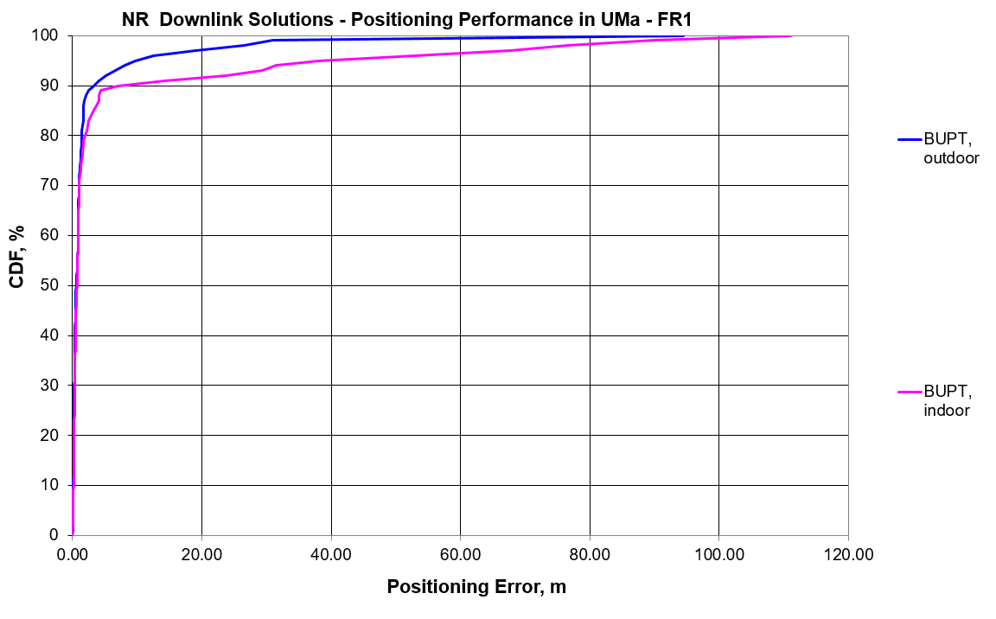

Figure 8.1.3.13-1: The CDF of Positioning error for scenario 3

Table 8.1.3.10-2: Results for downlink methods evaluations of Scenario 3 – Urban macro

|  |  |  |  |  |  |  |  |  |  |  |  |
| --- | --- | --- | --- | --- | --- | --- | --- | --- | --- | --- | --- |
| Percentile | 10 | 20 | 30 | 40 | 50 | 60 | 67 | 70 | 80 | 90 | 95 |
| Co-band TBS, outdoor | 0.13 | 0.22 | 0.27 | 0.37 | 0.58 | 0.84 | 0.94 | 1.02 | 1.43 | 3.24 | 9.65 |
| Co-band TBS, indoor | 0.14 | 0.23 | 0.32 | 0.46 | 0.68 | 0.85 | 1.00 | 1.02 | 1.92 | 7.01 | 38.00 |

#### 8.1.3.11 Results from [23]

The parameters corresponding to the results are listed in table 8.1.3.11-1 below.

Table 8.1.3.11-1 Parameters for Downlink evaluations in Scenario 3

|  |  |  |
| --- | --- | --- |
| Parameter | [23], FR1, 100 MHz | [23], FR1, 50 MHz |
| Channel model (baseline, otherwise state any modifications) | Baseline Channel Model based on common assumptions defined related to the channel models of 3GPP TRs 38.901 / 38.802 / 37.857. | |
| Carrier frequency | 4 GHz | |
| Subcarrier spacing | 30 KHz | 15 KHz |
| Reference Signal Transmission Bandwidth | 100 MHz | 50 MHz |
| Reference Signal Physical Structure and Resource Allocation (RE pattern) (reference to figure in contribution) | Comb-1 | |
| Reference signal (type of sequence, number of ports, …) | 1-port, QPSK sequence | |
| Number of sites | 19 (3-sector) | |
| Number of symbols used per occasion | 10 | |
| number of occasions used per positioning estimate | 10 | |
| Power-boosting level | 0 dB | |
| interference modelling (ideal muting, or other) | Ideal muting for DL | |
| Description of Measurement Algorithm (e.g. super resolution, interference cancellation, ….) | TOA estimation without oversampling with TOA pruning before the positioning engine using the ratio of the estimated TOA peak over the median of the Channel Energy Response (CER). | |
| Description of positioning technique / applied positioning algorithm (e.g. Least square, Taylor series, etc) | For DL-TDOA Pick the best between Taylor series, and Chan's Algorithm.  Chan's Algorithm according to:  Y. T. Chan, K. C. Ho, " A Simple and Efficient Estimator for Hyperbolic Location", IEEE Transactions on Signal Processing, vol. 42, pp. 1905-1915, Aug. 1994.  Taylor Series Algorithm:  W. H. Foy, " Position-Location Solutions by Taylor-Series Estimation", IEEE Transactions on Aerospace and Electronic Systems, vol. AES-12, pp. 187-194, March 1976.  Equal weight is used in the TOA covariance matrix. | |
| Network synchronization assumptions | Perfect Sync and Realistic Sync with T1 = 50 nsec | |
| Beam-related assumption (beam sweeping / alignment assumptions at the tx and rx sides) | The best beam pair is identified based on the criteria of receiving the earliest path given that the received power is larger than a threshold (20 dB lower than the maximum received power) using the genie CDL channel profiles. For a single sector scenario (only Indoor hotspop 4GHz), the directions of beams are within [, 180] degress in azimuth and [,180] degrees in zenith. For a 3-sector scenario, the directions of beams are within [, ] degress in azimuth and [,180] degrees in zenith. | |
| Precoding assumptions (codebook, nrof antenna elements used, etc) | Kronecker product between vertical and horizontal weight vectors taken from DFT, with oversampling factor = 1. The DFT beam candidate in beam selection method is generated according to the uniform vertical and horizontal angular distribution shown as follows:  , for i=1,…,rN  where r denotes the oversampling factor, N denotes the number of vertical/horizontal antennas. For FR1, Tx oversampling factor equals to 1. | |

The results corresponding to the UMa scenario are provided below

Table 8.1.3.11-2: Results for downlink methods evaluations of Scenario 3 – UMa Indoor UEs

|  |  |  |  |  |  |
| --- | --- | --- | --- | --- | --- |
| Percentile | 50 | 67 | 80 | 90 | 95 |
| DL-TDOA, FR1, 100 MHz, Perfect Sync | 14.7 | 25.2 | 42.9 | 69.2 | 102.3 |
| DL-TDOA, FR1, 100 MHz, Realistic Sync | 18 | 27.5 | 44.9 | 70.5 | 102.3 |
| DL-TDOA, FR1, 50 MHz, Perfect Sync | 11.8 | 17.9 | 31.5 | 52.9 | 65.4 |
| DL-TDOA, FR1, 50 MHz, Realistic Sync | 15.4 | 23.7 | 39.6 | 62 | 78.1 |

Table 8.1.3.11-3: Results for downlink methods evaluations of Scenario 3 – UMa Outdoor UEs

|  |  |  |  |  |  |
| --- | --- | --- | --- | --- | --- |
| Percentile | 50 | 67 | 80 | 90 | 95 |
| DL-TDOA, FR1, 100 MHz, Perfect Sync | 12.8 | 23.9 | 39.7 | 62.9 | 93.3 |
| DL-TDOA, FR1, 100 MHz, Realistic Sync | 15.7 | 26.3 | 40.9 | 65.1 | 97.8 |
| DL-TDOA, FR1, 50 MHz, Perfect Sync | 12.2 | 23.5 | 39.1 | 60.3 | 97.5 |
| DL-TDOA, FR1, 50 MHz, Realistic Sync | 15.3 | 23.4 | 41 | 62.5 | 97.8 |

#### 8.1.3.12 Results from [25]

The parameters corresponding to the results are listed in table 8.1.3.12-1 below.

Table 8.1.3.12-1: Parameters for downlink evaluations in Scenario 3

|  |  |  |  |  |
| --- | --- | --- | --- | --- |
| Parameter | Source 1 | Source 2 | Source 3 | Source 4 |
| Channel model (baseline, otherwise state any modifications) |  |  |  |  |
| Carrier frequency | 2GHz | 2GHz | 2GHz | 2GHz |
| Subcarrier spacing | 15khz | 15khz | 15khz | 15khz |
| Reference Signal Transmission Bandwidth | 10MHz | 50MHz | 50MHz | 50MHz |
| Reference Signal Physical Structure and Resource Allocation (RE pattern) (reference to figure in contribution) | TRS,comb 4, 9 occasions, 2 slot, 2 symbols per slot configuration | TRS,comb 4, 9 occasions, 2 slot, 2 symbols per slot configuration | Extended TRS: 9 occasions, 1 slot, 4 symbols per slot configuration | NR PRS: 3 occasions, 1 slot configuration, 12 symbols per slot |
| Reference signal (type of sequence, number of ports, …) | 1 port, TRS | 1 port, TRS | 1 port extended TRS | 1port PRS |
| Number of sites | 7 | 7 | 7 | 7 |
| Number of symbols used per occasion | 4 | 4 | 4 | 12 |
| number of occasions used per positioning estimate | 9 | 9 | 9 | 3 |
| Power-boosting level | 0 | 0 | 0 | 0 |
| Uplink power control (applied/not applied) |  |  |  |  |
| interference modelling (ideal muting, or other) | no interference | no interference | no interference | no interference |
| Description of Measurement Algorithm (e.g. super resolution, interference cancellation, ….) |  |  |  |  |
| Description of positioning technique / applied positioning algorithm (e.g. Least square, Taylor series, etc) | DL-TDOA | DL-TDOA | DL-TDOA | DL-TDOA |
| Network synchronization assumptions | no error | no error | no error | no error |
| Beam-related assumption (beam sweeping / alignment assumptions at the tx and rx sides) | N/A | N/A | N/A | N/A |
| Precoding assumptions (codebook, nrof antenna elements used, etc) | horizontal wide beam with same pattern in Table 6.1.1-3. vertical pattern as shown in R1-1901198 | horizontal wide beam with same pattern in Table 6.1.1-3. vertical pattern as shown in R1-1901198 | horizontal wide beam with same pattern in Table 6.1.1-3. vertical pattern as shown in R1-1901198 | horizontal wide beam with same pattern in Table 6.1.1-3. vertical pattern as shown in R1-1901198 |
| Additional notes, if any |  |  |  |  |

In this section, simulation results for urban macro scenario for FR1 is reported.

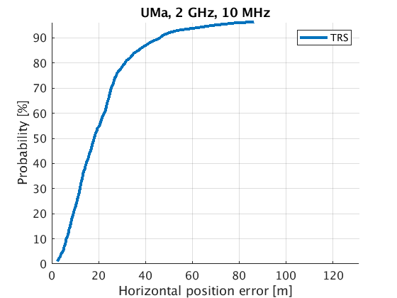

Figure 8.1.3.12-1: Positioning accuracy in urban macro scenario.

Table 8.1.3.12-2: Positioning accuracy summary of FR1,2 GHz, 10 MHz TRS in urban macro scenario.

|  |  |  |  |  |
| --- | --- | --- | --- | --- |
| Bandwidth configuration | 50% (m) | 67% (m) | 80% (m) | 90%  (m) |
| 2 GHz, 10 MHz | 18.08 | 24.59 | 31.29 | 46.15 |

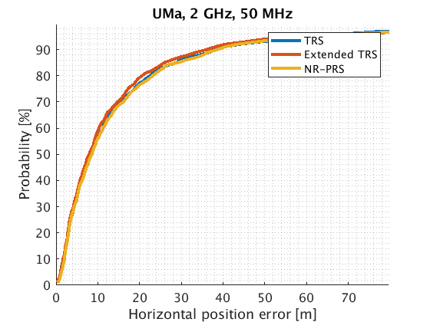

Figure 8.1.3.12-2: Positioning accuracy in FR1, 2 GHz, in urban macro scenario.

Table 8.1.3.12-3: Positioning accuracy summary in urban macro scenario.

|  |  |  |  |  |
| --- | --- | --- | --- | --- |
| Bandwidth configuration | 50% TRS/Extended TRS/ NR PRS (m) | 67% TRS/Extended TRS/ NR PRS (m) | 80% TRS/Extended TRS/ NR PRS  (m) | 90% TRS/Extended TRS/ NR PRS  (m) |
| 2 GHz, 50 MHz | 8.225/7.913/8.558 | 13.74/13.07/14.05 | 22.48/20.58/23.13 | 38.09/36.01/38.72 |

## 8.2 Uplink evaluations

### 8.2.1 System simulations for Scenario 1 – Indoor Office

#### 8.2.1.1 Results from [10]

Table 8.2.1.1-1: Parameters details for FR1 from [10]

|  |  |  |  |  |  |  |  |  |
| --- | --- | --- | --- | --- | --- | --- | --- | --- |
| Parameter | Case 1 InH, FR1 | Case 2 InH, FR1 | Case 3 InH, FR1 | Case 4 InH, FR1 | Case 5 InH, FR1 | Case 6 InH, FR1 | Case 7 InH, FR1 | Case 8 InH, FR1 |
| Channel model (baseline, otherwise state any modifications) | 38.901 | 38.901 | 38.901 | 38.901 | 38.901 | 38.901 | 38.901 | 38.901 |
| Carrier frequency | 4GHz | 4GHz | 2GHz | 2GHz | 4GHz | 4GHz | 2GHz | 2GHz |
| Subcarrier spacing | 30kHz | 15kHz | 15kHz | 15kHz | 30kHz | 15kHz | 15kHz | 15kHz |
| Reference Signal Transmission Bandwidth | 100MHz | 50MHz | 50MHz | 5MHz | 100MHz | 50MHz | 50MHz | 5MHz |
| Reference Signal Physical Structure and Resource Allocation (RE pattern) (reference to figure in contribution) | Comb-4 | Comb-4 | Comb-4 | Comb-4 | Comb-4 | Comb-4 | Comb-4 | Comb-4 |
| Reference signal (type of sequence, number of ports, …) | SRS: ZC, 1-port | SRS: ZC, 1-port | SRS: ZC, 1-port | SRS: ZC, 1-port | SRS: ZC, 1-port | SRS: ZC, 1-port | SRS: ZC, 1-port | SRS: ZC, 1-port |
| Number of sites | 12 | 12 | 12 | 12 | 12 | 12 | 12 | 12 |
| Number of symbols used per occasion | 4 | 4 | 4 | 4 | 4 | 4 | 4 | 4 |
| number of occasions used per positioning estimate | 4 | 4 | 4 | 4 | 4 | 4 | 4 | 4 |
| Power-boosting level | 6dB | 6dB | 6dB | 6dB | 6dB | 6dB | 6dB | 6dB |
| Uplink power control (applied/not applied) | Not applied | Not applied | Not applied | Not applied | Not applied | Not applied | Not applied | Not applied |
| interference modelling (ideal muting, or other) | Ideal muting | Ideal muting | Ideal muting | Ideal muting | Ideal muting | Ideal muting | Ideal muting | Ideal muting |
| Description of Measurement Algorithm (e.g. super resolution, interference cancellation, ….) | Regular | Regular | Regular | Regular | Super resolution | Super resolution | Super resolution | Super resolution |
| Description of positioning technique / applied positioning algorithm (e.g. Least square, Taylor series, etc) | UL-TDOA, Chan's algorithm | UL-TDOA, Chan's algorithm | UL-TDOA, Chan's algorithm | UL-TDOA, Chan's algorithm | UL-TDOA, Chan's algorithm | UL-TDOA, Chan's algorithm | UL-TDOA, Chan's algorithm | UL-TDOA, Chan's algorithm |
| Network synchronization assumptions | No sync error | No sync error | No sync error | No sync error | No sync error | No sync error | No sync error | No sync error |
| Beam-related assumption (beam sweeping / alignment assumptions at the tx and rx sides) | N/A | N/A | N/A | N/A | N/A | N/A | N/A | N/A |
| Precoding assumptions (codebook, nrof antenna elements used, etc) | SVD | SVD | SVD | SVD | SVD | SVD | SVD | SVD |
| Additional notes, if any |  |  |  |  |  |  |  |  |

Table 8.2.1.1-2: Parameters details for FR1 from [10]

|  |  |  |  |  |  |  |  |  |
| --- | --- | --- | --- | --- | --- | --- | --- | --- |
| Parameter | Case 9 InH, FR1 | Case 10 InH, FR1 | Case 11 InH, FR1 | Case 12 InH, FR1 | Case 13 InH, FR1 | Case 14 InH, FR1 | Case 15 InH, FR1 | Case 16 InH, FR1 |
| Channel model (baseline, otherwise state any modifications) | 38.901 | 38.901 | 38.901 | 38.901 | 38.901 | 38.901 | 38.901 | 38.901 |
| Carrier frequency | 4GHz | 4GHz | 2GHz | 2GHz | 4GHz | 4GHz | 2GHz | 2GHz |
| Subcarrier spacing | 30kHz | 15kHz | 15kHz | 15kHz | 30kHz | 15kHz | 15kHz | 15kHz |
| Reference Signal Transmission Bandwidth | 100MHz | 50MHz | 50MHz | 5MHz | 100MHz | 50MHz | 50MHz | 5MHz |
| Reference Signal Physical Structure and Resource Allocation (RE pattern) (reference to figure in contribution) | Comb-4 | Comb-4 | Comb-4 | Comb-4 | Comb-4 | Comb-4 | Comb-4 | Comb-4 |
| Reference signal (type of sequence, number of ports, …) | SRS: ZC, 1-port | SRS: ZC, 1-port | SRS: ZC, 1-port | SRS: ZC, 1-port | SRS: ZC, 1-port | SRS: ZC, 1-port | SRS: ZC, 1-port | SRS: ZC, 1-port |
| Number of sites | 12 | 12 | 12 | 12 | 12 | 12 | 12 | 12 |
| Number of symbols used per occasion | 4 | 4 | 4 | 4 | 4 | 4 | 4 | 4 |
| number of occasions used per positioning estimate | 4 | 4 | 4 | 4 | 4 | 4 | 4 | 4 |
| Power-boosting level | 6dB | 6dB | 6dB | 6dB | 6dB | 6dB | 6dB | 6dB |
| Uplink power control (applied/not applied) | Not applied | Not applied | Not applied | Not applied | Not applied | Not applied | Not applied | Not applied |
| interference modelling (ideal muting, or other) | Ideal muting | Ideal muting | Ideal muting | Ideal muting | Ideal muting | Ideal muting | Ideal muting | Ideal muting |
| Description of Measurement Algorithm (e.g. super resolution, interference cancellation, ….) | Regular | Regular | Regular | Regular | Regular | Regular | Regular | Regular |
| Description of positioning technique / applied positioning algorithm (e.g. Least square, Taylor series, etc) | UL-TDOA, Chan's algorithm | UL-TDOA, Chan's algorithm | UL-TDOA, Chan's algorithm | UL-TDOA, Chan's algorithm | UAOA, PSO algorithm | UAOA, PSO algorithm | UAOA, PSO algorithm | UAOA, PSO algorithm |
| Network synchronization assumptions | Sync error 50ns | Sync error 50ns | Sync error 50ns | Sync error 50ns | No sync error | No sync error | No sync error | No sync error |
| Beam-related assumption (beam sweeping / alignment assumptions at the tx and rx sides) | N/A | N/A | N/A | N/A | N/A | N/A | N/A | N/A |
| Precoding assumptions (codebook, nrof antenna elements used, etc) | SVD | SVD | SVD | SVD | SVD | SVD | SVD | SVD |
| Additional notes, if any |  |  |  |  |  |  |  |  |

Table 8.2.1.1-3: Parameters details for FR2 from [10]

|  |  |  |  |  |  |  |
| --- | --- | --- | --- | --- | --- | --- |
| Parameter | Case 17 InH, FR2 | Case 18 InH FR2 | Case 19 InH, FR2 | Case 20 InH FR2 | Case 21 InH FR2 | Case 22 InH FR2 |
| Channel model (baseline, otherwise state any modifications) | 38.901 | 38.901 | 38.901 | 38.901 | 38.901 | 38.901 |
| Carrier frequency | 30GHz | 30GHz | 30GHz | 30GHz | 30GHz | 30GHz |
| Subcarrier spacing | 120kHz | 120kHz | 120kHz | 120kHz | 120kHz | 120kHz |
| Reference Signal Transmission Bandwidth | 100MHz | 400MHz | 100MHz | 400MHz | 100MHz | 400MHz |
| Reference Signal Physical Structure and Resource Allocation (RE pattern) (reference to figure in contribution) | Comb-4 | Comb-4 | Comb-4 | Comb-4 | Comb-4 | Comb-4 |
| Reference signal (type of sequence, number of ports, …) | SRS: ZC, 1-port | SRS: ZC, 1-port | SRS: ZC, 1-port | SRS: ZC, 1-port | SRS: ZC, 1-port | SRS: ZC, 1-port |
| Number of sites | 12 | 12 | 12 | 12 | 12 | 12 |
| Number of symbols used per occasion | 4 | 4 | 4 | 4 | 4 | 4 |
| number of occasions used per positioning estimate | 4 | 4 | 4 | 4 | 4 | 4 |
| Power-boosting level | 6dB | 6dB | 6dB | 6dB | 6dB | 6dB |
| Uplink power control (applied/not applied) | Not applied | Not applied | Not applied | Not applied | Not applied | Not applied |
| interference modelling (ideal muting, or other) | Ideal muting | Ideal muting | Ideal muting | Ideal muting | Ideal muting | Ideal muting |
| Description of Measurement Algorithm (e.g. super resolution, interference cancellation, ….) | Regular | Regular | Regular | Regular | Regular | Regular |
| Description of positioning technique / applied positioning algorithm (e.g. Least square, Taylor series, etc) | UL-TDOA, Tylor expansion | UL-TDOA, Tylor expansion | UL-TDOA, Tylor expansion | UL-TDOA, Tylor expansion | ML estimation based on PDP | ML estimation based on PDP |
| Network synchronization assumptions | Sync error 0ns | Sync error 0ns | Sync error 50ns | Sync error 50ns | Sync error 0ns | Sync error 0ns |
| Beam-related assumption (beam sweeping / alignment assumptions at the tx and rx sides) | BPL with Largest RSRP | BPL with Largest RSRP | BPL with Largest RSRP | BPL with Largest RSRP | 8 TX-beam sweeping, RX beam in the largest RSRP BPL | 8 TX-beam sweeping, RX beam in the largest RSRP BPL |
| Precoding assumptions (codebook, nrof antenna elements used, etc) | DFT codebook | DFT codebook | DFT codebook | DFT codebook | DFT codebook | DFT codebook |
| Additional notes, if any |  |  |  |  |  |  |

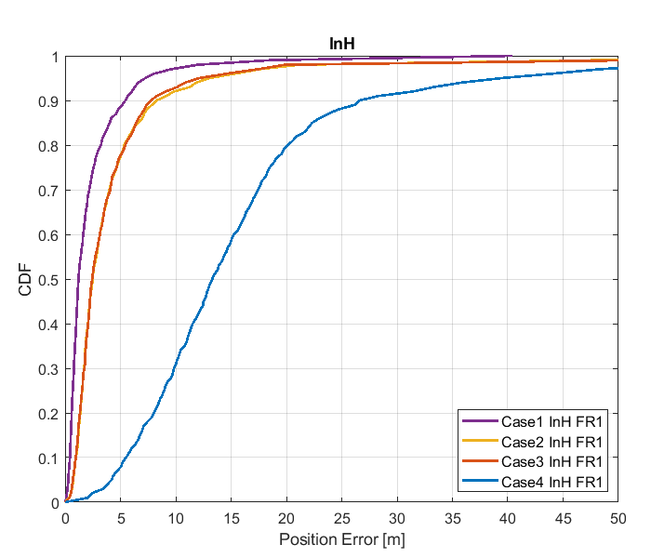

Figure 8.2.1.1-1: Results for FR1 from [10]

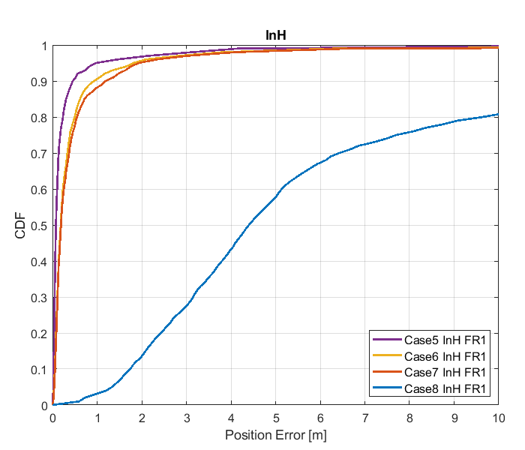

Figure 8.2.1.1-2: Results for FR1 from [10]

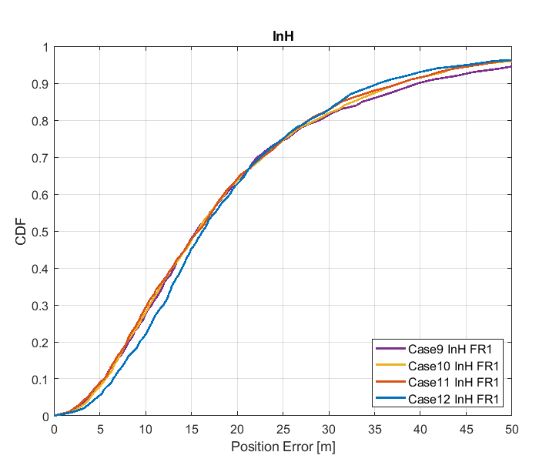

Figure 8.2.1.1-3: Results for FR1 from [10]

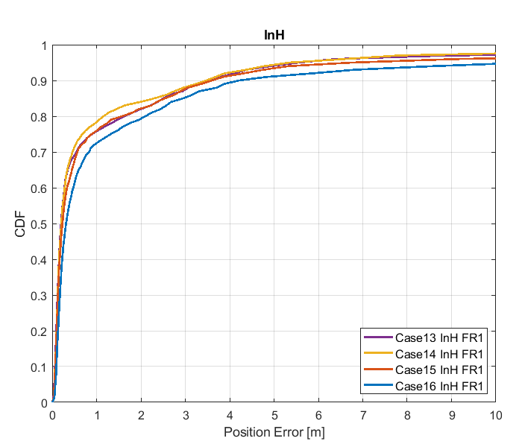

Figure 8.2.1.1-4: Results for FR1 from [10]

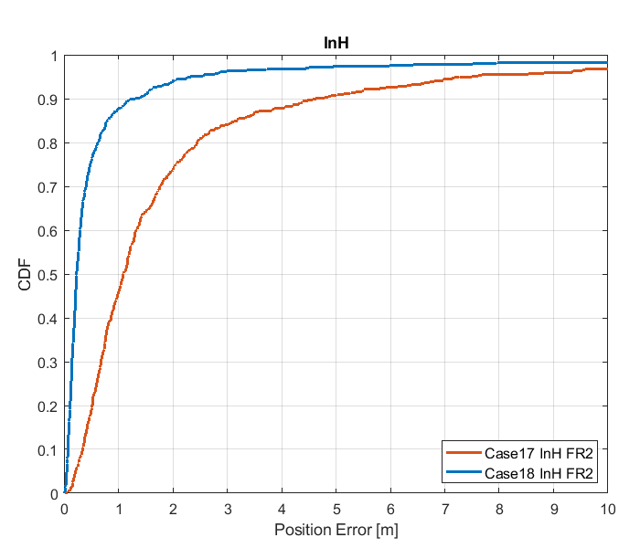

Figure 8.2.1.1-5 Results for FR2 from [10]

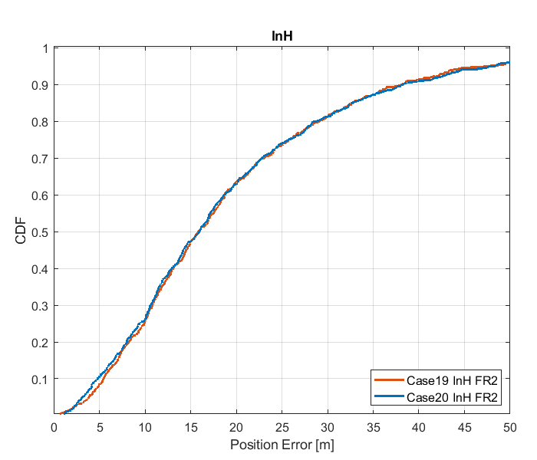

Figure 8.2.1.1-6: Results for FR2 from [10]

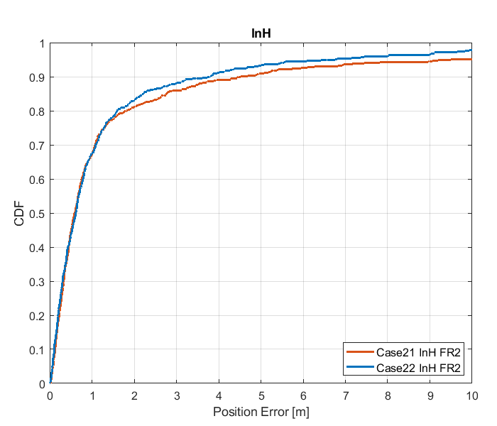

Figure 8.2.1.1-7: Results for FR2 from [10]

Table 8.2.1.1-4: Results for FR1 from [10]

|  |  |  |  |  |  |  |
| --- | --- | --- | --- | --- | --- | --- |
|  |  | Source | 50% | 67% | 80% | 90% |
| FR1 | InH | Case 1 InH FR1 | 1.2 | 2.0 | 3.3 | 5.5 |
| Case 2 InH FR1 | 2.5 | 3.7 | 5.3 | 8.3 |
| Case 3 InH FR1 | 2.5 | 3.7 | 5.5 | 7.8 |
| Case 4 InH FR1 | 13.4 | 17.0 | 20.4 | 28.1 |
| Case 5 InH FR1 | 0.08 | 0.1 | 0.2 | 0.5 |
| Case 6 InH FR1 | 0.2 | 0.3 | 0.5 | 0.9 |
| Case 7 InH FR1 | 0.2 | 0.3 | 0.5 | 1.2 |
| Case 8 InH FR1 | 4.4 | 6.0 | 9.6 | 18.3 |
| Case 9 InH FR1 | 15.6 | 21.3 | 29.0 | 39.9 |
| Case 10 InH FR1 | 15.7 | 21.4 | 28.6 | 37.9 |
| Case 11 InH FR1 | 15.8 | 21.4 | 27.8 | 37.8 |
| Case 12 InH FR1 | 16.6 | 21.9 | 29.4 | 38.7 |
| Case 13 InH FR1 | 0.2 | 0.4 | 1.6 | 3.5 |
| Case 14 InH FR1 | 0.2 | 0.4 | 1.6 | 3.5 |
| Case 15 InH FR1 | 0.2 | 0.5 | 1.6 | 3.6 |
| Case 16 InH FR1 | 0.3 | 0.7 | 2.1 | 4.2 |

Table 8.2.1.1-5: Results for FR2 from [10]

|  |  |  |  |  |  |  |
| --- | --- | --- | --- | --- | --- | --- |
|  |  | Source | 50% | 67% | 80% | 90% |
| FR2 | InH | Case 17 InH FR2 | 1.1 | 1.7 | 2.4 | 4.6 |
| Case 18 InH FR2 | 0.2 | 0.4 | 0.6 | 1.3 |
| Case 19 InH FR2 | 15.8 | 21.7 | 29.1 | 38.0 |
| Case 20 InH FR2 | 15.9 | 21.7 | 28.6 | 38.3 |
| Case 21 InH FR2 | 0.6 | 1.0 | 1.8 | 4.5 |
| Case 22 InH FR2 | 0.6 | 1.0 | 1.6 | 3.8 |

#### 8.2.1.2 Results from [11]

The parameters corresponding to the results are listed in table 8.2.1.2-1 below.

Table 8.2.1.2-1: Parameters for UL-TDOA evaluations

|  |  |
| --- | --- |
| Parameter | R1-1901717 |
| Channel model (baseline, otherwise state any modifications) | baseline |
| Carrier frequency | 4 GHz for FR1  30 GHz for FR2 |
| Subcarrier spacing | 30 kHz for FR1  120 kHz for FR2 |
| Reference Signal Transmission Bandwidth | 100 MHz for FR1  400 MHz for FR2 |
| Reference Signal Physical Structure and Resource Allocation (RE pattern) (reference to figure in contribution) | SRS  comb-4 frequency structure  4 symbols within a slot  No sequence/group/frequency hopping |
| Reference signal (type of sequence, number of ports, …) | 1 port, ZC sequence |
| Number of sites | 5 |
| Number of symbols used per occasion | 4 |
| number of occasions used per positioning estimate | 1 |
| Power-boosting level | 6 dB |
| Uplink power control (applied/not applied) | not applied |
| interference modelling (ideal muting, or other) | No interference |
| Description of Measurement Algorithm (e.g. super resolution, interference cancellation, ….) | Threshold-based ToA estimation method |
| Description of positioning technique / applied positioning algorithm (e.g. Least square, Taylor series, etc) | CHAN algorithm |
| Network synchronization assumptions | Perfect/50ns |
| Beam-related assumption (beam sweeping / alignment assumptions at the tx and rx sides) | alignment assumptions at the tx and rx sides |
| Precoding assumptions (codebook, nrof antenna elements used, etc) | N/A |
| UE type | Indoor UEs for Indoor open office |
| Additional notes, if any | only LOS path to calculate ToA |

The results corresponding to the Indoor open office scenario are provided below.



Figure. 8.2.1.2.-1 CDF curve of positioning for UL-TDOA evaluations of Indoor open office: FR1 (left) and FR2 (right)

Table 8.2.1.2-2: Accuracy results (m) for UL-TDOA evaluations of Indoor open office

|  |  |  |  |  |  |
| --- | --- | --- | --- | --- | --- |
| Percentile | | 50% | 67% | 80% | 90% |
| FR1 100M | Perfect sync | 1.4 | 1.9 | 3.2 | 5.8 |
| Sync. error 50ns | 17 | 22 | 27 | 41 |
| FR2 400M | Perfect sync | 0.31 | 0.48 | 0.68 | 1.1 |
| Sync. error 50ns | 14 | 19 | 22 | 30 |

#### 8.2.1.3 Results from [14]

The parameters corresponding to the results are listed in table 8.2.1.3-1 below.

Table 8.2.1.3-1: Parameters for Uplink evaluations in Scenario 1

|  |  |
| --- | --- |
| Parameter | [[14], FR1] |
| Channel model (baseline, otherwise state any modifications) | Baseline |
| Carrier frequency | 4GHz |
| Subcarrier spacing | 15kHz, 30KHz |
| Reference Signal Transmission Bandwidth | 5MHz, 100MHz |
| Reference Signal Physical Structure and Resource Allocation (RE pattern) (reference to figure in contribution) | NR SRS Comb-2 [66] |
| Reference signal (type of sequence, number of ports, …) | 1 TX port |
| Number of sites | 12 |
| Number of symbols used per occasion | 2 |
| number of occasions used per positioning estimate | 1 |
| Power-boosting level | 10*log10(2) |
| Uplink power control (applied/not applied) | N/A |
| interference modelling (ideal muting, or other) | Perfect muting |
| Description of Measurement Algorithm (e.g. super resolution, interference cancellation, ….) | Both no threshold and threshold of 0.5 at the UE |
| Description of positioning technique / applied positioning algorithm (e.g. Least square, Taylor series, etc) | Sectorized beams in RX Omni-direction in TX |
| Network synchronization assumptions | Perfect synchronization |
| Beam-related assumption (beam sweeping / alignment assumptions at the tx and rx sides) | N/A |
| Precoding assumptions (codebook, nrof antenna elements used, etc) | N/A |
| Additional notes, if any |  |

The results corresponding to the Indoor open office scenario are provided below

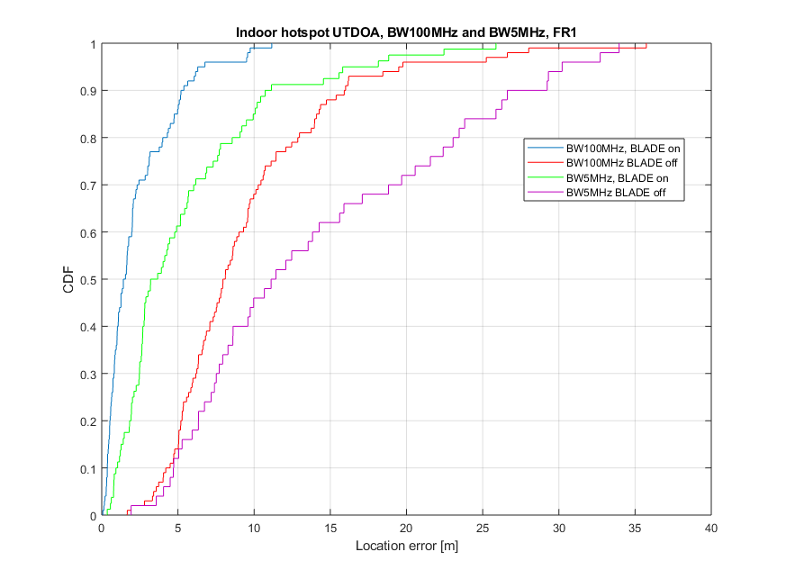

Figure 8.2.1.3-1

Table8.2.1.3-2: Results for uplink methods evaluations of Scenario 1 – Indoor Open Office

|  |  |  |  |  |
| --- | --- | --- | --- | --- |
| Percentile | 50 | 67 | 80 | 90 |
| UL-TDOA, FR1, 5 MHz, without ULADE | 11.43 | 18.82 | 23.06 | 26.62 |
| UL-TDOA, FR1, 100 MHz, without BLADE | 7.95 | 9.74 | 12.86 | 16.01 |
| UL-TDOA, FR1, 5 MHz, with BLADE | 3.2 | 5.66 | 9.08 | 10.72 |
| UL-TDOA, FR1, 100 MHz, with BLADE | 1.55 | 2.2 | 4.3 | 5.19 |

#### 8.2.1.4 Results from [19]

The parameters used for evaluation of the UL based positioning in Scenario 1 (Indoor Open Office) are listed in Table 8.2.1.4-1 below.

Table 8.2.1.4-1: Parameters for Uplink evaluations in Scenario 1

|  |  |  |  |
| --- | --- | --- | --- |
| Parameter | Setup 1 | Setup 2 | Setup 3 |
| Channel model (baseline, otherwise state any modifications) | Baseline | Baseline | Baseline |
| Carrier frequency | 4 GHz | 4 GHz | 30 GHz |
| Subcarrier spacing | 15 kHz | 30 kHz | 120 kHz |
| Reference Signal Transmission Bandwidth | 5 MHz | 100 MHz | 100 MHz |
| Reference Signal Physical Structure and Resource Allocation (RE pattern) (reference to figure in contribution) | 4 REs per PRB, 4 symbols | 4 REs per PRB, 4 symbols | 4 REs per PRB, 4 symbols |
| Reference signal (type of sequence, number of ports, …) | QPSK, Pseudo random, single Tx port | QPSK, Pseudo random, single Tx port | QPSK, Pseudo random, single Tx port |
| Number of sites | 12 sectors / 12 sites | 12 sectors / 12 sites | 36 sectors / 12 sites |
| Number of symbols used per occasion | 4(symb)xUE number | 4(symb)xUE number | 4(symb)x8(beams)xUE number |
| Number of occasions used per positioning estimate | 1 | 1 | 1 |
| Power-boosting level | 6 dB | 6 dB | 6 dB |
| Uplink power control (applied/not applied) | Max power | Max power | Max power |
| Interference modelling (ideal muting, or other) | Ideal muting | Ideal muting | Ideal muting |
| Description of Measurement Algorithm (e.g. super resolution, interference cancellation, ….) | Threshold based algorithm for the first arrival path (FAP) estimation | Threshold based algorithm for the first arrival path (FAP) estimation  MUSIC based algorithm for the angle of arrival (AoA) estimation | Threshold based algorithm for the first arrival path (FAP) estimation |
| Description of positioning technique / applied positioning algorithm (e.g. Least square, Taylor series, etc) | Taylor based, measurements above -15 dB are used for positioning | Taylor based, measurements above -15 dB are used for positioning | Taylor based, measurements above -15 dB are used for positioning |
| Network synchronization assumptions | Option 1: T1 = 0ns(Perfect)  Option 2: T1 = 50ns | Option 1: T1 = 0ns(Perfect)  Option 2: T1 = 50ns | Option 1: T1 = 0ns(Perfect)  Option 2: T1 = 50ns |
| Beam-related assumption (beam sweeping / alignment assumptions at the tx and rx sides) | No sweeping | No sweeping | Rx sweeping |
| Precoding assumptions (codebook, nrof antenna elements used, etc) | Single Tx port | Single Tx port | Single Tx port |
| Additional notes, if any |  |  |  |

The system level evaluation results for UL positioning in Scenario 1 (Indoor Open Office) are provided below.

|  |
| --- |
| Figure 8.2.1.4-1 (a) FR1 evaluations    Figure 8.2.1.4-2 (b) FR2 evaluations |

#### 8.2.1.5 Results from [23]

The parameters corresponding to the results are listed in table 8.2.1.5-1 below.

Table 8.2.1.5-1: Parameters for Uplink evaluations in Scenario 1

|  |  |  |  |  |  |
| --- | --- | --- | --- | --- | --- |
| Parameter | [23], FR1, 100 MHz | [23], FR1, 50 MHz | [23], FR1, 5 MHz | [23], FR2, 400 MHz | [23], FR2, 100 MHz |
| Channel model (baseline, otherwise state any modifications) | Baseline Channel Model based on common assumptions defined related to the channel models of 3GPP TRs 38.901 / 38.802 / 37.857. | | | | |
| Carrier frequency | 4 GHz | | | 30 GHz | |
| Subcarrier spacing | 30 KHz | 15 KHz | 15 KHz | 120 KHz | |
| Reference Signal Transmission Bandwidth | 100 MHz | 50 MHz | 5 MHz | 400 MHz | 100 MHz |
| Reference Signal Physical Structure and Resource Allocation (RE pattern) (reference to figure in contribution) | Comb-1 with 1-symbol PRS resource | | | | |
| Reference signal (type of sequence, number of ports, …) | 1-port, QPSK sequence | | | | |
| Number of sites | 12 | | | | |
| Number of symbols used per occasion | 1 | | | | |
| number of occasions used per positioning estimate | 1 | | | | |
| Power-boosting level | 0 dB | | | | |
| Uplink power control (applied/not applied) | Not applied (23 dBm Tx) | | | | |
| interference modelling (ideal muting, or other) | Interference from 4 UEs | | | | |
| Description of Measurement Algorithm (e.g. super resolution, interference cancellation, ….) | TOA estimation without oversampling with TOA pruning before the positioning engine using the ratio of the estimated TOA peak over the median of the Channel Energy Response (CER). | | | | |
| Description of positioning technique / applied positioning algorithm (e.g. Least square, Taylor series, etc) | For UL-TDOA Pick the best between Taylor series, and Chan's Algorithm.  Chan's Algorithm according to:  Y. T. Chan, K. C. Ho, " A Simple and Efficient Estimator for Hyperbolic Location", IEEE Transactions on Signal Processing, vol. 42, pp. 1905-1915, Aug. 1994.  Taylor Series Algorithm:  W. H. Foy, " Position-Location Solutions by Taylor-Series Estimation", IEEE Transactions on Aerospace and Electronic Systems, vol. AES-12, pp. 187-194, March 1976.  For UL-TDOA+AoA, the algorithm presented in the following paper is used:  Chunhua Yang, Yi Huang and Xu Zhu, 'HYBRID TDOA/AOA METHOD FOR INDOOR POSITIONING SYSTEMS', IEEE Sig. Proc. Letters, Vol23, issue 1, 2016  Equal weight is used in the TOA covariance matrix. | | | | |
| Network synchronization assumptions | Perfect Sync and Realistic Sync with T1 = 50 nsec | | | | |
| Beam-related assumption (beam sweeping / alignment assumptions at the tx and rx sides) | The best beam pair is identified based on the criteria of receiving the earliest path given that the received power is larger than a threshold (20 dB lower than the maximum received power) using the genie CDL channel profiles. For a single sector scenario (only Indoor hotspop 4GHz), the directions of beams are within [, 180] degress in azimuth and [,180] degrees in zenith. For a 3-sector scenario, the directions of beams are within [, ] degress in azimuth and [,180] degrees in zenith. | | | | |
| Precoding assumptions (codebook, nrof antenna elements used, etc) | Kronecker product between vertical and horizontal weight vectors taken from DFT, with oversampling factor = 1. The DFT beam candidate in beam selection method is generated according to the uniform vertical and horizontal angular distribution shown as follows:  , for i=1,…,rN  where r denotes the oversampling factor, N denotes the number of vertical/horizontal antennas. For FR2, Tx oversampling factor r equals to 2 and Rx oversampling factor equals to 1. For FR1, Tx oversampling factor for 100 MHz is 4, for 50 MHz is 1, for 5 MHz is 1. | | | | |

The results corresponding to the Indoor open office scenario are provided below

Table 8.2.1.5-2: Results for Uplink methods evaluations of Scenario 1 – Indoor Open Office

|  |  |  |  |  |  |
| --- | --- | --- | --- | --- | --- |
| Percentile | 50 | 67 | 80 | 90 | 95 |
| UL-TDOA, FR1, 100 MHz, Perfect Sync | 1.2 | 1.6 | 2.3 | 3.7 | 5.5 |
| UL-TDOA, FR1, 100 MHz, Realistic Sync | 12 | 17.3 | 25.9 | 43.3 | 58.2 |
| UL-TDOA, FR1, 50 MHz, Perfect Sync | 4.8 | 7.7 | 12.6 | 26.9 | 48.9 |
| UL-TDOA, FR1, 50 MHz, Realistic Sync | 11.8 | 17.7 | 26.2 | 48.1 | 64.9 |
| UL-TDOA, FR1, 5 MHz, Perfect Sync | 13.2 | 18.5 | 29.1 | 50.9 | 66.2 |
| UL-TDOA, FR1, 5 MHz, Realistic Sync | 16.3 | 24.3 | 37.4 | 56.6 | 70 |
| UL-TDOA, FR2, 400 MHz, Perfect Sync | 0.4 | 0.7 | 1.5 | 4.2 | 9.5 |
| UL-TDOA, FR2, 400 MHz, Realistic Sync | 12.2 | 17.3 | 25.3 | 41 | 56 |
| UL-TDOA, FR2, 100 MHz, Perfect Sync | 1.2 | 1.9 | 3 | 5.6 | 10.2 |
| UL-TDOA, FR2, 100 MHz, Realistic Sync | 12.3 | 17,5 | 25.3 | 41.1 | 56.8 |
| UL-TDOA+AoD, FR2, 400 MHz, Perfect Sync | 0.3 | 0.4 | 1 | 2.5 | 6.5 |
| UL-TDOA+AoD, FR2, 400 MHz, Realistic Sync | 10.5 | 15.8 | 23.4 | 36 | 47.7 |
| UL-TDOA+AoD, FR2, 100 MHz, Perfect Sync | 0.7 | 1 | 1.5 | 2.8 | 5.1 |
| UL-TDOA+AoD, FR2, 100 MHz, Realistic Sync | 11.9 | 18 | 26.3 | 41.1 | 53.3 |

#### 8.2.1.6 Results from [24]

Table 8.2.1.6-1: Parameters for Uplink evaluations in Scenario 1

|  |  |
| --- | --- |
| Parameter | InH, FR1 |
| Channel model (baseline, otherwise state any modifications) | Mixed and Open office according to TR38.901 |
| Carrier frequency | 4 GHz |
| Subcarrier spacing | 15 kHz for 5 MHz  15 kHz for 50 MHz  30 kHz for 100 MHz |
| Reference Signal Transmission Bandwidth | 5, 50 and 100MHz |
| Reference signal (type of sequence, number of ports, …) | SRS, 1 antenna port, comb 2 structure |
| Number of sites | 12 |
| Number of symbols used per occasion | 1 |
| number of occasions used per positioning estimate | 1 |
| Power-boosting level | No boosting |
| Uplink power control (applied/not applied) | Alpha = 0, P0 = 10dBm |
| interference modelling (ideal muting, or other) | No interference |
| Description of Measurement Algorithm (e.g. super resolution, interference cancellation, ….) | Detect the first peak up to 9dB below the maximum peak. An interpolation factor of 10 is applied to the cross-correlation. The TOA is estimated based on the inflection point of the rising edge of the first detected peak. |
| Description of positioning technique / applied positioning algorithm (e.g. Least squares, Taylor series, etc) | Least squares |
| Network synchronization assumptions | Perfectly synchronized |
| Beam-related assumption (beam sweeping / alignment assumptions at the tx and rx sides) | Beam selection: Assign UEs to the best gNB with respect to the RSRP (at gNB: rx side). |
| Precoding assumptions (codebook, nrof antenna elements used, etc) | TXRU virtualization:  2 TXRU per dimension per polarization.  M_TXRU = 2, N_TXRU = 2  Analog beamforming for (gNB and UE):  weights are obtained by taking the Kronecker product of the vertical and horizontal weight vectors as described in 2D sub-array partition model in TR 36.897 |
| Additional notes, if any | TOAs are filtered based on the measurement quality before applying them in positioning. |

Table 8.2.1.6-1: Results from [24]

|  |  |  |  |  |  |  |
| --- | --- | --- | --- | --- | --- | --- |
|  |  | 50% | 70% | 80% | 90% | 95% |
| **UL-TDOA** | **InH Open Office** | | | | | |
| 4 GHz/30 kHz/100 MHz | 0.53 m | 0.59 m | 0.67 m | 0.88 m | 1.40 m |
| 4 GHz/15 kHz/50 MHz | 0.61 m | 0.77 m | 1.03 m | 1.69 m | 2.78 m |
| 4 GHz/15 kHz/5 MHz | 3.44 m | 4.59 m | 6.03 m | 11.99 m | 20.19 m |
| **InH Mixed Office** | | | | | |
| 4 GHz/30 kHz/100 MHz | 1.21 m | 1.92 m | 2.83 m | 5.47 m | 8.41 m |
| 4 GHz/15 kHz/50 MHz | 1.47 m | 2.14 m | 3.08 m | 5.30 m | 8.50 m |
| 4 GHz/15 kHz/5 MHz | 6.19 m | 8.93 m | 11.29 m | 21.06 m | 79.70 m |



Figure 8.2.1.6-1: FR1 UL-TDOA 2D positioning error for mixed office scenario for 5, 50, 100 MHz SRS configurations



Figure 8.2.1.6-2: FR1 UL-TDOA 2D positioning error for open office scenario for 5, 50, 100 MHz SRS configurations

#### 8.2.1.7 Results from [25]

The parameters corresponding to the results are listed in table 8.2.1.7-1 below.

Table 8.2.1.7-1: Parameters for Uplink evaluations in Scenario 1

|  |  |
| --- | --- |
| Parameter | Source 1 |
| Channel model (baseline, otherwise state any modifications) | IOO FR1 |
| Carrier frequency | 2GHz |
| Subcarrier spacing | 15kHz |
| Reference Signal Transmission Bandwidth | 50MHz |
| Reference Signal Physical Structure and Resource Allocation (RE pattern) (reference to figure in contribution) | UL SRS, 4 symbols per slot,1 slot, 9 occasions |
| Reference signal (type of sequence, number of ports, …) | UL SRS, 1 port |
| Number of sites |  |
| Number of symbols used per occasion | 4 |
| number of occasions used per positioning estimate | 9 |
| Power-boosting level | 0 |
| Uplink power control (applied/not applied) |  |
| interference modelling (ideal muting, or other) |  |
| Description of Measurement Algorithm (e.g. super resolution, interference cancellation, ….) |  |
| Description of positioning technique / applied positioning algorithm (e.g. Least square, Taylor series, etc) | UL-TDOA |
| Network synchronization assumptions | No error |
| Beam-related assumption (beam sweeping / alignment assumptions at the tx and rx sides) | N/A |
| Precoding assumptions (codebook, nrof antenna elements used, etc) |  |
| Additional notes, if any |  |

The results corresponding to the Indoor open office scenario are provided below

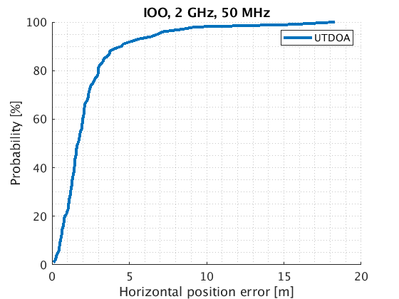

Figure 8.2.1.7-1: Positioning error FR1, 2 GHz, in indoor open office scenario using SRS in UL.

Table 8.2.1.7-2: Positioning accuracy summary in indoor open office scenario using SRS in UL for FR1 .

|  |  |  |  |  |
| --- | --- | --- | --- | --- |
| Bandwidth configuration | 50% (m) | 67% (m) | 80% (m) | 90%  (m) |
| 2 GHz, 100 MHz (source 1) | 1.677 | 2.194 | 2.99 | 4.48 |

### 8.2.2 System simulations for Scenario 2 - UMi

#### 8.2.2.1 Results from [10]

Table 8.2.2.1-1: Parameters details for FR1 from [10]

|  |  |  |  |  |  |  |  |  |
| --- | --- | --- | --- | --- | --- | --- | --- | --- |
| Parameter | Case 1 UMi, FR1 | Case 2 UMi, FR1 | Case 3 UMi, FR1 | Case 4 UMi, FR1 | Case 5 UMi, FR1 | Case 6 UMi, FR1 | Case 7 UMi, FR1 | Case 8 UMi, FR1 |
| Channel model (baseline, otherwise state any modifications) | 38.901 | 38.901 | 38.901 | 38.901 | 38.901 | 38.901 | 38.901 | 38.901 |
| Carrier frequency | 4GHz | 4GHz | 2GHz | 2GHz | 4GHz | 4GHz | 2GHz | 2GHz |
| Subcarrier spacing | 30kHz | 15kHz | 15kHz | 15kHz | 30kHz | 15kHz | 15kHz | 15kHz |
| Reference Signal Transmission Bandwidth | 100MHz | 50MHz | 50MHz | 5MHz | 100MHz | 50MHz | 50MHz | 5MHz |
| Reference Signal Physical Structure and Resource Allocation (RE pattern) (reference to figure in contribution) | Comb-4 | Comb-4 | Comb-4 | Comb-4 | Comb-4 | Comb-4 | Comb-4 | Comb-4 |
| Reference signal (type of sequence, number of ports, …) | SRS: ZC, 1-port | SRS: ZC, 1-port | SRS: ZC, 1-port | SRS: ZC, 1-port | SRS: ZC, 1-port | SRS: ZC, 1-port | SRS: ZC, 1-port | SRS: ZC, 1-port |
| Number of sites | 19 | 19 | 19 | 19 | 19 | 19 | 19 | 19 |
| Number of symbols used per occasion | 4 | 4 | 4 | 4 | 4 | 4 | 4 | 4 |
| number of occasions used per positioning estimate | 4 | 4 | 4 | 4 | 4 | 4 | 4 | 4 |
| Power-boosting level | 6dB | 6dB | 6dB | 6dB | 6dB | 6dB | 6dB | 6dB |
| Uplink power control (applied/not applied) | Not applied | Not applied | Not applied | Not applied | Not applied | Not applied | Not applied | Not applied |
| interference modelling (ideal muting, or other) | Ideal muting | Ideal muting | Ideal muting | Ideal muting | Ideal muting | Ideal muting | Ideal muting | Ideal muting |
| Description of Measurement Algorithm (e.g. super resolution, interference cancellation, ….) | Regular | Regular | Regular | Regular | Super resolution | Super resolution | Super resolution | Super resolution |
| Description of positioning technique / applied positioning algorithm (e.g. Least square, Taylor series, etc) | UL-TDOA, Chan's algorithm | UL-TDOA, Chan's algorithm | UL-TDOA, Chan's algorithm | UL-TDOA, Chan's algorithm | UL-TDOA, Chan's algorithm | UL-TDOA, Chan's algorithm | UL-TDOA, Chan's algorithm | UL-TDOA, Chan's algorithm |
| Network synchronization assumptions | No sync error | No sync error | No sync error | No sync error | No sync error | No sync error | No sync error | No sync error |
| Beam-related assumption (beam sweeping / alignment assumptions at the tx and rx sides) | N/A | N/A | N/A | N/A | N/A | N/A | N/A | N/A |
| Precoding assumptions (codebook, nrof antenna elements used, etc) | SVD | SVD | SVD | SVD | SVD | SVD | SVD | SVD |
| Additional notes, if any |  |  |  |  |  |  |  |  |

Table 8.2.2.1-2: Parameters details for FR1 from [10]

|  |  |  |  |  |  |  |  |  |
| --- | --- | --- | --- | --- | --- | --- | --- | --- |
| Parameter | Case 9 UMi, FR1 | Case 10 UMi, FR1 | Case 11 UMi, FR1 | Case 12 UMi, FR1 | Case 13 UMi, FR1 | Case 14 UMi, FR1 | Case 15 UMi, FR1 | Case 16 UMi, FR1 |
| Channel model (baseline, otherwise state any modifications) | 38.901 | 38.901 | 38.901 | 38.901 | 38.901 | 38.901 | 38.901 | 38.901 |
| Carrier frequency | 4GHz | 4GHz | 2GHz | 2GHz | 4GHz | 4GHz | 2GHz | 2GHz |
| Subcarrier spacing | 30kHz | 15kHz | 15kHz | 15kHz | 30kHz | 15kHz | 15kHz | 15kHz |
| Reference Signal Transmission Bandwidth | 100MHz | 50MHz | 50MHz | 5MHz | 100MHz | 50MHz | 50MHz | 5MHz |
| Reference Signal Physical Structure and Resource Allocation (RE pattern) (reference to figure in contribution) | Comb-4 | Comb-4 | Comb-4 | Comb-4 | Comb-4 | Comb-4 | Comb-4 | Comb-4 |
| Reference signal (type of sequence, number of ports, …) | SRS: ZC, 1-port | SRS: ZC, 1-port | SRS: ZC, 1-port | SRS: ZC, 1-port | SRS: ZC, 1-port | SRS: ZC, 1-port | SRS: ZC, 1-port | SRS: ZC, 1-port |
| Number of sites | 19 | 19 | 19 | 19 | 19 | 19 | 19 | 19 |
| Number of symbols used per occasion | 4 | 4 | 4 | 4 | 4 | 4 | 4 | 4 |
| number of occasions used per positioning estimate | 4 | 4 | 4 | 4 | 4 | 4 | 4 | 4 |
| Power-boosting level | 6dB | 6dB | 6dB | 6dB | 6dB | 6dB | 6dB | 6dB |
| Uplink power control (applied/not applied) | Not applied | Not applied | Not applied | Not applied | Not applied | Not applied | Not applied | Not applied |
| interference modelling (ideal muting, or other) | Ideal muting | Ideal muting | Ideal muting | Ideal muting | Ideal muting | Ideal muting | Ideal muting | Ideal muting |
| Description of Measurement Algorithm (e.g. super resolution, interference cancellation, ….) | Regular | Regular | Regular | Regular | Regular | Regular | Regular | Regular |
| Description of positioning technique / applied positioning algorithm (e.g. Least square, Taylor series, etc) | UL-TDOA, Chan's algorithm | UL-TDOA, Chan's algorithm | UL-TDOA, Chan's algorithm | UL-TDOA, Chan's algorithm | UAOA,  PSO algorithm | UAOA,  PSO algorithm | UAOA,  PSO algorithm | UAOA,  PSO algorithm |
| Network synchronization assumptions | Sync error 50ns | Sync error 50ns | Sync error 50ns | Sync error 50ns | No sync error | No sync error | No sync error | No sync error |
| Beam-related assumption (beam sweeping / alignment assumptions at the tx and rx sides) | N/A | N/A | N/A | N/A | N/A | N/A | N/A | N/A |
| Precoding assumptions (codebook, nrof antenna elements used, etc) | SVD | SVD | SVD | SVD | SVD | SVD | SVD | SVD |
| Additional notes, if any |  |  |  |  |  |  |  |  |

Table 8.2.2.1-3: Parameters details for FR1 from [10]

|  |  |  |  |  |  |  |
| --- | --- | --- | --- | --- | --- | --- |
| Parameter | Case 17 UMi, FR2 | Case 18 UMi FR2 | Case 19 UMi, FR2 | Case 20 UMi FR2 | Case 21 UMi FR2 | Case 22 UMi FR2 |
| Channel model (baseline, otherwise state any modifications) | 38.901 | 38.901 | 38.901 | 38.901 | 38.901 | 38.901 |
| Carrier frequency | 30GHz | 30GHz | 30GHz | 30GHz | 30GHz | 30GHz |
| Subcarrier spacing | 120kHz | 120kHz | 120kHz | 120kHz | 120kHz | 120kHz |
| Reference Signal Transmission Bandwidth | 100MHz | 400MHz | 100MHz | 400MHz | 100MHz | 400MHz |
| Reference Signal Physical Structure and Resource Allocation (RE pattern) (reference to figure in contribution) | Comb-4 | Comb-4 | Comb-4 | Comb-4 | Comb-4 | Comb-4 |
| Reference signal (type of sequence, number of ports, …) | SRS: ZC, 1-port | SRS: ZC, 1-port | SRS: ZC, 1-port | SRS: ZC, 1-port | SRS: ZC, 1-port | SRS: ZC, 1-port |
| Number of sites | 7 | 7 | 7 | 7 | 7 | 7 |
| Number of symbols used per occasion | 4 | 4 | 4 | 4 | 4 | 4 |
| number of occasions used per positioning estimate | 4 | 4 | 4 | 4 | 4 | 4 |
| Power-boosting level | 6dB | 6dB | 6dB | 6dB | 6dB | 6dB |
| Uplink power control (applied/not applied) | Not applied | Not applied | Not applied | Not applied | Not applied | Not applied |
| interference modelling (ideal muting, or other) | Ideal muting | Ideal muting | Ideal muting | Ideal muting | Ideal muting | Ideal muting |
| Description of Measurement Algorithm (e.g. super resolution, interference cancellation, ….) | Regular | Regular | Regular | Regular | Regular | Regular |
| Description of positioning technique / applied positioning algorithm (e.g. Least square, Taylor series, etc) | UL-TDOA, Tylor expansion | UL-TDOA, Tylor expansion | UL-TDOA, Tylor expansion | UL-TDOA, Tylor expansion | ML estimation based on PDP | ML estimation based on PDP |
| Network synchronization assumptions | Sync error 0ns | Sync error 0ns | Sync error 50ns | Sync error 50ns | Sync error 0ns | Sync error 0ns |
| Beam-related assumption (beam sweeping / alignment assumptions at the tx and rx sides) | BPL with Largest RSRP | BPL with Largest RSRP | BPL with Largest RSRP | BPL with Largest RSRP | 8 TX-beam sweeping, RX beam in the largest RSRP BPL | 8 TX-beam sweeping, RX beam in the largest RSRP BPL |
| Precoding assumptions (codebook, nrof antenna elements used, etc) | DFT codebook | DFT codebook | DFT codebook | DFT codebook | DFT codebook | DFT codebook |
| Additional notes, if any |  |  |  |  |  |  |

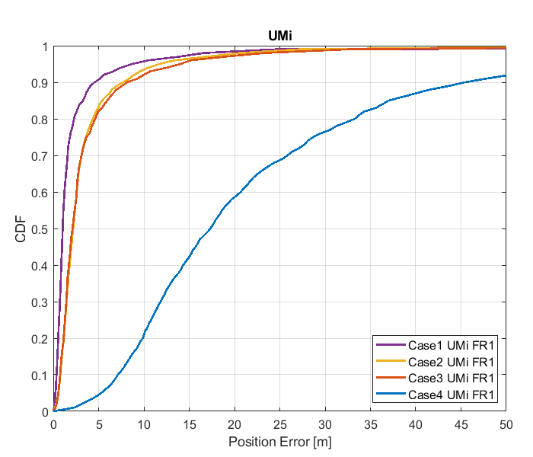

Figure 8.2.2.1-1: Results for FR1 from [10]

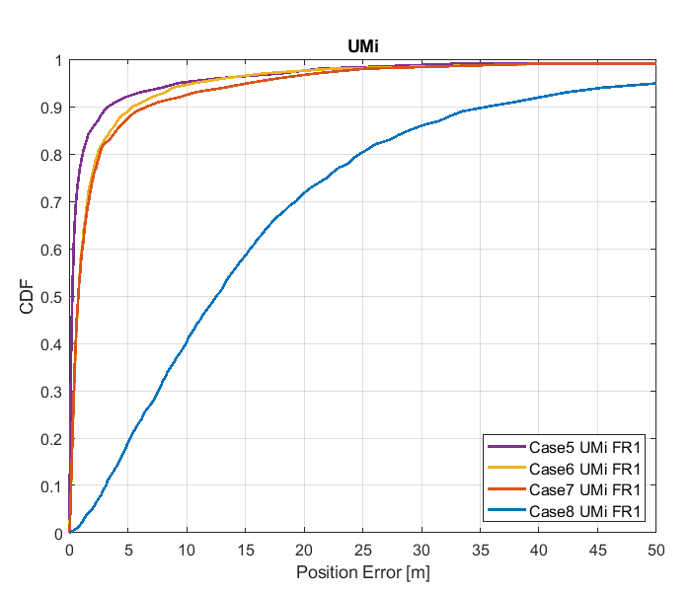

Figure 8.2.2.1-2: Results for FR1 from [10]

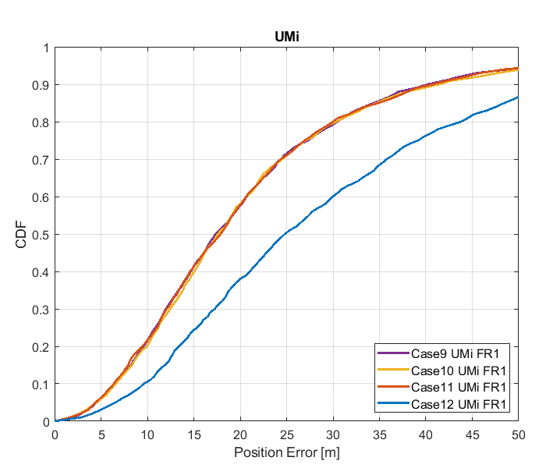

Figure 8.2.2.1-3: Results for FR1 from [10]

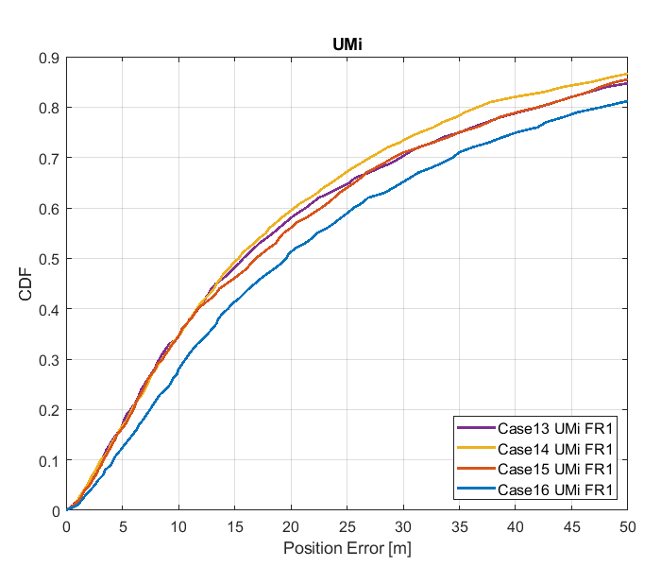

Figure 8.2.2.1-4: Results for FR1 from [10]

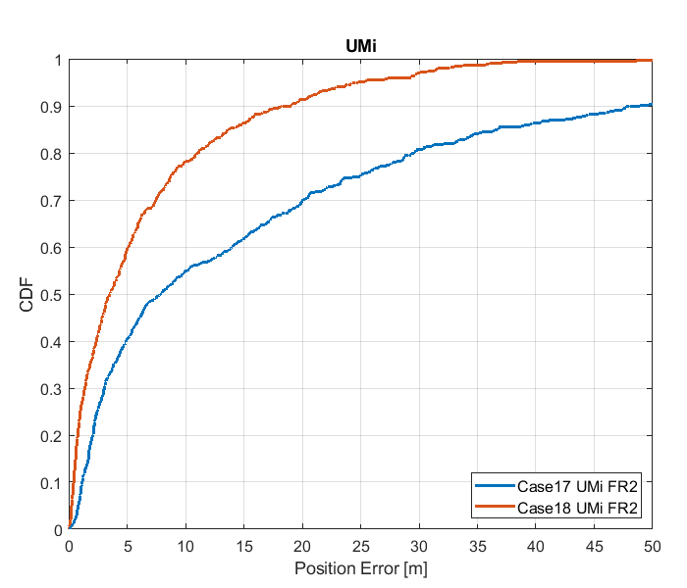

Figure 8.2.2.1-5: Results for FR2 from [10]

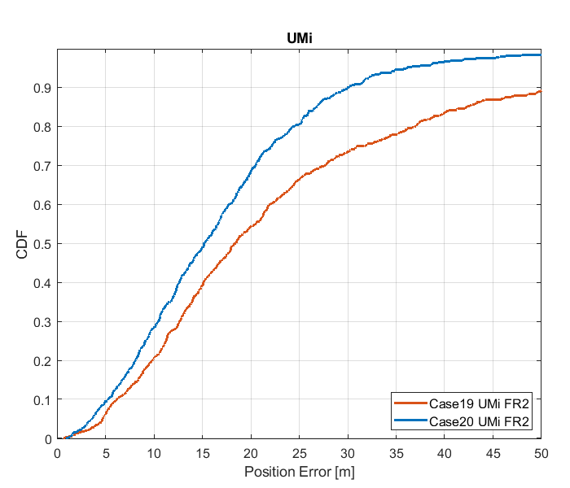

Figure 8.2.2.1-6: Results for FR2 from [10]

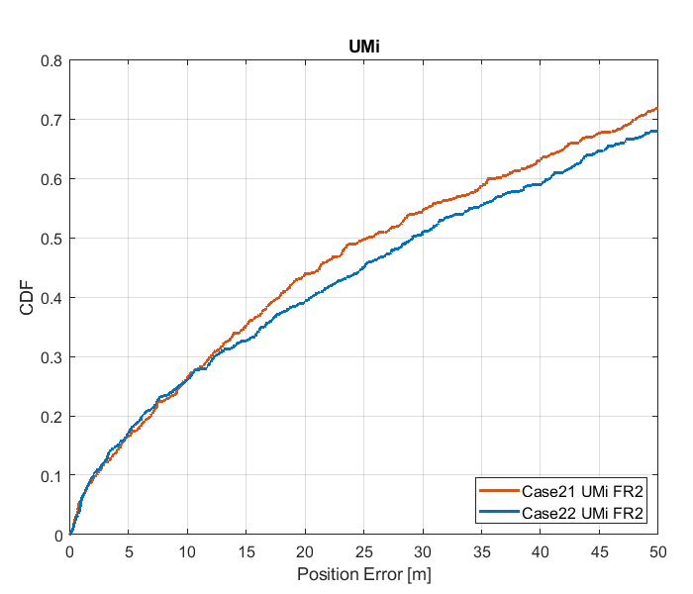

Figure 8.2.2.1-7: Results for FR2 from [10]

Table 8.2.2.1.4: Results for FR1 from [10]

|  |  |  |  |  |  |  |
| --- | --- | --- | --- | --- | --- | --- |
|  |  | Source | 50% | 67% | 80% | 90% |
| FR1 | UMi | Case 1 UMi FR1 | 1.9 | 1.5 | 2.3 | 4.6 |
| Case 2 UMi FR1 | 2.2 | 2.9 | 4.4 | 7.7 |
| Case 3 UMi FR1 | 2.1 | 2.9 | 4.6 | 8.2 |
| Case 4 UMi FR1 | 17.3 | 23.7 | 33.3 | 45.5 |
| Case 5 UMi FR1 | 0.3 | 0.5 | 1.2 | 3.4 |
| Case 6 UMi FR1 | 0.8 | 1.4 | 2.4 | 5.4 |
| Case 7 UMi FR1 | 0.8 | 1.5 | 2.6 | 6.7 |
| Case 8 UMi FR1 | 12.6 | 17.9 | 24.8 | 35.8 |
| Case 9 UMi FR1 | 17.3 | 23.4 | 30.4 | 40.2 |
| Case 10 UMi FR1 | 17.6 | 23.0 | 30.4 | 41.5 |
| Case 11 UMi FR1 | 17.8 | 23.3 | 30.0 | 40.8 |
| Case 12 UMi FR1 | 24.8 | 34.5 | 43.8 | 55.6 |
| Case 13 UMi FR1 | 15.7 | 26.6 | 41.8 | 63.8 |
| Case 14 UMi FR1 | 15.3 | 24.8 | 36.6 | 60.5 |
| Case 15 UMi FR1 | 16.9 | 26.6 | 41.7 | 61.6 |
| Case 16 UMi FR1 | 19.6 | 31.3 | 47.5 | 65.3 |

Table 8.2.2.1.5: Results for FR2 from [10]

|  |  |  |  |  |  |  |
| --- | --- | --- | --- | --- | --- | --- |
|  |  | Source | 50% | 67% | 80% | 90% |
| FR2 | UMi | Case 17 UMi FR2 | 7.8 | 18.3 | 29.5 | 48.0 |
| Case 18 UMi FR2 | 3.5 | 6.3 | 11.1 | 18.3 |
| Case 19 UMi FR2 | 18.4 | 25.2 | 36.9 | 52.7 |
| Case 20 UMi FR2 | 15.2 | 19.7 | 24.4 | 30.1 |
| Case 21 UMi FR2 | 25.3 | 44.4 | 60.8 | 85.5 |
| Case 22 UMi FR2 | 29.1 | 48.6 | 68.2 | 95.4 |

#### 8.2.2.2 Results from [11]

The parameters corresponding to the results are listed in table 8.2.2.1-1 below.

Table 8.2.2.2-1: Parameters for UL-TDOA evaluations

|  |  |
| --- | --- |
| Parameter | R1-1901717 |
| Channel model (baseline, otherwise state any modifications) | baseline |
| Carrier frequency | 4 GHz for FR1  30 GHz for FR2 |
| Subcarrier spacing | 30 kHz for FR1  120 kHz for FR2 |
| Reference Signal Transmission Bandwidth | 100 MHz for FR1  400 MHz for FR2 |
| Reference Signal Physical Structure and Resource Allocation (RE pattern) (reference to figure in contribution) | SRS  comb-4 frequency structure  4 symbols within a slot  No sequence/group/frequency hopping |
| Reference signal (type of sequence, number of ports, …) | 1 port, ZC sequence |
| Number of sites | 5 |
| Number of symbols used per occasion | 4 |
| number of occasions used per positioning estimate | 1 |
| Power-boosting level | 6 dB |
| Uplink power control (applied/not applied) | not applied |
| interference modelling (ideal muting, or other) | No interference |
| Description of Measurement Algorithm (e.g. super resolution, interference cancellation, ….) | Threshold-based ToA estimation method |
| Description of positioning technique / applied positioning algorithm (e.g. Least square, Taylor series, etc) | CHAN algorithm |
| Network synchronization assumptions | Perfect/50ns |
| Beam-related assumption (beam sweeping / alignment assumptions at the tx and rx sides) | alignment assumptions at the tx and rx sides |
| Precoding assumptions (codebook, nrof antenna elements used, etc) | N/A |
| UE type | Outdoor UEs for UMi |
| Additional notes, if any | only LOS path to calculate ToA |

The results corresponding to the UMi scenario are provided below.



Figure 8.2.2.2-1: CDF curve of positioning for UL-TDOA evaluations of UMi: FR1 (left) and FR2 (right)

Table 8.2.2.2-2: Accuracy results (m) for UL-TDOA evaluations of UMi

|  |  |  |  |  |  |
| --- | --- | --- | --- | --- | --- |
| Percentile | | 50% | 67% | 80% | 90% |
| FR1 100M | Perfect sync | 0.88 | 1.3 | 2.5 | 21 |
| Sync. error 50ns | 13 | 17 | 23 | 35 |
| FR2 400M | Perfect sync | 0.23 | 0.36 | 2.0 | 14 |
| Sync. error 50ns | 12 | 16 | 21 | 31 |

#### 8.2.2.3 Results from [14]

The parameters corresponding to the results are listed in table 9 below.

Table 8.2.2.3-1: Parameters for Uplink evaluations in Scenario 2

|  |  |
| --- | --- |
| Parameter | [[14], FR1] |
| Channel model (baseline, otherwise state any modifications) | Baseline |
| Carrier frequency | 4GHz |
| Subcarrier spacing | 15kHz, 30KHz |
| Reference Signal Transmission Bandwidth | 5MHz, 100MHz |
| Reference Signal Physical Structure and Resource Allocation (RE pattern) (reference to figure in contribution) | NR SRS Comb-2 [66] |
| Reference signal (type of sequence, number of ports, …) | 1 TX port |
| Number of sites | 21 |
| Number of symbols used per occasion | 2 |
| number of occasions used per positioning estimate | 1 |
| Power-boosting level | 10*log10(2) |
| Uplink power control (applied/not applied) | N/A |
| interference modelling (ideal muting, or other) | Perfect muting |
| Description of Measurement Algorithm (e.g. super resolution, interference cancellation, ….) | Both no threshold and threshold of 0.5 at the UE |
| Description of positioning technique / applied positioning algorithm (e.g. Least square, Taylor series, etc) | Sectorized beams in RX Omni-direction in TX |
| Network synchronization assumptions | Perfect synchronization |
| Beam-related assumption (beam sweeping / alignment assumptions at the tx and rx sides) | N/A |
| Precoding assumptions (codebook, nrof antenna elements used, etc) | N/A |
| Additional notes, if any |  |

The results corresponding to the Urban Micro scenario are provided below

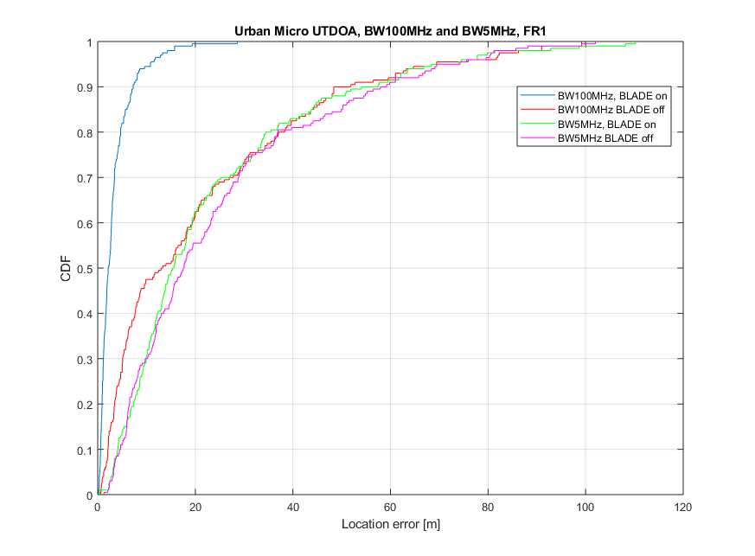

Figure 8.2.2.3-1

Table 8.2.2.3-2: Results for uplink methods evaluations of Scenario 2 – Urban Micro

|  |  |  |  |  |
| --- | --- | --- | --- | --- |
| Percentile | 50 | 67 | 80 | 90 |
| UL-TDOA, FR1, 5 MHz, without ULADE | 17.52 | 27.1 | 39.73 | 59.19 |
| UL-TDOA, FR1, 100 MHz, without BLADE | 12.98 | 22.8 | 36.94 | 52.79 |
| UL-TDOA, FR1, 5 MHz, with BLADE | 15.61 | 22.91 | 36.94 | 57.48 |
| UL-TDOA, FR1, 100 MHz, with BLADE | 2.2 | 3.19 | 4.7 | 7.23 |

#### 8.2.2.4 Results from [15]

The parameters corresponding to the results are listed in table 8.2.2.4-1 below.

Table 8.2.2.4-1: Parameters for Uplink evaluations in Scenario 2

|  |  |
| --- | --- |
| Parameter | [15] (R1-1903222) |
| Channel model (baseline, otherwise state any modifications) | According to 3GPP TR 38.901 (UMi Street Canyon) |
| Carrier frequency | 4GHz |
| Subcarrier spacing | 15KHz |
| Reference Signal Transmission Bandwidth | 5MHz, 50MHz |
| Reference Signal Physical Structure and Resource Allocation (RE pattern) (reference to figure in contribution) | NR SRS, Comb=4 |
| Reference signal (type of sequence, number of ports, …) | ZC sequence 1 port |
| Number of sites | 57 sectors / 19 sites,  Up to 6 sites used for UL-TDOA |
| Number of symbols used per occasion | 4 |
| number of occasions used per positioning estimate | 1 |
| Power-boosting level | 6dB (10*log10(4) = 6) |
| Uplink power control (applied/not applied) | Not applied, and UE power is fixed to 23dBm |
| interference modelling (ideal muting, or other) | Ideal muting |
| Description of Measurement Algorithm (e.g. super resolution, interference cancellation, ….) | No super resolution, and no interference cancellation |
| Description of positioning technique / applied positioning algorithm (e.g. Least square, Taylor series, etc) | Chan's algorithm "A simple and efficient estimator for Hyperbolic location", Y.T. Chan and K.C. Ho, IEEE transactions on signal processing, vol.42, no. 8, August 1994. |
| Network synchronization assumptions | Perfect synchronization. |
| Beam-related assumption (beam sweeping / alignment assumptions at the tx and rx sides) | Not applied |
| Precoding assumptions (codebook, nrof antenna elements used, etc) | Not applied |
| Additional notes, if any |  |

The results corresponding to the UMi Street Canyon scenario are provided below

Table 8.2.2.4-2: Results for downlink methods evaluations of Scenario 2 –UMi

|  |  |  |  |  |
| --- | --- | --- | --- | --- |
| Percentile | 50 | 67 | 80 | 90 |
| [5Mhz: UL-TDOA ] | 25.4 | 44.8 | 63.6 | 82.5 |
| [50Mhz: UL-TDOA ] | 20.1 | 29.5 | 34.2 | 44.1 |

#### 8.2.2.5 Results from [19]

The parameters used for evaluation of the UL based positioning in Scenario 2 (UMi) are listed in Table 8.2.2.5-1 below.

Table 8.2.2.5-1: Parameters for Uplink evaluations in Scenario 2

|  |  |  |  |
| --- | --- | --- | --- |
| Parameter | Setup 1 | Setup 2 | Setup 3 |
| Channel model (baseline, otherwise state any modifications) | Baseline | Baseline | Baseline |
| Carrier frequency | 4 GHz | 4 GHz | 30 GHz |
| Subcarrier spacing | 15 kHz | 30 kHz | 120 kHz |
| Reference Signal Transmission Bandwidth | 5 MHz | 100 MHz | 100 MHz |
| Reference Signal Physical Structure and Resource Allocation (RE pattern) (reference to figure in contribution) | 4 REs per PRB, 4 symbols | 4 REs per PRB, 4 symbols | 4 REs per PRB, 4 symbols |
| Reference signal (type of sequence, number of ports, …) | QPSK, Pseudo random, single Tx port | QPSK, Pseudo random, single Tx port | QPSK, Pseudo random, single Tx port |
| Number of sites | 57 sectors / 19 sites | 57 sectors / 19 sites | 57 sectors / 19 sites |
| Number of symbols used per occasion | 4(symb)xUE number | 4(symb)xUE number | 4(symb)x16(beams)xUE number |
| Number of occasions used per positioning estimate | 1 | 1 | 1 |
| Power-boosting level | 6 dB | 6 dB | 6 dB |
| Uplink power control (applied/not applied) | Max power | Max power | Max power |
| Interference modelling (ideal muting, or other) | Ideal muting | Ideal muting | Ideal muting |
| Description of Measurement Algorithm (e.g. super resolution, interference cancellation, ….) | Threshold based algorithm for the first arrival path (FAP) estimation | Threshold based algorithm for the first arrival path (FAP) estimation | Threshold based algorithm for the first arrival path (FAP) estimation |
| Description of positioning technique / applied positioning algorithm (e.g. Least square, Taylor series, etc) | Taylor based, measurements above -15 dB are used for positioning | Taylor based, measurements above -15 dB are used for positioning | Taylor based, measurements above -15 dB are used for positioning |
| Network synchronization assumptions | Option 1: T1 = 0ns(Perfect)  Option 2: T1 = 50ns | Option 1: T1 = 0ns(Perfect)  Option 2: T1 = 50ns | Option 1: T1 = 0ns(Perfect)  Option 2: T1 = 50ns |
| Beam-related assumption (beam sweeping / alignment assumptions at the tx and rx sides) | No Tx sweeping | No Tx sweeping | Rx sweeping |
| Precoding assumptions (codebook, nrof antenna elements used, etc) | Single Tx port | Single Tx port | Single Tx port |
| Additional notes, if any |  |  |  |

The system level evaluation results for UL positioning in Scenario 2 (UMi) are provided below.

|  |
| --- |
| Figure 8.2.2.5-1 (a) FR1 evaluations    Figure 8.2.2.5-2 (b) FR2 evaluations |

#### 8.2.2.6 Results from [23]

The parameters corresponding to the results are listed in table 8.2.2.6-1 below.

Table 8.2.2.6-1: Parameters for Downlink evaluations in Scenario 1

|  |  |  |  |  |  |
| --- | --- | --- | --- | --- | --- |
| Parameter | [23], FR1, 100 MHz | [23], FR1, 50 MHz | [23], FR1, 5 MHz | [23], FR2, 400 MHz | [23], FR2, 100 MHz |
| Channel model (baseline, otherwise state any modifications) | Baseline Channel Model based on common assumptions defined related to the channel models of 3GPP TRs 38.901 / 38.802 / 37.857. | | | | |
| Carrier frequency | 4 GHz | | | 30 GHz | |
| Subcarrier spacing | 30 KHz | 15 KHz | 15 KHz | 120 KHz | |
| Reference Signal Transmission Bandwidth | 100 MHz | 50 MHz | 5 MHz | 400 MHz | 100 MHz |
| Reference Signal Physical Structure and Resource Allocation (RE pattern) (reference to figure in contribution) | Comb-1 with 1-symbol PRS resource | | | | |
| Reference signal (type of sequence, number of ports, …) | 1-port, QPSK sequence | | | | |
| Number of sites | 19 (3-sector) | | | | |
| Number of symbols used per occasion | 1 | | | | |
| number of occasions used per positioning estimate | 1 | | | | |
| Power-boosting level | 0 dB | | | | |
| Uplink power control (applied/not applied) | Not applied (23 dBm Tx) | | | | |
| interference modelling (ideal muting, or other) | Interference from 4 UEs | | | | |
| Description of Measurement Algorithm (e.g. super resolution, interference cancellation, ….) | TOA estimation without oversampling with TOA pruning before the positioning engine using the ratio of the estimated TOA peak over the median of the Channel Energy Response (CER). | | | | |
| Description of positioning technique / applied positioning algorithm (e.g. Least square, Taylor series, etc) | For UL-TDOA Pick the best between Taylor series, and Chan's Algorithm.  Chan's Algorithm according to:  Y. T. Chan, K. C. Ho, " A Simple and Efficient Estimator for Hyperbolic Location", IEEE Transactions on Signal Processing, vol. 42, pp. 1905-1915, Aug. 1994.  Taylor Series Algorithm:  W. H. Foy, " Position-Location Solutions by Taylor-Series Estimation", IEEE Transactions on Aerospace and Electronic Systems, vol. AES-12, pp. 187-194, March 1976.  Equal weight is used in the TOA covariance matrix. | | | | |
| Network synchronization assumptions | Perfect Sync and Realistic Sync with T1 = 50 nsec | | | | |
| Beam-related assumption (beam sweeping / alignment assumptions at the tx and rx sides) | The best beam pair is identified based on the criteria of receiving the earliest path given that the received power is larger than a threshold (20 dB lower than the maximum received power) using the genie CDL channel profiles. For a single sector scenario (only Indoor hotspop 4GHz), the directions of beams are within [, 180] degress in azimuth and [,180] degrees in zenith. For a 3-sector scenario, the directions of beams are within [, ] degress in azimuth and [,180] degrees in zenith. | | | | |
| Precoding assumptions (codebook, nrof antenna elements used, etc) | Kronecker product between vertical and horizontal weight vectors taken from DFT, with oversampling factor = 1. The DFT beam candidate in beam selection method is generated according to the uniform vertical and horizontal angular distribution shown as follows:  , for i=1,…,rN  where r denotes the oversampling factor, N denotes the number of vertical/horizontal antennas. For FR2, Tx oversampling factor r equals to 2. For FR1, oversampling factor equals to1. Rx oversampling factor equals to 1. | | | | |

The results corresponding to the Indoor open office scenario are provided below

Table 8.2.2.6-2: Results for Uplink methods evaluations of Scenario 1 – UMi

|  |  |  |  |  |  |
| --- | --- | --- | --- | --- | --- |
| Percentile | 50 | 67 | 80 | 90 | 95 |
| UL-TDOA, FR1, 100 MHz, Perfect Sync | 3.6 | 6.3 | 10.5 | 18.4 | 29.6 |
| UL-TDOA, FR1, 100 MHz, Realistic Sync | 12.7 | 16.6 | 21.4 | 29.2 | 41.2 |
| UL-TDOA, FR1, 50 MHz, Perfect Sync | 6.1 | 9.4 | 13 | 18.8 | 25.5 |
| UL-TDOA, FR1, 50 MHz, Realistic Sync | 11.2 | 14.8 | 18.9 | 24.7 | 31.5 |
| UL-TDOA, FR1, 5 MHz, Perfect Sync | 16.2 | 22.3 | 28.7 | 38.1 | 46.5 |
| UL-TDOA, FR1, 5 MHz, Realistic Sync | 18.2 | 24.4 | 31.5 | 40.5 | 50.2 |
| UL-TDOA, FR2, 400 MHz, Perfect Sync | 2.2 | 6.2 | 16.8 | 95.3 | - |
| UL-TDOA, FR2, 400 MHz, Realistic Sync | 16.9 | 24.3 | 38.1 | 119.7 | - |
| UL-TDOA, FR2, 100 MHz, Perfect Sync | 2.9 | 6.5 | 13.7 | 48.2 | - |
| UL-TDOA, FR2, 100 MHz, Realistic Sync | 15.4 | 21.2 | 30.1 | 52.1 | - |

### 8.2.3 System simulations for Scenario 3 - UMa

#### 8.2.3.1 Results from [10]

Table 8.2.3.1-1: Parameters details for FR1 from [10]

|  |  |  |  |  |  |  |  |  |
| --- | --- | --- | --- | --- | --- | --- | --- | --- |
| Parameter | Case 1 UMa, FR1 | Case 2 UMa, FR1 | Case 3 UMa, FR1 | Case 4 UMa, FR1 | Case 5 UMa, FR1 | Case 6 UMa, FR1 | Case 7 UMa, FR1 | Case 8 UMa, FR1 |
| Channel model (baseline, otherwise state any modifications) | 38.901 | 38.901 | 38.901 | 38.901 | 38.901 | 38.901 | 38.901 | 38.901 |
| Carrier frequency | 4GHz | 4GHz | 2GHz | 2GHz | 4GHz | 4GHz | 2GHz | 2GHz |
| Subcarrier spacing | 30kHz | 15kHz | 15kHz | 15kHz | 30kHz | 15kHz | 15kHz | 15kHz |
| Reference Signal Transmission Bandwidth | 100MHz | 50MHz | 50MHz | 5MHz | 100MHz | 50MHz | 50MHz | 5MHz |
| Reference Signal Physical Structure and Resource Allocation (RE pattern) (reference to figure in contribution) | Comb-4 | Comb-4 | Comb-4 | Comb-4 | Comb-4 | Comb-4 | Comb-4 | Comb-4 |
| Reference signal (type of sequence, number of ports, …) | SRS: ZC, 1-port | SRS: ZC, 1-port | SRS: ZC, 1-port | SRS: ZC, 1-port | SRS: ZC, 1-port | SRS: ZC, 1-port | SRS: ZC, 1-port | SRS: ZC, 1-port |
| Number of sites | 19 | 19 | 19 | 19 | 19 | 19 | 19 | 19 |
| Number of symbols used per occasion | 4 | 4 | 4 | 4 | 4 | 4 | 4 | 4 |
| number of occasions used per positioning estimate | 4 | 4 | 4 | 4 | 4 | 4 | 4 | 4 |
| Power-boosting level | 6dB | 6dB | 6dB | 6dB | 6dB | 6dB | 6dB | 6dB |
| Uplink power control (applied/not applied) | Not applied | Not applied | Not applied | Not applied | Not applied | Not applied | Not applied | Not applied |
| interference modelling (ideal muting, or other) | Ideal muting | Ideal muting | Ideal muting | Ideal muting | Ideal muting | Ideal muting | Ideal muting | Ideal muting |
| Description of Measurement Algorithm (e.g. super resolution, interference cancellation, ….) | Regular | Regular | Regular | Regular | Super resolution | Super resolution | Super resolution | Super resolution |
| Description of positioning technique / applied positioning algorithm (e.g. Least square, Taylor series, etc) | UL-TDOA, Chan's algorithm | UL-TDOA, Chan's algorithm | UL-TDOA, Chan's algorithm | UL-TDOA, Chan's algorithm | UL-TDOA, Chan's algorithm | UL-TDOA, Chan's algorithm | UL-TDOA, Chan's algorithm | UL-TDOA, Chan's algorithm |
| Network synchronization assumptions | No sync error | No sync error | No sync error | No sync error | No sync error | No sync error | No sync error | No sync error |
| Beam-related assumption (beam sweeping / alignment assumptions at the tx and rx sides) | N/A | N/A | N/A | N/A | N/A | N/A | N/A | N/A |
| Precoding assumptions (codebook, nrof antenna elements used, etc) | SVD | SVD | SVD | SVD | SVD | SVD | SVD | SVD |
| Additional notes, if any |  |  |  |  |  |  |  |  |

Table 8.2.3.1-2: Parameters details for FR1 from [10]

|  |  |  |  |  |  |  |  |  |
| --- | --- | --- | --- | --- | --- | --- | --- | --- |
| Parameter | Case 9 UMa, FR1 | Case 10 UMa, FR1 | Case 11 UMa, FR1 | Case 12 UMa, FR1 | Case 13 UMa, FR1 | Case 14 UMa, FR1 | Case 15 UMa, FR1 | Case 16 UMa, FR1 |
| Channel model (baseline, otherwise state any modifications) | 38.901 | 38.901 | 38.901 | 38.901 | 38.901 | 38.901 | 38.901 | 38.901 |
| Carrier frequency | 4GHz | 4GHz | 2GHz | 2GHz | 4GHz | 4GHz | 2GHz | 2GHz |
| Subcarrier spacing | 30kHz | 15kHz | 15kHz | 15kHz | 30kHz | 15kHz | 15kHz | 15kHz |
| Reference Signal Transmission Bandwidth | 100MHz | 50MHz | 50MHz | 5MHz | 100MHz | 50MHz | 50MHz | 5MHz |
| Reference Signal Physical Structure and Resource Allocation (RE pattern) (reference to figure in contribution) | Comb-4 | Comb-4 | Comb-4 | Comb-4 | Comb-4 | Comb-4 | Comb-4 | Comb-4 |
| Reference signal (type of sequence, number of ports, …) | SRS: ZC, 1-port | SRS: ZC, 1-port | SRS: ZC, 1-port | SRS: ZC, 1-port | SRS: ZC, 1-port | SRS: ZC, 1-port | SRS: ZC, 1-port | SRS: ZC, 1-port |
| Number of sites | 19 | 19 | 19 | 19 | 19 | 19 | 19 | 19 |
| Number of symbols used per occasion | 4 | 4 | 4 | 4 | 4 | 4 | 4 | 4 |
| number of occasions used per positioning estimate | 4 | 4 | 4 | 4 | 4 | 4 | 4 | 4 |
| Power-boosting level | 6dB | 6dB | 6dB | 6dB | 6dB | 6dB | 6dB | 6dB |
| Uplink power control (applied/not applied) | Not applied | Not applied | Not applied | Not applied | Not applied | Not applied | Not applied | Not applied |
| interference modelling (ideal muting, or other) | Ideal muting | Ideal muting | Ideal muting | Ideal muting | Ideal muting | Ideal muting | Ideal muting | Ideal muting |
| Description of Measurement Algorithm (e.g. super resolution, interference cancellation, ….) | Regular | Regular | Regular | Regular | Regular | Regular | Regular | Regular |
| Description of positioning technique / applied positioning algorithm (e.g. Least square, Taylor series, etc) | UL-TDOA, Chan's algorithm | UL-TDOA, Chan's algorithm | UL-TDOA, Chan's algorithm | UL-TDOA, Chan's algorithm | UAOA,  PSO algorithm | UAOA,  PSO algorithm | UAOA,  PSO algorithm | UAOA,  PSO algorithm |
| Network synchronization assumptions | Sync error 50ns | Sync error 50ns | Sync error 50ns | Sync error 50ns | No sync error | No sync error | No sync error | No sync error |
| Beam-related assumption (beam sweeping / alignment assumptions at the tx and rx sides) | N/A | N/A | N/A | N/A | N/A | N/A | N/A | N/A |
| Precoding assumptions (codebook, nrof antenna elements used, etc) | SVD | SVD | SVD | SVD | SVD | SVD | SVD | SVD |
| Additional notes, if any |  |  |  |  |  |  |  |  |

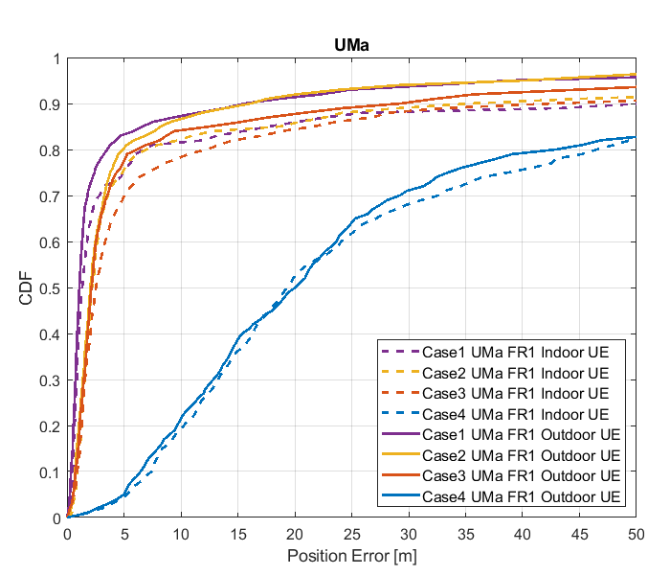

Figure 8.2.3.1-1: Results for FR1 from [10]

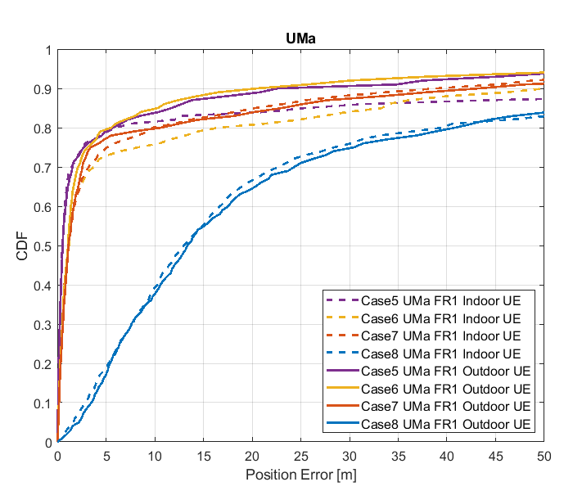

Figure 8.2.3.1-2: Results for FR1 from [10]

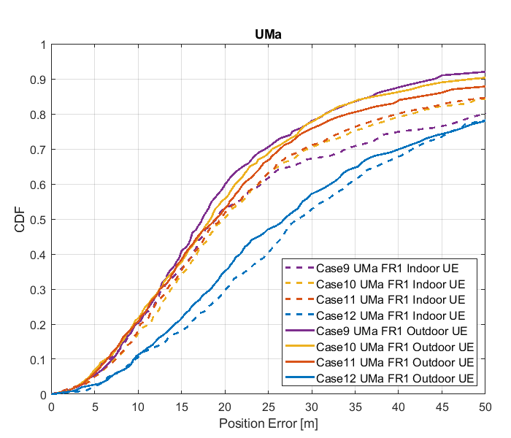

Figure 8.2.3.1-3: Results for FR1 from [10]

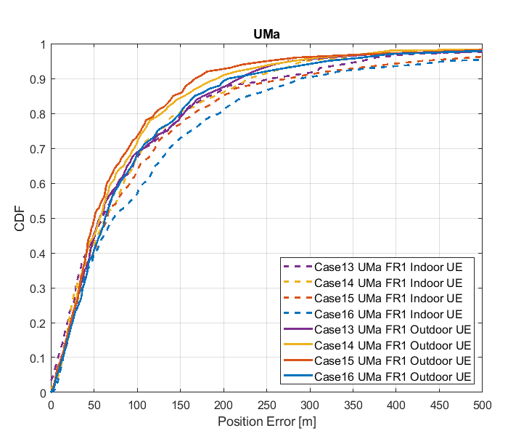

Figure 8.2.3.1-4: Results for FR1 from [10]

Table 8.2.3.1-3: Results for FR1 from [10]

|  |  |  |  |  |  |  |
| --- | --- | --- | --- | --- | --- | --- |
|  |  | Source | 50% | 67% | 80% | 90% |
| FR1 | UMa indoor | Case 1 UMa FR1 | 1.3 | 2.3 | 6.7 | 50.5 |
| Case 2 UMa FR1 | 2.2 | 3.2 | 7.1 | 37.0 |
| Case 3 UMa FR1 | 2.5 | 4.4 | 12.3 | 42.6 |
| Case 4 UMa FR1 | 19.4 | 28.8 | 46.5 | 82.6 |
| Case 5 UMa FR1 | 0.5 | 1.1 | 6.1 | 101.4 |
| Case 6 UMa FR1 | 1.2 | 2.8 | 16.6 | 50.1 |
| Case 7 UMa FR1 | 1.1 | 2.5 | 10.0 | 38.9 |
| Case 8 UMa FR1 | 13.0 | 20.3 | 39.5 | 75.9 |
| Case 9 UMa FR1 | 19.0 | 29.4 | 49.8 | 96.5 |
| Case 10 UMa FR1 | 20.0 | 27.8 | 41.6 | 67.7 |
| Case 11 UMa FR1 | 19.5 | 26.8 | 40.0 | 70.8 |
| Case 12 UMa FR1 | 28.4 | 39.3 | 53.3 | 82.6 |
| Case 13 UMa FR1 | 61.8 | 117.5 | 168.6 | 254.7 |
| Case 14 UMa FR1 | 65.3 | 96.4 | 144.6 | 224.1 |
| Case 15 UMa FR1 | 64.6 | 111.1 | 165.8 | 274.1 |
| Case 16 UMa FR1 | 82.3 | 129.1 | 199.4 | 288.3 |
| UMa outdoor | Case 1 UMa FR1 | 1.1 | 1.6 | 3.5 | 15.6 |
| Case 2 UMa FR1 | 2.1 | 3.1 | 4.9 | 16.2 |
| Case 3 UMa FR1 | 2.2 | 3.2 | 6.2 | 29.3 |
| Case 4 UMa FR1 | 20.1 | 26.8 | 43.0 | 67.0 |
| Case 5 UMa FR1 | 0.6 | 1.3 | 5.7 | 23.0 |
| Case 6 UMa FR1 | 1.1 | 1.8 | 5.6 | 20.7 |
| Case 7 UMa FR1 | 1.2 | 2.3 | 10.7 | 43.7 |
| Case 8 UMa FR1 | 13.4 | 21.7 | 40.9 | 89.1 |
| Case 9 UMa FR1 | 17.4 | 23.1 | 31.6 | 44.2 |
| Case 10 UMa FR1 | 18.4 | 23.9 | 31.6 | 49.1 |
| Case 11 UMa FR1 | 18.9 | 25.1 | 34.2 | 58.1 |
| Case 12 UMa FR1 | 26.9 | 36.3 | 53.4 | 82.5 |
| Case 13 UMa FR1 | 53.8 | 92.3 | 147.2 | 210.4 |
| Case 14 UMa FR1 | 56.8 | 91.2 | 133.9 | 211.7 |
| Case 15 UMa FR1 | 49.0 | 76.8 | 123.3 | 164.6 |
| Case 16 UMa FR1 | 58.8 | 94.5 | 144.3 | 198.1 |

#### 8.2.3.2 Results from [11]

The parameters corresponding to the results are listed in table 8.2.3.2-1 below.

Table 8.2.3.2-1: Parameters for UL-TDOA evaluations

|  |  |
| --- | --- |
| Parameter | R1-1901717 |
| Channel model (baseline, otherwise state any modifications) | baseline |
| Carrier frequency | 4 GHz for FR1 |
| Subcarrier spacing | 30 kHz for FR1 |
| Reference Signal Transmission Bandwidth | 100 MHz for FR1 |
| Reference Signal Physical Structure and Resource Allocation (RE pattern) (reference to figure in contribution) | SRS  comb-4 frequency structure  4 symbols within a slot  No sequence/group/frequency hopping |
| Reference signal (type of sequence, number of ports, …) | 1 port, ZC sequence |
| Number of sites | 5 |
| Number of symbols used per occasion | 4 |
| number of occasions used per positioning estimate | 1 |
| Power-boosting level | 6 dB |
| Uplink power control (applied/not applied) | not applied |
| interference modelling (ideal muting, or other) | No interference |
| Description of Measurement Algorithm (e.g. super resolution, interference cancellation, ….) | Threshold-based ToA estimation method |
| Description of positioning technique / applied positioning algorithm (e.g. Least square, Taylor series, etc) | CHAN algorithm |
| Network synchronization assumptions | Perfect/50ns |
| Beam-related assumption (beam sweeping / alignment assumptions at the tx and rx sides) | alignment assumptions at the tx and rx sides |
| Precoding assumptions (codebook, nrof antenna elements used, etc) | N/A |
| UE type | Outdoor UEs for UMa |
| Additional notes, if any | only LOS path to calculate ToA |

The results corresponding to the UMa scenario are provided below.



Figure 8.2.3.2-1: CDF curve of positioning for UL-TDOA evaluations of UMa in FR1

Table 8.2.3.2-2: Accuracy results (m) for UL-TDOA evaluations of UMa

|  |  |  |  |  |
| --- | --- | --- | --- | --- |
| Percentile (%) | 50% | 67% | 80% | 90% |
| perfect synchronization | 1.6 | 3.5 | 14 | 113 |
| synchronization error (50ns) | 14 | 20 | 32 | 130 |

#### 8.2.3.3 Results from [14]

The parameters corresponding to the results are listed in table 8.2.3.3-1 below.

Table 8.2.3.3-1: Parameters for Uplink evaluations in Scenario 3

|  |  |
| --- | --- |
| Parameter | [[14], FR1] |
| Channel model (baseline, otherwise state any modifications) | Baseline |
| Carrier frequency | 4GHz |
| Subcarrier spacing | 15kHz, 30KHz |
| Reference Signal Transmission Bandwidth | 5MHz, 100MHz |
| Reference Signal Physical Structure and Resource Allocation (RE pattern) (reference to figure in contribution) | NR SRS Comb-2 [66] |
| Reference signal (type of sequence, number of ports, …) | 1 TX port |
| Number of sites | 12 |
| Number of symbols used per occasion | 2 |
| number of occasions used per positioning estimate | 1 |
| Power-boosting level | 10*log10(2) |
| Uplink power control (applied/not applied) | N/A |
| interference modelling (ideal muting, or other) | Perfect muting |
| Description of Measurement Algorithm (e.g. super resolution, interference cancellation, ….) | Both no threshold and threshold of 0.5 at the UE |
| Description of positioning technique / applied positioning algorithm (e.g. Least square, Taylor series, etc) | Sectorized beams in RX Omni-direction in TX |
| Network synchronization assumptions | Perfect synchronization |
| Beam-related assumption (beam sweeping / alignment assumptions at the tx and rx sides) | N/A |
| Precoding assumptions (codebook, nrof antenna elements used, etc) | N/A |
| Additional notes, if any |  |

The results corresponding to the Urban Macro scenario are provided below

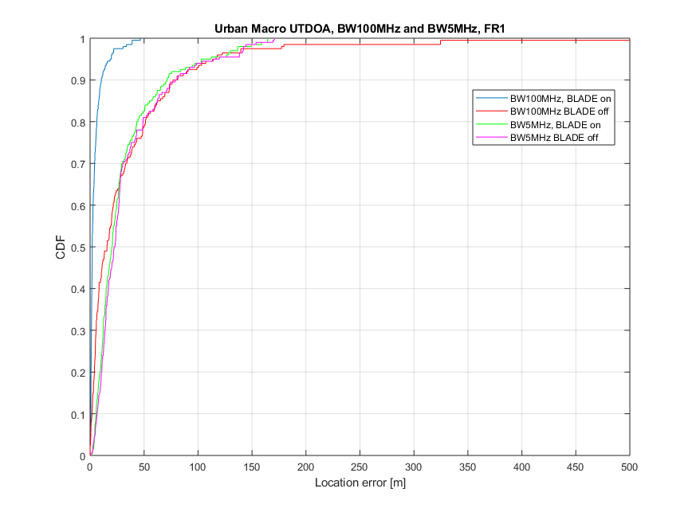

Figure 8.2.3.3-1

Table 8.2.3.3-2: Results for uplink methods evaluations of Scenario 3 – Urban Macro

|  |  |  |  |  |
| --- | --- | --- | --- | --- |
| Percentile | 50 | 67 | 80 | 90 |
| UL-TDOA, FR1, 5 MHz, without ULADE | 28.22 | 32.11 | 51.31 | 81.28 |
| UL-TDOA, FR1, 100 MHz, without BLADE | 3.88 | 29.25 | 48.96 | 78.83 |
| UL-TDOA, FR1, 5 MHz, with BLADE | 20.04 | 28.41 | 43.25 | 71.38 |
| UL-TDOA, FR1, 100 MHz, with BLADE | 1.98 | 3.88 | 6.29 | 10.45 |

#### 8.2.3.4 Results from [19]

The parameters used for evaluation of the UL based positioning in Scenario 3 (UMa) are listed in Table 8.2.3.1-1 below.

Table 8.2.3.4-1: Parameters for Uplink evaluations in Scenario 3

|  |  |  |
| --- | --- | --- |
| Parameter | Setup 1 | Setup 2 |
| Channel model (baseline, otherwise state any modifications) | Baseline | Baseline |
| Carrier frequency | 4 GHz | 4 GHz |
| Subcarrier spacing | 15 kHz | 30 kHz |
| Reference Signal Transmission Bandwidth | 5 MHz | 100 MHz |
| Reference Signal Physical Structure and Resource Allocation (RE pattern) (reference to figure in contribution) | 4 REs per PRB, 4 symbols | 4 REs per PRB, 4 symbols |
| Reference signal (type of sequence, number of ports, …) | QPSK, Pseudo random, single Tx port | QPSK, Pseudo random, single Tx port |
| Number of sites | 57 sectors / 19 sites | 57 sectors / 19 sites |
| Number of symbols used per occasion | 4(symb)xUE number | 4(symb)xUE number |
| Number of occasions used per positioning estimate | 1 | 1 |
| Power-boosting level | 6 dB | 6 dB |
| Uplink power control (applied/not applied) | Max power | Max power |
| Interference modelling (ideal muting, or other) | Ideal muting | Ideal muting |
| Description of Measurement Algorithm (e.g. super resolution, interference cancellation, ….) | Threshold based algorithm for the first arrival path (FAP) estimation | Threshold based algorithm for the first arrival path (FAP) estimation |
| Description of positioning technique / applied positioning algorithm (e.g. Least square, Taylor series, etc) | Taylor based, measurements above -15 dB are used for positioning | Taylor based, measurements above -15 dB are used for positioning |
| Network synchronization assumptions | Option 1: T1 = 0ns(Perfect)  Option 2: T1 = 50ns | Option 1: T1 = 0ns(Perfect)  Option 2: T1 = 50ns |
| Beam-related assumption (beam sweeping / alignment assumptions at the tx and rx sides) | No Tx sweeping | No Tx sweeping |
| Precoding assumptions (codebook, nrof antenna elements used, etc) | Single Tx port | Single Tx port |
| Additional notes, if any |  |  |

The system level evaluation results for UL positioning in Scenario 3 (UMa) are provided below.

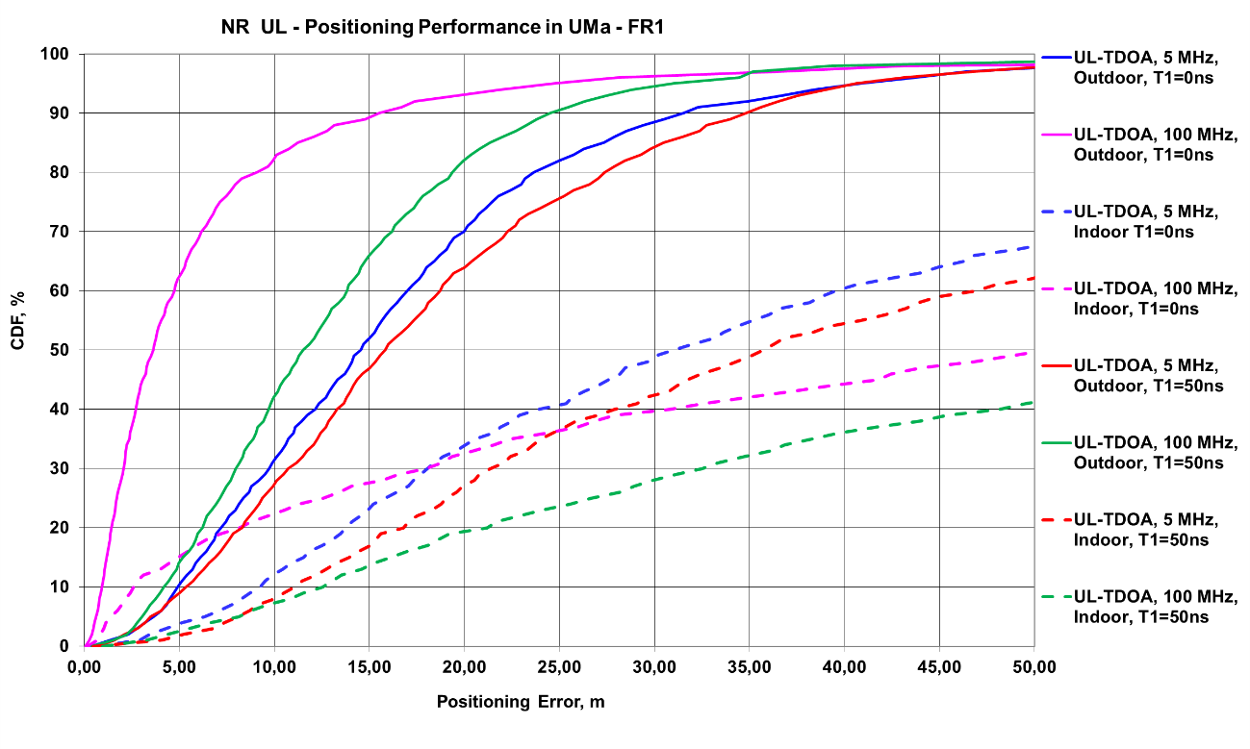

Figure 8.2.3.4-1 (a) FR1 evaluations

#### 8.2.3.5 Results from [23]

The parameters corresponding to the results are listed in table 8.2.3.5-1 below.

Table 8.2.3.5-1: Parameters for uplink evaluations in Scenario 3

|  |  |  |
| --- | --- | --- |
| Parameter | [23], FR1, 100 MHz | [23], FR1, 50 MHz |
| Channel model (baseline, otherwise state any modifications) | Baseline Channel Model based on common assumptions defined related to the channel models of 3GPP TRs 38.901 / 38.802 / 37.857. | |
| Carrier frequency | 4 GHz | |
| Subcarrier spacing | 30 KHz | 15 KHz |
| Reference Signal Transmission Bandwidth | 100 MHz | 50 MHz |
| Reference Signal Physical Structure and Resource Allocation (RE pattern) (reference to figure in contribution) | Comb-1 | |
| Reference signal (type of sequence, number of ports, …) | 1-port, QPSK sequence | |
| Number of sites | 19 (3-sector) | |
| Number of symbols used per occasion | 10 | |
| number of occasions used per positioning estimate | 10 | |
| Power-boosting level | 0 dB | |
| interference modelling (ideal muting, or other) | Ideal muting for DL | |
| Description of Measurement Algorithm (e.g. super resolution, interference cancellation, ….) | TOA estimation without oversampling with TOA pruning before the positioning engine using the ratio of the estimated TOA peak over the median of the Channel Energy Response (CER). | |
| Description of positioning technique / applied positioning algorithm (e.g. Least square, Taylor series, etc) | For UL-TDOA Pick the best between Taylor series, and Chan's Algorithm.  Chan's Algorithm according to:  Y. T. Chan, K. C. Ho, " A Simple and Efficient Estimator for Hyperbolic Location", IEEE Transactions on Signal Processing, vol. 42, pp. 1905-1915, Aug. 1994.  Taylor Series Algorithm:  W. H. Foy, " Position-Location Solutions by Taylor-Series Estimation", IEEE Transactions on Aerospace and Electronic Systems, vol. AES-12, pp. 187-194, March 1976.  Equal weight is used in the TOA covariance matrix. | |
| Network synchronization assumptions | Perfect Sync and Realistic Sync with T1 = 50 nsec | |
| Beam-related assumption (beam sweeping / alignment assumptions at the tx and rx sides) | The best beam pair is identified based on the criteria of receiving the earliest path given that the received power is larger than a threshold (20 dB lower than the maximum received power) using the genie CDL channel profiles. For a single sector scenario (only Indoor hotspop 4GHz), the directions of beams are within [, 180] degress in azimuth and [,180] degrees in zenith. For a 3-sector scenario, the directions of beams are within [, ] degress in azimuth and [,180] degrees in zenith. | |
| Precoding assumptions (codebook, nrof antenna elements used, etc) | Kronecker product between vertical and horizontal weight vectors taken from DFT, with oversampling factor = 1. The DFT beam candidate in beam selection method is generated according to the uniform vertical and horizontal angular distribution shown as follows:  , for i=1,…,rN  where r denotes the oversampling factor, N denotes the number of vertical/horizontal antennas. For FR1, Tx oversampling factor equals to 1. | |

The results corresponding to the UMa scenario are provided below

Table 8.2.3.5-2: Results for uplink methods evaluations of Scenario 3 – UMa Indoor UEs

|  |  |  |  |  |  |
| --- | --- | --- | --- | --- | --- |
| Percentile | 50 | 67 | 80 | 90 | 95 |
| UL-TDOA, FR1, 100 MHz, Perfect Sync | 24.3 | 53 | 138.5 | - | - |
| UL-TDOA, FR1, 100 MHz, Realistic Sync | 32 | 62.3 | 143.9 | - | - |
| UL-TDOA, FR1, 50 MHz, Perfect Sync | 22.5 | 43.8 | 71 | 118.9 | - |
| UL-TDOA, FR1, 50 MHz, Realistic Sync | 26.6 | 50 | 79.1 | 140 | - |

Table 8.2.3.5-3: Results for uplink methods evaluations of Scenario 3 – UMa Outdoor UEs

|  |  |  |  |  |  |
| --- | --- | --- | --- | --- | --- |
| Percentile | 50 | 67 | 80 | 90 | 95 |
| UL-TDOA, FR1, 100 MHz, Perfect Sync | 23 | 37.4 | 62.8 | 106.3 | - |
| UL-TDOA, FR1, 100 MHz, Realistic Sync | 24.4 | 37.7 | 63.9 | 106.8 | - |
| UL-TDOA, FR1, 50 MHz, Perfect Sync | 18 | 30.9 | 50.3 | 88.2 | - |
| UL-TDOA, FR1, 50 MHz, Realistic Sync | 18.2 | 33.1 | 50.7 | 95.7 | - |

## 8.3 Downlink and uplink evaluations

### 8.3.1 System simulations for Scenario 1 – Indoor Office

#### 8.3.1.1 Results from [10]

Table 8.3.1.1-1: Parameters details for FR1 from [10]

|  |  |  |  |  |  |  |  |  |
| --- | --- | --- | --- | --- | --- | --- | --- | --- |
| Parameter | Case 1 InH, FR1 | Case 2 InH, FR1 | Case 3 InH, FR1 | Case 4 InH, FR1 | Case 5 InH, FR1 | Case 6 InH, FR1 | Case 7 InH, FR1 | Case 8 InH, FR1 |
| Channel model (baseline, otherwise state any modifications) | 38.901 | 38.901 | 38.901 | 38.901 | 38.901 | 38.901 | 38.901 | 38.901 |
| Carrier frequency | 4GHz | 4GHz | 2GHz | 2GHz | 4GHz | 4GHz | 2GHz | 2GHz |
| Subcarrier spacing | 30kHz | 15kHz | 15kHz | 15kHz | 30kHz | 15kHz | 15kHz | 15kHz |
| Reference Signal Transmission Bandwidth | 100MHz | 50MHz | 50MHz | 5MHz | 100MHz | 50MHz | 50MHz | 5MHz |
| Reference Signal Physical Structure and Resource Allocation (RE pattern) (reference to figure in contribution) | DL: Comb-6  UL: Comb-4 | DL: Comb-6  UL: Comb-4 | DL: Comb-6  UL: Comb-4 | DL: Comb-6  UL: Comb-4 | DL: Comb-6  UL: Comb-4 | DL: Comb-6  UL: Comb-4 | DL: Comb-6  UL: Comb-4 | DL: Comb-6  UL: Comb-4 |
| Reference signal (type of sequence, number of ports, …) | DL: PRS, Gold, 1-port  UL: SRS, ZC, 1-port | DL: PRS, Gold, 1-port  UL: SRS, ZC, 1-port | DL: PRS, Gold, 1-port  UL: SRS, ZC, 1-port | DL: PRS, Gold, 1-port  UL: SRS, ZC, 1-port | DL: PRS, Gold, 1-port  UL: SRS, ZC, 1-port | DL: PRS, Gold, 1-port  UL: SRS, ZC, 1-port | DL: PRS, Gold, 1-port  UL: SRS, ZC, 1-port | DL: PRS, Gold, 1-port  UL: SRS, ZC, 1-port |
| Number of sites | 12 | 12 | 12 | 12 | 12 | 12 | 12 | 12 |
| Number of symbols used per occasion | DL: 8  UL: 4 | DL: 8  UL: 4 | DL: 8  UL: 4 | DL: 8  UL: 4 | DL: 8  UL: 4 | DL: 8  UL: 4 | DL: 8  UL: 4 | DL: 8  UL: 4 |
| number of occasions used per positioning estimate | 4 | 4 | 4 | 4 | 4 | 4 | 4 | 4 |
| Power-boosting level | DL: 7.8dB  UL: 6dB | DL: 7.8dB  UL: 6dB | DL: 7.8dB  UL: 6dB | DL: 7.8dB  UL: 6dB | DL: 7.8dB  UL: 6dB | DL: 7.8dB  UL: 6dB | DL: 7.8dB  UL: 6dB | DL: 7.8dB  UL: 6dB |
| Uplink power control (applied/not applied) | Not applied | Not applied | Not applied | Not applied | Not applied | Not applied | Not applied | Not applied |
| interference modelling (ideal muting, or other) | Ideal muting | Ideal muting | Ideal muting | Ideal muting | Ideal muting | Ideal muting | Ideal muting | Ideal muting |
| Description of Measurement Algorithm (e.g. super resolution, interference cancellation, ….) | Regular | Regular | Regular | Regular | Super resolution (MUSIC) | Super resolution (MUSIC) | Super resolution (MUSIC) | Super resolution (MUSIC) |
| Description of positioning technique / applied positioning algorithm (e.g. Least square, Taylor series, etc) | E-CID | E-CID | E-CID | E-CID | E-CID | E-CID | E-CID | E-CID |
| Network synchronization assumptions | No sync error | No sync error | No sync error | No sync error | No sync error | No sync error | No sync error | No sync error |
| Beam-related assumption (beam sweeping / alignment assumptions at the tx and rx sides) | N/A | N/A | N/A | N/A | N/A | N/A | N/A | N/A |
| Precoding assumptions (codebook, nrof antenna elements used, etc) | SVD | SVD | SVD | SVD | SVD | SVD | SVD | SVD |
| Additional notes, if any |  |  |  |  |  |  |  |  |

Table 8.3.1.1-2: Parameters details for FR1 from [10]

|  |  |  |  |  |  |  |  |  |
| --- | --- | --- | --- | --- | --- | --- | --- | --- |
| Parameter | Case 9 InH, FR1 | Case 10 InH, FR1 | Case 11 InH, FR1 | Case 12 InH, FR1 | Case 13 InH, FR1 | Case 14 InH, FR1 | Case 15 InH, FR1 | Case 16 InH, FR1 |
| Channel model (baseline, otherwise state any modifications) | 38.901 | 38.901 | 38.901 | 38.901 | 38.901 | 38.901 | 38.901 | 38.901 |
| Carrier frequency | 4GHz | 4GHz | 2GHz | 2GHz | 4GHz | 4GHz | 2GHz | 2GHz |
| Subcarrier spacing | 30kHz | 15kHz | 15kHz | 15kHz | 30kHz | 15kHz | 15kHz | 15kHz |
| Reference Signal Transmission Bandwidth | 100MHz | 50MHz | 50MHz | 5MHz | 100MHz | 50MHz | 50MHz | 5MHz |
| Reference Signal Physical Structure and Resource Allocation (RE pattern) (reference to figure in contribution) | DL: Comb-6  UL: Comb-4 | DL: Comb-6  UL: Comb-4 | DL: Comb-6  UL: Comb-4 | DL: Comb-6  UL: Comb-4 | DL: Comb-6  UL: Comb-4 | DL: Comb-6  UL: Comb-4 | DL: Comb-6  UL: Comb-4 | DL: Comb-6 UL: Comb-4 |
| Reference signal (type of sequence, number of ports, …) | DL: PRS, Gold, 1-port  UL: SRS, ZC, 1-port | DL: PRS, Gold, 1-port  UL: SRS, ZC, 1-port | DL: PRS, Gold, 1-port  UL: SRS, ZC, 1-port | DL: PRS, Gold, 1-port  UL: SRS, ZC, 1-port | DL: PRS, Gold, 1-port  UL: SRS, ZC, 1-port | DL: PRS, Gold, 1-port  UL: SRS, ZC, 1-port | DL: PRS, Gold, 1-port  UL: SRS, ZC, 1-port | DL: PRS, Gold, 1-port  UL: SRS, ZC, 1-port |
| Number of sites | 12 | 12 | 12 | 12 | 12 | 12 | 12 | 12 |
| Number of symbols used per occasion | DL: 8  UL: 4 | DL: 8  UL: 4 | DL: 8  UL: 4 | DL: 8  UL: 4 | DL: 8  UL: 4 | DL: 8  UL: 4 | DL: 8  UL: 4 | DL: 8  UL: 4 |
| number of occasions used per positioning estimate | 4 | 4 | 4 | 4 | 4 | 4 | 4 | 4 |
| Power-boosting level | DL: 7.8dB  UL: 6dB | DL: 7.8dB  UL: 6dB | DL: 7.8dB  UL: 6dB | DL: 7.8dB  UL: 6dB | DL: 7.8dB  UL: 6dB | DL: 7.8dB  UL: 6dB | DL: 7.8dB  UL: 6dB | DL: 7.8dB  UL: 6dB |
| Uplink power control (applied/not applied) | Not applied | Not applied | Not applied | Not applied | Not applied | Not applied | Not applied | Not applied |
| interference modelling (ideal muting, or other) | Ideal muting | Ideal muting | Ideal muting | Ideal muting | Ideal muting | Ideal muting | Ideal muting | Ideal muting |
| Description of Measurement Algorithm (e.g. super resolution, interference cancellation, ….) | Regular | Regular | Regular | Regular | Super resolution (MUSIC) | Super resolution (MUSIC) | Super resolution (MUSIC) | Super resolution (MUSIC) |
| Description of positioning technique / applied positioning algorithm (e.g. Least square, Taylor series, etc) | Multi-RTT, PSO algorithm | Multi-RTT, PSO algorithm | Multi-RTT, PSO algorithm | Multi-RTT, PSO algorithm | Multi-RTT, PSO algorithm | Multi-RTT, PSO algorithm | Multi-RTT, PSO algorithm | Multi-RTT, PSO algorithm |
| Network synchronization assumptions | No sync error | No sync error | No sync error | No sync error | No sync error | No sync error | No sync error | No sync error |
| Beam-related assumption (beam sweeping / alignment assumptions at the tx and rx sides) | N/A | N/A | N/A | N/A | N/A | N/A | N/A | N/A |
| Precoding assumptions (codebook, nrof antenna elements used, etc) | SVD | SVD | SVD | SVD | SVD | SVD | SVD | SVD |
| Additional notes, if any |  |  |  |  |  |  |  |  |

Table 8.3.1.1-3: Parameters details for FR2 from [10]

|  |  |  |  |  |
| --- | --- | --- | --- | --- |
| Parameter | Case 17 InH, FR2 | Case 18 InH FR2 | Case 19 InH, FR2 | Case 20 InH FR2 |
| Channel model (baseline, otherwise state any modifications) | 38.901 | 38.901 | 38.901 | 38.901 |
| Carrier frequency | 30GHz | 30GHz | 30GHz | 30GHz |
| Subcarrier spacing | 120kHz | 120kHz | 120kHz | 120kHz |
| Reference Signal Transmission Bandwidth | 100MHz | 400MHz | 100MHz | 400MHz |
| Reference Signal Physical Structure and Resource Allocation (RE pattern) (reference to figure in contribution) | DL: Comb-6  UL: Comb-4 | DL: Comb-6  UL: Comb-4 | DL: Comb-6  UL: Comb-4 | DL: Comb-6  UL: Comb-4 |
| Reference signal (type of sequence, number of ports, …) | DL: PRS, Gold, 1-port  UL: SRS, ZC, 1-port | DL: PRS, Gold, 1-port  UL: SRS, ZC, 1-port | DL: PRS, Gold, 1-port  UL: SRS, ZC, 1-port | DL: PRS, Gold, 1-port  UL: SRS, ZC, 1-port |
| Number of sites | 12 | 12 | 12 | 12 |
| Number of symbols used per occasion | DL: 8  UL: 4 | DL: 8  UL: 4 | DL: 8  UL: 4 | DL: 8  UL: 4 |
| number of occasions used per positioning estimate | 4 | 4 | 4 | 4 |
| Power-boosting level | DL: 7.8dB  UL: 6dB | DL: 7.8dB  UL: 6dB | DL: 7.8dB  UL: 6dB | DL: 7.8dB  UL: 6dB |
| Uplink power control (applied/not applied) | Not applied | Not applied | Not applied | Not applied |
| interference modelling (ideal muting, or other) | Ideal muting | Ideal muting | Ideal muting | Ideal muting |
| Description of Measurement Algorithm (e.g. super resolution, interference cancellation, ….) | Regular | Regular | Regular | Regular |
| Description of positioning technique / applied positioning algorithm (e.g. Least square, Taylor series, etc) | E-CID | E-CID | Multi-RTT, Tylor expansion | Multi-RTT, Tylor expansion |
| Network synchronization assumptions | Sync error 0ns | Sync error 0ns | Sync error 0ns | Sync error 0ns |
| Beam-related assumption (beam sweeping / alignment assumptions at the tx and rx sides) | BPL with Largest RSRP | BPL with Largest RSRP | BPL with Largest RSRP | BPL with Largest RSRP |
| Precoding assumptions (codebook, nrof antenna elements used, etc) | DFT codebook | DFT codebook | DFT codebook | DFT codebook |
| Additional notes, if any |  |  |  |  |

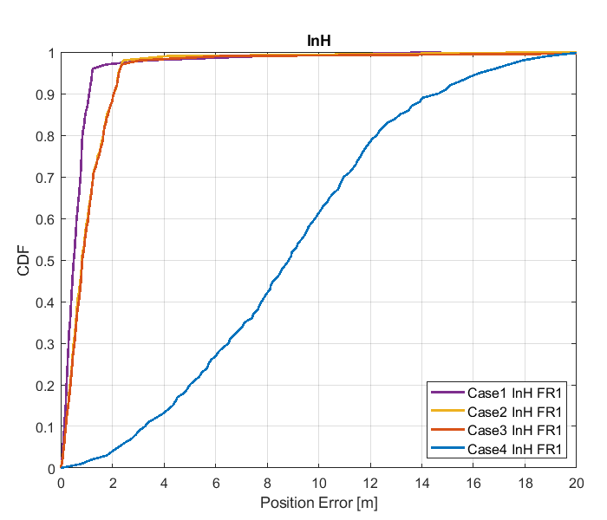

Figure 8.3.1.1-1: Results for FR1 from [10]

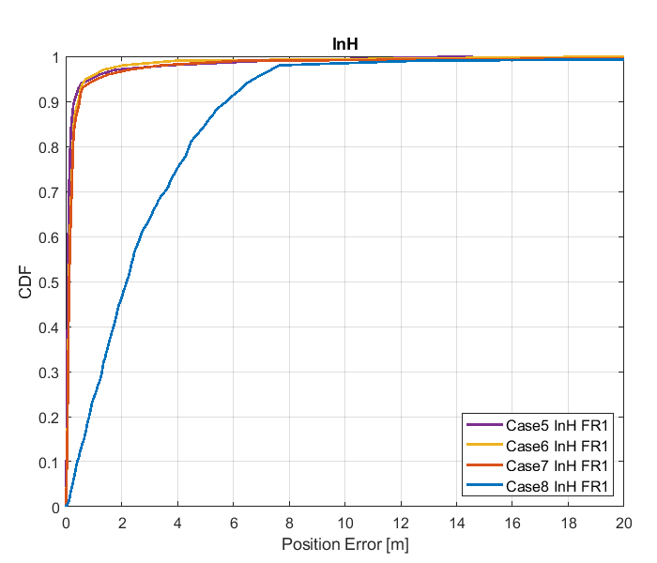

Figure 8.3.1.1-2: Results for FR1 from [10]

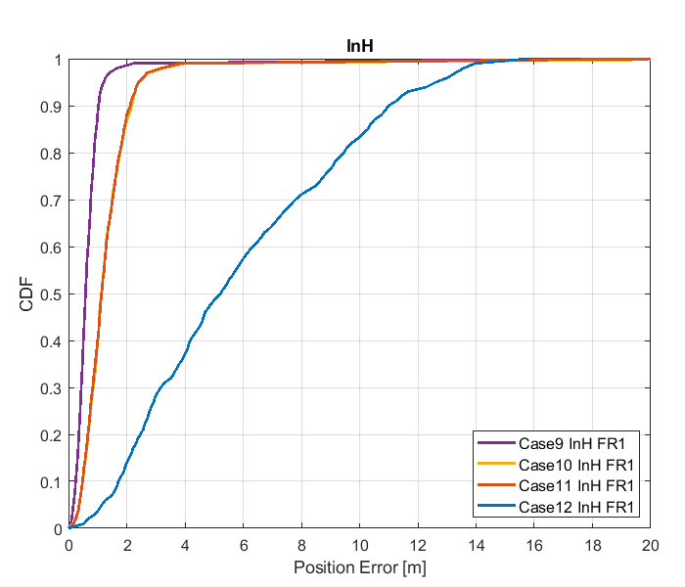

Figure 8.3.1.1-3: Results for FR1 from [10]

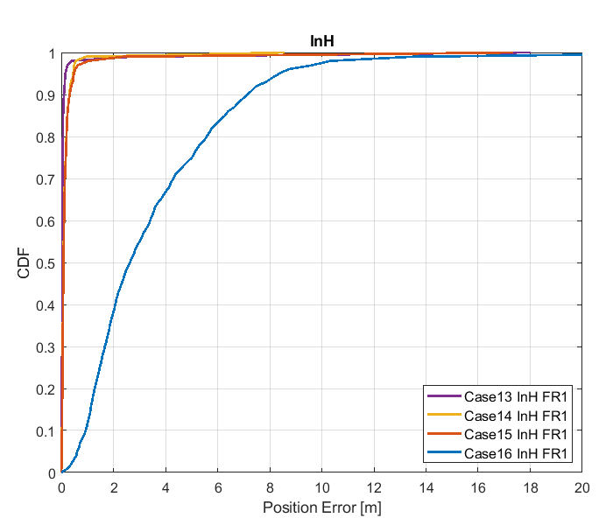

Figure 8.3.1.1-4: Results for FR1 from [10]

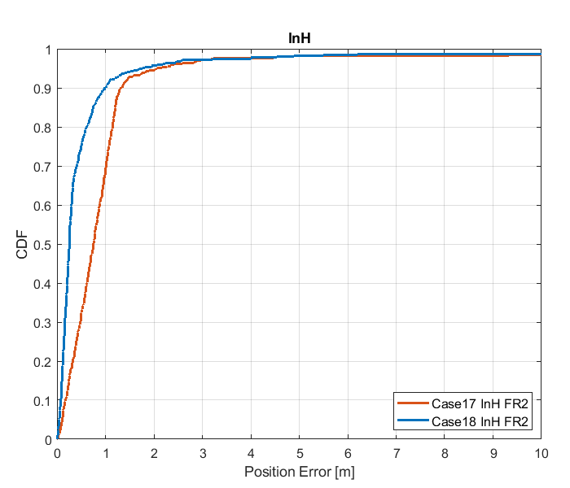

Figure 8.3.1.1-5: Results for FR2 from [10]

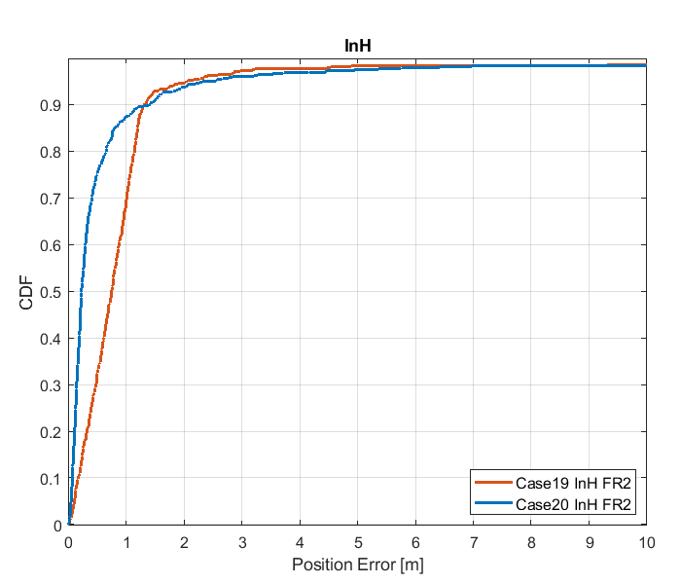

Figure 8.3.1.1-6: Results for FR2 from [10]

Table 8.3.1.1-4: Results for FR1 from [10]

|  |  |  |  |  |  |  |
| --- | --- | --- | --- | --- | --- | --- |
|  |  | Source | 50% | 67% | 80% | 90% |
| FR1 | InH | Case 1 InH FR1 | 0.5 | 0.7 | 0.8 | 1.1 |
| Case 2 InH FR1 | 0.8 | 1.2 | 1.7 | 2.1 |
| Case 3 InH FR1 | 0.8 | 1.2 | 1.7 | 2.1 |
| Case 4 InH FR1 | 8.8 | 10.7 | 12.3 | 14.6 |
| Case 5 InH FR1 | 0.1 | 0.1 | 0.2 | 0.3 |
| Case 6 InH FR1 | 0.1 | 0.2 | 0.3 | 0.5 |
| Case 7 InH FR1 | 0.1 | 0.2 | 0.3 | 0.5 |
| Case 8 InH FR1 | 2.2 | 3.3 | 4.4 | 5.8 |
| Case 9 InH FR1 | 0.6 | 0.7 | 0.9 | 1.0 |
| Case 10 InH FR1 | 1.1 | 1.4 | 1.8 | 2.2 |
| Case 11 InH FR1 | 1.1 | 1.4 | 1.8 | 2.1 |
| Case 12 InH FR1 | 5.2 | 7.4 | 9.5 | 11.0 |
| Case 13 InH FR1 | 0.04 | 0.05 | 0.06 | 0.1 |
| Case 14 InH FR1 | 0.08 | 0.1 | 0.2 | 0.3 |
| Case 15 InH FR1 | 0.09 | 0.1 | 0.2 | 0.3 |
| Case 16 InH FR1 | 2.6 | 4.0 | 5.6 | 7.2 |

Table 8.3.1.1-5: Results for FR2 from [10]

|  |  |  |  |  |  |  |
| --- | --- | --- | --- | --- | --- | --- |
|  |  | Source | 50% | 67% | 80% | 90% |
| FR2 | InH | Case 17 InH FR2 | 0.8 | 1.0 | 1.1 | 1.3 |
| Case 18 InH FR2 | 0.3 | 0.4 | 0.6 | 1.0 |
| Case 19 InH FR2 | 0.8 | 1.0 | 1.1 | 1.3 |
| Case 20 InH FR2 | 0.2 | 0.4 | 0.7 | 1.4 |

#### 8.3.1.2 Results from [19]

The parameters used for evaluation of the DL & UL based positioning in Scenario 1 (Indoor Open Office) are listed in Table 8.3.1.1-1 below.

Table 8.3.1.2-1: Parameters for Downlink and Uplink evaluations in Scenario 1

|  |  |  |  |
| --- | --- | --- | --- |
| Parameter | Setup 1 | Setup 2 | Setup 3 |
| Channel model (baseline, otherwise state any modifications) | Baseline | Baseline | Baseline |
| Carrier frequency | 4 GHz | 4 GHz | 30 GHz |
| Subcarrier spacing | 15 kHz | 30 kHz | 120 kHz |
| Reference Signal Transmission Bandwidth | 5 MHz | 100 MHz | 100 MHz |
| Reference Signal Physical Structure and Resource Allocation (RE pattern) (reference to figure in contribution) | DL: 12 REs per PRB, single symbol UL: 4 REs per PRB, 4 symbols | DL: 12 REs per PRB, single symbol UL: 4 REs per PRB, 4 symbols | DL: 12 REs per PRB, single symbol UL: 4 REs per PRB, 4 symbols |
| Reference signal (type of sequence, number of ports, …) | QPSK, Pseudo random, single Tx port | QPSK, Pseudo random, single Tx port | QPSK, Pseudo random, single Tx port |
| Number of sites | 12 sectors / 12 sites | 12 sectors / 12 sites | 36 sectors / 12 sites |
| Number of symbols used per occasion | DL: 1x12(sites)  UL: 4(symb)xUE number | DL: 1x12(sites)  UL: 4(symb)xUE number | DL: 8(beams)x36(sectors) UL: 4(symb)x8(beams)x 36(sectors) |
| Number of occasions used per positioning estimate | 1 | 1 | 1 |
| Power-boosting level | DL: 0 dB  UL: 6 dB | DL: 0 dB  UL: 6 dB | DL: 0 dB  UL: 6 dB |
| Uplink power control (applied/not applied) | Max power | Max power | Max power |
| Interference modelling (ideal muting, or other) | Ideal muting | Ideal muting | Ideal muting |
| Description of Measurement Algorithm (e.g. super resolution, interference cancellation, ….) | Threshold based algorithm for the first arrival path (FAP) estimation | Threshold based algorithm for the first arrival path (FAP) estimation | Threshold based algorithm for the first arrival path (FAP) estimation |
| Description of positioning technique / applied positioning algorithm (e.g. Least square, Taylor series, etc) | Taylor based, measurements above -15 dB are used for positioning | Taylor based, measurements above -15 dB are used for positioning | Taylor based, measurements above -15 dB are used for positioning |
| Network synchronization assumptions | Option 1: T1 = 0ns(Perfect)  Option 2: T1 = 50ns | Option 1: T1 = 0ns(Perfect)  Option 2: T1 = 50ns | Option 1: T1 = 0ns(Perfect)  Option 2: T1 = 50ns |
| Beam-related assumption (beam sweeping / alignment assumptions at the tx and rx sides) | No sweeping | No sweeping | DL: Tx sweeping  UL: Rx sweeping |
| Precoding assumptions (codebook, nrof antenna elements used, etc) | Single Tx port | Single Tx port | Single Tx port |
| Additional notes, if any |  |  |  |

The system level evaluation results for DL & UL positioning in Scenario 1 (Indoor Open Office) are provided below.

|  |
| --- |
| Figure 8.3.1.2-1 (a) FR1 evaluations    Figure 8.3.1.2-2 (b) FR2 evaluations |

#### 8.3.1.3 Results from [23]

The parameters corresponding to the results are listed in table 8.3.1.3-1 below.

Table 8.3.1.3-1: Parameters for Downlink and Uplink evaluations in Scenario 1

|  |  |  |  |  |  |
| --- | --- | --- | --- | --- | --- |
| Parameter | [23], FR1, 100 MHz | [23], FR1, 50 MHz | [23], FR1, 5 MHz | [23], FR2, 400 MHz | [23], FR2, 100 MHz |
| Channel model (baseline, otherwise state any modifications) | Baseline Channel Model based on common assumptions defined related to the channel models of 3GPP TRs 38.901 / 38.802 / 37.857. | | | | |
| Carrier frequency | 4 GHz | | | 30 GHz | |
| Subcarrier spacing | 30 KHz | 15 KHz | 15 KHz | 120 KHz | |
| Reference Signal Transmission Bandwidth | 100 MHz | 50 MHz | 5 MHz | 400 MHz | 100 MHz |
| Reference Signal Physical Structure and Resource Allocation (RE pattern) (reference to figure in contribution) | Comb-1 with 1-symbol PRS resource | | | | |
| Reference signal (type of sequence, number of ports, …) | 1-port, QPSK sequence | | | | |
| Number of sites | 12 | | | | |
| Number of symbols used per occasion | 1 | | | | |
| number of occasions used per positioning estimate | 1 | | | | |
| Power-boosting level | 0 dB | | | | |
| Uplink power control (applied/not applied) | Not applied (23 dBm Tx) | | | | |
| interference modelling (ideal muting, or other) | Ideal muting for DL, interference from 4 UEs in UL | | | | |
| Description of Measurement Algorithm (e.g. super resolution, interference cancellation, ….) | TOA estimation without oversampling with TOA pruning before the positioning engine using the ratio of the estimated TOA peak over the median of the Channel Energy Response (CER). | | | | |
| Description of positioning technique / applied positioning algorithm (e.g. Least square, Taylor series, etc) | For multi-RTT, the algebraic solution proposed in  -Norrdine, Abdelmoumen. (2015). An Algebraic Solution to the Multilateration Problem. 10.13140/RG.2.1.1681.3602.  Equal weight is used in the TOA covariance matrix. | | | | |
| Network synchronization assumptions | Perfect Sync and Realistic Sync with T1 = 50 nsec | | | | |
| Beam-related assumption (beam sweeping / alignment assumptions at the tx and rx sides) | The best beam pair is identified based on the criteria of receiving the earliest path given that the received power is larger than a threshold (20 dB lower than the maximum received power) using the genie CDL channel profiles. For a single sector scenario (only Indoor hotspop 4GHz), the directions of beams are within [, 180] degress in azimuth and [,180] degrees in zenith. For a 3-sector scenario, the directions of beams are within [, ] degress in azimuth and [,180] degrees in zenith. | | | | |
| Precoding assumptions (codebook, nrof antenna elements used, etc) | Kronecker product between vertical and horizontal weight vectors taken from DFT, with oversampling factor = 1. The DFT beam candidate in beam selection method is generated according to the uniform vertical and horizontal angular distribution shown as follows:  , for i=1,…,rN  where r denotes the oversampling factor, N denotes the number of vertical/horizontal antennas. For FR2, Tx oversampling factor r equals to 2 and Rx oversampling factor equals to 1. For FR1, Tx oversampling factor for 100 MHz is 4, for 50 MHz is 1, for 5 MHz is 1. | | | | |

The results corresponding to the Indoor open office scenario are provided below

Table 8.3.1.3-2: Results for downlink and uplink methods evaluations of Scenario 1 – Indoor Open Office

|  |  |  |  |  |  |
| --- | --- | --- | --- | --- | --- |
| Percentile | 50 | 67 | 80 | 90 | 95 |
| Multi-RTT, FR1, 100 MHz, Perfect & Realistic Sync | 1.2 | 1.7 | 2.3 | 3.2 | 4.3 |
| Multi-RTT, FR1, 50 MHz, Perfect & Realistic Sync | 5.1 | 8.1 | 13.4 | 24.9 | 36.7 |
| Multi-RTT, FR1, 5 MHz, Perfect & Realistic Sync | 15.3 | 22.1 | 29.8 | 42.5 | 57.2 |
| Multi-RTT, FR2, 400 MHz, Perfect & Realistic Sync | 0.4 | 0.7 | 1.8 | 5.2 | 12.7 |
| Multi-RTT, FR2, 100 MHz, Perfect & Realistic Sync | 1.5 | 2.2 | 3.1 | 5.7 | 10.6 |

#### 8.3.1.4 Results from [24]

Table 8.3.1.4-1: Parameters for Downlink and Uplink evaluations in Scenario 1

|  |  |
| --- | --- |
| Parameter | InH, FR1 |
| Channel model (baseline, otherwise state any modifications) | Mixed and Open office according to TR38.901 |
| Carrier frequency | 4 GHz |
| Subcarrier spacing | 15 kHz for 5 MHz  15 kHz for 50 MHz  30 kHz for 100 MHz |
| Reference Signal Transmission Bandwidth | 5, 50 and 100MHz |
| Reference signal (type of sequence, number of ports, …) | SRS, 1 antenna port, comb 2 structure |
| Number of sites | 12 |
| Number of symbols used per occasion | 1 |
| number of occasions used per positioning estimate | 1 |
| Power-boosting level | No boosting |
| Uplink power control (applied/not applied) | Alpha = 0, P0 = 10dBm |
| interference modelling (ideal muting, or other) | No interference |
| Description of Measurement Algorithm (e.g. super resolution, interference cancellation, ….) | Detect the first peak up to 9dB below the maximum peak. An interpolation factor of 10 is applied to the cross-correlation. The TOA is estimated based on the inflection point of the rising edge of the first detected peak. |
| Description of positioning technique / applied positioning algorithm (e.g. Least squares, Taylor series, etc) | Least squares |
| Network synchronization assumptions | Perfectly synchronized |
| Beam-related assumption (beam sweeping / alignment assumptions at the tx and rx sides) | Beam selection: Assign UEs to the best gNB with respect to the RSRP (at gNB: rx side). |
| Precoding assumptions (codebook, nrof antenna elements used, etc) | TXRU virtualization:  2 TXRU per dimension per polarization.  M_TXRU = 2, N_TXRU = 2  Analog beamforming for (gNB and UE):  weights are obtained by taking the Kronecker product of the vertical and horizontal weight vectors as described in 2D sub-array partition model in TR 36.897 |
| Additional notes, if any | TOAs are filtered based on the measurement quality before applying them in positioning. |



Figure 8.3.1.4-1: FR1 RTT 2D positioning error for mixed office scenario for 5, 50, 100MHz SRS configurations



Figure 8.3.1.4-2: FR1 RTT 2D positioning error for open office scenario for 5, 50, 100MHz SRS configurations

Table 8.3.1.4-1

|  |  |  |  |  |  |  |
| --- | --- | --- | --- | --- | --- | --- |
|  |  | 50% | 70% | 80% | 90% | 95% |
| **RTT** | **InH Open Office** | | | | | |
| 4 GHz/30 kHz/100 MHz | 0.57 m | 0.68 m | 0.75 m | 0.82 m | 0.91 m |
| 4 GHz/15 kHz/50 MHz | 0.67 m | 0.86 m | 0.95 m | 1.10 m | 1.18 m |
| 4 GHz/15 kHz/5 MHz | 3.32 m | 4.03 m | 4.36 m | 4.75 m | 5.37 m |
| **InH Mixed Office** | | | | | |
| 4 GHz/30 kHz/100 MHz | 0.86 m | 1.15 m | 1.41 m | 1.70 m | 2.06 m |
| 4 GHz/15k Hz/50 MHz | 1.70 m | 2.07 m | 2.36 m | 2.78 m | 3.20 m |
| 4 GHz/15 kHz/5 MHz | 7.66 m | 9.60 m | 10.62 m | 11.98 m | 13.18 m |

#### 8.3.1.5 Results from [25]

The parameters corresponding to the results are listed in table 8.3.1.5-1 below.

Table 8.3.1.5-1: Parameters for Downlink and uplink evaluations in Scenario 1

|  |  |
| --- | --- |
| Parameter | Figure 8.3.1.5-2, A to F |
| Channel model (baseline, otherwise state any modifications) | IOO  FR1 |
| Carrier frequency | 4GHz |
| Subcarrier spacing | 30khz |
| Reference Signal Transmission Bandwidth | 100MHz |
| Reference Signal Physical Structure and Resource Allocation (RE pattern) (reference to figure in contribution) |  |
| Reference signal (type of sequence, number of ports, …) | 1 port, TRS in DL and SRS in UL |
| Number of sites | 12 |
| Number of symbols used per occasion | 4 |
| number of occasions used per positioning estimate | 1 |
| Power-boosting level | 0 |
| Uplink power control (applied/not applied) |  |
| interference modelling (ideal muting, or other) | None |
| Description of Measurement Algorithm (e.g. super resolution, interference cancellation, ….) |  |
| Description of positioning technique / applied positioning algorithm (e.g. Least square, Taylor series, etc) | See below |
| Network synchronization assumptions | no error |
| Beam-related assumption (beam sweeping / alignment assumptions at the tx and rx sides) | N/A |
| Precoding assumptions (codebook, nrof antenna elements used, etc) | None |
| Additional notes, if any |  |

The results corresponding to the Indoor open office scenario are provided below



Figure 8.3.1.5-1: Agreed evaluation setup for IOO scenario.

Figure 6 shows the agreed setup for the IOO scenario, FR1. As can be seen the base stations are placed in two rows of six columns each. For the sake of ease of discussions, numbers are assigned to the base stations in the Figure 6.

In this scenario, we investigate the performance of different configurations of RTT and overhearing nodes. The following measurements and procedure information cases are considered:

A) Positioning information from RTT procedures with all 12 nodes is considered for each UE. This corresponds to 12 DL and 12 UL signals being transmitted in the considered setup, where the DL signals can either be dedicated or common, addressing additional information i, k or m in the list in section 3.

B) The RTT procedure is only configured for a boundary node (node 1 in Figure 6), but all other nodes are overhearing the signaling exchange. Here, only 1 DL and 1 UL signal is configured, corresponding to additional information f, h, j, l.

C) The RTT procedure is only configured for a center node (node 5 in Figure 6), but all other nodes are overhearing the signaling exchange. Here, only 1 DL and 1 UL signal is configured, corresponding to additional information f, h, j, l.

D) The RTT procedure is only configured for two center nodes (nodes 5 and 6 in Figure 6), but all other nodes are overhearing the signaling exchange. Here, only 2 DL and 2 UL signal is configured, corresponding to additional information f, h, j, l.

E) The RTT procedure is configured with all nodes, and all nodes are overhearing the signaling exchange, This corresponds to 12 DL and 12 UL signals being transmitted in the considered setup, where the DL signals can either be dedicated or common, addressing additional information f, h, j, m in the list in section 3.

F) DL DL-TDOA for reference

The resulting positioning accuracy performance is summarized in Figure 7, and the 80-percentile performance accuracy together with some signaling costs are summarized in Table 8.3.1.5-2.

Table 8.3.1.5-2: Positioning accuracy 80 percentile and DL and UL signaling load per UE

|  |  |  |  |  |  |  |
| --- | --- | --- | --- | --- | --- | --- |
|  | A | B | C | D | E | D |
| 80% acc | 1.4m | 2.8m | 2.6m | 2.1m | 1.4m | 1.6m |
| DL cost/UE | 12 | 1 | 1 | 2 | 12 | 12 |
| UL cost/UE | 12 | 1 | 1 | 2 | 12 | 0 |

### 8.3.2 System simulations for Scenario 2 - UMi

#### 8.3.2.1 Results from [10]

Table 8.3.2.1-1: Parameters details for FR1 from [10]

|  |  |  |  |  |  |  |  |  |
| --- | --- | --- | --- | --- | --- | --- | --- | --- |
| Parameter | Case 1 UMi, FR1 | Case 2 UMi, FR1 | Case 3 UMi, FR1 | Case 4 UMi, FR1 | Case 5 UMi, FR1 | Case 6 UMi, FR1 | Case 7 UMi, FR1 | Case 8 UMi, FR1 |
| Channel model (baseline, otherwise state any modifications) | 38.901 | 38.901 | 38.901 | 38.901 | 38.901 | 38.901 | 38.901 | 38.901 |
| Carrier frequency | 4GHz | 4GHz | 2GHz | 2GHz | 4GHz | 4GHz | 2GHz | 2GHz |
| Subcarrier spacing | 30kHz | 15kHz | 15kHz | 15kHz | 30kHz | 15kHz | 15kHz | 15kHz |
| Reference Signal Transmission Bandwidth | 100MHz | 50MHz | 50MHz | 5MHz | 100MHz | 50MHz | 50MHz | 5MHz |
| Reference Signal Physical Structure and Resource Allocation (RE pattern) (reference to figure in contribution) | DL: Comb-6  UL: Comb-4 | DL: Comb-6  UL: Comb-4 | DL: Comb-6  UL: Comb-4 | DL: Comb-6  UL: Comb-4 | DL: Comb-6  UL: Comb-4 | DL: Comb-6  UL: Comb-4 | DL: Comb-6  UL: Comb-4 | DL: Comb-6  UL: Comb-4 |
| Reference signal (type of sequence, number of ports, …) | DL: PRS, Gold, 1-port  UL: SRS, ZC, 1-port | DL: PRS, Gold, 1-port  UL: SRS, ZC, 1-port | DL: PRS, Gold, 1-port  UL: SRS, ZC, 1-port | DL: PRS, Gold, 1-port  UL: SRS, ZC, 1-port | DL: PRS, Gold, 1-port  UL: SRS, ZC, 1-port | DL: PRS, Gold, 1-port  UL: SRS, ZC, 1-port | DL: PRS, Gold, 1-port  UL: SRS, ZC, 1-port | DL: PRS, Gold, 1-port  UL: SRS, ZC, 1-port |
| Number of sites | 19 | 19 | 19 | 19 | 19 | 19 | 19 | 19 |
| Number of symbols used per occasion | DL: 8  UL: 4 | DL: 8  UL: 4 | DL: 8  UL: 4 | DL: 8  UL: 4 | DL: 8  UL: 4 | DL: 8  UL: 4 | DL: 8  UL: 4 | DL: 8  UL: 4 |
| number of occasions used per positioning estimate | 4 | 4 | 4 | 4 | 4 | 4 | 4 | 4 |
| Power-boosting level | DL: 7.8dB  UL: 6dB | DL: 7.8dB  UL: 6dB | DL: 7.8dB  UL: 6dB | DL: 7.8dB  UL: 6dB | DL: 7.8dB  UL: 6dB | DL: 7.8dB  UL: 6dB | DL: 7.8dB  UL: 6dB | DL: 7.8dB  UL: 6dB |
| Uplink power control (applied/not applied) | Not applied | Not applied | Not applied | Not applied | Not applied | Not applied | Not applied | Not applied |
| interference modelling (ideal muting, or other) | Ideal muting | Ideal muting | Ideal muting | Ideal muting | Ideal muting | Ideal muting | Ideal muting | Ideal muting |
| Description of Measurement Algorithm (e.g. super resolution, interference cancellation, ….) | Regular | Regular | Regular | Regular | Super resolution (MUSIC) | Super resolution (MUSIC) | Super resolution (MUSIC) | Super resolution (MUSIC) |
| Description of positioning technique / applied positioning algorithm (e.g. Least square, Taylor series, etc) | E-CID | E-CID | E-CID | E-CID | E-CID | E-CID | E-CID | E-CID |
| Network synchronization assumptions | No sync error | No sync error | No sync error | No sync error | No sync error | No sync error | No sync error | No sync error |
| Beam-related assumption (beam sweeping / alignment assumptions at the tx and rx sides) | N/A | N/A | N/A | N/A | N/A | N/A | N/A | N/A |
| Precoding assumptions (codebook, nrof antenna elements used, etc) | SVD | SVD | SVD | SVD | SVD | SVD | SVD | SVD |
| Additional notes, if any |  |  |  |  |  |  |  |  |

Table 8.3.2.1-2: Parameters details for FR1 from [10]

|  |  |  |  |  |  |  |  |  |
| --- | --- | --- | --- | --- | --- | --- | --- | --- |
| Parameter | Case 9 UMi, FR1 | Case 10 UMi, FR1 | Case 11 UMi, FR1 | Case 12 UMi, FR1 | Case 13 UMi, FR1 | Case 14 UMi, FR1 | Case 15 UMi, FR1 | Case 16 UMi, FR1 |
| Channel model (baseline, otherwise state any modifications) | 38.901 | 38.901 | 38.901 | 38.901 | 38.901 | 38.901 | 38.901 | 38.901 |
| Carrier frequency | 4GHz | 4GHz | 2GHz | 2GHz | 4GHz | 4GHz | 2GHz | 2GHz |
| Subcarrier spacing | 30kHz | 15kHz | 15kHz | 15kHz | 30kHz | 15kHz | 15kHz | 15kHz |
| Reference Signal Transmission Bandwidth | 100MHz | 50MHz | 50MHz | 5MHz | 100MHz | 50MHz | 50MHz | 5MHz |
| Reference Signal Physical Structure and Resource Allocation (RE pattern) (reference to figure in contribution) | DL: Comb-6  UL: Comb-4 | DL: Comb-6  UL: Comb-4 | DL: Comb-6  UL: Comb-4 | DL: Comb-6  UL: Comb-4 | DL: Comb-6  UL: Comb-4 | DL: Comb-6  UL: Comb-4 | DL: Comb-6  UL: Comb-4 | DL: Comb-6  UL: Comb-4 |
| Reference signal (type of sequence, number of ports, …) | DL: PRS, Gold, 1-port  UL: SRS, ZC, 1-port | DL: PRS, Gold, 1-port  UL: SRS, ZC, 1-port | DL: PRS, Gold, 1-port  UL: SRS, ZC, 1-port | DL: PRS, Gold, 1-port  UL: SRS, ZC, 1-port | DL: PRS, Gold, 1-port  UL: SRS, ZC, 1-port | DL: PRS, Gold, 1-port  UL: SRS, ZC, 1-port | DL: PRS, Gold, 1-port  UL: SRS, ZC, 1-port | DL: PRS, Gold, 1-port  UL: SRS, ZC, 1-port |
| Number of sites | 19 | 19 | 19 | 19 | 19 | 19 | 19 | 19 |
| Number of symbols used per occasion | DL: 8  UL: 4 | DL: 8  UL: 4 | DL: 8  UL: 4 | DL: 8  UL: 4 | DL: 8  UL: 4 | DL: 8  UL: 4 | DL: 8  UL: 4 | DL: 8  UL: 4 |
| number of occasions used per positioning estimate | 4 | 4 | 4 | 4 | 4 | 4 | 4 | 4 |
| Power-boosting level | DL: 7.8dB  UL: 6dB | DL: 7.8dB  UL: 6dB | DL: 7.8dB  UL: 6dB | DL: 7.8dB  UL: 6dB | DL: 7.8dB  UL: 6dB | DL: 7.8dB  UL: 6dB | DL: 7.8dB  UL: 6dB | DL: 7.8dB  UL: 6dB |
| Uplink power control (applied/not applied) | Not applied | Not applied | Not applied | Not applied | Not applied | Not applied | Not applied | Not applied |
| interference modelling (ideal muting, or other) | Ideal muting | Ideal muting | Ideal muting | Ideal muting | Ideal muting | Ideal muting | Ideal muting | Ideal muting |
| Description of Measurement Algorithm (e.g. super resolution, interference cancellation, ….) | Regular | Regular | Regular | Regular | Super resolution (MUSIC) | Super resolution (MUSIC) | Super resolution (MUSIC) | Super resolution (MUSIC) |
| Description of positioning technique / applied positioning algorithm (e.g. Least square, Taylor series, etc) | Multi-RTT, PSO algorithm | Multi-RTT, PSO algorithm | Multi-RTT, PSO algorithm | Multi-RTT, PSO algorithm | Multi-RTT, PSO algorithm | Multi-RTT, PSO algorithm | Multi-RTT, PSO algorithm | Multi-RTT, PSO algorithm |
| Network synchronization assumptions | No sync error | No sync error | No sync error | No sync error | No sync error | No sync error | No sync error | No sync error |
| Beam-related assumption (beam sweeping / alignment assumptions at the tx and rx sides) | N/A | N/A | N/A | N/A | N/A | N/A | N/A | N/A |
| Precoding assumptions (codebook, nrof antenna elements used, etc) | SVD | SVD | SVD | SVD | SVD | SVD | SVD | SVD |
| Additional notes, if any |  |  |  |  |  |  |  |  |

Table 8.3.2.1-3: Parameters details for FR2 from [10]

|  |  |  |  |  |
| --- | --- | --- | --- | --- |
| Parameter | Case 17 UMi, FR2 | Case 18 UMi FR2 | Case 19 UMi, FR2 | Case 20 UMi FR2 |
| Channel model (baseline, otherwise state any modifications) | 38.901 | 38.901 | 38.901 | 38.901 |
| Carrier frequency | 30GHz | 30GHz | 30GHz | 30GHz |
| Subcarrier spacing | 120kHz | 120kHz | 120kHz | 120kHz |
| Reference Signal Transmission Bandwidth | 100MHz | 400MHz | 100MHz | 400MHz |
| Reference Signal Physical Structure and Resource Allocation (RE pattern) (reference to figure in contribution) | DL: Comb-6  UL: Comb-4 | DL: Comb-6  UL: Comb-4 | DL: Comb-6  UL: Comb-4 | DL: Comb-6  UL: Comb-4 |
| Reference signal (type of sequence, number of ports, …) | DL: PRS, Gold, 1-port  UL: SRS, ZC, 1-port | DL: PRS, Gold, 1-port  UL: SRS, ZC, 1-port | DL: PRS, Gold, 1-port  UL: SRS, ZC, 1-port | DL: PRS, Gold, 1-port  UL: SRS, ZC, 1-port |
| Number of sites | 7 | 7 | 7 | 7 |
| Number of symbols used per occasion | DL: 8  UL: 4 | DL: 8  UL: 4 | DL: 8  UL: 4 | DL: 8  UL: 4 |
| number of occasions used per positioning estimate | 4 | 4 | 4 | 4 |
| Power-boosting level | DL: 7.8dB  UL: 6dB | DL: 7.8dB  UL: 6dB | DL: 7.8dB  UL: 6dB | DL: 7.8dB  UL: 6dB |
| Uplink power control (applied/not applied) | Not applied | Not applied | Not applied | Not applied |
| interference modelling (ideal muting, or other) | Ideal muting | Ideal muting | Ideal muting | Ideal muting |
| Description of Measurement Algorithm (e.g. super resolution, interference cancellation, ….) | Regular | Regular | Regular | Regular |
| Description of positioning technique / applied positioning algorithm (e.g. Least square, Taylor series, etc) | E-CID | E-CID | Multi-RTT, Tylor expansion | Multi-RTT, Tylor expansion |
| Network synchronization assumptions | Sync error 0ns | Sync error 0ns | Sync error 0ns | Sync error 0ns |
| Beam-related assumption (beam sweeping / alignment assumptions at the tx and rx sides) | BPL with Largest RSRP | BPL with Largest RSRP | BPL with Largest RSRP | BPL with Largest RSRP |
| Precoding assumptions (codebook, nrof antenna elements used, etc) | DFT codebook | DFT codebook | DFT codebook | DFT codebook |
| Additional notes, if any |  |  |  |  |

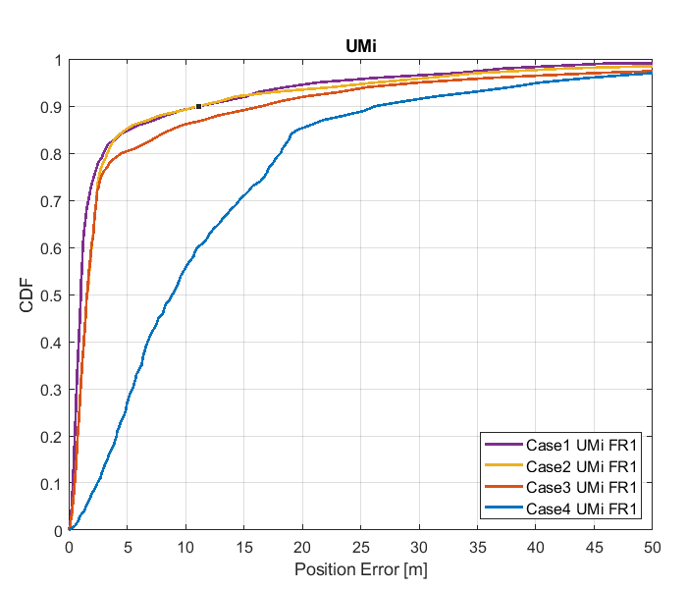

Figure 8.3.2.1-1: Results for FR1 from [10]

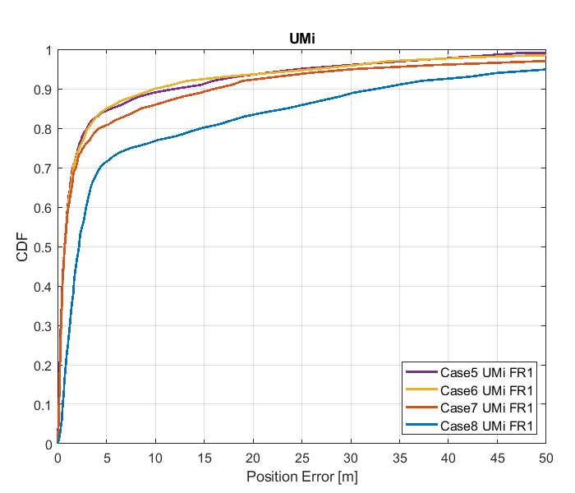

Figure 8.3.2.1-2: Results for FR1 from [10]

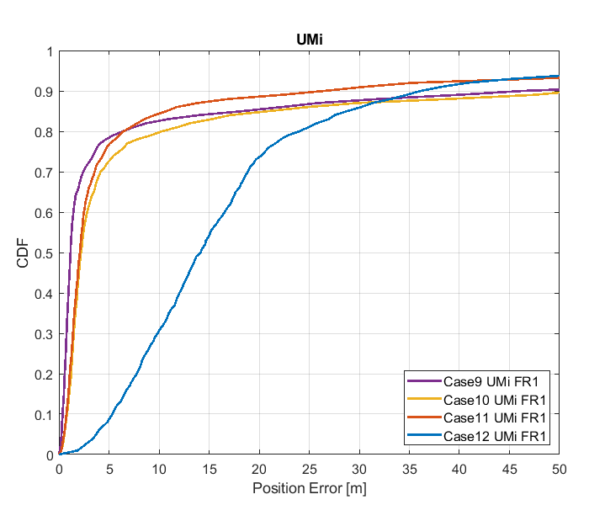

Figure 8.3.2.1-3: Results for FR1 from [10]

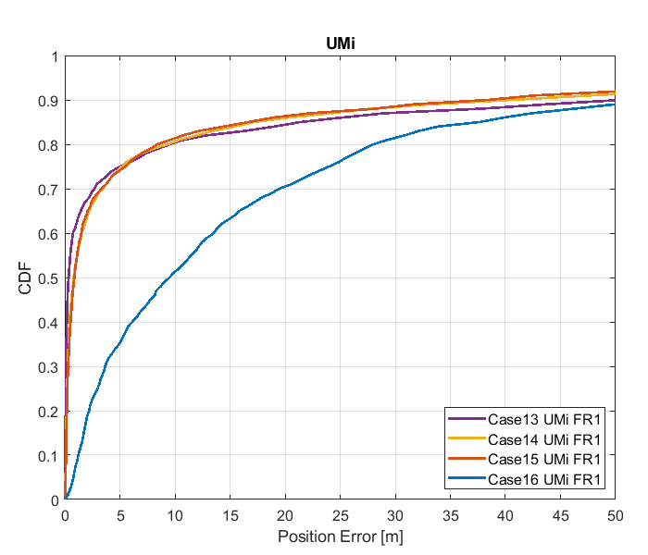

Figure 8.3.2.1-4: Results for FR1 from [10]

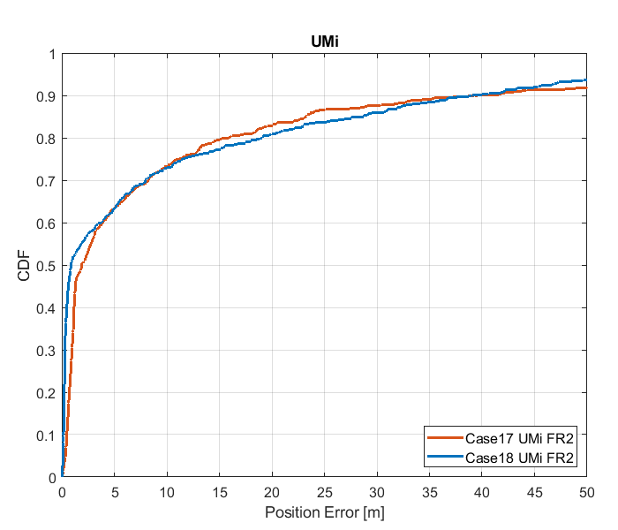

Figure 8.3.2.1-5: Results for FR2 from [10]

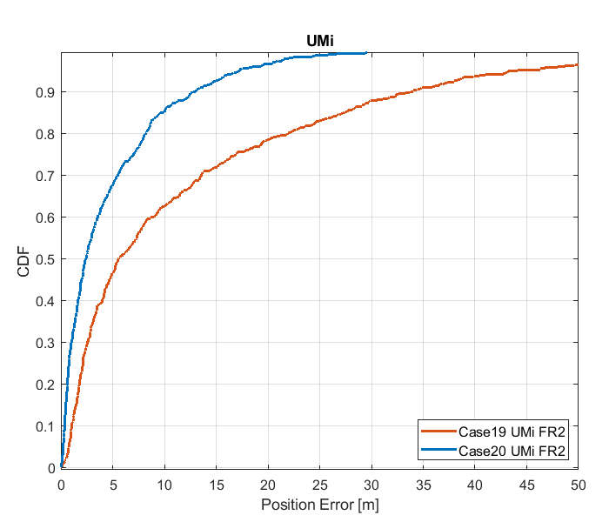

Figure 8.3.2.1-6: Results for FR2 from [10]

Table 8.3.2.1-4 Results for FR1 from [10]

|  |  |  |  |  |  |  |
| --- | --- | --- | --- | --- | --- | --- |
|  |  | Source | 50% | 67% | 80% | 90% |
| FR1 | UMi | Case 1 UMi FR1 | 1.0 | 1.5 | 3.0 | 11.3 |
| Case 2 UMi FR1 | 1.6 | 2.2 | 3.3 | 11.2 |
| Case 3 UMi FR1 | 1.6 | 2.2 | 4.6 | 16.7 |
| Case 4 UMi FR1 | 8.9 | 13.6 | 18.2 | 28.3 |
| Case 5 UMi FR1 | 0.7 | 1.4 | 3.1 | 12.1 |
| Case 6 UMi FR1 | 0.7 | 1.4 | 3.2 | 10.1 |
| Case 7 UMi FR1 | 0.7 | 1.6 | 4.3 | 16.2 |
| Case 8 UMi FR1 | 2.2 | 3.8 | 14.7 | 32.7 |
| Case 9 UMi FR1 | 1.2 | 2.0 | 6.4 | 46.7 |
| Case 10 UMi FR1 | 2.2 | 3.7 | 10.3 | 52.0 |
| Case 11 UMi FR1 | 2.2 | 3.2 | 6.5 | 26.6 |
| Case 12 UMi FR1 | 14.1 | 18.2 | 24.0 | 36.2 |
| Case 13 UMi FR1 | 0.4 | 1.9 | 9.6 | 50.7 |
| Case 14 UMi FR1 | 0.8 | 2.7 | 9.4 | 40.6 |
| Case 15 UMi FR1 | 0.9 | 2.4 | 8.5 | 39.1 |
| Case 16 UMi FR1 | 9.5 | 17.3 | 28.0 | 53.5 |

Table 8.3.2.1-5: Results for FR2 from [10]

|  |  |  |  |  |  |  |
| --- | --- | --- | --- | --- | --- | --- |
|  |  | Source | 50% | 67% | 80% | 90% |
| FR2 | UMi | Case 17 UMi FR2 | 1.9 | 6.5 | 15.4 | 39.3 |
| Case 18 UMi FR2 | 0.9 | 6.4 | 18.9 | 39.1 |
| Case 19 UMi FR2 | 5.6 | 12.5 | 21.9 | 33.7 |
| Case 20 UMi FR2 | 2.4 | 4.8 | 8.2 | 12.7 |

#### 8.3.2.2 Results from [19]

The parameters used for evaluation of the DL & UL based positioning in Scenario 2 (UMi) are listed in Table 8.3.2.1-1 below.

Table 8.3.2.2-1: Parameters for Downlink and Uplink evaluations in Scenario 2

|  |  |  |  |
| --- | --- | --- | --- |
| Parameter | Setup 1 | Setup 2 | Setup 3 |
| Channel model (baseline, otherwise state any modifications) | Baseline | Baseline | Baseline |
| Carrier frequency | 4 GHz | 4 GHz | 30 GHz |
| Subcarrier spacing | 15 kHz | 30 kHz | 120 kHz |
| Reference Signal Transmission Bandwidth | 5 MHz | 100 MHz | 100 MHz |
| Reference Signal Physical Structure and Resource Allocation (RE pattern) (reference to figure in contribution) | DL: 12 REs per PRB, single symbol UL: 4 REs per PRB, 4 symbols | DL: 12 REs per PRB, single symbol UL: 4 REs per PRB, 4 symbols | DL: 12 REs per PRB, single symbol UL: 4 REs per PRB, 4 symbols |
| Reference signal (type of sequence, number of ports, …) | QPSK, Pseudo random, single Tx port | QPSK, Pseudo random, single Tx port | QPSK, Pseudo random, single Tx port |
| Number of sites | 57 sectors / 19 sites | 57 sectors / 19 sites | 57 sectors / 19 sites |
| Number of symbols used per occasion | DL: 1x57(sites)  UL: 4(symb)xUE number | DL: 1x57(sites)  UL: 4(symb)xUE number | DL: 16(beams)x57(sectors) UL: 4(symb)x16(beams)x 57(sectors) |
| Number of occasions used per positioning estimate | 1 | 1 | 1 |
| Power-boosting level | DL: 0 dB  UL: 6 dB | DL: 0 dB  UL: 6 dB | DL: 0 dB  UL: 6 dB |
| Uplink power control (applied/not applied) | Max power | Max power | Max power |
| Interference modelling (ideal muting, or other) | Ideal muting | Ideal muting | Ideal muting |
| Description of Measurement Algorithm (e.g. super resolution, interference cancellation, ….) | Threshold based algorithm for the first arrival path (FAP) estimation | Threshold based algorithm for the first arrival path (FAP) estimation | Threshold based algorithm for the first arrival path (FAP) estimation |
| Description of positioning technique / applied positioning algorithm (e.g. Least square, Taylor series, etc) | Taylor based, measurements above -15 dB are used for positioning | Taylor based, measurements above -15 dB are used for positioning | Taylor based, measurements above -15 dB are used for positioning |
| Network synchronization assumptions | Option 1: T1 = 0ns(Perfect)  Option 2: T1 = 50ns | Option 1: T1 = 0ns(Perfect)  Option 2: T1 = 50ns | Option 1: T1 = 0ns(Perfect)  Option 2: T1 = 50ns |
| Beam-related assumption (beam sweeping / alignment assumptions at the tx and rx sides) | No sweeping | No sweeping | DL: Tx sweeping  UL: Rx sweeping |
| Precoding assumptions (codebook, nrof antenna elements used, etc) | Single Tx port | Single Tx port | Single Tx port |
| Additional notes, if any |  |  |  |

The system level evaluation results for DL & UL positioning in Scenario 2 (UMi) are provided below.

|  |
| --- |
| Figure 8.3.2.2-1 (a) FR1 evaluations    Figure 8.3.2.2-2 (b) FR2 evaluations |

#### 8.3.2.3 Results from [23]

The parameters corresponding to the results are listed in table 8.3.2.3-1 below.

Table 8.3.2.3-1: Parameters for Downlink and Uplink evaluations in Scenario 2

|  |  |  |  |  |  |
| --- | --- | --- | --- | --- | --- |
| Parameter | [23], FR1, 100 MHz | [23], FR1, 50 MHz | [23], FR1, 5 MHz | [23], FR2, 400 MHz | [23], FR2, 100 MHz |
| Channel model (baseline, otherwise state any modifications) | Baseline Channel Model based on common assumptions defined related to the channel models of 3GPP TRs 38.901 / 38.802 / 37.857. | | | | |
| Carrier frequency | 4 GHz | | | 30 GHz | |
| Subcarrier spacing | 30 KHz | 15 KHz | 15 KHz | 120 KHz | |
| Reference Signal Transmission Bandwidth | 100 MHz | 50 MHz | 5 MHz | 400 MHz | 100 MHz |
| Reference Signal Physical Structure and Resource Allocation (RE pattern) (reference to figure in contribution) | Comb-1 with 1-symbol PRS resource | | | | |
| Reference signal (type of sequence, number of ports, …) | 1-port, QPSK sequence | | | | |
| Number of sites | 19 | | | | |
| Number of symbols used per occasion | 1 | | | | |
| number of occasions used per positioning estimate | 1 | | | | |
| Power-boosting level | 0 dB | | | | |
| Uplink power control (applied/not applied) | Not applied (23 dBm Tx) | | | | |
| interference modelling (ideal muting, or other) | Ideal muting for DL, interference from 4 UEs in UL | | | | |
| Description of Measurement Algorithm (e.g. super resolution, interference cancellation, ….) | TOA estimation without oversampling with TOA pruning before the positioning engine using the ratio of the estimated TOA peak over the median of the Channel Energy Response (CER). | | | | |
| Description of positioning technique / applied positioning algorithm (e.g. Least square, Taylor series, etc) | For multi-RTT, the algebraic solution proposed in  -Norrdine, Abdelmoumen. (2015). An Algebraic Solution to the Multilateration Problem. 10.13140/RG.2.1.1681.3602.  Equal weight is used in the TOA covariance matrix. | | | | |
| Network synchronization assumptions | Perfect Sync and Realistic Sync with T1 = 50 nsec | | | | |
| Beam-related assumption (beam sweeping / alignment assumptions at the tx and rx sides) | The best beam pair is identified based on the criteria of receiving the earliest path given that the received power is larger than a threshold (20 dB lower than the maximum received power) using the genie CDL channel profiles. For a single sector scenario (only Indoor hotspop 4GHz), the directions of beams are within [, 180] degress in azimuth and [,180] degrees in zenith. For a 3-sector scenario, the directions of beams are within [, ] degress in azimuth and [,180] degrees in zenith. | | | | |
| Precoding assumptions (codebook, nrof antenna elements used, etc) | Kronecker product between vertical and horizontal weight vectors taken from DFT, with oversampling factor = 1. The DFT beam candidate in beam selection method is generated according to the uniform vertical and horizontal angular distribution shown as follows:  , for i=1,…,rN  where r denotes the oversampling factor, N denotes the number of vertical/horizontal antennas. For FR2, Tx oversampling factor r equals to 2 and Rx oversampling factor equals to 1. For FR1, Tx oversampling factor equals to1. | | | | |

The results corresponding to the Indoor open office scenario are provided below

Table 8.3.2.3-2: Results for downlink and uplink methods evaluations of Scenario 2 – UMi

|  |  |  |  |  |  |
| --- | --- | --- | --- | --- | --- |
| Percentile | 50 | 67 | 80 | 90 | 95 |
| Multi-RTT, FR1, 100 MHz, Perfect & Realistic Sync | 2.8 | 4.6 | 8 | 16.6 | 28.1 |
| Multi-RTT, FR1, 50 MHz, Perfect & Realistic Sync | 4.4 | 6.4 | 9.5 | 15.8 | 27 |
| Multi-RTT, FR1, 5 MHz, Perfect & Realistic Sync | 17.9 | 23.3 | 29.8 | 38.1 | 45.3 |
| Multi-RTT, FR2, 400 MHz, Perfect & Realistic Sync | 1.1 | 2.6 | 5 | 11.6 | 24.2 |
| Multi-RTT, FR2, 100 MHz, Perfect & Realistic Sync | 2 | 3.4 | 5.8 | 11.3 | 21 |

### 8.3.3 System simulations for Scenario 3 - UMa

#### 8.3.3.1 Results from [10]

Table 8.3.3.1-1: Parameters details for FR1 from [10]

|  |  |  |  |  |  |  |  |  |
| --- | --- | --- | --- | --- | --- | --- | --- | --- |
| Parameter | Case 1 UMa, FR1 | Case 2 UMa, FR1 | Case 3 UMa, FR1 | Case 4 UMa, FR1 | Case 5 UMa, FR1 | Case 6 UMa, FR1 | Case 7 UMa, FR1 | Case 8 UMa, FR1 |
| Channel model (baseline, otherwise state any modifications) | 38.901 | 38.901 | 38.901 | 38.901 | 38.901 | 38.901 | 38.901 | 38.901 |
| Carrier frequency | 4GHz | 4GHz | 2GHz | 2GHz | 4GHz | 4GHz | 2GHz | 2GHz |
| Subcarrier spacing | 30kHz | 15kHz | 15kHz | 15kHz | 30kHz | 15kHz | 15kHz | 15kHz |
| Reference Signal Transmission Bandwidth | 100MHz | 50MHz | 50MHz | 5MHz | 100MHz | 50MHz | 50MHz | 5MHz |
| Reference Signal Physical Structure and Resource Allocation (RE pattern) (reference to figure in contribution) | DL: Comb-6  UL: Comb-4 | DL: Comb-6  UL: Comb-4 | DL: Comb-6  UL: Comb-4 | DL: Comb-6  UL: Comb-4 | DL: Comb-6  UL: Comb-4 | DL: Comb-6  UL: Comb-4 | DL: Comb-6  UL: Comb-4 | DL: Comb-6  UL: Comb-4 |
| Reference signal (type of sequence, number of ports, …) | DL: PRS, Gold, 1-port  UL: SRS, ZC, 1-port | DL: PRS, Gold, 1-port  UL: SRS, ZC, 1-port | DL: PRS, Gold, 1-port  UL: SRS, ZC, 1-port | DL: PRS, Gold, 1-port  UL: SRS, ZC, 1-port | DL: PRS, Gold, 1-port  UL: SRS, ZC, 1-port | DL: PRS, Gold, 1-port  UL: SRS, ZC, 1-port | DL: PRS, Gold, 1-port  UL: SRS, ZC, 1-port | DL: PRS, Gold, 1-port  UL: SRS, ZC, 1-port |
| Number of sites | 19 | 19 | 19 | 19 | 19 | 19 | 19 | 19 |
| Number of symbols used per occasion | DL: 8  UL: 4 | DL: 8  UL: 4 | DL: 8  UL: 4 | DL: 8  UL: 4 | DL: 8  UL: 4 | DL: 8  UL: 4 | DL: 8  UL: 4 | DL: 8  UL: 4 |
| number of occasions used per positioning estimate | 4 | 4 | 4 | 4 | 4 | 4 | 4 | 4 |
| Power-boosting level | DL: 7.8dB  UL: 6dB | DL: 7.8dB  UL: 6dB | DL: 7.8dB  UL: 6dB | DL: 7.8dB  UL: 6dB | DL: 7.8dB  UL: 6dB | DL: 7.8dB  UL: 6dB | DL: 7.8dB  UL: 6dB | DL: 7.8dB  UL: 6dB |
| Uplink power control (applied/not applied) | Not applied | Not applied | Not applied | Not applied | Not applied | Not applied | Not applied | Not applied |
| interference modelling (ideal muting, or other) | Ideal muting | Ideal muting | Ideal muting | Ideal muting | Ideal muting | Ideal muting | Ideal muting | Ideal muting |
| Description of Measurement Algorithm (e.g. super resolution, interference cancellation, ….) | Regular | Regular | Regular | Regular | Super resolution (MUSIC) | Super resolution (MUSIC) | Super resolution (MUSIC) | Super resolution (MUSIC) |
| Description of positioning technique / applied positioning algorithm (e.g. Least square, Taylor series, etc) | E-CID | E-CID | E-CID | E-CID | E-CID | E-CID | E-CID | E-CID |
| Network synchronization assumptions | No sync error | No sync error | No sync error | No sync error | No sync error | No sync error | No sync error | No sync error |
| Beam-related assumption (beam sweeping / alignment assumptions at the tx and rx sides) | N/A | N/A | N/A | N/A | N/A | N/A | N/A | N/A |
| Precoding assumptions (codebook, nrof antenna elements used, etc) | SVD | SVD | SVD | SVD | SVD | SVD | SVD | SVD |
| Additional notes, if any |  |  |  |  |  |  |  |  |

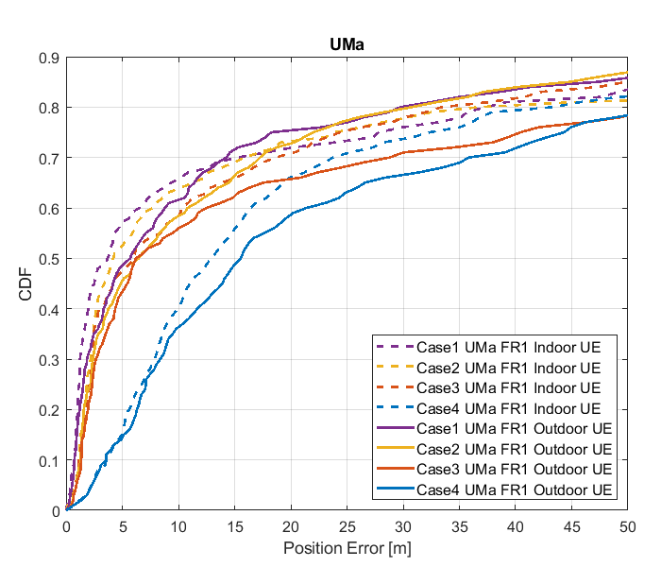

Figure 8.3.3.1-1: Results for FR1 from [10]

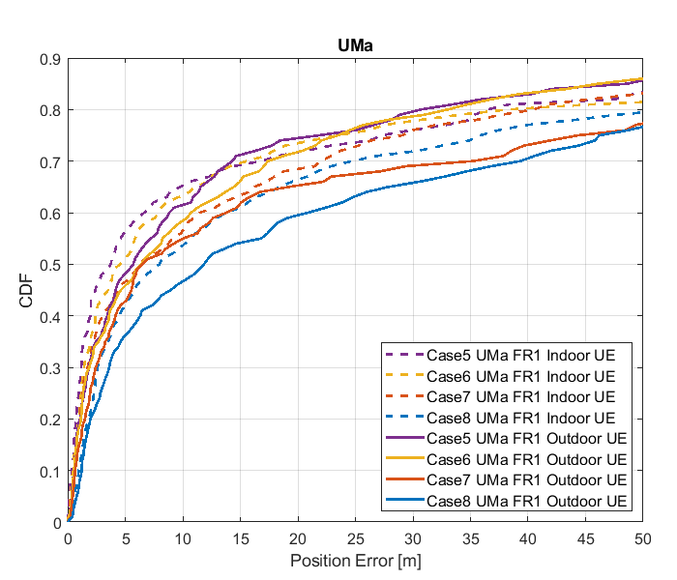

Figure 8.3.3.1-2: Results for FR1 from [10]

Table 8.3.3.1-2: Results for FR1 from [10]

|  |  |  |  |  |  |  |
| --- | --- | --- | --- | --- | --- | --- |
|  |  | Source | 50% | 67% | 80% | 90% |
| FR1 | UMa indoor | Case 1 UMa FR1 | 3.7 | 10.8 | 37.5 | 71.3 |
| Case 2 UMa FR1 | 4.2 | 12.6 | 37.2 | 114.4 |
| Case 3 UMa FR1 | 6.0 | 16.0 | 33.7 | 112.6 |
| Case 4 UMa FR1 | 12.9 | 21.1 | 43.3 | 124.9 |
| Case 5 UMa FR1 | 3.7 | 12.4 | 36.6 | 73.4 |
| Case 6 UMa FR1 | 4.6 | 12.4 | 38.5 | 114.4 |
| Case 7 UMa FR1 | 6.1 | 18.0 | 40.5 | 105.4 |
| Case 8 UMa FR1 | 8.0 | 20.7 | 52.8 | 128.7 |
| UMa outdoor | Case 1 UMa FR1 | 5.7 | 12.2 | 29.8 | 70.3 |
| Case 2 UMa FR1 | 6.5 | 15.2 | 30.8 | 73.2 |
| Case 3 UMa FR1 | 6.3 | 22.3 | 53.9 | 100.8 |
| Case 4 UMa FR1 | 15.6 | 31.3 | 54.7 | 105.9 |
| Case 5 UMa FR1 | 5.7 | 12.4 | 36.6 | 73.4 |
| Case 6 UMa FR1 | 6.4 | 15.2 | 33.0 | 75.6 |
| Case 7 UMa FR1 | 6.5 | 23.0 | 57.3 | 106.2 |
| Case 8 UMa FR1 | 11.9 | 32.8 | 58.0 | 115.6 |

#### 8.3.3.2 Results from [19]

The parameters used for evaluation of the DL & UL based positioning in Scenario 3 (UMa) are listed in Table 8.3.3.1-1 below.

Table 8.3.3.2-1: Parameters for Downlink and Uplink evaluations in Scenario 3

|  |  |  |
| --- | --- | --- |
| Parameter | Setup 1 | Setup 2 |
| Channel model (baseline, otherwise state any modifications) | Baseline | Baseline |
| Carrier frequency | 4 GHz | 4 GHz |
| Subcarrier spacing | 15 kHz | 30 kHz |
| Reference Signal Transmission Bandwidth | 5 MHz | 100 MHz |
| Reference Signal Physical Structure and Resource Allocation (RE pattern) (reference to figure in contribution) | DL: 12 REs per PRB, single symbol UL: 4 REs per PRB, 4 symbols | DL: 12 REs per PRB, single symbol UL: 4 REs per PRB, 4 symbols |
| Reference signal (type of sequence, number of ports, …) | QPSK, Pseudo random, single Tx port | QPSK, Pseudo random, single Tx port |
| Number of sites | 57 sectors / 19 sites | 57 sectors / 19 sites |
| Number of symbols used per occasion | DL: 1x57(sites)  UL: 4(symb)xUE number | DL: 1x57(sites)  UL: 4(symb)xUE number |
| Number of occasions used per positioning estimate | 1 | 1 |
| Power-boosting level | DL: 0 dB  UL: 6 dB | DL: 0 dB  UL: 6 dB |
| Uplink power control (applied/not applied) | Max power | Max power |
| Interference modelling (ideal muting, or other) | Ideal muting | Ideal muting |
| Description of Measurement Algorithm (e.g. super resolution, interference cancellation, ….) | Threshold based algorithm for the first arrival path (FAP) estimation | Threshold based algorithm for the first arrival path (FAP) estimation |
| Description of positioning technique / applied positioning algorithm (e.g. Least square, Taylor series, etc) | Taylor based, measurements above -15 dB are used for positioning | Taylor based, measurements above -15 dB are used for positioning |
| Network synchronization assumptions | Option 1: T1 = 0ns(Perfect)  Option 2: T1 = 50ns | Option 1: T1 = 0ns(Perfect)  Option 2: T1 = 50ns |
| Beam-related assumption (beam sweeping / alignment assumptions at the tx and rx sides) | No sweeping | No sweeping |
| Precoding assumptions (codebook, nrof antenna elements used, etc) | Single Tx port | Single Tx port |
| Additional notes, if any |  |  |

The system level evaluation results for DL & UL positioning in Scenario 3 (UMa) are provided below.

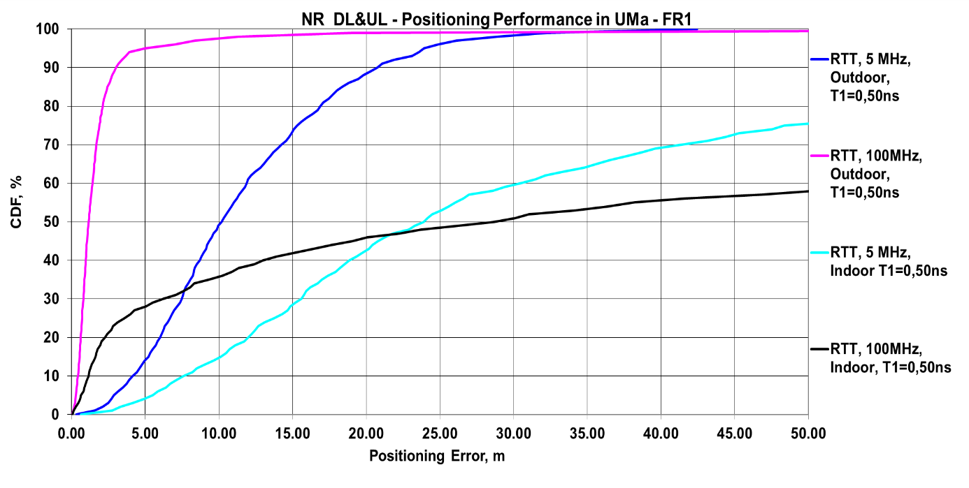

Figure 8.3.3.2-1: (a) FR1 evaluations

#### 8.3.3.3 Results from [23]

The parameters corresponding to the results are listed in table 8.3.3.3-1 below.

Table 8.3.3.3-1: Parameters for Downlink and Uplink evaluations in Scenario 3

|  |  |  |
| --- | --- | --- |
| Parameter | [23], FR1, 100 MHz | [23], FR1, 50 MHz |
| Channel model (baseline, otherwise state any modifications) | Baseline Channel Model based on common assumptions defined related to the channel models of 3GPP TRs 38.901 / 38.802 / 37.857. | |
| Carrier frequency | 4 GHz | |
| Subcarrier spacing | 30 KHz | 15 KHz |
| Reference Signal Transmission Bandwidth | 100 MHz | 50 MHz |
| Reference Signal Physical Structure and Resource Allocation (RE pattern) (reference to figure in contribution) | Comb-1 | |
| Reference signal (type of sequence, number of ports, …) | 1-port, QPSK sequence | |
| Number of sites | 19 | |
| Number of symbols used per occasion | 10 | |
| number of occasions used per positioning estimate | 10 | |
| Power-boosting level | 0 dB | |
| interference modelling (ideal muting, or other) | Ideal muting for DL | |
| Description of Measurement Algorithm (e.g. super resolution, interference cancellation, ….) | TOA estimation without oversampling with TOA pruning before the positioning engine using the ratio of the estimated TOA peak over the median of the Channel Energy Response (CER). | |
| Description of positioning technique / applied positioning algorithm (e.g. Least square, Taylor series, etc) | For multi-RTT, the algebraic solution proposed in  - Norrdine, Abdelmoumen. (2015). An Algebraic Solution to the Multilateration Problem. 10.13140/RG.2.1.1681.3602.  Equal weight is used in the TOA covariance matrix. | |
| Network synchronization assumptions | Perfect Sync and Realistic Sync with T1 = 50 nsec | |
| Beam-related assumption (beam sweeping / alignment assumptions at the tx and rx sides) | The best beam pair is identified based on the criteria of receiving the earliest path given that the received power is larger than a threshold (20 dB lower than the maximum received power) using the genie CDL channel profiles. For a single sector scenario (only Indoor hotspop 4GHz), the directions of beams are within [, 180] degress in azimuth and [,180] degrees in zenith. For a 3-sector scenario, the directions of beams are within [, ] degress in azimuth and [,180] degrees in zenith. | |
| Precoding assumptions (codebook, nrof antenna elements used, etc) | Kronecker product between vertical and horizontal weight vectors taken from DFT, with oversampling factor = 1. The DFT beam candidate in beam selection method is generated according to the uniform vertical and horizontal angular distribution shown as follows:  , for i=1,…,rN  where r denotes the oversampling factor, N denotes the number of vertical/horizontal antennas. For FR1, Tx oversampling factor equals to 1. | |

The results corresponding to the UMa scenario are provided below

Table 8.3.3.3-2: Results for downlink and uplink methods evaluations of Scenario 3 – UMa Indoor UEs

|  |  |  |  |  |  |
| --- | --- | --- | --- | --- | --- |
| Percentile | 50 | 67 | 80 | 90 | 95 |
| Multi-RTT, FR1, 100 MHz, Perfect & Realistic Sync | 16.7 | 42.6 | 93.2 | 190.8 | - |
| Multi-RTT, FR1, 50 MHz, Perfect & Realistic Sync | 15.4 | 28.8 | 46.3 | 79.2 | 110.5 |

Table 8.3.3.3-3: Results for downlink and uplink methods evaluations of Scenario 3 – UMa Outdoor UEs

|  |  |  |  |  |  |
| --- | --- | --- | --- | --- | --- |
| Percentile | 50 | 67 | 80 | 90 | 95 |
| Multi-RTT, FR1, 100 MHz, Perfect & Realistic Sync | 14.2 | 28.2 | 44.4 | 70.7 | 138.3 |
| Multi-RTT, FR1, 50 MHz, Perfect & Realistic Sync | 12.6 | 25.9 | 45.7 | 74.4 | 100.3 |

## 8.4 GNSS and Hybrid NR-GNSS Evaluations

### 8.4.1 Hybrid GNSS-DL-TDOA evaluation [37]

One source provided simulation results [37] for hybrid NR and GNSS positioning. No GNSS models or scenarios have been agreed in 3GPP for positioning evaluations. No conclusions can be drawn from the results in this Section. This section captures these results, which are based on the agreed RAT dependent simulation scenarios together with considered GNSS models and scenarios.

#### 8.4.1.1 Scenarios and Methodology

For evaluating GNSS and hybrid positioning GNSS and DL-TDOA performance, only outdoor scenarios are selected, namely UMa and UMi. In [37] the GNSS conditions (signal attenuation, multipath, etc.) were modelled accordingly ETSI TS 103 246-3 Operational Environments [27]: Urban Canyon and Asymmetric Visibility. Furthermore, in order to evaluate GNSS and RAT-dependent under same environmental conditions, in [37] the Operational Environments were aligned to 3GPP UMa and UMi based on elevation mask profiles for the GNSS satellites.

Code-based measurements have been generated for all four GNSS constellations (GPS, Galileo, BeiDou, and GLONASS) on two frequency carriers, namely 1.575 GHz and 1.176 GHz. The DL-TDOA observables are simulated according to the scenario parameters agreed by RAN1 and listed section 6.1. DL-TDOA observables are obtained from 6 gNBs with a PRS system bandwidth of 100 MHz and ideal muting pattern. The channel model as provided in the TR 38.901 is used as baseline while results with modifications to the channel model adding a NLOS bias are also presented.

Table 8.4.1.1-1: Hybrid GNSS-DL-TDOA Evaluation assumptions

|  |  |  |
| --- | --- | --- |
| Parameter | GNSS | DL-TDOA |
| Layout | A GNSS constellation simulator has been used to generate the geometry of each constellation for a specific latitude, longitude and date.  (NOTE 1) | For UMa: Hexagonal grid, 19 macro sites, 3 sectors per site ISD = 500m.  For UMi: Hexagonal grid, 19 micro sites, 3 sectors per site ISD = 200m |
| System Bandwidth per Carrier | L1/E1: 24.552 MHz  L5/E5a: 20.460 MHz | 100 MHz |
| GNSS constellations | Galileo, GPS, GLONASS, BeiDou | N.A |
| Carrier Frequency | L1: 1.575 GHz  L5: 1.176 GHz | 4 GHz |
| Number of Carriers | 2 | 1 |
| Subcarrier spacing | N.A | 30 kHz |
| HDOP range | 1.6 to 2.5 | 0.6 to 2.0 |
| Penetration | From [27]:  For outdoor UEs in UMa: X1=0 dB, X2=100 dB, X3=15 dB  For outdoor UEs in UMi: X1=0 dB, X2=100 dB | For outdoor UEs: 0dB |
| Satellite / BS antenna Height | GPS = 20 200 km  Galileo = 23 222 km  GLONASS = 19 100 km  BeiDou MEO = 21 528 km  (NOTE 2) | For UMa: 25m + α  α ~ uniform(-5,25) m  For UMi: 10m + β, where β~uniform[-5, 10 |
| Satellite masking | From [27]:  For UMa: 60 degrees, one side of the street.  For UMi: 60 degrees, both sides of the street | N.A |
| Antenna Configuration | N.A | For UMa: 4 GHz: (8, 8, 2, 1, 1)  (dH, dV) = (0.5, 0.8)   For UMi: 4 GHz: (8, 8, 2, 1, 1)  (dH, dV) = (0.5, 0.8)  |
| Network synchronization assumptions | N.A | T1: 0ns (perfectly synchronized), 50ns  The network synchronization error, per UE dropping, is defined as a truncated Gaussian distribution of (T1 ns) rms values between an eNB and a timing reference source which is assumed to have perfect timing, subject to a largest timing difference of T2 ns, where T2 = 2*T1.  That is, the range of timing errors is [-T2, T2] |
| UE Height | hUT = 1.5 m | |
| UE Dropping | For outdoor UEs: uniform in cell | |
| UE noise figure | 9 dB | |
| UE Speed | 3 km/h | |
| Description of positioning technique / applied positioning algorithm | GNSS standalone: Weighted Least Square  Hybrid GNSS-DL-TDOA: tight integration i.e., measurement level in Weighted Least Square estimator | |
| Note 1: The assumption is that all GNSS constellations are at Full Operational Capabilities i.e., all satellites are deployed and operational.  Note 2: All GNSS satellites are placed in Medium Earth Orbit (MEO). Each GNSS constellation has a specific height at which its satellites are placed. | | |

#### 8.4.1.2 Simulation results

Simulation results for GNSS and hybrid GNSS-RAT-dependent were provided by one source in [37] . The following section presents the evaluation results obtained for hybrid positioning between standalone GNSS and hybrid positioning between GNSS and DL-TDOA at FR1.

Table 8.4.1.2-1: UMa - GNSS horizontal positioning error [m]

|  |  |  |  |  |  |
| --- | --- | --- | --- | --- | --- |
| Source | 50% | 67% | 80% | 90% | 95% |
| [37] | 2.33 | 3.01 | 3.72 | 4.64 | 5.42 |

Table 8.4.1.2-2: UMa - Hybrid GNSS-DL-TDOA horizontal positioning error [m]

|  |  |  |  |  |  |  |  |
| --- | --- | --- | --- | --- | --- | --- | --- |
| Source | Conditions | | 50% | 67% | 80% | 90% | 95% |
| [37] | 0ns | Baseline channel model | 0.70 | 0.96 | 1.24 | 1.59 | 1.98 |
| Modified channel model | 2.24 | 2.91 | 3.63 | 4.51 | 5.33 |
| 50ns | Baseline channel model | 2.29 | 2.99 | 3.71 | 4.61 | 5.43 |
| Modified channel model | 2.29 | 2.99 | 3.71 | 4.61 | 5.45 |
| NOTE: To modify the channel model, the normalization of the spread delays has been removed from equation 7.5-2 in TR 38.901 to introduce a NLOS bias. | | | | | | | |

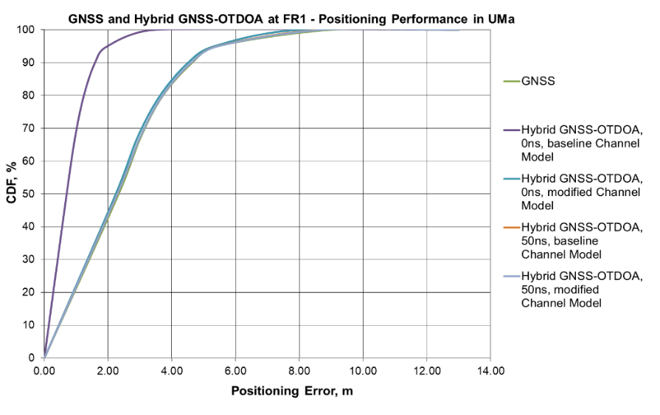

Figure 8.4.1.2-1: Horizontal positioning error in UMa for GNSS and hybrid GNSS-DL-TDOA

Table 8.4.1.2-3: UMi - GNSS horizontal positioning error [m]

|  |  |  |  |  |  |
| --- | --- | --- | --- | --- | --- |
| Source | 50% | 67% | 80% | 90% | 95% |
| [37] | 4.07 | 5.56 | 7.19 | 9.30 | 10.51 |

Table 8.4.1.2-4: UMi - Hybrid GNSS-DL-TDOA horizontal positioning error [m]

|  |  |  |  |  |  |  |  |
| --- | --- | --- | --- | --- | --- | --- | --- |
| Source | Conditions | | 50% | 67% | 80% | 90% | 95% |
| [37] | 0ns | Baseline channel model | 0.83 | 1.14 | 1.46 | 1.85 | 2.26 |
| Modified channel model | 2.0 | 2.67 | 3.40 | 4.37 | 5.48 |
| 50ns | Baseline channel model | 3.84 | 5.16 | 6.61 | 8.40 | 10.02 |
| Modified channel model | 3.87 | 5.16 | 6.66 | 8.47 | 10.09 |
| NOTE: To modify the channel model, the normalization of the spread delays has been removed from equation 7.5-2 in TR 38.901 to introduce a NLOS bias. | | | | | | | |

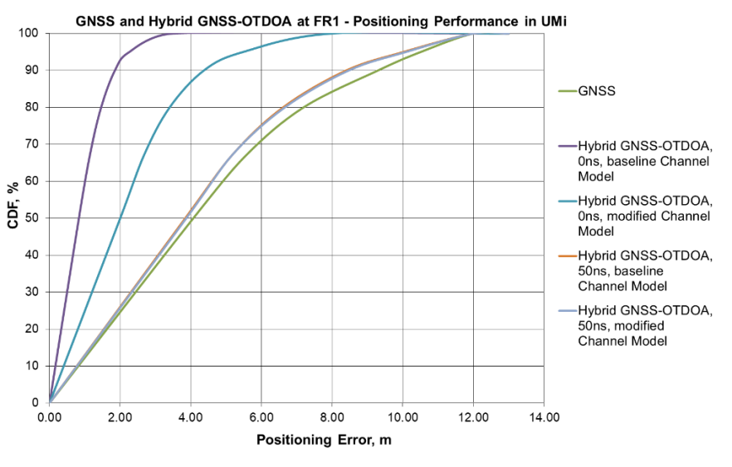

Figure 8.4.1.2-2: Horizontal positioning error in UMi for GNSS and hybrid GNSS-DL-TDOA

Below are the vertical positioning error for GNSS and hybrid GNSS-DL-TDOA.

Table 8.4.1.2-5: UMa - GNSS vertical positioning error [m]

|  |  |  |  |  |  |
| --- | --- | --- | --- | --- | --- |
| Source | 50% | 67% | 80% | 90% | 95% |
| [37] | 2.28 | 3.40 | 4.55 | 5.87 | 7.05 |

Table 8.4.1.2-6: UMa - Hybrid GNSS-DL-TDOA vertical positioning error [m]

|  |  |  |  |  |  |  |  |
| --- | --- | --- | --- | --- | --- | --- | --- |
| Source | Conditions | | 50% | 67% | 80% | 90% | 95% |
| [37] | 0ns | Baseline channel model | 1.89 | 2.82 | 3.76 | 4.98 | 6.06 |
| Modified channel model | 2.25 | 3.36 | 4.50 | 5.86 | 6.98 |
| 50ns | Baseline channel model | 2.29 | 3.39 | 4.53 | 5.89 | 7.07 |
| Modified channel model | 2.28 | 3.40 | 4.55 | 5.89 | 7.04 |
| NOTE: To modify the channel model, the normalization of the spread delays has been removed from equation 7.5-2 in TR 38.901 to introduce a NLOS bias. | | | | | | | |

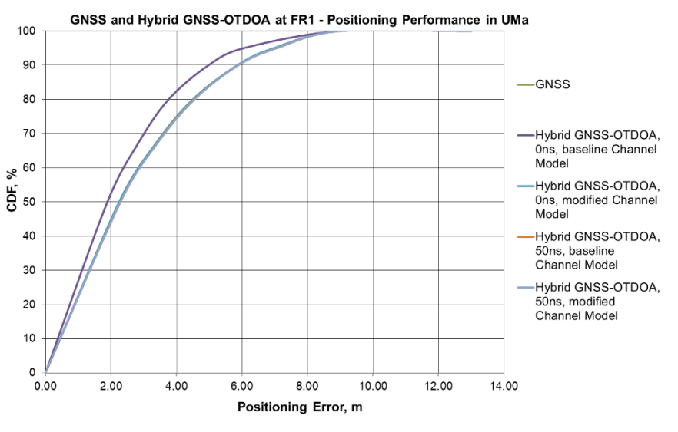

Figure 8.4.1.2-3: Vertical positioning error in UMa for GNSS and hybrid GNSS-DL-TDOA

Table 8.4.1.2-7: UMi - GNSS vertical positioning error [m]

|  |  |  |  |  |  |
| --- | --- | --- | --- | --- | --- |
| Source | 50% | 67% | 80% | 90% | 95% |
| [37] | 2.74 | 4.03 | 5.48 | 7.12 | 8.64 |

Table 8.4.1.2-8: UMi - Hybrid GNSS-DL-TDOA vertical positioning error [m]

|  |  |  |  |  |  |  |  |  |  |  |
| --- | --- | --- | --- | --- | --- | --- | --- | --- | --- | --- |
| Source | Conditions | | 50% | | 67% | | 80% | | 90% | 95% |
| [37] | 0ns | Baseline channel model | 2.18 | | 3.27 | | 4.41 | | 5.81 | 7.02 |
|  | Modified channel model | | 2.77 | | 4.03 | | 5.39 | 7.00 | 8.47 |
| 50ns | Baseline channel model | | 2.49 | | 3.72 | | 4.98 | 6.37 | 7.77 |
| Modified channel model | | 2.76 | | 4.03 | | 5.37 | 7.02 | 8.46 |
| NOTE: To modify the channel model, the normalization of the spread delays has been removed from equation 7.5-2 in TR 38.901 to introduce a NLOS bias. | | | | | | | | | | |

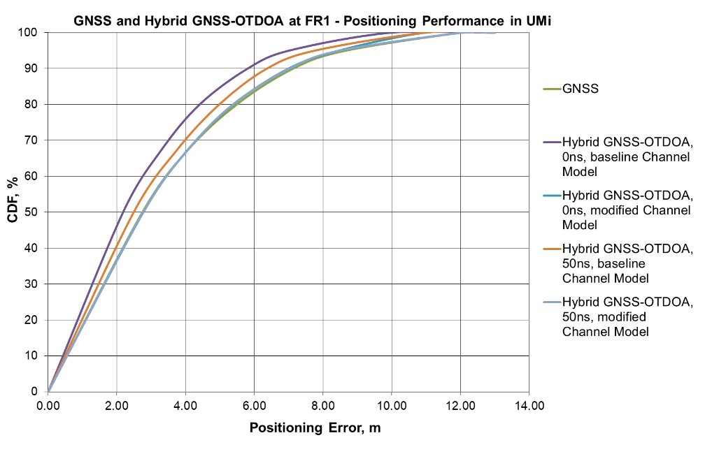

Figure 8.4.1.2-4: Vertical positioning error in UMi for GNSS and hybrid GNSS-DL-TDOA

#### 8.4.1.3 Summary for horizontal and vertical positioning error

Below are the summary of the simulations results. Due to usage of GNSS all UEs are considered to be outdoor.

Table 8.4.1.3-1: GNSS and Hybrid GNSS-DL-TDOA CDF percentiles for 50m, 10m, 3m and 1m horizontal positioning error [%]

|  |  |  |  |  |  |  |  |  |
| --- | --- | --- | --- | --- | --- | --- | --- | --- |
| Scenario | 50m | | 10m | | 3m | | 1m | |
| UMa | UMi | UMa | UMi | UMa | UMi | UMa | UMi |
| GNSS | 100% | 100% | 100% | 92% | 67% | 35% | 14% | 7% |
| Hybrid GNSS – DL-TDOA perfect synchronisation | 100% | 100% | 100% | 100% | 100% | 99% | 70% | 61% |
| Hybrid GNSS – DL-TDOA 50 ns synchronisation error | 100% | 100% | 100% | 95% | 68% | 38% | 15% | 7% |
| Hybrid GNSS – DL-TDOA perfect synchronisation, modified channel model | 100% | 100% | 100% | 100% | 70% | 74% | 16% | 23% |
| Hybrid GNSS – DL-TDOA 50ns synchronisation error, modified channel model | 100% | 100% | 100% | 95% | 68% | 38% | 15% | 7% |
| NOTE: The 3m target corresponds to the horizontal positioning accuracy requirement for NR Positioning Service Level 2 while the 1m target corresponds to the horizontal positioning accuracy requirement for NR Positioning Service Levels 3 and 4 as defined in TS 22.261. | | | | | | | | |

Table 8.4.1.3-2: GNSS and Hybrid GNSS-DL-TDOA CDF percentiles for 50m, 10m, 3m and 2m vertical positioning error [%]

|  |  |  |  |  |  |  |  |  |
| --- | --- | --- | --- | --- | --- | --- | --- | --- |
| Scenario | 50m | | 10m | | 3m | | 2m | |
| UMa | UMi | UMa | UMi | UMa | UMi | UMa | UMi |
| GNSS | 100% | 100% | 100% | 98% | 62% | 54% | 45% | 38% |
| Hybrid GNSS – DL-TDOA perfect synchronisation | 100% | 100% | 100% | 100% | 70% | 64% | 53% | 47% |
| Hybrid GNSS – DL-TDOA 50 ns synchronisation error | 100% | 100% | 100% | 98% | 62% | 54% | 46% | 38% |
| Hybrid GNSS – DL-TDOA perfect synchronisation, modified channel model | 100% | 100% | 100% | 99% | 63% | 58% | 46% | 42% |
| Hybrid GNSS – DL-TDOA 50ns synchronisation error, modified channel model | 100% | 100% | 100% | 98% | 62% | 54% | 46% | 38% |
| NOTE: The 3m target corresponds to the horizontal positioning accuracy requirement for NR Positioning Service Levels 1 and 2 while the 2m target corresponds to the horizontal positioning accuracy requirement for NR Positioning Service Levels 3 to 6 as defined in TS 22.261. | | | | | | | | |

## 8.5 Summary for evaluations

### 8.5.1 Summary for Downlink evaluations

#### 8.5.1.1 Summary for Scenario 1 – Indoor Office

For the Indoor open office scenario, channel models and simulation assumptions, the following can be observed for horizontal accuracy as described in section 5 of the TR for regulatory and commercial requirements:

- For scenario 1, the evaluations from 12 sources showed that DL-TDOA can meet the regulatory requirements.

- For scenario 1, the evaluations from 12 sources showed that DL-TDOA can meet the commercial requirements, when no synchronization error is included in the evaluation. When synchronization error is modeled, the commercial requirements as described in section 5 of the TR are not met.

- For scenario 1, 1 source evaluated DL AoD for FR2, and observed that it can meet the regulatory requirements.

- For scenario 1, 1 source evaluated DL AoD for FR2, and observed that it can meet the commercial requirements.

- For scenario 1, 1 source evaluated DL-TDOA+AoD for FR2, and observed that it can meet the regulatory requirements.

- For scenario 1, 1 source evaluated DL-TDOA+AoD for FR2, and observed that it can meet the commercial requirements, when no synchronization error is included in the evaluation. When synchronization error is modeled, the commercial requirements for horizontal accuracy are not met.

#### 8.5.1.2 Summary for Scenario 2 – UMi

For the UMi scenario, channel models and simulation assumptions, the following can be observed for horizontal accuracy as described in section 5 of the TR for regulatory and commercial requirements:

- For scenario 2 the evaluations from 12 out of 12 sources showed that DL-TDOA can meet the regulatory requirements for FR1 and FR2.

- For scenario 2, the evaluations from 12, out of 12 sources showed that DL-TDOA can meet the commercial requirement, when no synchronization error is included in the evaluation for FR1 and FR2.

- When synchronization error is modeled, the DL-TDOA evaluations from 0 out of 6 sources showed the commercial requirements as described in section 5 of the TR can be met for FR1 and FR2.

- For scenario 2, 1 source evaluated AoD, and observed that it can meet the regulatory requirements for FR2.

- For scenario 2, 1 source evaluated AoD+ZoD positioning method , and observed that it can not meet the regulatory requirements for FR1 or FR2.

- For AoD+ZoD+serving cell TA positioning method described in [18], the regulatory requirements for FR1 or FR2 were met.

#### 8.5.1.3 Summary for Scenario 3 – UMa

For the UMa scenario, channel models and simulation assumptions, the following can be observed for horizontal accuracy as described in section 5 of the TR for regulatory and commercial requirements:

- For scenario 3, the evaluations from 12 out of 12 sources showed that DL-TDOA can meet the regulatory requirements.

- For scenario 3, and for outdoor UEs the evaluations from 7 out of 12 sources showed that DL-TDOA can meet the commercial requirements, when no synchronization error is included in the evaluation.

- For scenario 3, and for outdoor UEs, when synchronization error is modeled, the evaluations from 0 out of 6 sources showed that for DL-TDOA the commercial requirements as described in section 5 of the TR can be met.

### 8.5.2 Summary for Uplink evaluations

#### 8.5.2.1 Summary for Scenario 1 – Indoor Office

For the indoor open office scenario, channel models and simulation assumptions, the following can be observed for horizontal accuracy as described in section 5 of the TR for regulatory and commercial requirements:

- For scenario 1, the evaluations from 8 out of 8 sources showed that UL-TDOA can meet the regulatory requirements.

- For scenario 1, the evaluations from 8 out of 8 sources showed that UL-TDOA can meet the commercial requirements, when no synchronization error is included in the evaluation.

- For scenario 1, when synchronization error is modeled, the evaluations from 1 out of 4 sources showed that for UL-TDOA the commercial requirements as described in section 5 of the TR can be met.

- For scenario 1, 3 sources evaluated UL AoA and observed that it can meet the regulatory requirements.

- For scenario 1, 3 sources evaluated UL AoA , and observed that it can meet the commercial requirements.

#### 8.5.2.2 Summary for Scenario 2 – UMi

For the UMi scenario, channel models and simulation assumptions, the following can be observed for horizontal accuracy as described in section 5 of the TR for regulatory and commercial requirements:

- For scenario 2, the evaluations from 6 out of 6 sources showed that UL-TDOA can meet the regulatory requirements.

- For scenario 2, the evaluations from 4 out of 6 sources showed that UL-TDOA can meet the commercial requirements, when no synchronization error is included in the evaluation.

- For scenario 2, when synchronization error is modeled, the evaluations from 0 out of 4 sources showed that for UL-TDOA the commercial requirements as described in section 5 of the TR can be met.

- For scenario 2, 1 source evaluated UL AoA and observed that it can meet the regulatory requirements.

- For scenario 2, 1 source evaluated UL AoA , and observed that it can not meet the commercial requirements.

#### 8.5.2.3 Summary for Scenario 3 – UMa

For the UMa scenario, channel models and simulation assumptions, the following can be observed for horizontal accuracy as described in section 5 of the TR for regulatory and commercial requirements:

- For scenario 3, the evaluations from 3 out of 5 sources showed that UL-TDOA can meet the regulatory requirements.

- 1 source showed that indoor and outdoor UEs could not meet the regulatory requirements, even under perfect network synchronization.

- 1 source showed that indoor UEs could not meet the regulatory requirements, even under perfect network synchronization.

- For scenario 3, and for outdoor UEs the evaluations from 3 out of 5 sources showed that UL-TDOA can meet the commercial requirements, when no synchronization error is included in the evaluation.

- For scenario 3, and for outdoor UEs, when synchronization error is modeled, the evaluations from 0 out of 4 sources showed that for UL-TDOA the commercial requirements as described in section 5 of the TR can be met.

- For scenario 3, 1 source evaluated UL AoA and observed that it can not meet the regulatory requirements.

### 8.5.3 Summary for Downlink and Uplink evaluations

#### 8.5.3.1 Summary for Scenario 1 – Indoor Office

For the indoor open office scenario, channel models and simulation assumptions, the following can be observed for horizontal accuracy as described in section 5 of the TR for regulatory and commercial requirements:

- For scenario 1, the evaluations from 5 out 5 sources showed that multi-cell RTT can meet the regulatory requirements.

- For scenario 1, the evaluations from 5 out 5 sources showed that multi-cell RTT can meet the commercial requirements.

- Note: There are multiple solutions under the multi cell RTT definition.

- For scenario 1, the evaluations from 1 out 1 source showed that E-CID (single cell RTT + UL AOA as in [10]) can meet the regulatory requirements.

- For scenario 1, the evaluations from 1 out 1 source showed that E-CID (single cell RTT + UL AOA as in [10]) can meet the commercial requirements.

#### 8.5.3.2 Summary for Scenario 2 – UMi

For scenario 2, channel models and simulation assumptions, the following can be observed for horizontal accuracy as described in section 5 of the TR for regulatory and commercial requirements:

- For scenario 2, the evaluations from 3 out 3 sources showed that multi-cell RTT can meet the regulatory requirements.

- For scenario 2, the evaluations from 3 out 3 sources showed that multi-cell RTT can meet the commercial requirements.

- For scenario 2, the evaluations from 1 out 1 source showed that E-CID (single cell RTT + UL AOA as in [10]) can meet the regulatory requirements.

- For scenario 2, the evaluations from 1 out 1 source showed that E-CID (single cell RTT + UL AOA as in [10]) can meet the commercial requirements.

#### 8.5.3.3 Summary for Scenario 3 – UMa

For scenario 3, channel models and simulation assumptions, the following can be observed for horizontal accuracy as described in section 5 of the TR for regulatory and commercial requirements:

- For scenario 3 and outdoor UEs, the evaluations from 2 sources out of 2 showed that multi cell RTT can meet the regulatory requirements.

- Indoor UEs do not meet the regulatory requirements according to 1 source, while 1 source showed that the regulatory requirements were met.

- For scenario 3 and outdoor UEs, the evaluations from 2 sources out of 2 showed that multi-cell RTT cannot meet the commercial requirements.

- For scenario 3, the evaluations from 1 source showed that E-CID (single cell RTT + UL AOA as in [10]) can meet the regulatory requirements.

- For scenario 3 and outdoor UEs, the evaluations from 1 out 1 source showed that E-CID (single cell RTT + UL AOA as in [10]) cannot meet the commercial requirements.

# 9 Identified NR impacts

## 9.1 Signal definitions and configuration parameters

### 9.1.1 Downlink signal definitions and configuration parameters

**NR DL Reference Signals for Positioning**

The following candidate reference signals were identified for NR DL positioning evaluation

- NR CSI-RS (including TRS configuration)

- NR Synchronization Signals (SSBs)

- New DL positioning reference signals (DL PRS)

Enhancements to existing NR DL reference signals (e.g., based on extensions to current reference signals or with new reference signals) are necessary to meet accuracy requirements at least in some scenarios.

New DL positioning reference signals should be defined for supporting NR positioning. When and how existing NR DL reference signals can be used for positioning is left to future specification work.

**NR PRS Properties**

NR DL PRS design for FR1 and FR2 should support:

- Configurable NR DL PRS signal bandwidth

- The granularity of configuration, relationship with BWPs and whether the configuration is cell and/or UE specific are left to future specification work.

- Configurable NR DL PRS signal numerology (SCS)

- Whether CP for NR DL PRS is configurable is left to future specification work.

- Configurable NR DL PRS frequency and time allocation

- Use of DL beam sweeping / alignment

- i.e. beam alignment of gNB DL PRS transmission and UE reception of DL PRS

- Localized in time NR DL PRS transmissions with periodic and/or on-demand resource allocation

- signaling details are left to future specification work.

- Dedicated NR DL PRS resources - time-frequency grid at resource block level

- PRS transmitted in one cell may or may not collide with PRS transmissions in other cell

- e.g. frequency vShift/comb-offset is the same or different for two different PRSs in the same RB

- There is no data/control transmission in time-frequency grid of dedicated NR-DL PRS resources

- FDM multiplexing with other signals at RE level inside of PRS time-frequency grid is precluded

- Whether to support interference randomization techniques across PRS signals is left to future specification work.

- Whether to support shared in time/frequency NR DL PRS resources with other transmissions including data/control is left to future specification work, including:

- Which physical channel/signals can share resources with NR DL PRS

- Whether to support interference randomization techniques for PRS transmission with other signals

**NR DL PRS Resource**

NR DL PRS resource is defined as a set of resource elements used for NR DL PRS transmission that can span multiple PRBs within *N* (1 or more) consecutive symbol(s) within a slot, where *N* is left to future specification work.

- In any OFDM symbol, PRS resource occupies consecutive PRBs

- Whether multiple symbols can be non-consecutive is left to future specification work.

- Whether to support PRS Resource Set is left to future specification work.

For NR DL PRS resource design:

NR DL PRS resource design with one antenna port is supported. The use of more than two antenna ports per NR DL PRS resource need not be supported. Whether to support two antenna ports is left to future specification work.

- A PRS resource should have a PRS resource ID and a PRS sequence should have a PRS sequence ID

**UE Measurements for NR Positioning**

The following UE measurements were identified for NR positioning for serving and neighbouring gNBs:

- NR supports RSTD measurements for NR DL PRS

- Whether to support RSTD b/w different configured PRS resources, beams, TRPs, cells, etc is left to future specification work.

- NR supports RSRP measurement for NR DL PRS

- UE RX-TX time difference measurements

- Whether NR supports RSTD measurement quality metric for NR DL PRS is left to future specification work

- Whether to support other measurements are left to future specification work

**NR DL PRS Hopping**

Whether to support PRS frequency hopping is left to future specification work

### 9.1.2 Uplink signal definitions and configuration parameters

**NR UL Reference Signals for Positioning**

The following candidate reference signals were identified for UL positioning evaluation and are to left for future specification work

- NR PRACH

- NR SRS

- NR UL DMRS

- NR UL PTRS

- New UL positioning reference signals (UL PRS)

NR UL SRS is used as a starting point for design and analysis of UL PRS

- Whether and which enhancements are needed are left for future specification work.

- NR UL PRS relationship with UL BWP and component carrier is left to future specification work.

The following aspects for NR UL PRS design are left for further analysis:

- Use of UL beam sweeping at FR2

- Beam sweeping includes possibility of quasi-omni transmission

- Use of UL beam alignment at FR2 through DL reception and beam correspondence

- UL power control aspects

- UL timing advance aspects

**gNB Measurements for NR Positioning**

The following measurements for NR UL PRS at serving and neighbor gNBs should be supported:

- UL RTOA measurements

- UL Angle Of Arrival (AOA) measurements (including Azimuth and Zenith Angles)

- UL RSRP (reference signal received power) measurements

- gNB RX-TX time difference measurements

## 9.2 Procedure and protocol aspects

In Rel-15, as specified in TS 38.305 [56], for UE positioning in NR, the LTE Positioning Protocol (LPP) TS 36.355[28] is reused and is terminated between a target device and a positioning server. A new NR Positioning Protocol A (NRPPa) TS 38.455 [1] was introduced to carry the information between NG-RAN and LMF.

LPP and NRPPa will be extended to support the NR RAT dependent positioning methods in future specification work.

Note 1: the details on how to extend LPP and NRPPa are to be discussed when the normative specifications are developed.

## 9.3 Architecture aspects

### 9.3.1 NG-RAN support for location management functionality

To achieve low latency and high-performance location estimates, different solutions for the support of location management functionality in NG-RAN have been discussed in SA2 and captured in TR 23.731[33].

An example [57] on support of location management functionality in NG-RAN is shown in figure 9.3.1-1 and it involves a location management component (LMC) in NG-RAN:



Figure 9.3.1-1: Local LCS architecture

From RAN perspective the support of location management functionality in NG-RAN impacts:

- NG-C interface: signalling between NG-RAN and AMF;

- Protocol/signalling between NG-RAN and UE;

- Protocol/signalling between NG-RANs;

- Architecture of location management component within NG-RAN;

During the study some sources raised the concern on whether there is security risk to allow support for location management functionality in NG-RAN and whether there are adequate latency gains to cater to new use cases. The security aspects should be assessed by SA3 as it is out of RAN2 scope. Further, the following issues need to be addressed when the normative specifications are developed:

- Impact of UE mobility in support of location management functionality in NG-RAN

- Co-existence of LMC in NG-RAN and LMF.

The impacts on architecture and network interface for location management component within NG-RAN are out of RAN2 scope and should be checked by RAN3.

### 9.3.2 Architecture procedure and protocol High Layer aspects

The NR positioning architecture and signaling protocols of rel-15 should be enhanced to support rel-16 regulatory requirements and commercial services.

Regarding NR positioning methods, the location of the transmission measurement function under disaggregated architecture (CU-DU) should be further considered.

Regarding location management functionality in the NG-RAN, the location of the LMC function should be further considered, including possible new interface(s), impact on existing protocols, and coordination with the LMF in the 5GC. RAN3 could not reach a common understanding of the network architecture complexity to introduce this functionality.

The NG-RAN acting as LCS client needs more justification in term of scenarios. It was also identified the possibility to modify the signalling procedure compared to the SA2 proposals. Also, the authorisation and privacy aspects should be considered.

## 9.4 Additional Enhancement Identified for NR Positioning

### 9.4.1 Received Signal Waveform Reporting

The received signal waveform reporting was proposed as one of the mechanisms for NR positioning. The main principle of this approach is to digitize and record waveform of the received signals (e.g. at the configured time-intervals) at UE side / gNB side or any other network entity and report received signal waveform to the location server or gNB, so that location server or gNB can utilize received signal waveform report and transmitted signals (e.g. reference signals) to perform measurements of signal location parameters required for UE positioning [40]-[41].

### 9.4.2 UE-Based Positioning

Performing the positioning estimation at the UE (UE-based positioning) using RAT-dependent DL-only, UL-only, or DL+UL measurements and information related to the gNBs (e.g., location of gNBs) was proposed during this study [42]-[43]. UE-based RAT-dependent positioning and their hybridization with e.g. RAT-independent methods was also proposed. It was concluded that DL-only UE-based positioning is feasible from a RAN1 perspective. System level aspects need further consideration in other working groups.

### 9.4.3 Multipath Measurements

Multipath measurements for positioning were proposed [44]-[45]. The measurements include delay and angle information from multiple paths. Such measurements are needed to enable multi-path based positioning (e.g. using single base station) as described in [45].

### 9.4.4 LOS Detection

LOS detection was proposed for NR positioning. In order to address this problem the utilization of signal properties and measurements were proposed (e.g. polarization properties [46]-[47])

### 9.4.5 Positioning for UEs in RRC_IDLE/INACTIVE States

Study was conducted on whether it is beneficial to support and if so, how to support, NR based positioning for UEs in RRC-IDLE and/or RRC-INACTIVE states. The solutions based on this approach are described in [48]-[50].

### 9.4.6 UL SRS Enhancements for NR Positioning

Multiple sources proposed a variety of UL SRS enhancements for NR positioning. The following list of enhancements for UL SRS was proposed:

- SRS physical structure (e.g. comb configuration, sequence design)

- SRS resource enhancements (e.g. resource configuration settings, resource set usage for positioning)

- SRS beam alignment and beam sweeping procedures

- SRS transmission power control

- SRS timing advance procedure

- SRS BW configuration enhancements w.r.t. to UL BWP

### 9.4.7 Carrier Phase Based Positioning

The NR carrier-phase based positioning technique was proposed in [51]-[52]. It refers to the positioning method, where the transmitter (either the gNB or the UE) transmits the positioning reference signals at the pre-configured carrier frequency, and the receiver (either the UE or the gNB) obtains the carrier phase measurements by tracking reference signals.

In [53], phase measurements are derived from the complex correlations at the receiver side. The measurements combined with TDOA are used to estimate user position.

### 9.4.8 Phase Difference of Arrival Based Positioning

Phase-based RSTD measurement (PDoA) was proposed in [54] to be applied for DL-TDOA or RTT positioning techniques [55].

# 10. Conclusions

This study focused on analysis of the 3GPP NR RAT dependent positioning technologies and RAT-independent positioning technologies.

Regulatory and commercial target performance requirements for RAT dependent solutions are captured in Section 5.

Three NR positioning evaluation scenarios were identified for system level analysis of RAT-dependent positioning techniques as described in Section 6.1.

Evaluation results have shown that in considered evaluation scenarios it is feasible to achieve regulatory and commercial target performance requirements for horizontal positioning accuracy using RAT-dependent solutions as described in Section 8.5 that provides summary of evaluations results from different sources. The summary in Section 8.5 indicates which RAT-dependent solutions can reach target performance requirements for each evaluation scenario.

Based on conducted analysis it is recommended to define reference signals to be used for UE and gNB measurements to facilitate support of the following positioning techniques:

- DL based positioning

- DL-TDOA and DL-AoD based positioning techniques

- UL based positioning

- UL-TDOA and UL-AoA based positioning techniques

- DL and UL based positioning

- RTT based positioning technique

- E-CID based positioning technique

At least the following set of measurements was identified as necessary for NR RAT dependent positioning solutions and recommended to be specified:

- UE measurements based on reference signals from serving and neighbouring gNBs

- DL RSTD measurements

- DL RSRP measurements

- UE RX-TX time difference measurements

- gNB measurements at serving and neighbouring gNBs

- UL RTOA measurements

- UL Angle of Arrival (AoA) measurements (including Azimuth and Zenith Angles)

- UL RSRP (reference signal received power) measurements

- gNB RX-TX time difference measurements

It was identified that enhancements are necessary (e.g., based on extensions to current reference signals or with new reference signals) to meet horizontal accuracy requirements in some scenarios. In order to achieve target performance characteristics, it is recommended to introduce new downlink positioning reference signals (DL - PRS). As for UL reference signals, it was identified that UL SRS can be used as a starting point for UL PRS for NR positioning. A variety of enhancements for UL SRS were proposed by many sources and were reported to be beneficial by these sources.

Enhancements identified in Section 9.4 can be considered for future specification work.

The following is concluded for protocols in NR positioning:

- LPP is reused and will be extended to support the NR RAT dependent positioning methods;

- NRPPa is reused and will be extended to support the NR RAT dependent positioning methods

Conclusion for positioning architecture:

- Regarding NR positioning methods, the location of the transmission measurement function under disaggregated architecture (CU-DU) should be further considered.

- Regarding location management functionality in RAN, RAN3 could not reach a common understanding on any recommendation.

- Regarding NG-RAN acting as LCS client, RAN3 needs more justification in term of scenarios and foresee also further consideration on the authorization and privacy aspects.

The following is concluded for positioning architecture of NR positioning:

- Regarding location management functionality in RAN, RAN2 conclude that this option is recommended for normative work, provided the concerns (as described in subclause 9.3.1) raised in the study phase are addressed.

GNSS SSR completion (PPP-RTK support) can be considered for further specification work.

DL-only UE-based positioning is feasible from a RAN1 perspective. System level aspects need further consideration in other working groups.

It is recommended to proceed with a normative work to support NR positioning.

Annex A: Change history

|  |  |  |  |  |  |  |  |
| --- | --- | --- | --- | --- | --- | --- | --- |
| **Change history** | | | | | | | |
| **Date** | **Meeting** | **TDoc** | **CR** | **Rev** | **Cat** | **Subject/Comment** | **New version** |
| 2018-10 | RAN1#94b | R1-1811527 |  |  |  | Baseline TR skeleton. | 0.0.1 |
| 2018-11 | RAN1#95 | R1-1813589 |  |  |  | Baseline TR skeleton update after RAN1#94bis | 0.0.2 |
| 2018-11 | RAN1#95 | R1-1814357 |  |  |  | Update from RAN1#95 | 0.0.3 |
| 2018-12 | RAN#82 | RP-182702 |  |  |  | Presentation for information at RAN#82 | 1.0.0 |
| 2019-01 | RAN1#AdHoc1901 | R1-1901450 |  |  |  | Update from RAN1#AdHoc- 1901 | 1.0.1 |
| 2019-02 | RAN1#96 | R1-1903487 |  |  |  | Update from RAN1#96 | 1.0.2 |
| 2019-02 | RAN1#96 | R1-1903688 |  |  |  | Update from RAN1#96 | 1.0.3 |
| 2019-02 | RAN1#96 | R1-1903775 |  |  |  | Update from RAN1#96 | 1.0.4 |
| 2019-02 | RAN1#96 | R1-1903534 |  |  |  | Update from RAN1#96 | 1.0.5 |
| 2019-03 | RAN1#96 | R1-1903824 |  |  |  | Endorsed version post RAN1#96 decisions | 1.1.0 |
| 2019-03 | RAN#83 | RP-190478 |  |  |  | Presentation to plenary for approval, inc. MCC clean-up | 2.0.0 |
| 2019-03 | RAN#83 | RP_190724 |  |  |  | Removing square brackets in positioning requirements in section 5 | 2.1.0 |
| 2019-03 | RAN#83 |  |  |  |  | Spec under change control further to RAN decision and approval | 16.0.0 |